**Lab Practical #03:**

Study of different types of network cables & connectors and crimping a LAN.

**Practical Assignment #03:**

1. List various networks cable. Also, write short description.
2. Difference between guided and unguided media.
3. Give cross-wired cable and straight through cable diagram (Color Code wise).

## List various networks cable and connectors. Also, write short description.

1. **Twisted Pair Cable:** 
   * **Description**: Pairs of wires twisted to reduce interference, used in LANs.
   * **Diagram**:



1. **Coaxial Cable:** 
   * **Description**: Single copper wire with insulation and shielding, used for cable TV and early LANs.
   * **Diagram**:

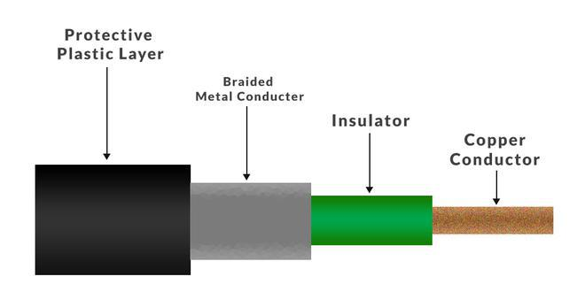

1. **Fiber Optic Cable:** 
   * **Description**: Uses light to transmit data with high speed and long-distance coverage.
   * **Diagram**:



1. **Shielded Twisted Pair (STP):** 
   * **Description**: Like UTP but with additional shielding for better noise resistance.
   * **Diagram**:

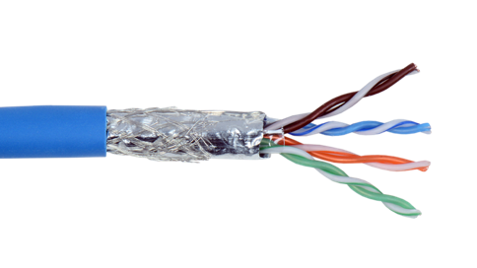

1. **Unshielded Twisted Pair (UTP):** 
   * **Description**: Most commonly used in LANs. No shielding, lower cost, easy to install.
   * **Diagram**:

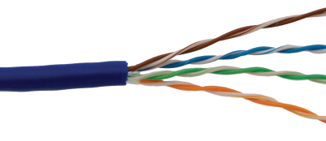

1. **Difference between guided and unguided media.**

|  |  |  |
| --- | --- | --- |
| No. | Guided Media | Unguided Media |
| 1 | Uses physical path for transmission. | Uses air or vacuum for transmission. |
| 2 | Twisted pair, Coaxial, Fiber optic. | Radio waves, Microwaves, Infrared. |
| 3 | Directed and confined. | Broadcasts in all directions. |
| 4 | Less interference. | More environmental interference. |
| 5 | More expensive. | Cheaper, no cables needed. |

## Give cross-wired cable and straight through cable diagram (Color Code wise).

1. Cross-wired Cable Diagram (Color Code)

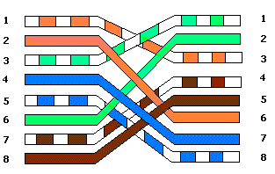

1. Straight Through Cable Diagram (Color Code)

