Lab Practical #1:
1) Write a C program to count the number of 1’s and 0’s in the binary representation of a number.
2) Write a C program to perform bitwise AND, OR, XOR, and NOT operations on integers.
3) Write a C program that takes a string and performs bitwise AND and XOR operations with a constant value (e.g., 127). (Simulates simple encryption idea)
4) Write a C program to implement left and right circular bit rotations.
5) Write a C program to swap two variables without using a third variable (using XOR).
Program-1:
#include <stdio.h>

void countAndBinary(int n)
{
int original = n;
int count0 = 0, count1 = 0;
int binary[32];
int index = 0;

while (n > 0)
{
int rem = n % 2;
binary[index++] = rem;

if (rem == 1)
count1++;
else
count0++;

n = n / 2;
}

printf("Binary of %d is: ", original);
for (int i = index - 1; i >= 0; i--)
{
printf("%d", binary[i]);
}

printf("\nCount of 1s = %d\n", count1);
printf("Count of 0s = %d\n", count0);
}

int main()
{
int n;

printf("Enter any Number: ");
scanf("%d", &n);

countAndBinary(n);

return 0;
}

Output:
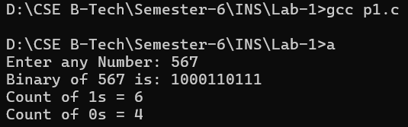

Program-2:
#include <stdio.h>
int main() {
int a, b;
printf("Enter two integers: ");
scanf("%d %d", &a, &b);

printf("Bitwise AND of %d and %d is: %d\n", a, b, a & b);
printf("Bitwise OR of %d and %d is: %d\n", a, b, a | b);
printf("Bitwise XOR of %d and %d is: %d\n", a, b, a ^ b);
printf("Bitwise NOT of %d is: %d\n", a, ~a);
printf("Bitwise NOT of %d is: %d\n", b, ~b);

return 0;
}

Output:
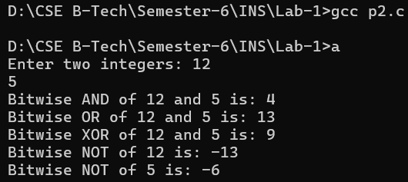

Program-3:
#include <stdio.h>
#include <string.h>

#define KEY 127

int main() {
char str[100];
printf("Enter a string: ");
fgets(str, sizeof(str), stdin);

str[strcspn(str, "\n")] = '\0';

int len = strlen(str);

printf("\nOriginal String: %s\n", str);

// AND
printf("After AND with %d: ", KEY);
for (int i = 0; i < len; i++) {
printf("%c", str[i] & KEY);
}
printf("\n");

// XOR (print hex)
printf("After XOR with %d (hex): ", KEY);
for (int i = 0; i < len; i++) {
printf("%02X ", str[i] ^ KEY);
}
printf("\n");

return 0;
}

Output:
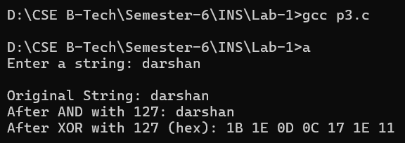

Program-4:
#include <stdio.h>

int main() {
unsigned int num, n, left_rotate, right_rotate;
int bits = 32;

printf("Enter a number: ");
scanf("%u", &num);

printf("Enter number of positions to rotate: ");
scanf("%u", &n);

n %= bits;

left_rotate = (num << n) | (num >> (bits - n));

right_rotate = (num >> n) | (num << (bits - n));

printf("\nOriginal Number: %u\n", num);
printf("After Left Circular Rotation : %u\n", left_rotate);
printf("After Right Circular Rotation: %u\n", right_rotate);

return 0;
}

Output:
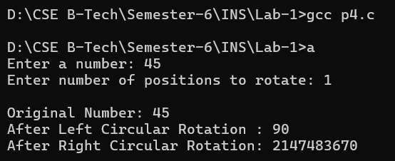

Program-5:
#include <stdio.h>

int main() {
int a, b;

printf("Enter value of a: ");
scanf("%d", &a);

printf("Enter value of b: ");
scanf("%d", &b);

// Swap using XOR
a = a ^ b;
b = a ^ b;
a = a ^ b;

printf("\nAfter swapping:\n");
printf("a = %d\n", a);
printf("b = %d\n", b);

return 0;
}

Output:
