Lab Practical #2:
- Write a program to reverse a string using pointers.
- Implement string functions like strlen, strcat, and strcmp.
- Implement a program to read and write a text file.
- Write a C program to test whether a number is prime or composite.
- Write a C program to generate prime numbers in a given range.

Program-1:
#include <stdio.h>

int main() {
char str[100], *ptr_start, *ptr_end, temp;
int len = 0;

printf("Enter a string: ");
fgets(str, sizeof(str), stdin);

while (str[len] != '\0' && str[len] != '\n')
len++;

ptr_start = str;
ptr_end = str + len - 1;

while (ptr_start < ptr_end) {
temp = *ptr_start;
*ptr_start = *ptr_end;
*ptr_end = temp;

ptr_start++;
ptr_end--;
}

printf("Reversed string: %s\n", str);

return 0;
}

Output:
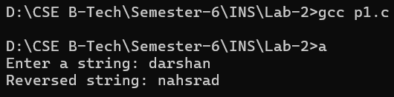

Program-2:
#include <stdio.h>

int my_strlen(char str[]) {
int i = 0;
while (str[i] != '\0') {
i++;
}
return i;
}

void my_strcat(char dest[], char src[]) {
int i = 0, j = 0;

while (dest[i] != '\0') {
i++;
}

while (src[j] != '\0') {
dest[i] = src[j];
i++;
j++;
}

dest[i] = '\0';
}

int my_strcmp(char s1[], char s2[]) {
int i = 0;

while (s1[i] != '\0' && s2[i] != '\0') {
if (s1[i] != s2[i]) {
return s1[i] - s2[i];
}
i++;
}

return s1[i] - s2[i];
}

int main() {
char s1[100], s2[100];

printf("Enter first string: ");
fgets(s1, sizeof(s1), stdin);

printf("Enter second string: ");
fgets(s2, sizeof(s2), stdin);

for (int i = 0; s1[i]; i++)
if (s1[i] == '\n') s1[i] = '\0';

for (int i = 0; s2[i]; i++)
if (s2[i] == '\n') s2[i] = '\0';

printf("\nLength of s1 : %d\n", my_strlen(s1));
printf("Length of s2 : %d\n", my_strlen(s2));

my_strcat(s1, s2);
printf("After concatenation (s1 + s2): %s\n", s1);

int result = my_strcmp(s1, s2);

if (result == 0)
printf("Strings are equal.\n");
else if (result > 0)
printf("s1 is greater than s2.\n");
else
printf("s1 is smaller than s2.\n");

return 0;
}

Output:
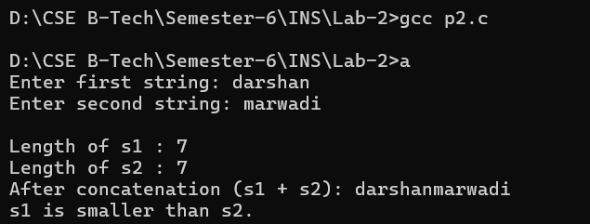

Program-3:
#include <stdio.h>

int main() {
FILE *fp;
char text[200];

fp = fopen("sample.txt", "w");

if (fp == NULL) {
printf("Error opening file!\n");
return 1;
}

printf("Enter text to write into file: ");
fgets(text, sizeof(text), stdin);

fprintf(fp, "%s", text);
fclose(fp);

fp = fopen("sample.txt", "r");

if (fp == NULL) {
printf("Error opening file!\n");
return 1;
}

printf("\nReading from file:\n");
while (fgets(text, sizeof(text), fp) != NULL) {
printf("%s", text);
}

fclose(fp);

return 0;
}

Output:
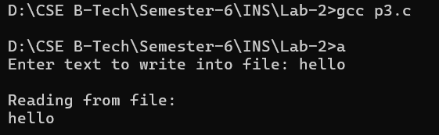

Program-4:
#include <stdio.h>

int main() {
int num, i, flag = 0;

printf("Enter a number: ");
scanf("%d", &num);

if (num <= 1) {
printf("Number is neither prime nor composite.\n");
return 0;
}

// Check divisors from 2 to num/2
for (i = 2; i <= num / 2; i++) {
if (num % i == 0) {
flag = 1;
break;
}
}

if (flag == 0)
printf("%d is a PRIME number.\n", num);
else
printf("%d is a COMPOSITE number.\n", num);

return 0;
}

Output:
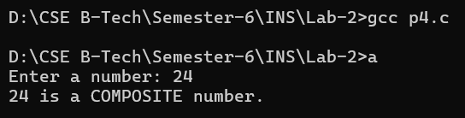

Program-5:
#include <stdio.h>

int main() {
int start, end, i, j, flag;

printf("Enter start of range: ");
scanf("%d", &start);

printf("Enter end of range: ");
scanf("%d", &end);

printf("Prime numbers between %d and %d are:\n", start, end);

for (i = start; i <= end; i++) {
if (i <= 1)
continue;

flag = 0;

for (j = 2; j <= i / 2; j++) {
if (i % j == 0) {
flag = 1;
break;
}
}

if (flag == 0)
printf("%d ", i);
}

printf("\n");
return 0;
}

Output:
