Lab Practical #4:
Implementation of monoalphabetic and polyalphabetic substitution cipher technique.

Program:
// Monoalphabetic cipher implementation in C.

#include <stdio.h>
#include <ctype.h>

int main() {
char text[100];
int key;

printf("Enter text: ");
fgets(text, sizeof(text), stdin);

printf("Enter key: ");
scanf("%d", &key);

for (int i = 0; text[i] != '\0'; i++) {
if (isalpha(text[i])) {
char base = islower(text[i]) ? 'a' : 'A';
text[i] = (text[i] - base + key) % 26 + base;
}
}

printf("Encrypted text: %s", text);
return 0;
}

Output:
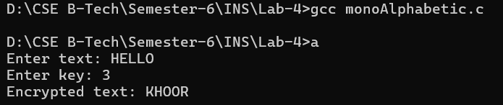

Program:
// Polyalphabetic Cipher Implementation in C.

#include <stdio.h>
#include <string.h>
#include <ctype.h>

int main() {
char text[100], key[20];
int i, j = 0;

printf("Enter text: ");
fgets(text, sizeof(text), stdin);

printf("Enter key: ");
scanf("%s", key);

for (i = 0; text[i] != '\0'; i++) {
if (isalpha(text[i])) {
char base = islower(text[i]) ? 'a' : 'A';
text[i] = (text[i] - base + (tolower(key[j]) - 'a')) % 26 + base;
j = (j + 1) % strlen(key);
}
}

printf("Encrypted text: %s", text);
return 0;
}

Output:
