Lab Practical #6:
Implementation of Hill Cipher Technique.
- 2x2 key matrix
- 3x3 key matrix

Program:
#include <stdio.h>
#include <string.h>

int main() {
int key[2][2] = {{3, 3}, {2, 5}};
char plaintext[100];
int i;

printf("Enter Plaintext (uppercase): ");
scanf("%s", plaintext);

// If length is odd, add X
if (strlen(plaintext) % 2 != 0) {
strcat(plaintext, "X");
}

printf("Ciphertext: ");

for (i = 0; i < strlen(plaintext); i += 2) {
int p1 = plaintext[i] - 'A';
int p2 = plaintext[i + 1] - 'A';

int c1 = (key[0][0]*p1 + key[0][1]*p2) % 26;
int c2 = (key[1][0]*p1 + key[1][1]*p2) % 26;

printf("%c%c", c1 + 'A', c2 + 'A');
}

return 0;
}

Output:
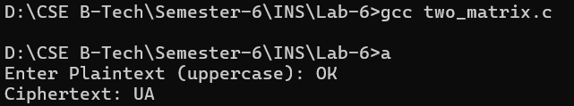
Program:
#include <stdio.h>
#include <string.h>

int main() {
int key[3][3] = {
{6, 24, 1},
{13, 16, 10},
{20, 17, 15}
};

char plaintext[100];
int i;

printf("Enter Plaintext (uppercase): ");
scanf("%s", plaintext);

// Padding with X if needed
while (strlen(plaintext) % 3 != 0) {
strcat(plaintext, "X");
}

printf("Ciphertext: ");

for (i = 0; i < strlen(plaintext); i += 3) {
int p[3], c[3], j;

for (j = 0; j < 3; j++) {
p[j] = plaintext[i + j] - 'A';
}

for (j = 0; j < 3; j++) {
c[j] = (key[j][0]*p[0] + key[j][1]*p[1] + key[j][2]*p[2]) % 26;
printf("%c", c[j] + 'A');
}
}

return 0;
}

Output:
