Practical 4

Use Burp proxy to capture and modify the message.
Step 1:
Intercepting the message request sent to https://demo.owasp-juice.shop
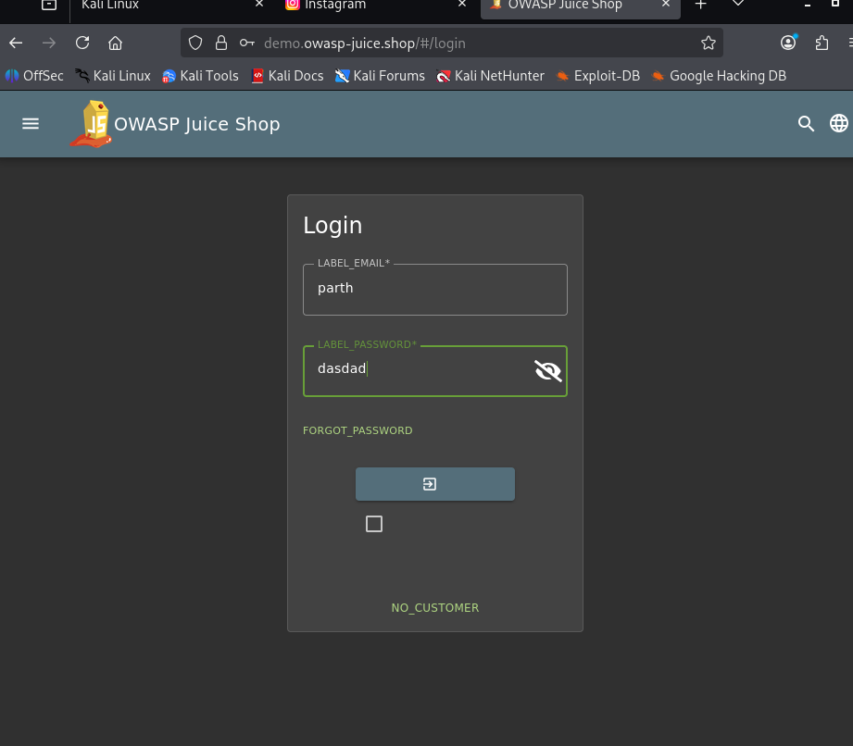
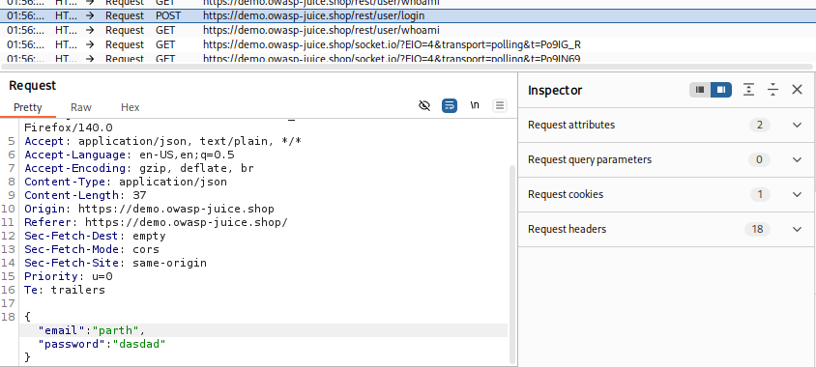

Step 2:
Modifying the content to login and then pressing forward
