Practical – 1
Aim - To test the hypothesis for homogeneity of different treatments using ANOVA.
Experiment - The following data gives the retail prices in rupees of a certain commodity in six randomly selected shops, in each of the four cities C1, C2, C3, C4
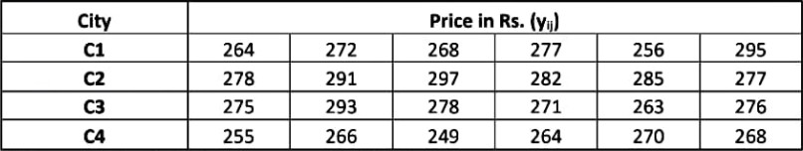

Table 1. Data of Retail Prices in Six Shops for Four Cities
- Carry out the ANOVA and answer the following questions:
  - Do the price of commodity differ significantly in the four cities?
  - If yes, find the critical difference (CD) or LSD at 5% level of significance.
  - Which pair of treatment means differ significantly?
- If we decode the data to uij = (yij -270), how are the various sum of squares, variance ratio and ANOVA table affected.

Theory - Suppose we have N observations yij (i = 1, 2, ...., k & j = 1, 2, ..., ni) of a random

variable y, grouped into k treatments of size n1, n2, ..., nk respectively where N = In this case, the fixed effect model is given by:
yij = µ + αi + 𝜀_{𝑖𝑗} ; i = 1, 2, ...., k & j = 1, 2, ..., ni
𝑘
𝑖=1
Σ ni

where, µ is the mean effect given by: µ =
^{𝑘} Σ ni µi

µi is the fixed effect due to different treatments
𝑖=1
αi is the effect of ith treatment and given by: αi = µi - µ
𝜀_{𝑖𝑗} is the error effect due to chance
To test the homogeneity between different treatments, the null hypothesis is H0: µ1 = µ2 = ... = µk

The alternate hypothesis is
H1: At least two of the means µ1, µ2, ..., µk are different where µi is the mean of the observations of i^{th} treatment
Now,
Total sum of observations = G = ^{𝑘} Σ 𝑛𝑖 Σ yij
𝑖=1 𝑗=1

Raw Sum of Squares = RSS = Correction Factor = CF = G² / N
𝑘
𝑖=1
Σ
𝑛𝑖 2
𝑗=1
Σ yij

Total Sum of Squares = TSS = RSS - CF
𝑘 𝑇2
Sum of Squares due to Treatment = SST = 𝑖=1Σ ^{𝑖.} - CF
𝑛
𝑖
𝑘 𝑇2
Sum of Squares due to Error = SSE = TSS - SST = RSS - 𝑖=1Σ ^{𝑖.}
𝑛
𝑖
Mean Sum of Squares due to Treatment = MSST = SST / k – 1 Mean Sum of Squares due to Error = MSSE = SSE / N – k

The test statistic under H0 is, F0 = MSST / MSSE

Source of  Variation | Sum of Square, SS | Degrees of  freedom, df | Mean Sum of  Square, MSS | Variance Ratio
Treatment | SST | k - 1 | MSST | 𝑀𝑆𝑆𝑇  𝐹𝑜 = 𝑀𝑆𝑆𝐸
Error | SSE | N - k | MSSE
Total | TSS | N - 1

Table 2. One Way ANOVA Table
If 𝐹_{𝑐𝑎𝑙} > 𝐹_{𝑡𝑎𝑏} , then we reject the null hypothesis H0. Otherwise, we accept H0.

Calculations -

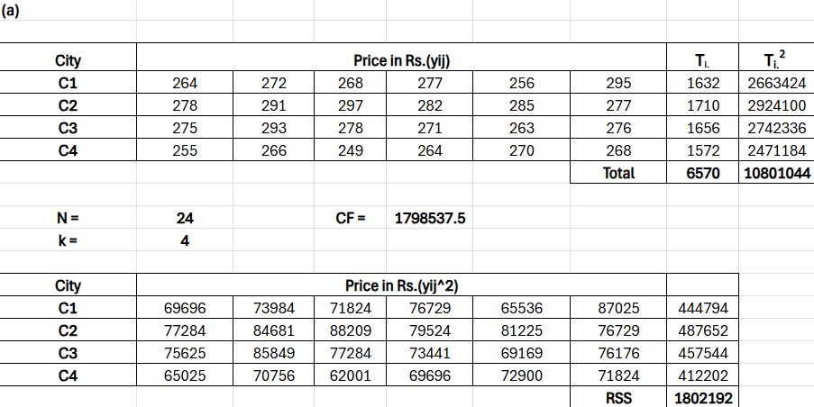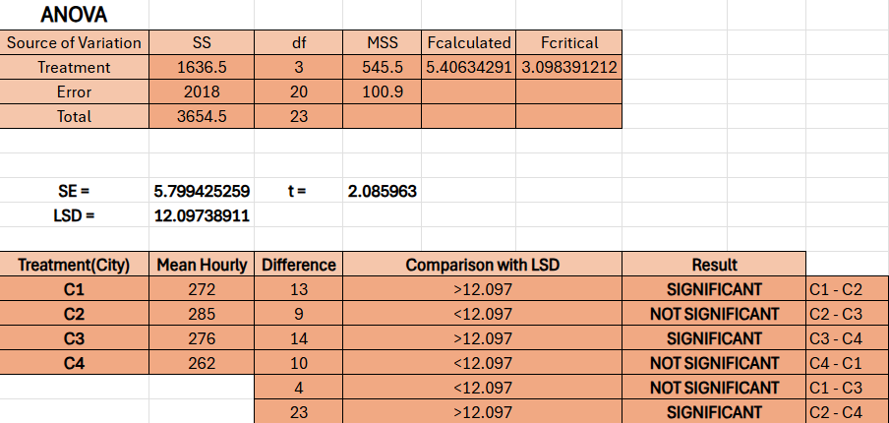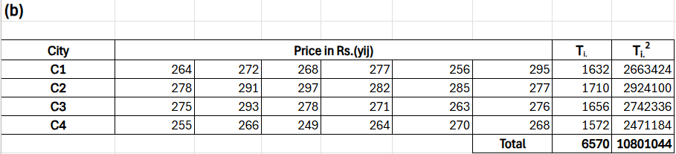

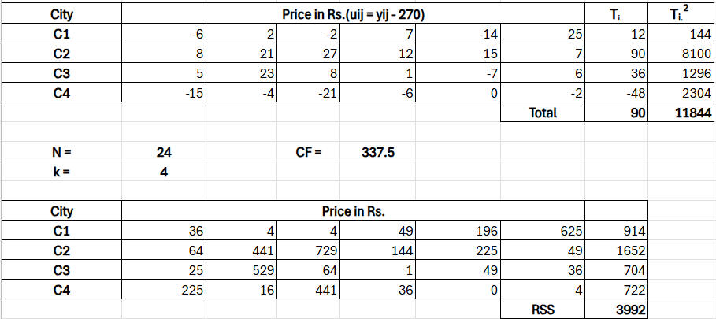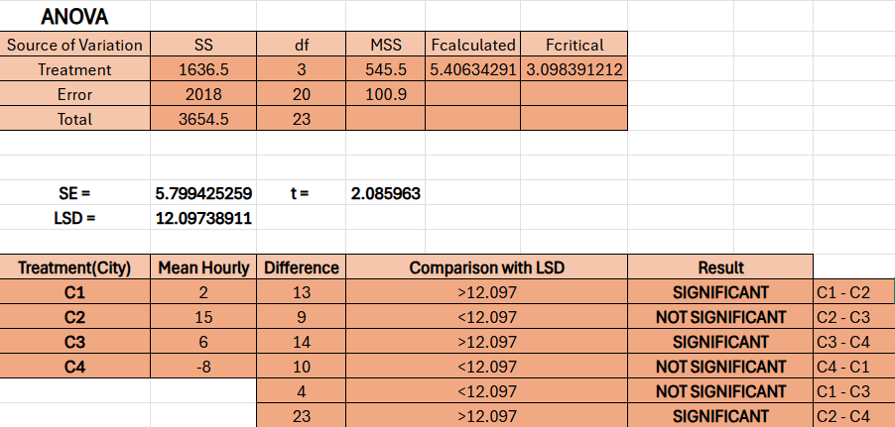
Result -
- The value of 𝐹_{𝑐𝑎𝑙}(5.406) > 𝐹_{𝑡𝑎𝑏}(3.098) for degrees of freedom 3, 20 and at 5% level of significance.
Critical Difference (CD) or LSD at 5% level of significance is 12.097. The difference between different pairs of cities is:
  - C1 and C2 = 13 > LSD
  - C2 and C3 = 9 < LSD
  - C3 and C4 = 14 > LSD
  - C4 and C1 = 10 < LSD
  - C1 and C3 = 4 < LSD

  - C2 and C4 = 23 > LSD
- SST original = SST after shifting origin SSE original = SSE after shifting origin TSS original = TSS after shifting origin
Variance Ratio original = Variance Ratio after shifting origin ANOVA Table original = ANOVA Table after shifting origin

Conclusion -
(a)
- As the value of 𝐹_{𝑐𝑎𝑙}(5.406) > 𝐹_{𝑡𝑎𝑏}(3.098) , we reject the null hypothesis. Hence, the retail price of commodity differs significantly in the four cities.
- The value of Critical Difference (CD) or LSD at 5% level of significance is 12.097.
- The pairs of treatment means which differ significantly are-
C1 & C2, C3 & C4, and C2 & C4

(b) From the original ANOVA table and the ANOVA table for data after shifting origin we can see that there is no difference between various sum of squares, variance ratios and ANOVA table.
Hence, shifting the origin has no effect on ANOVA table.

