Practical – 2
Aim - To test the hypothesis for homogeneity of different treatments using ANOVA.
Experiment – The following table shows the lives (in hours) of four batches of electric lamps:
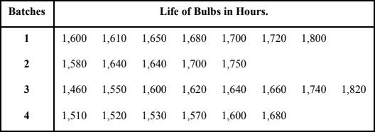
Perform an analysis of variance for the above data and show that a significance test does not reject their homogeneity.

Theory - Suppose we have N observations yij (i = 1, 2, ...., k & j = 1, 2, ..., ni) of a random

variable y, grouped into k treatments of size n1, n2, ..., nk respectively where N = In this case, the fixed effect model is given by:
y_{ij} = µ + α_{i} + 𝜀_{𝑖𝑗} ; i = 1, 2, ...., k & j = 1, 2, ..., ni
𝑘
𝑖=1
Σ ni

where, µ is the mean effect given by: µ =
^{𝑘} Σ ni µi

µi is the fixed effect due to different treatments
𝑖=1
αi is the effect of ith treatment and given by: αi = µi - µ
𝜀_{𝑖𝑗} is the error effect due to chance
To test the homogeneity between different treatments, the null hypothesis is H0: µ1 = µ2 = ... = µk

The alternate hypothesis is

H1: At least two of the means µ1, µ2, ..., µk are different where µi is the mean of the observations of i^{th} treatment
Now,
Total sum of observations = G = ^{𝑘} Σ 𝑛𝑖 Σ yij
𝑖=1 𝑗=1
Raw Sum of Squares = RSS = ^{𝑘} Σ ^{𝑛𝑖} Σ y ²
𝑖=1 𝑗=1 ij
Correction Factor = CF = G² / N
Total Sum of Squares = TSS = RSS - CF
𝑘 𝑇2
Sum of Squares due to Treatment = SST = 𝑖=1Σ ^{𝑖.} - CF
𝑛
𝑖
𝑘 𝑇2
Sum of Squares due to Error = SSE = TSS - SST = RSS - 𝑖=1Σ ^{𝑖.}
𝑛
𝑖
Mean Sum of Squares due to Treatment = MSST = SST / k – 1 Mean Sum of Squares due to Error = MSSE = SSE / N – k

The test statistic under H0 is, F0 = MSST / MSSE

 | Sum of Square, SS | Degrees of freedom, df | Mean Sum of Square, MSS | Variance Ratio
Treatment | SST | k - 1 | MSST | 𝑀𝑆𝑆𝑇  𝐹𝑜 = 𝑀𝑆𝑆𝐸
Error | SSE | N - k | MSSE
Total | TSS | N - 1
Table 2. One Way ANOVA Table
If 𝐹_{𝑐𝑎𝑙} > 𝐹_{𝑡𝑎𝑏} , then we reject the null hypothesis H0. Otherwise, we accept H0.

Calculations –
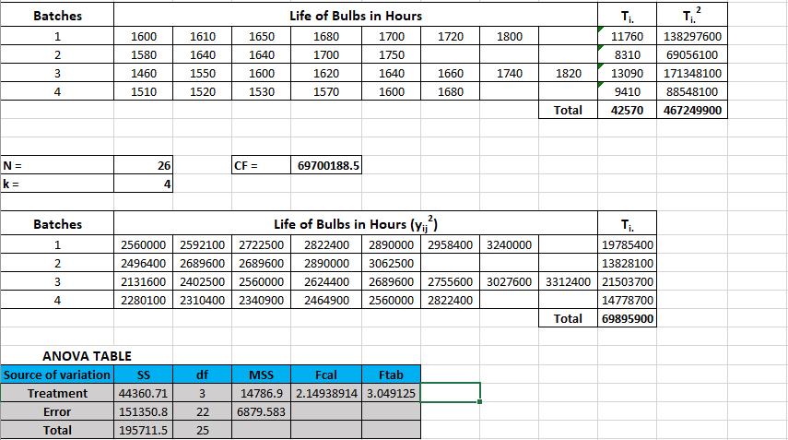

Result –
The value of Fcal (2.149) < Ftab (3.049) for degrees of freedom 3, 22 and at 5% level of significance.

Conclusion -
As the value of Fcal (2.149) < Ftab (3.049), we accept the null hypothesis. Hence, the lives of bulbs does not differ significantly in the batches.

