Practical 3
Aim - To verify that sample mean is an unbiased estimator of population mean and sample mean square is unbiased estimator of population mean square, and finding the variance of sample mean in the case of SRSWOR.
Experiment - Consider a population of 5 units with values 122, 143, 129, 150 and 110. Write down all possible sample size of 2 without replacement from the population and verify that
i) Sample mean is an unbiased estimator of population mean
ii) Sample mean square is unbiased estimator of population mean square
Also obtain variance of sample mean.
Theory - Let, N = population size & n = sample size
The total number of possible samples of size n from a population of size N selected using simple random sampling without replacement (SRSWOR) is
^{N}C_{n}
Mean of sample mean = E($\overline{y}$_{n}) = $\sum_{i=1}^{{}_{n}^{N}C}{{\overline{y}}_{i} }/ {}_{n}^{N}C$
where $\overline{y}$_{n} is the mean of the i^{th} sample (i = 1, 2,…, ^{N}C_{n})
Now E($\overline{y}$_{n}) = $\overline{Y}$_{N}, where $\overline{Y}$_{N} is the population mean

Mean square of sample mean squares = E(s²) = $\sum_{i=1}^{{}_{n}^{N}C}{s_{i}^{2} }/ {}_{n}^{N}C$
where s² is the mean square of the i^{th} sample (i = 1, 2,…, ^{N}C_{n})
Now E(s²) = S², where S² is the population mean square

Also, variance of sample mean = V($\overline{y}$_{n}) = (1/n – 1/N) S²

Calculation -
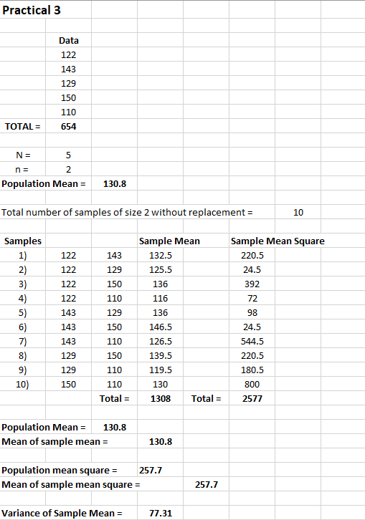

Result -
i) Mean of sample mean = Population Mean = 130.8
ii) Mean of sample mean square = Population Mean Square = 257.7
iii) Variance of Sample Mean = 77.31

Conclusion -
i) The expected value of sample mean is equal to the population mean(=130.8). Hence, sample mean is an unbiased estimator of population mean.
ii) The expected value of sample mean square is equal to the population mean square(=257.7). Hence, sample mean square is an unbiased estimator of population mean square.

