Practical – 5
Aim - To test the hypothesis for homogeneity of different treatments using Two Way ANOVA.
Experiment - The following data gives the quality rating of service station by five professional raters:
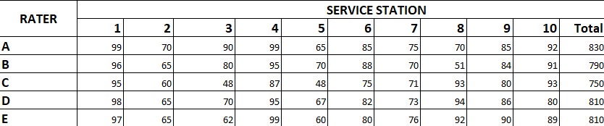
Table 1. Quality rating of service station by five professional raters
Analyze the data and discuss whether there is any significant difference between raters or between service stations.

Theory - Suppose we have N observations y_{ij} (i = 1, 2, ...., k & j = 1, 2, ..., n_{i}) of a random variable y, grouped into k treatments or h varieties.
In this case, the fixed effect model is given by:
y_{ij} = µ + α_{i} + β_{j} + $ε_{ij}$ ; i = 1, 2, ...., k & j = 1, 2, ..., h
where, µ is the mean effect
µ_{i} is the fixed effect due to different treatments
α_{i} is the effect of ith treatment
β_{j} is the effect of ith treatment
$ε_{ij}$ is the error effect due to chance
To test the homogeneity between different treatments, the null hypothesis is
H₀: α₁ = α₂ ₌ … = α_{k}
and β₁ = β₂ = … = β_{h}
The alternate hypothesis is
H₁: At least two of the means α_{1,} α_{2,} … ,α_{k}
are different or β₁, β₂,…, β_{h} are different
Now,
Total sum of observations = G = ${}_{i=1}^{k}Σ _{j=1}^{h}Σ$ y_{ij}
Raw Sum of Squares = RSS = ${}_{i=1}^{k}Σ _{j=1}^{h}Σ$ y_{ij}²
Correction Factor = CF = G² / N
Total Sum of Squares = TSS = RSS - CF
Sum of Squares due to Treatment = SSA = ${}_{i=1}^{k}Σ \frac{T_{i. }^{2}}{h}$ – CF
Sum of Squares due to Varieties = SSB = ${}_{j=1}^{h}Σ \frac{T_{.j }^{2}}{k}$ - CF
Sum of Squares due to Error = SSE = TSS – SSA – SSB
Mean Sum of Squares due to Treatment = MSSA = SSA / k – 1
Mean Sum of Squares due to Treatment = MSSB = SSB / h – 1
Mean Sum of Squares due to Error = MSSE = SSE / ((k-1)(h-1))

The test statistic under H₀ is,
F₀ = MSST / MSSE

Source of Variation | Sum of Square, SS | Degrees of freedom, df | Mean Sum of Square, MSS | Variance Ratio
Treatment | SSA | k - 1 | MSSA | $$F_{A}=\frac{MSSA}{MSSE}$$
Varieties | SSB | h – 1 | MSSB
Error | SSE | (k-1)(h-1) | MSSE
Total | TSS | N - 1 |  | $$F_{B}=\frac{MSSB}{MSSE}$$
Table 2. Two Way ANOVA Table
If $F_{cal }> F_{tab}$ , then we reject the null hypothesis H₀.
Otherwise, we accept H₀.

Calculations –
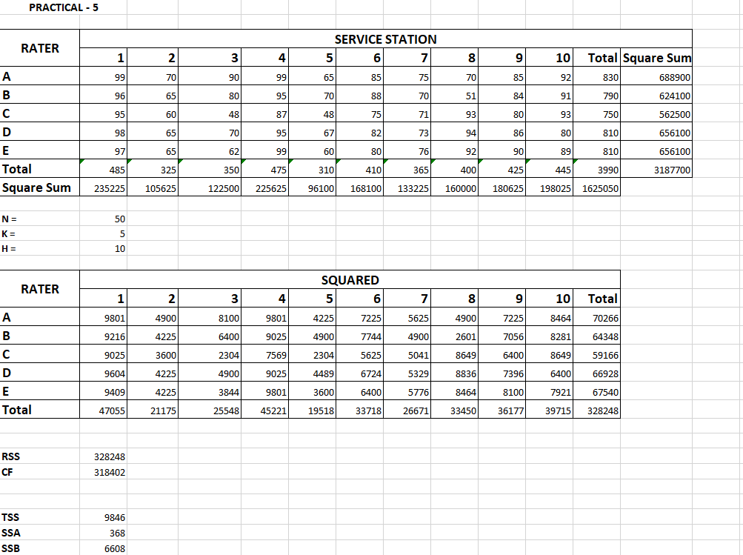

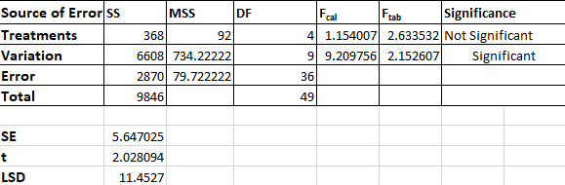

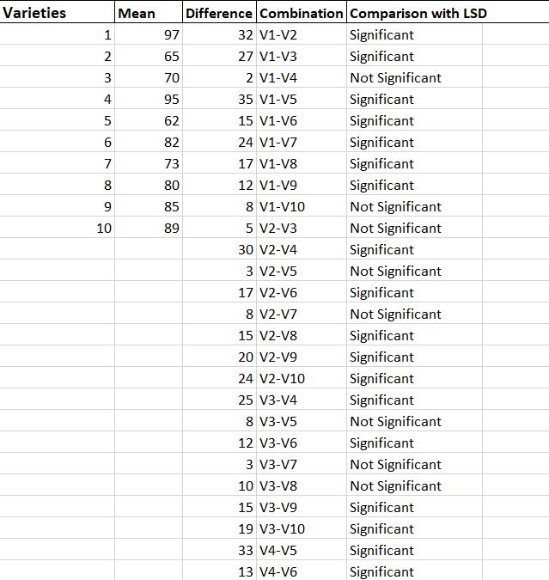
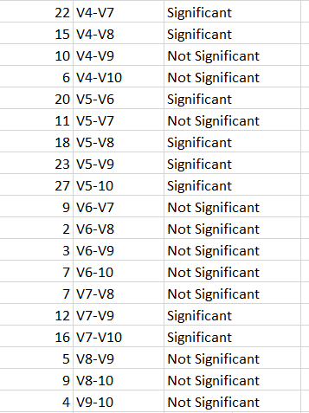

Result -
The value of $F_{cal, A}\left(1.154\right) > F_{tab}\left(2.633\right)$ for degrees of freedom 4, 36 and at 5% level of significance.

The value of $F_{cal, B}\left(9.209\right) > F_{tab}\left(2.152\right)$ for degrees of freedom 9, 36 and at 5% level of significance.
Critical Difference (CD) or LSD at 5% level of significance is 11.453.

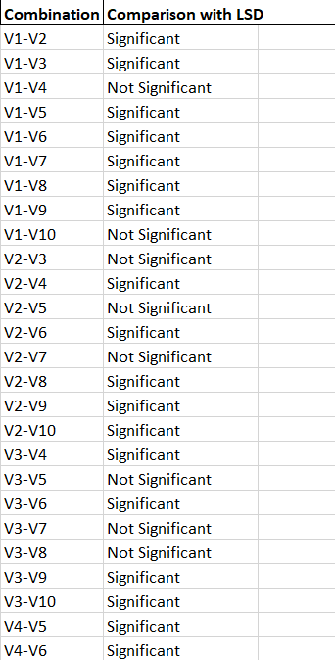
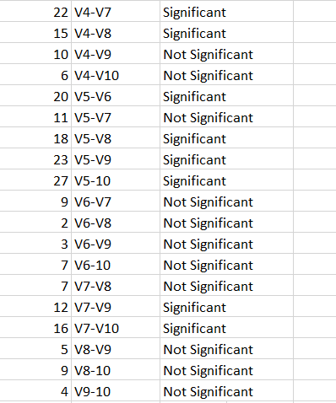
Conclusion -
(i) As the value of $F_{cal, B}\left(9.209\right) > F_{tab}\left(2.152\right)$, we reject the null hypothesis. Hence, there is a significant difference between Service Stations.
(ii) The value of Critical Difference (CD) or LSD at 5% level of significance is 11.453.
(iii) The pairs of treatment means which differ significantly are-
V1&V2, V3&V4, V4&V5, V5&V6, V1&V3, V1&V5, V1&V6, V1&V7, V1&V8, V1&V9, V2&V4, V2&V6, V2&V8, V2&V9, V2&V10, V3&V6, V3&V9, V3&V10, V4&V6, V4&V7, V4&V8, V5&V8, V5&V9, V5&V10, V7&V9, and V7&V10.

