Aim: To calculate sample size, sampling variance, according to the strata and compare the sampling variance and comment.
Experiment: The following table gives complete enumeration of the data of 340 villages of certain districts. The villages were stratified according to their agricultural area into 4 strata. Table 1. below gives the distribution of villages into 4 strata, strata mean and standard deviation. 1) Allocate the total sample of 34 villages according to
(a) Proportional allocation
(b) Neyman allocation
2) Calculate the sampling variance of estimated average output area under wheat for a sample of 34 villages if villages are selected by
(a) SRSWOR
(b) Proportional allocation
(c) Neyman allocation
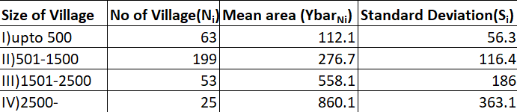
Table 1. Data of 340 Villages after Stratification
Theory: Let, N = total population size
n = total sample size
N_{i} = size of population strata (i = 1,2,…,k)
Under proportional allocation of stratified random sampling,
Sample size from each strata = n_{i} = N_{i} * n / N
Var($\overline{y}$_{st})_{prop} = (1/n – 1/N)*(Sum(P_{i}S_{i}²))
where P_{i} = N_{i} / N
S_{i} = standard deviation of each strata
In SRSWOR,
Var($\overline{y}$_{n})_{wor} = (1/n – 1/N)*S²
where S² = population standard deviation = Sum(P_{i}S_{i}²) + Sum(P_{i}$\overline{Y}$_{Ni}²) – (Sum(P_{i}$\overline{Y}$_{N}²)²
$\overline{Y}$_{Ni} = mean of each population strata
$\overline{Y}$_{N} = population mean

Under Neyman allocation of stratified random sampling,
n_{i} = (n* N_{i}S_{i}) / Sum(N_{i}S_{i})
Var($\overline{y}$_{st})_{Ney} = (1/n)* (Sum(P_{i}S_{i})²) – (1/N)*(Sum(P_{i}S_{i}²))
Calculation:
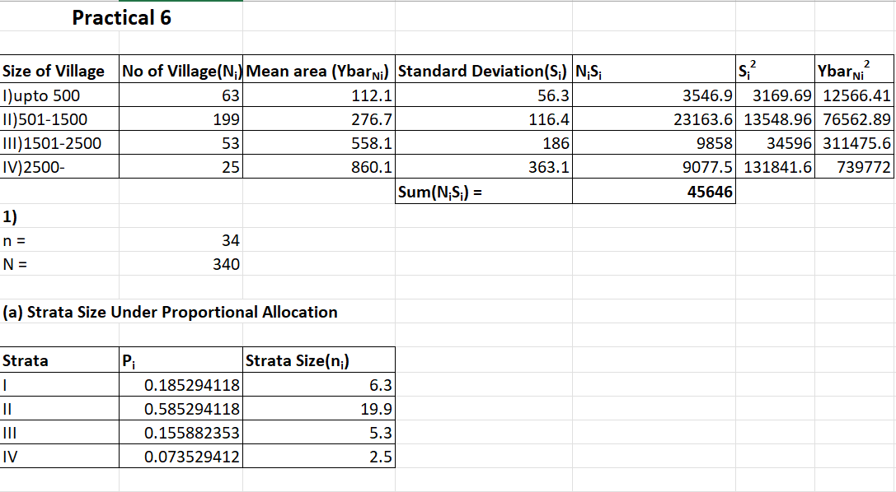
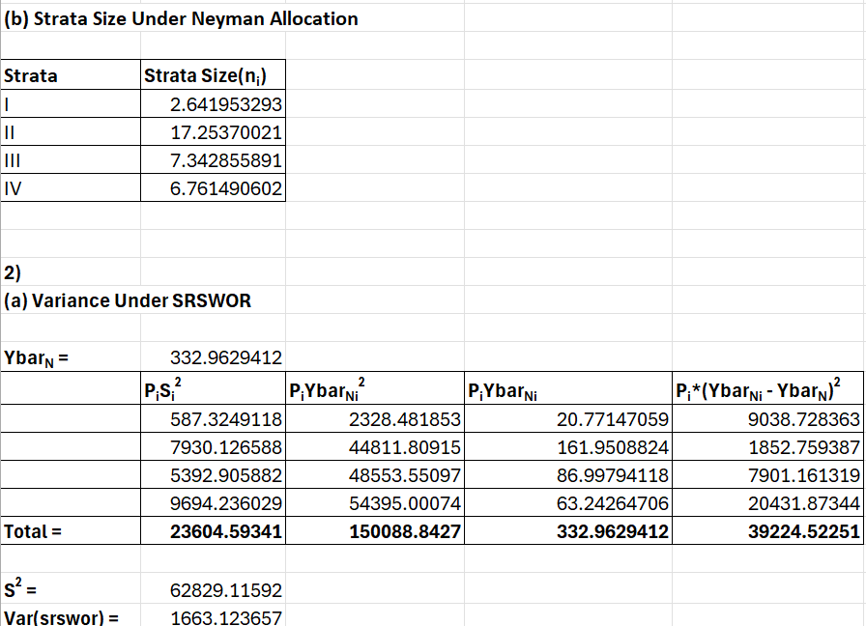
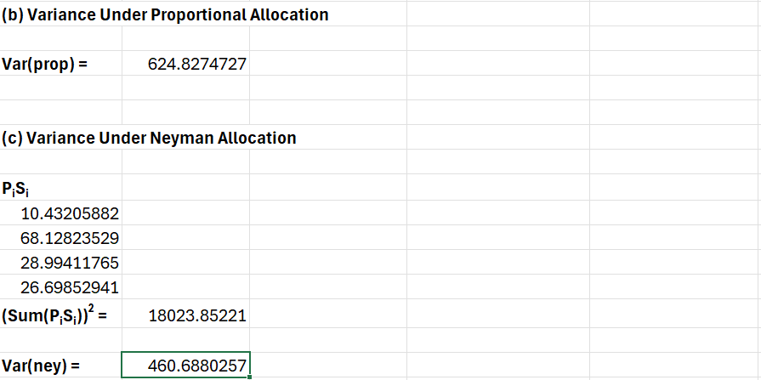
Result:
1)
(a) Sample Size of each strata under Proportional Allocation is:-
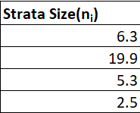
(b) Sample Size of each strata under Neyman Allocation is:-
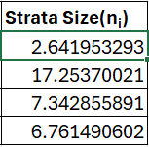
2) The sampling variance of estimated average output area under wheat for
(a) SRSWOR is 1663.124
(b) Proportional allocation is 624.827
(c) Neyman allocation is 460.688

Conclusion:
As we can see that Var($\overline{y}$_{st})_{Ney} < Var($\overline{y}$_{st})_{prop} < Var($\overline{y}$_{n})_{wor}. Hence, Stratified Random Sampling with Neyman allocation is the most efficient type of sampling followed by Stratified Random Sampling with Proportional allocation. Overall, we can see that both the types of Stratified Random Sampling are more efficient than Simple Random Sampling.

