Emmet

Emmet is a plugin for text editors that allows you to write HTML and CSS faster by using abbreviations that expand into full code. Eg, go in VS Code, just type <im.., the complete tags initiating with im are visible. Further, selecting and entering on a listed tag, directly may give out the code snippet of that tag. Emmet also automatically provides the closing tag.

Thus, it can save a lot of time when writing the code because you can type aa few characters and then expand them into a long block of code with a single keystroke.

Just try writing the HTML code in a normal text editor like notepad. It’ll take a very, very long time. Though, for VS code, the Emmet is already included. Even in the suggestions in HTML page in VS code, we can note the mention of Emmet. (Select the Edit menu and you will see Emmet written there.

For most other popular text editors like Sublime, Notepad++, Komodo Edit, etc. you need to go on Emmet’s website. Download it. And manually insert the plugin in the application.

**Features of Emmet:-**

1. Abbreviation expression: Write short form of a keyword, it appears in the suggestion.
2. Code Formatting: Code’s spacing and structure automatic correction.
3. Code snippets: Gives out certain code snippets.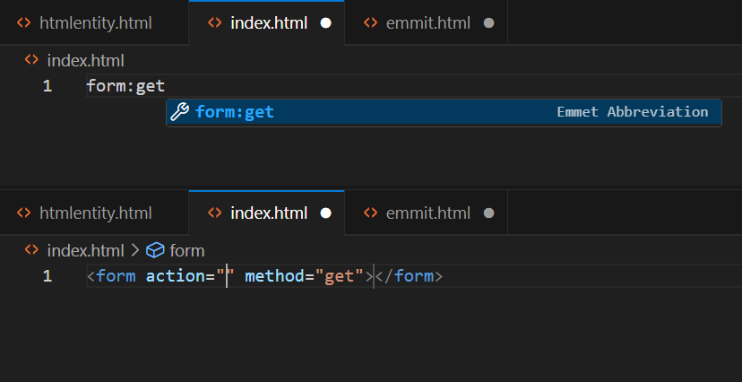

Here once I entered the given suggestion, the entire code snippet appeared.

One such similar code snippet is the boiler plate code.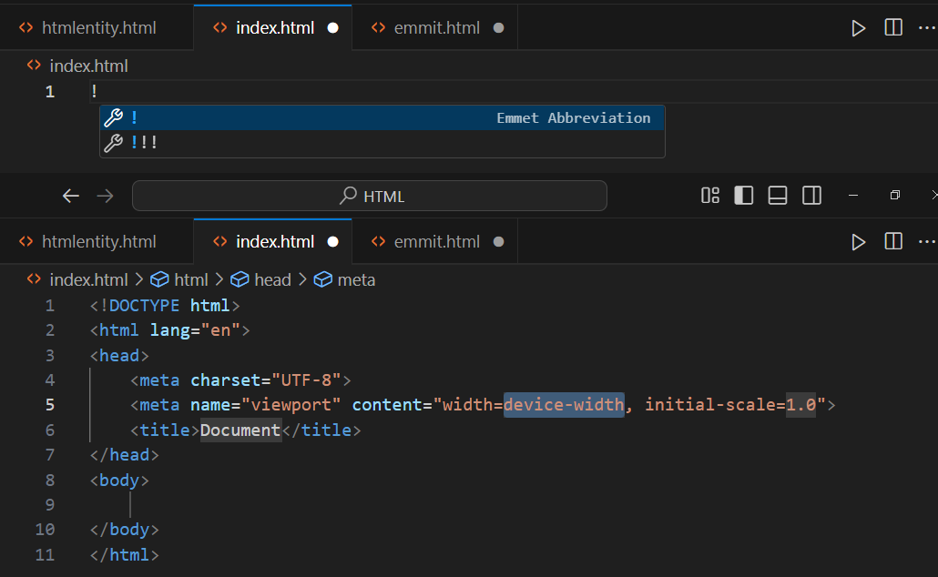Here, the automatic default tags are given. Explanations:

* <!DOCTYPE html> : Starting tag denotes the HTML version used. Here <!DOCTYPE html> means HTML5 is used. Previously, in HTML4, a standard long URL link had to be pasted there. That work is reduced now.
* <html> : The tag encompasses the HTML code whole. It can be passed with the lang attribute explicitly specifying the language used.
* <head> : This tag includes the web page’s meta data. Specifically:
  + <title> : This includes the title that appears at top of the tab in browser. It can be passed with a logo or favicon.
  + <meta>: Meta is said to be the information of the information. Metadata provides information about the page that is not visible to users but is crucial for browsers, search engines, and other services. The <meta> tag is a void element (does not have a closing tag).

