

K.R. MANGALAM UNIVERSITY
School of Engineering and Technology

Lab Assignment -2:
Algorithmic Strategies

Submitted by: Submitted to:
PARTH GOYAL Dr. Aarti
2401420028

Assignment Tasks:
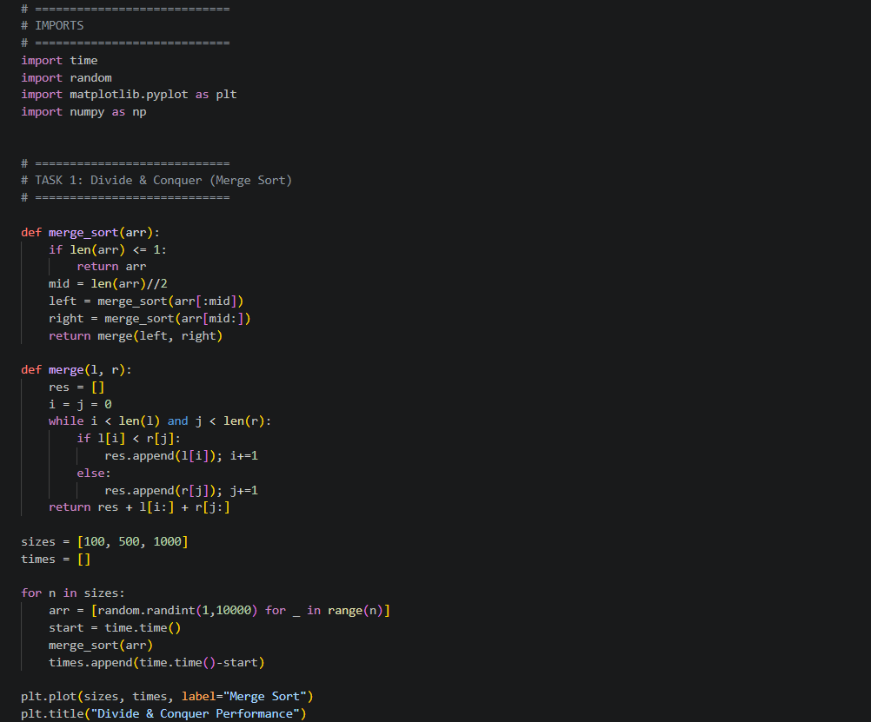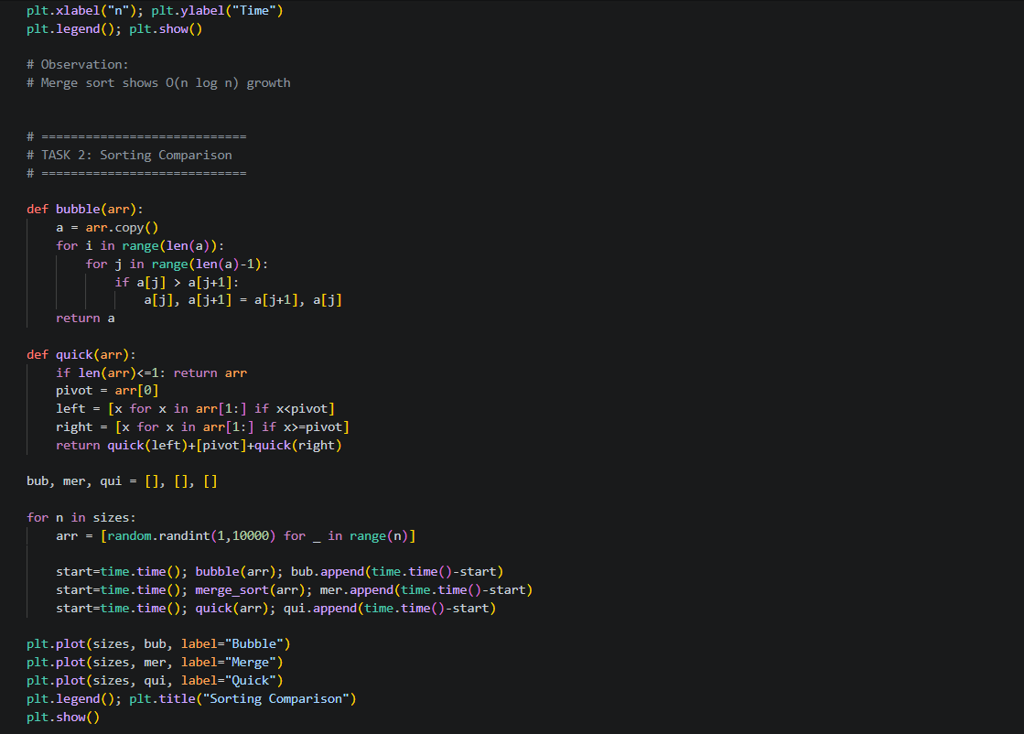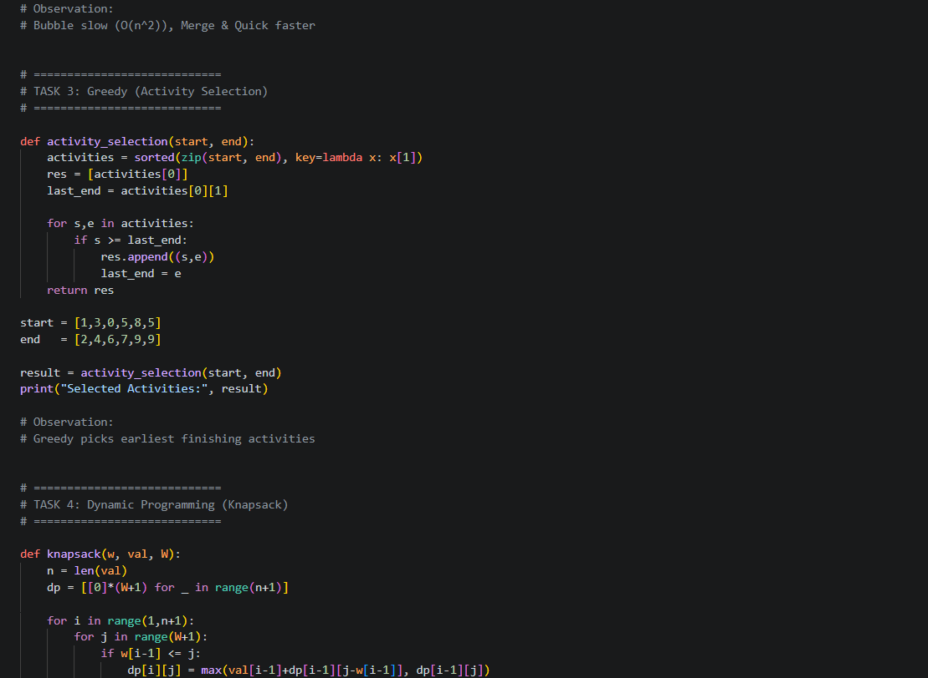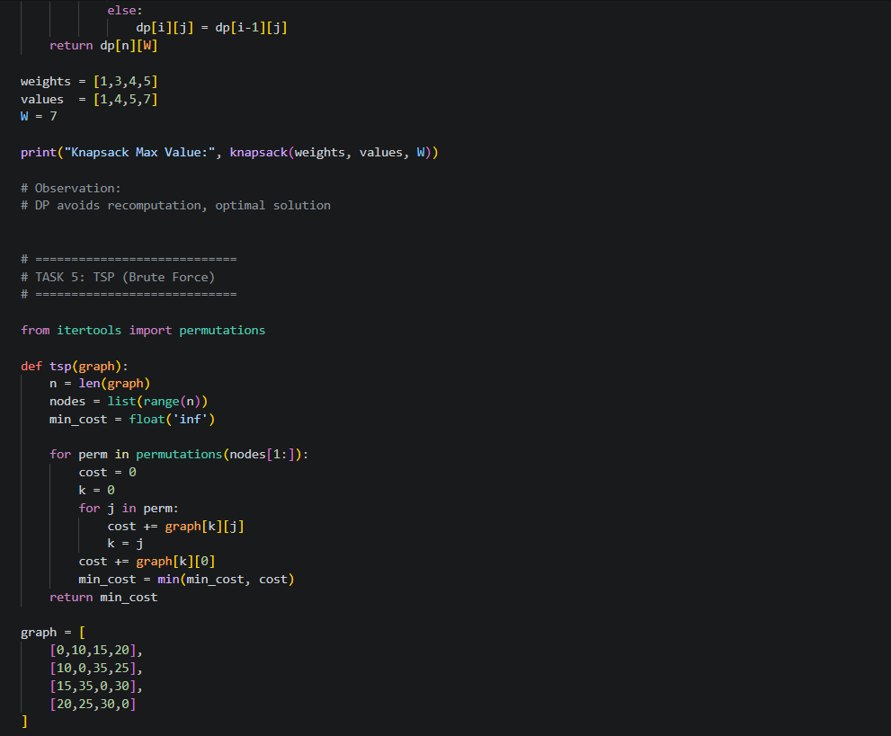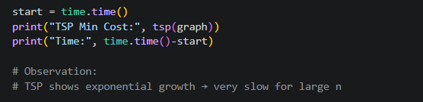

RESULTS:
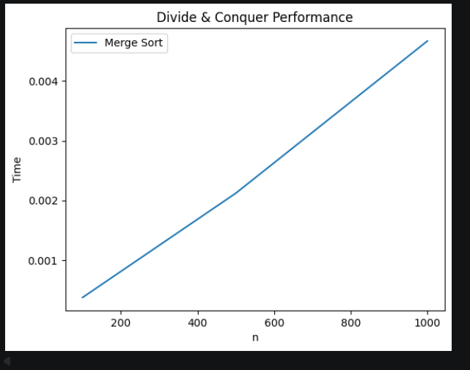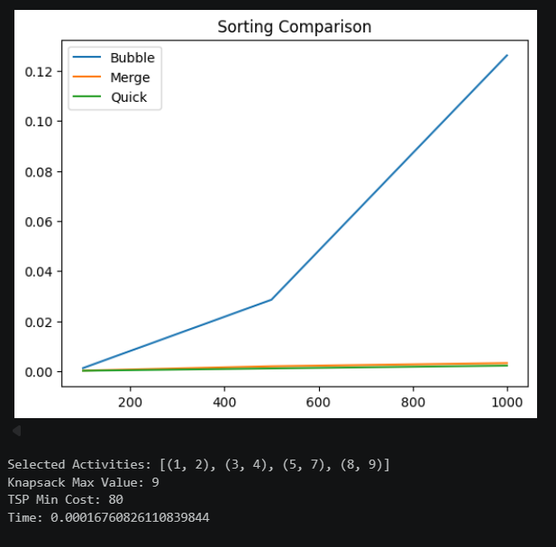

GITHUB REPOSITORY

