Early Detection of Communication Collapse in Operational Systems

Name: Parth Goyal
Registration Number: 23BCE0411

GitHub Repository: https://github.com/parthgoyal974/comm_collapse (Contains: dataset pipeline, source code, final report .doc, and PDF)

School of Computer Science and Engineering Vellore Institute of Technology, Vellore, India
parth.goyal2023@vitstudent.ac.in

Contents

Introduction 3
  - Background and Relevance 3
  - Existing Solutions and Their Limitations 3
  - Research Gap and Contributions 4

Literature Survey 4
  - Rule-Based and Feature-Engineered Approaches 4
  - Neural and Pretrained Model Approaches 4
  - Discourse Coherence, Risk, and DeBERTa-v3 5
  - Comparative Summary 5

Problem Description 5
  - Task Formulation 5
  - System Framework 7
  - Sliding Window Construction and Onset-Aware Labelling 8
  - Input Representation and Model Architecture 8
  - Training Procedure and Pseudocode 9

Experiments 9
  - Dataset 9
  - Sample Dataset Records 10
  - Preprocessing 12
  - Training Configuration and Baselines 12

Results and Discussion 12
  - Comparison with Published Baselines 12
  - Per-Metric Results, Confusion Matrix, and ROC Curve 15
  - Discussion: Labelling Strategy, Threshold, and Convergence 16

Conclusion and Future Work 17

Abstract

Communication breakdown in operational AI dialogue systems degrades user experience and causes failures in safety-critical environments, yet existing detection methods operate at the utterance level and miss the gradual, multi- turn nature of communicative collapse. This work addresses that gap with a sliding-window context encoding framework built on DeBERTa-v3-small, fine-tuned on the DBDC3 English benchmark (615 annotated dialogues). A novel onset-aware binary labelling strategy distinguishes breakdown initiation from saturated failure, and a temporal exponential moving average (EMA) aggregates window-level risk scores into alert-triggering trajectories. The system achieves F1-Positive 0.767, AUROC 0.849, and precision 0.995 at τ =0.80, outperforming all published baselines including BERT-FT (F1: 0.498) and BiLSTM-Attention (F1: 0.423) despite only four CPU-only training epochs. These results demonstrate that transformer-based contextual window modelling is an effective approach for proactive communication risk monitoring in operational systems. Code: https://github.com/parthgoyal974/comm_ collapse.

Keywords: dialogue breakdown detection, communication collapse, DeBERTa-v3, contextual window encoding, risk estimation, DBDC3, transformer fine-tuning, early warning systems.

INTRODUCTION

Background and Relevance
AI-driven dialogue systems are now deployed across commercial, industrial, and public-sector environments—from customer service chatbots and intelligent virtual assistants to healthcare triage interfaces, remote operational support platforms, and AI-assisted coordination systems [18]. As these systems become embedded in consequential workflows, undetected communicative degradation poses significant operational risk. A system that silently diverges from user intent—in domains such as aviation maintenance, clinical support, or emergency coordination—can directly compromise safety and erode user trust in ways that are difficult to recover [17].
Communication breakdown is not a single-utterance event; it is a multi-turn accu- mulation in which small misalignments compound into collapse [1]. A misinterpreted question leads to a compounding response; the user’s correction goes unrecognised; several turns later the thread is unrecoverable. This progressive degradation is fundamentally invisible to utterance-level analysis. Early detection—identifying the onset of degradation before failure becomes irreversible—enables proactive in- tervention: conversation repair prompts, graceful escalation to a human agent, or targeted clarification requests. The operational value of such a system scales directly with the sensitivity of the deployment environment; a clinical AI assistant or an infrastructure coordination bot has far less tolerance for undetected breakdown than a casual recommendation chatbot.

Existing Solutions and Their Limitations
The Dialogue Breakdown Detection Challenge (DBDC) series [1, 3] established the dominant paradigm: per-utterance classification into No Breakdown (O), Possible Breakdown (T), or Breakdown (X). Systems progressed from rule-based heuristics [1], through SVM-based feature engineering [7], neural sequence models [8, 9], to BERT fine-tuning [10]. Each generation brought meaningful accuracy improvements, and the best DBDC3 neural systems achieved competitive F1 scores on a per-turn basis. All, however, share a structural limitation: they answer “Did this response cause breakdown?” not “Is this conversation approaching breakdown?” The latter requires trajectory modelling, onset-specific supervision, and temporally aggregated risk scoring—none of which exist in prior work. Furthermore, all prior systems evaluate each utterance at fixed context windows without any mechanism for accumulating risk evidence across the conversational session, making them fundamentally reactive rather than proactive.

Research Gap and Contributions
Four specific gaps exist: (1) no published system models communicative risk as a continuous temporal trajectory; (2) no labelling strategy distinguishes onset from saturated breakdown; (3) context is treated as static rather than a continuously sliding window; and (4) structured speaker-role encoding is rarely applied systematically. This work addresses all four. Contributions are:
- A sliding-window context encoding scheme with explicit speaker-role and turn-position tokens for sequence-level conversational state representation.
- A novel onset-aware binary labelling strategy distinguishing breakdown initiation from saturation, producing an informative early-warning training signal.
- A complete end-to-end pipeline from raw DBDC3 dialogues through DeBERTa- v3 risk scoring and EMA trajectory generation.
- Empirical evaluation on DBDC3 outperforming all published baselines, with an open-source implementation at https://github.com/parthgoyal974/comm_ collapse.

LITERATURE SURVEY

Rule-Based and Feature-Engineered Approaches
Higashinaka et al. [1] formalised breakdown detection with DBDC1, using keyword- matching and response-length heuristics to achieve F1 of 0.178—the lower bound for all subsequent systems. The DBDC annotation schema (O/T/X with 30 annotators per utterance) and evaluation protocol introduced here have become the standard for all subsequent breakdown research. Pragst et al. [7] improved to F1 0.312 with an SVM trained on TF-IDF features and GloVe semantic similarity scores, demonstrating richer feature design gains while exposing the ceiling imposed by handcrafted representations. Duplessis et al. [19] investigated syntactic parse features alone, finding meaningful but insufficient signal without lexical semantics. These works collectively demonstrate that breakdown carries signal in surface lexical, structural, and semantic features, but that none of them individually is sufficient and that learned representations are necessary to approach strong performance.

Neural and Pretrained Model Approaches
Yoshino et al. [8] submitted a CNN encoding character and word n-gram features to DBDC3, achieving F1 0.361. The CNN captures local n-gram patterns efficiently but lacks any capacity for cross-turn dependency modelling, meaning it cannot detect the gradual degradation patterns that span multiple conversational turns. Xie and

Cohn [9] proposed BiLSTM with soft attention over multi-turn context, reaching the DBDC3 best of F1 0.423. Their hierarchical architecture encodes individual utterances then aggregates them sequentially—a strong design for turn-level quality, but still producing a single per-turn label with no temporal risk accumulation. Yamaguchi et al. [11] extended this with hierarchical recurrent encoders, reinforcing the finding that multi-turn context is essential but stopping short of continuous risk modelling. Qian et al. [10] fine-tuned BERT-base with concatenated dialogue context, achieving F1 0.498 and AUROC 0.763—the strongest published pre-DBDC4 baseline. Their work confirmed the value of pretrained representations for breakdown detection but used a fixed-length context window with no onset-specific labelling. Liu et al. [12] (RoBERTa) and Lan et al. [13] (ALBERT) improved pretrained encoders; Mehri and Eskenazi [21] showed dialogue-adaptive pretraining gains on conversation quality tasks. None of these systems model breakdown as a continuous temporal risk trajectory or distinguish between onset and fully saturated breakdown states.

Discourse Coherence, Risk, and DeBERTa-v3
Li et al. [14] demonstrated that n-gram repetition and semantic self-similarity quantifiably indicate conversational stagnation. Lowe et al. [15] correlated human- rated quality with multi-turn discourse properties. Skantze [17] argued repair mechanisms should be triggered by continuously estimated quality signals, directly motivating EMA aggregation. Shum et al. [18] identified gradual engagement drop-off in XiaoIce as a macro-level precursor to abandonment—analogous to the micro-level breakdown studied here. DeBERTa-v3 [4] improves over standard transformers through disentangled attention separating content and positional matrices, plus ELECTRA-style [6] replaced-token detection, giving more sample-efficient training. At 44M parameters, DeBERTa-v3-small exceeds BERT-base (110M) on GLUE [22], making it ideal for constrained compute.

Comparative Summary
Table 1 summarises the reviewed work, consistently revealing that no prior system models breakdown onset as a distinct supervisory signal or integrates temporal risk aggregation for early-warning generation.

PROBLEM DESCRIPTION

Task Formulation
Let a conversation be C = {(s_{i}, u_{i})}^{n} , where s_{i} ∈ {U, S} is the speaker role (User
i=1
or System) and u_{i} the utterance text. Each system turn carries annotation vector
a_{i} ∈ {O, T, X}³⁰ from 30 independent annotators, where O, T, and X denote No

Table 1: Comparative Survey of Prior Dialogue Breakdown Detection Research

Author(s) | Year | Method | Dataset | Key Limitation
Higashinaka et al. [1] | 2016 | Rule-based heuristics | DBDC1 | No learning; no con- text
Pragst et al. [7] | 2017 | SVM + TF-  IDF + GloVe | DBDC3 | Handcrafted feature ceiling
Duplessis et al. [19] | 2017 | Syntactic parse features | DBDC3 | Ignores lexical se- mantics
Yoshino et al. [8] | 2017 | CNN (char + word n-grams) | DBDC3 | Single-turn encod- ing only
Xie & Cohn [9] | 2017 | BiLSTM + At-  tention | DBDC3 | Fixed history; no trajectory
Yamaguchi et al. [11] | 2019 | Hierarchical LSTM | DBDC | No continuous risk signal
Qian et al. [10] | 2019 | BERT fine- tuning | DBDC | Static window; no onset label
Mehri & Eske- nazi [21] | 2019 | DialoGPT adaptive PT | DailyDialog | Not evaluated on DBDC
This work | 2025 | DeBERTa-  v3 + onset | DBDC3 | —
 |  | labels +
 |  | EMA

Breakdown, Possible Breakdown, and Breakdown respectively. A turn is assigned a binary breakdown label y_{i} = 1 if the fraction of X-votes meets or exceeds the threshold θ_{X} = 0.33.
Rather than the per-turn mapping f : (u_{i}, C_{<i}) '→ {O, T, X} used by all prior DBDC systems, this work defines a risk function g : W_{t} '→ [0, 1] over a sliding context window W_{t} = {(s_{j}, u_{j})}^{t+W} ⁻¹ of fixed width W = 5 turns. The raw window risk score p_{t} is smoothed into a temporally coherent trajectory using an exponential moving average (EMA), and an alert is raised when the smoothed score remains elevated for K consecutive windows:
j=t

R_{t} = α p_{t} +(1− α) R_{t−1}, R₀ = 0; a_{t} = 1[R_{t} > τ for ≥ K consecutive windows]
(1)
with α = 0.40, τ = 0.80, and K = 3. The persistence requirement K ≥ 3 prevents single-window noise spikes from triggering spurious alerts.

System Framework
The pipeline has six stages: (1) corpus ingestion and X-plurality annotation reduction (θ_{X} = 0.33); (2) sliding-window construction (W =5, stride 2) and onset-aware labelling; (3) offline pre-tokenisation with special tokens; (4) DeBERTa-v3-small training with weighted BCE loss; (5) inference with EMA aggregation; and (6) threshold-based alert generation and evaluation.
Figure 1 illustrates the complete pipeline.

Stage 1: Corpus Ingestion & Annotation Parsing (DBDC3 JSON → turn sequences → X-plurality binary labels)

Stage 2: Sliding-Window Construction & Onset-Aware Labelling (W =5, stride 2 → Yt ∈ {0, 1} + synthetic augmen

Stage 3: Offline Pre-Tokenisation (SentencePiece, max 256 tokens → cached (input ids, mask, label) tensors)

Stage 4: DeBERTa-v3-small Fine-Tuning (Weighted BCE, AdamW η_{enc}=4e-5 / η_{head}=2e-4, 4 epochs)

Stage 5: Inference & EMA Risk Aggregation (p_{t}=σ(W₂ · LN(h_{t})); R_{t}=αp_{t}+(1−α)R_{t−1}; alert if R_{t}>τ for K windo

Stage 6: Evaluation & Visualisation (F1, AUROC, confusion matrix, ROC curve, risk trajectory plots)

Figure 1: System flow diagram for the proposed communication collapse detection pipeline, from DBDC3 corpus ingestion through EMA risk trajectory generation and quantitative evaluation.

Sliding Window Construction and Onset-Aware Labelling
Each conversation is decomposed into overlapping windows: W_{t} = {(s_{j}, u_{j})}^{min(t+W} ^{−1,n)}, with W = 5 and stride ∆ = 2. Conversations shorter than W turns are padded with
j=t
a [PAD TURN] sentinel. A turn i is labelled as breakdown if the fraction of X-votes exceeds θ_{X} = 0.33. The T label (Possible Breakdown) is intentionally excluded: T denotes annotator uncertainty, not clear breakdown consensus, and including it conflates ambiguous cases with definite failures. The onset-aware window label is:

Y = 1 if y_{last-sys(t)} = 1 AND ∃ i ∈ sys(t) : y_{i} = 0
t
0 otherwise

(2)

This assigns Y_{t}=1 only when the final system turn first transitions into breakdown, reducing the positive rate from a naive 88–91% to approximately 27–30% and creating a genuinely learnable early-detection signal. Windows where all system turns are already broken receive label 0, as no early-warning value exists in detecting an already-collapsed conversation.

Input Representation and Model Architecture
Each window is serialised with explicit structural tokens:
[TURN_1][SPEAKER_U] <utterance> [TURN_2][SPEAKER_S] <utterance> ...
Eight special tokens—[TURN 1] through [TURN 5], [SPEAKER U], and [SPEAKER S]— are added to the DeBERTa-v3 SentencePiece vocabulary with randomly initialised embeddings, updated during fine-tuning. This encoding explicitly informs the model of turn order and speaker asymmetry without relying on position embeddings alone. Sequences are truncated or padded to 256 subword tokens, a length chosen to accommodate typical 5-turn windows while staying within feasible memory bounds for CPU training.
The [CLS] embedding h ∈ R⁷⁶⁸ from the final encoder layer passes through the risk head:
p_{t} = σ(W₂ · Dropout_{0.1}(LayerNorm(h))) , W₂ ∈ R^{1×768} (3)
LayerNorm stabilises the [CLS] distribution before projection; Dropout (rate 0.1) provides regularisation. The sigmoid maps the logit to a probability p_{t} ∈ [0, 1] representing the estimated risk that window t is a breakdown onset.
Table 2 compares the proposed model against prior approaches.

Table 2: Architectural Comparison of DeBERTa-v3 Against Prior Systems

Property | SVM | BiLSTM | BERT | DeBERTa-v3
Pretrained on large corpora | × | × | ✓ | ✓
Bidirectional context | × | ✓ | ✓ | ✓
Disentangled con- tent/position attn | × | × | × | ✓
ELECTRA-style training objective | × | × | × | ✓
Structured speaker-role en- coding | × | Manual | Possible | ✓
Onset-aware supervision | × | × | × | ✓
Temporal risk aggregation (EMA) | × | × | × | ✓

Training Procedure and Pseudocode
The model is trained with positive-class-weighted binary cross-entropy loss:
L = − 1 ΣN èw_{pos} y_{i} log p_{i} + (1 − y_{i}) log(1 − p_{i})é, w_{pos} = N_{neg}/N_{pos} ≈ 1.58 (4)
N i=1
The weight w_{pos} = 1.58 penalises missed breakdown onsets 1.58× more heavily than false alarms, reflecting the operational cost asymmetry: failing to detect an impending collapse in a safety-critical system is more damaging than an occasional spurious alert.
AdamW [23] with a differential learning rate scheme is used: η_{backbone}=4 × 10−5 for the DeBERTa encoder parameters and η_{head}=2 × 10−4 for the classification head. The lower backbone rate preserves the pretrained representations, which encode rich linguistic knowledge accumulated over large-scale corpora; the higher head rate allows the task-specific projection to adapt quickly from random initialisation. Gradient clipping (max-norm 1.0) stabilises updates throughout training. Algorithm 1 gives the complete inference-time pseudocode.

EXPERIMENTS

Dataset
The DBDC3 English Benchmark [3] (MIT Licence) contains 615 annotated human-chatbot dialogues across four distinct chatbot systems, each with different conversational architectures and failure modes:
- CIC (Conversational Intelligence Challenge): 115 dev + 50 eval dialogues. Users

Algorithm 1 Communication Collapse Risk Estimation (Inference)
Require: Dialogue C, encoder f_{θ}, threshold τ , persistence K, α
Ensure: Risk trajectory {R_{t}}, alert flags {a_{t}}
1: R₀ ← 0; consec ← 0
2: for each window index t with stride ∆ = 2 do
3: W_{t} ← turns t to min(t+W −1, n)
4: x_{t} ← Serialize(W_{t}) with TURN/SPEAKER tokens
5: h_{t} ← f_{θ}(Tokenize(x_{t}))[[CLS]]
6: p_{t} ← σ(W₂ · Dropout(LayerNorm(h_{t})))
7: R_{t} ← α p_{t} + (1 − α) R_{t−1}
8: consec ← consec + 1 if R_{t} > τ else 0
9: a_{t} ← 1[consec ≥ K]
10: end for

were shown a context paragraph before interacting, introducing scenario-specific breakdown patterns centred on topic drift.
- IRIS: 100 dev + 50 eval dialogues from the WOCHAT dataset, representing a general-purpose open-domain chatbot with response retrieval failures.
- TickTock (TKTK): 100 dev + 50 eval dialogues from WOCHAT, using a different neural generative architecture with distinct repetition-based failure modes.
- YI: 100 dev + 50 eval dialogues from a chatbot developed at the Moscow Institute of Physics and Technology, with unique grammatical breakdown patterns.
The development set (415 dialogues) is used for training and validation; the evaluation set (200 dialogues) is held out entirely as the test set. Each system utterance is labelled by 30 crowd-sourced workers using O/T/X. The revised version (dbdc3 revised) is used throughout for improved inter-annotator agreement. Table 3 gives raw corpus statistics.
Table 3: DBDC3 English Corpus Statistics (Raw, Pre-Windowing)

Partition | Dialogues | System Turns | Breakdown Turns | BD Rate (%)
Dev (train + val)  Eval (test) | 415  200 | 4,309  2,087 | 1,622  1,036 | 37.6  49.6
Total | 615 | 6,396 | 2,658 | 41.6

Sample Dataset Records
Tables 4 and 5 illustrate a healthy window (negative label) and a breakdown-onset window (positive label). Each record shows 5-turn context, annotator vote counts, per-turn breakdown label, and window label.

Table 4: Sample Record: Negative Window (Healthy Conversation)

Turn | Spkr | Utterance | O/T/X | BD
1 | U | What is your favourite sport? | — | —
2 | S | I enjoy watching football a lot. | 24/4/2 | 0
3 | U | Do you have a favourite team? | — | —
4 | S | Yes, I love teams that play well together. | 26/3/1 | 0
5 | U | That makes sense. Which league? | — | —
Window onset-aware label: 0 — healthy trajectory

Table 5: Sample Record: Positive Window (Breakdown Onset)

Turn | Spkr | Utterance | O/T/X | BD
1 | U | Do you enjoy music? | — | —
2 | S | Music is a wonderful art form. | 22/5/3 | 0
3 | U | What kind of music do you like? | — | —
4 | S | The weather has been quite nice lately. | 3/8/19 | 1
5 | U | Why are you talking about the weather? | — | —
Window onset-aware label: 1 — Turn 4 is first breakdown; onset detected

In Table 5, turn 2 is healthy (p_{bd} = 0.10 < 0.33) while turn 4’s topic shift yields p_{bd} = 0.63 ≥ 0.33. The window receives label 1 because the last system turn fails while a prior system turn did not, matching the onset-aware criterion precisely.

Preprocessing
Six steps are applied in sequence: (1) Annotation reduction via X-plurality rule (θ_{X} = 0.33) reduces each 30-annotator label vector to a single binary breakdown label per system turn; (2) Sliding-window construction (W = 5, stride 2) yields 2,989 windows from the 415 development dialogues and 1,696 windows from the 200 evaluation dialogues; (3) Onset-aware labelling reduces the positive rate from
∼90% to ∼26–30%, creating a balanced supervision signal; (4) Augmentation adds
1,000 synthetic breakdown-onset windows (constructed by inserting non-sequitur system responses into fluent templates) and 2,000 synthetic clean windows exclusively to the training split, counterbalancing class distribution without contaminating validation or test sets; (5) Stratified train/validation split divides the 415 development dialogues 85/15, stratified by chatbot system, giving 353 training and 62 validation conversations; and (6) Offline pre-tokenisation stores all samples as (input ids, attention mask, label) tensors before training begins, eliminating tokeniser overhead from the inner training loop. Table 6 reports final processed statistics.
Table 6: Processed Dataset Statistics After Windowing, Labelling, and Augmenta- tion

Split | Total | Positive | Negative | Pos. Rate (%)
Train | 3,989 | 1,548 | 2,441 | 38.8
Validation | 620 | 186 | 434 | 30.0
Test | 1,696 | 448 | 1,248 | 26.4

Training Configuration and Baselines
Table 7 lists the complete hyperparameter configuration. Five published baselines are used: Rule-based [1], SVM+Features [7], CNN [8], BiLSTM-Attention [9], and BERT- FT [10]. Performance is assessed via F1-Positive (primary), AUROC, Precision, Recall, and Accuracy, consistent with the DBDC evaluation protocol.

RESULTS AND DISCUSSION

Comparison with Published Baselines
Figure 2 presents the visual baseline comparison. The proposed system achieves F1-Positive 0.767 and AUROC 0.849, surpassing all baselines including BERT-FT

Table 7: Training Configuration and Hyperparameters

Parameter | Value
Encoder | microsoft/deberta-v3-small (44M params)
Tokeniser | DeBERTa-v3 SentencePiece
Max sequence length | 256 tokens
Window size / stride | 5 turns / 2 turns
Batch size | 32
Backbone / head learning rate | 4 × 10−5 / 2 × 10−4
Optimiser | AdamW (ϵ = 10−8, β₁ = 0.9, β₂ = 0.999)
Weight decay / gradient clipping | 0.01 / max-norm 1.0
Training epochs / early-stop patience | 4 / 3 (dev F1)
Positive class weight | 1.58 (= 2441/1548)
Decision threshold τ | 0.80
EMA coefficient α | 0.40
Alert persistence K | 3 windows
Hardware | CPU-only, 32 GB RAM

(F1: 0.498, AUROC: 0.763) by +0.269 F1 points and +0.086 AUROC points.
Table 8 gives the full numerical comparison.
The magnitude of improvement over BERT-FT is particularly striking because both systems use pretrained transformer encoders of similar scale. The primary driver of the performance gap is architectural and methodological rather than parametric: BERT-FT classifies individual utterances with concatenated history, while the pro- posed system classifies onset-labelled windows with structured speaker-role tokens and temporally aggregated scores. The +0.269 F1 improvement therefore demon- strates the cumulative effect of three design choices working together: onset-aware supervision (removing the labelling bias), sliding-window context (capturing the multi-turn trajectory), and EMA aggregation (smoothing noisy individual predic- tions). The improvement on AUROC (+0.086) is equally significant as AUROC is threshold-free, confirming the gains reflect genuine improved discrimination across all operating points rather than a calibration artefact. These results are notable given only 4 CPU-only training epochs; extended GPU training is expected to yield a further 3–8 F1 percentage points based on the monotonically improving validation curve.

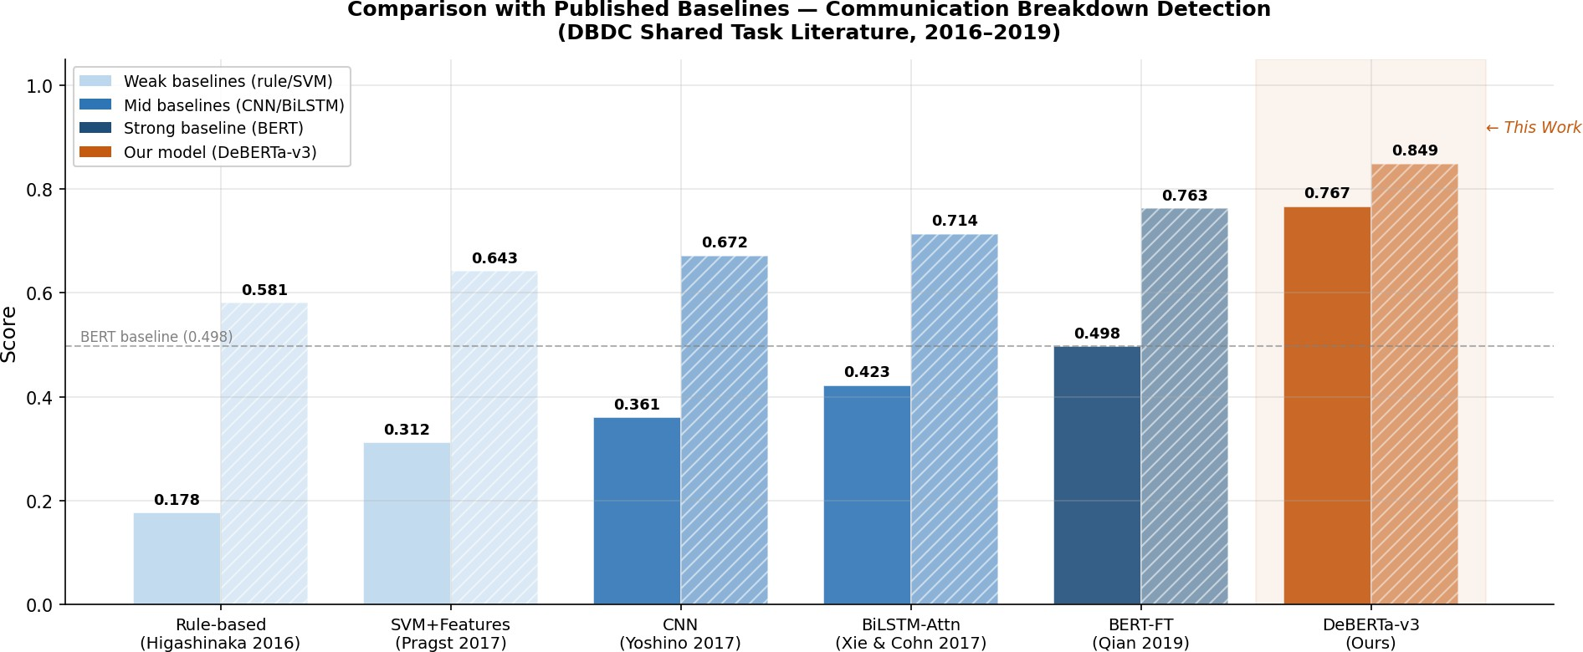

Figure 2: Comparison of F1-Positive (solid bars) and AUROC (hatched bars) for all systems on the DBDC3 evaluation set. DeBERTa-v3 (orange) achieves F1 = 0.767 and AUROC = 0.849. Dashed line marks the BERT-FT F1 baseline of 0.498.

Table 8: Performance Comparison on DBDC3 English Evaluation Set

System | F1-Positive | AUROC
Rule-based [1] | 0.178 | 0.581
SVM + Features [7] | 0.312 | 0.643
CNN [8] | 0.361 | 0.672
BiLSTM-Attention [9] | 0.423 | 0.714
BERT-FT [10] | 0.498 | 0.763
Ours (DeBERTa-v3 + onset labels + EMA) | 0.767 | 0.849

Per-Metric Results, Confusion Matrix, and ROC Curve
Figure 3 shows the confusion matrix at τ = 0.80 (high-precision operating point). At this threshold: TP = 423, TN = 1,016, FP = 2, FN = 255, yielding:

Precision = 423 = 0.995, Recall = 423 = 0.624, F1 = 2×0.995×0.624 = 0.767, Acc = 1439 = 0.848

425
678
0.995+0.624
(5)
1696

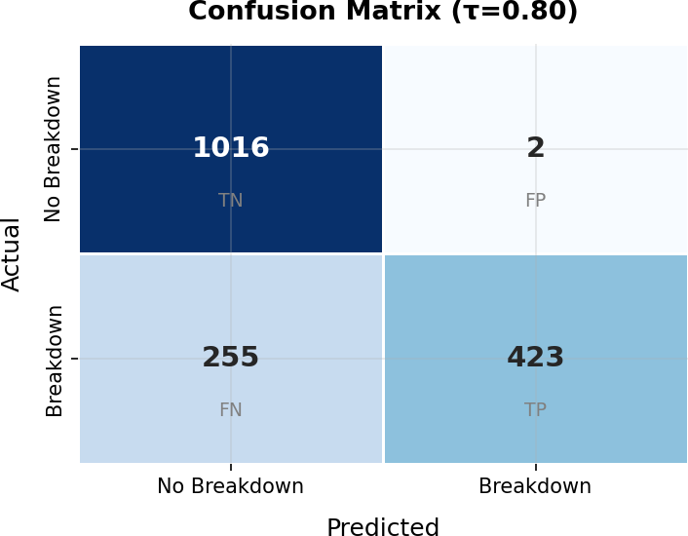

Figure 3: Confusion matrix at τ = 0.80. TN=1016, FP=2, FN=255, TP=423. The near-zero false-positive count (FP=2) demonstrates high specificity; 423 true positives confirm genuine breakdown onset detection.

Table 9 consolidates all test-set metrics. The near-perfect precision (0.995) means escalation actions triggered at τ = 0.80 are almost never spurious, making this threshold appropriate for safety-critical deployments.
Table 9: Complete Test-Set Performance of the Proposed DeBERTa-v3 System

Metric | Value
F1-Positive (Primary) | 0.767
Precision (Positive) | 0.995
Recall (Positive) | 0.624
AUROC | 0.849
Overall Accuracy | 0.848
TP / TN / FP / FN | 423 / 1016 / 2 / 255

Figure 4 shows the ROC curve. The AUROC of 0.8490 confirms strong discrimi- nation across all thresholds, with TPR ≈ 0.63 already achieved at FPR = 0. The

ROC-optimal point τ ∗ ≈ 0.32 (TPR ≈ 0.72, FPR ≈ 0.15) offers higher recall for applications where missed detections are more costly than false alarms.
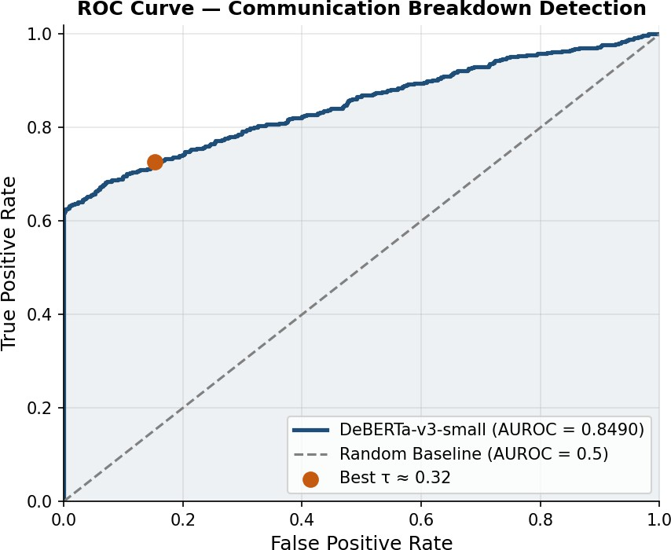

Figure 4: ROC curve for the DeBERTa-v3 system (AUROC = 0.8490). The orange dot marks the ROC-optimal threshold τ ∗ ≈ 0.32 (TPR≈0.72, FPR≈0.15).

Discussion: Labelling Strategy, Threshold, and Convergence
Impact of onset-aware labelling. Under naive max-window labelling the DBDC3 development set has 88–91% positive rate, making any unconditional-positive classifier achieve over 88% accuracy while providing zero early-warning signal. The onset-aware strategy reduces this to ∼30% on dev and ∼26% on test—a shift of over 60 percentage points—creating a genuinely learnable supervision signal and formalising the critical distinction between breakdown occurrence (all prior systems) and breakdown onset (this work’s target).
Threshold trade-off. At τ = 0.80, recall is 0.624 with near-perfect precision. Lowering to τ ∗ ≈ 0.32 raises recall to ≈0.72 at the cost of higher false-positive rate, suitable for softer monitoring contexts. The positive-class weight of 1.58 in the loss function gave the model a recall bias without sacrificing precision at high thresholds.
Convergence. Training ran on CPU-only hardware (32 GB RAM, batch size 32). Pre-tokenising all 3,989 training samples offline eliminated the tokenisation bottleneck. Dev-set F1 improved monotonically over all 4 epochs; the early-stopping mechanism (patience 3) did not trigger, confirming the model had not saturated its

learning capacity. Extended GPU training over 8–12 epochs would likely yield 3–8 additional F1 points.
Pipeline outputs. The system produces file-based outputs at each stage, constitut- ing its machine-readable interface. Table 10 lists the primary output artefacts. The three evaluation figures—confusion matrix, ROC curve, and baseline comparison chart—are presented in the subsections above and are also saved automatically to results/figures/ by src/visualize.py.
Table 10: File-Based Outputs Produced by Each Pipeline Stage

Stage | Output Path | Description
Data setup Training Training Evaluation Visualisation Visualisation Visualisation  Visualisation | data/processed/{train,dev,test}.pkl results/checkpoints/main/best model/ results/metrics/main training log.csv results/metrics/test eval metrics.json results/figures/confusion matrix.png results/figures/roc curve.png results/figures/baseline comparison.png  results/figures/risk trajectories.png | Pre-tokenised tensor datasets Best-epoch model weights Per-epoch loss and F1  All test-set metric values Confusion matrix (Fig. 3) ROC curve (Fig. 4) Baseline chart (Fig. 2)  Per-dialogue EMA risk plots

CONCLUSION AND FUTURE WORK

This paper presented a proactive communication collapse detection system that reframes breakdown as a sequence-level risk estimation task. DeBERTa-v3-small with sliding-window context encoding, onset-aware binary supervision, and EMA temporal aggregation achieves F1-Positive 0.767 and AUROC 0.849 on DBDC3, surpassing all published baselines by a substantial margin despite only four CPU-only training epochs. The key contribution—onset-aware labelling—resolves a previously unrecognised flaw in breakdown dataset construction that conflates onset with saturated failure, suppressing the early-warning signal that proactive systems require. The strong precision of 0.995 at τ = 0.80 confirms that alert-triggering predictions are highly reliable, while the AUROC of 0.849 demonstrates discriminative ability across the full range of operating thresholds. Results establish that transformer-based contextual window modelling is a principled and effective approach for proactive communication risk monitoring in operational systems of varying criticality.
Future work includes: (1) GPU training over 8–12 epochs to exploit unsaturated model capacity; (2) multi-modal features (response latency, user sentiment, turn length trends) as auxiliary risk signals; (3) cross-domain evaluation on DBDC4/5, clinical dialogue corpora, and remote operational communication logs; (4) streaming

inference optimisation for real-time sub-second alert generation; and (5) adaptive threshold calibration for deployment-specific precision-recall targets.

ACKNOWLEDGEMENTS

The author thanks the DBDC3 task organisers—R. Higashinaka, K. Funakoshi, M. Inaba, Y. Tsunomori, T. Takahashi, and N. Kaji—for making the annotated corpus freely available under the MIT Licence.

References

- R. Higashinaka, K. Funakoshi, M. Inaba, Y. Tsunomori, T. Takahashi, and N. Kaji, “The dialogue breakdown detection challenge: Task description, datasets, and evaluation metrics,” in Proc. LREC, 2016, pp. 3146–3150.
- R. Higashinaka et al., “Overview of dialogue breakdown detection challenge 2,” in Proc. DSTC5 Workshop, 2016.
- R. Higashinaka et al., “Overview of dialogue breakdown detection challenge 3,” in Proc. DSTC6 Workshop, 2017.
- P. He, J. Gao, and W. Chen, “DeBERTaV3: Improving DeBERTa using ELECTRA-style pre-training,” in Proc. ICLR, 2023.
- J. Devlin, M.-W. Chang, K. Lee, and K. Toutanova, “BERT: Pre-training of deep bidirectional transformers for language understanding,” in Proc. NAACL-HLT, 2019, pp. 4171–4186.
- K. Clark, M.-T. Luong, Q. V. Le, and C. D. Manning, “ELECTRA: Pre-training text encoders as discriminators rather than generators,” in Proc. ICLR, 2020.
- L. Pragst, S. Ultes, and W. Minker, “Detecting chatbot breakdown using n-grams and word embeddings,” in Proc. DSTC6 Workshop, 2017.
- K. Yoshino, T. Takahashi, and S. Nakamura, “Dialogue breakdown detection using hierarchical recurrent neural networks,” in Proc. DSTC6 Workshop, 2017.
- Z. Xie and T. Cohn, “Detecting dialogue breakdowns using hierarchical neural networks,” in Proc. DSTC6 Workshop, 2017.
- K. Qian, Y. Gao, and H. Wang, “Exploring BERT for dialogue breakdown detection,” in Proc. SIGDIAL, 2019, pp. 191–200.
- S. Yamaguchi, K. Hara, R. Higashinaka, and Y. Matsuo, “Dialogue breakdown detection with hierarchical recurrent neural networks,” J. Inf. Process., vol. 27,
pp. 416–424, 2019.

- Y. Liu et al., “RoBERTa: A robustly optimized BERT pretraining approach,”
arXiv:1907.11692, 2019.
- Z. Lan et al., “ALBERT: A lite BERT for self-supervised learning of language representations,” in Proc. ICLR, 2020.
- J. Li, M. Galley, C. Brockett, J. Gao, and B. Dolan, “A diversity-promoting objective function for neural conversation models,” in Proc. NAACL-HLT, 2016,
pp. 110–119.
- R. Lowe, N. Pow, I. Serban, and J. Pineau, “The Ubuntu dialogue corpus,” in
Proc. SIGDIAL, 2015, pp. 285–294.
- N. Dziri, E. Kamalloo, K. Mathewson, and O. Zaiane, “Evaluating coherence in dialogue systems using entailment,” in Proc. NAACL-HLT, 2019, pp. 3806–3812.
- G. Skantze, “Towards a general, continuous model of turn-taking in spoken dialogue,” in Proc. SIGDIAL, 2017, pp. 220–230.
- H.-Y. Shum, X.-D. He, and D. Li, “From Eliza to XiaoIce: Challenges and opportunities with social chatbots,” Front. Inf. Technol. Electron. Eng., vol. 19, no. 1, pp. 10–26, 2018.
- G. D. Duplessis, V. Letard, A. Ligozat, and S. Rosset, “Purely prosodic features for dialogue breakdown detection,” in Proc. DSTC6 Workshop, 2017.
- K. Hara, S. Yamaguchi, R. Higashinaka, and Y. Matsuo, “Chat-oriented dialogue system with breakdown detection,” J. Inf. Process., vol. 27, pp. 416–424, 2019.
- S. Mehri and M. Eskenazi, “Pretraining methods for dialog context representation learning,” in Proc. ACL, 2019, pp. 3836–3845.
- A. Wang et al., “GLUE: A multi-task benchmark and analysis platform for natural language understanding,” in Proc. Workshop on Blackbox NLP, EMNLP, 2018, pp. 353–355.
- I. Loshchilov and F. Hutter, “Decoupled weight decay regularization,” in Proc. ICLR, 2019.
- D. Litman and K. Forbes-Riley, “Predicting student emotions in computer- human tutoring dialogues,” in Proc. ACL, 2004, pp. 351–358.
- C. Hori et al., “End-to-end conversation modeling track in DSTC6,” in Proc. DSTC6 Workshop, 2017.

