**KEYGENME-PY**

* This program contains the first part called key_part_static1_trial that has the first part of the flag: picoCTF{1n_7h3_|<3y_of_. The portion of the flag we need to find if key_part_dynamic1_trial.
* The check_key functions contains the code that fills in the key_part_dynamic1_trial.
* It takes the hexdigest of the sha256 hash of b"GOUGH" and then selects a certain character by an indexing to a certain point on that string.
* We can simply find the hexdigest of the sha256 hash of b"GOUGH" and then get the characters at the positions it checks: "".join([hashlib.sha256(b"GOUGH").hexdigest()[x] for x in [4,5,3,6,2,7,1,8]]). This is the missing section of the flag.

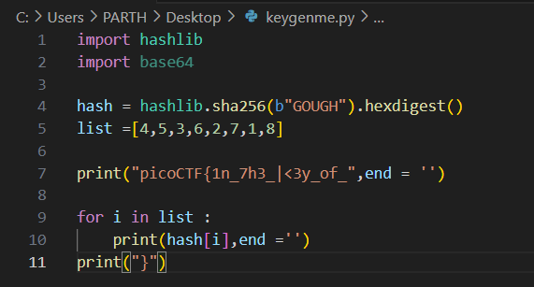

FLAG :

picoCTF{1n_7h3_|<3y_of_f911a486}