**MOD1**

Created a first list called message with the text from the question(message.txt)

A second list called decryptGuide with the orientations to decode the result :

* Alphabet: 0-25 is the alphabet in uppercase using the lib string
* Decimals: 26-35 are the decimal digits
* Underscore: 36 is an underscore

Finally, a for loop which will get every number of the message and run it in the euclidean function with the modulous 37 provided by the challenge and turn into a decrypted number, after that, get the current number as an index in the decryptGuide to get the result in the print at the end.

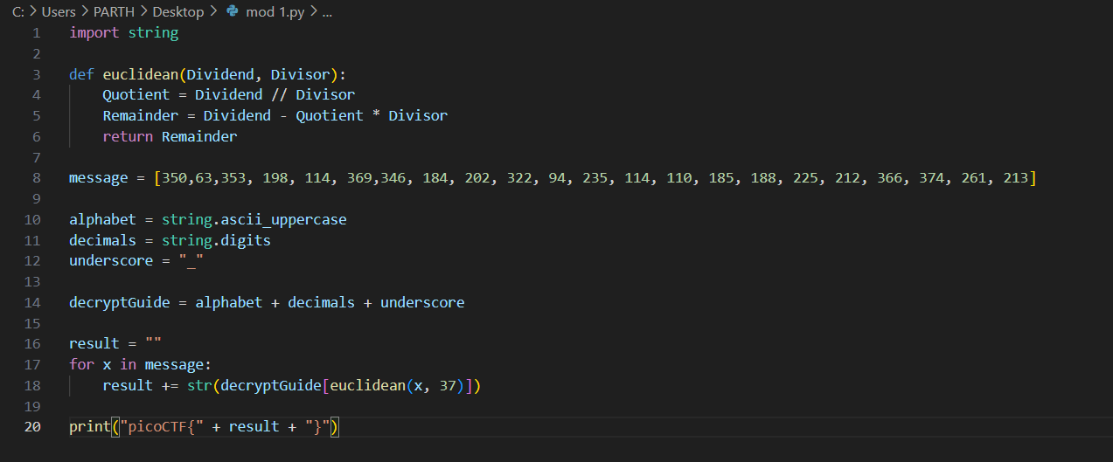

FLAG :

picoCTF{R0UND_N_R0UND_ADD17EC2}