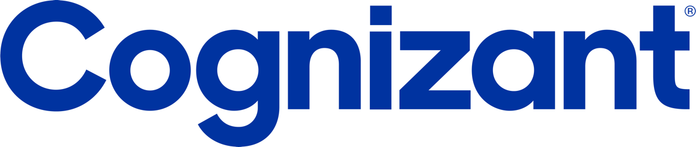

Bright House Financials

Cloud Operations & Support

<Version 0.1>

 | Prepared By / Last Updated By | Reviewed By | Approved By
Name | Sethuraman Nachiappan
Role | Cloud SME
Signature
Date | 9/17/20

Table of Contents
1.0 Introduction 4
2.0 Scope of Services 4
3.0 Service Operations Guide Scope 4
3.1.1 What this document covers 4
3.1.2 What this document does not cover 4
3.1.3 User Expectations 4
4.0 Document Objective 4
4.1 Signed SOW 5
4.2 Document Repository 5
5.0 Scope 5
5.1 In-Scope 5
5.2 Out-of-Scope 6
6.0 High Level Architecture Diagram 6
7.0 Azure Regions 7
8.0 Resource Tagging 8
9.0 Azure Inventory 8
10. High level overview of Access 8
10.1 VDI Access 8
10.2 VPN Client Connection 9
10.3 Azure Portal Access 9
10.4 CyberArk Portal Access 9
10. 5 Server Admin Access 9
11. Network High Level Diagram 9
12. Azure Subscription Structure 10
13. Azure VM provisioning process flow 11
9.0 Alert Management Guidelines 12
9.1 Alert Management Workflow 12
9.2 Alert Monitoring Process 12
9.3 Alert Severity Level Definitions 12
9.4 Error Messages Vs Severity 13
9.5 Escalation Process Overview 13
9.6 KPI’s and SL’s 14
9.7 Critical Alert Management 14
10.0 Incident Management Guidelines 14
10.1 Incident Management Workflow 14
10.2 Severity Levels Definitions 14
10.3 Severity Matrix 14
10.4 Escalation Matrix 24
10.5 KPIs & SLs for Incident Management 24
10.6 Critical Incident Management 25
11.0 Problem Management 25
11.1 Problem Management Workflow 25
11.2 KPIs & SLs for Problem Management 25
12.0 Change Management 25
12.1 Change Management Workflow 25
12.2 Change Approval Board 25
12.3 Emergency Change Handling 25
12.4 KPIs & SLs for Change Management 25
13.0 Release Management 25
13.1 Release Management Workflow 26
13.2 KPIs & SLs for Change Management 26
14.0 Knowledge Management 26
14.1 Knowledge Management Workflow 26
14.2 KEDB 26
Incidents: 26
Service Requests: 26
Change Requests: 27
14.3 Roles and Responsibilities 27
14.3.1 Operator & Production control Analyst level Checklists 27
14.4 KPIs & SLs for Change Management 28
15.0 Appendix 28
16.0 Change Log 28

Introduction
This run book will be a used as a base guide by the BHF offshore Cloud Operations team’s for steady state operations. This document gives the complete environment details required to run the smooth Operations for the different activities under the scope of Cognizant Cloud support team.

Scope of Services
As per SOW, BHF team will support following technologies, detailed activities are mentioned in the SOW. please refer document repository link for detailed SOW related activities.
- General Cloud Operations & Management
- Shared Drive and Active Directory
- Windows/Linux, SQL Support & Maintenance
- Single Sign-on Support
- DevOps Toolchain and CI/CD Support & Cloud Platforms
- MS SQL database support

Service Operations Guide Scope

What this document covers
The purpose of the Service Operations guide or Run Book is to provide the day to day activities required to support the service at an operations or procedural level.

What this document does not cover
This document does not attempt to instruct a user concerning the technology covered, tools training policies or monitoring systems training.

User Expectations
It is expected that this document will be used by the Service Delivery teams supporting dedicated Cloud operations.

Document Objective
Objective of this document is to portray the “Bright House Financials USA" environment hosted on Azure cloud in US EAST2 and DR on US Central. This run book will be a used as a base guide by the COGNIZANT onshore & the offshore Operations teams for steady state operations.

Signed SOW
Cloud Operations team Standard SOW attached for reference. Pease refer in scope and out of scope services.

Document Repository
All the documents are stored in: SharePoint link

Scope

In-Scope
5.1.1 General Cloud Operation Support
Cognizant will manage Brighthouse cloud environments, components and services including the Brighthouse Azure, AWS and Open Shift subscriptions. This includes support for all cloud compute, storage, file systems including server operating systems, cloud monitoring, cloud network, cloud authentication and access control, Cloud Budget and capacity management and backup and disaster recovery services.
5.1.2. Shared Drive Services
Cognizant will maintain and manage Brighthouse shared file system and any file repositories hosted in any of the Brighthouse cloud environments which will include data access control and recovery. Cognizant shall also support and manage the day-to-day operations of the Brighthouse hybrid Active Directory service that includes Authentication and integration with other Brighthouse environments.
5.1.3 Directory Services
Cognizant will also support and manage the day-to-day operations of all the Bright house Directory services that includes AD Authentication and integration with other Bright house environments.
5.1.4 Windows, Linux SQL Server Support & Management
Cognizant will support and monitor and manage the day to day operations of Windows and Linux servers as well as SQL database services. It shall perform health checks, create, manage and maintain server templates and databases hosted in all cloud environments.
5.1.5 SQL Support & Maintenance
Support and monitor and manage the day to day operations of Windows and Linux servers as well as SQL database services. It includes health checks, create, manage and maintain server templates and databases hosted in all cloud environments.
5.1.6 DevOps Toolchain and CI/CD Support
Cognizant will support and manage DevOps Toolchain and CI/CD pipeline within BHF cloud environments. This will include the backup of all DevOps toolchain and pipeline configuration/orchestration, auditing and ensuring the environment is secured and complaint.
5.1.7 Cloud Native Platform (OpenShift, ) Support
Cognizant will need to work directly with Red Hat, Lightbend, and BHF platform team to provide general support including integration with BHF CI/CD pipeline and ITSM processes.
5.1.8 SSO Support
Cognizant will maintain, manage and update Azure AD SSO solution. This includes managing SAML federation with all cloud providers, and support for mobile SSO integration.

Out-of-Scope
- Ansible Tower Support
- L1 or Desktop Support
- Application Performance Monitoring is out of Scope
- Application Testing

High Level Architecture Diagram

The below diagram depicts the infrastructure architecture on BHF VNET connectivity.

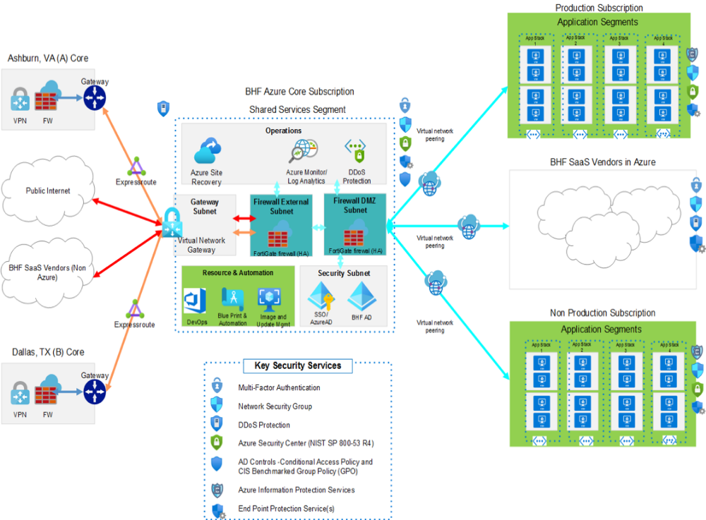
The primary network, which is deployed in East US, is comprised of a hub VNET but with two spoke VNETs instead of one.
In a hub and spoke topology, all spokes connect to the hub via Azure VNET peering. When two VNETs are peered, the networks appear as one. All services in one VNET are accessible to the other unless specifically blocked by Network Security Groups. Communications between the VNETs are routed through the Microsoft backbone just like traffic within a VNET and is kept private.
All EXPRESSROUTE traffic through the gateway will be routed to the external firewall. Azure monitor and Log Analytics will be used to monitor infrastructure resources and Security Center will help to remediate common security risks. Multi-Factor will be used to enable Users authentications and NSG will control the Inbound and Outbound network traffic.

Conditional access policies will be implemented to allow only devices from BHF network to access Azure and GPO policies. Active Directory and SSO will be used to authenticate users to critical web applications. Azure Site Recovery will be configured for secondary region.

Azure Regions

For EA, we will have both primary and region pair for Azure.

Geography | Primary Region | Region Pair
North America | US East2 | US Central

Resource Tagging

Tags provide a way to logically organize resources with custom properties and can be applied to resource groups and/or directly to individual resources. Tags can be used to refine the selection criteria for resources or resource groups from the console, web portal, PowerShell, or the Azure resource API. Tags are particularly useful when you need to organize resources for billing or management.
In EA subscription, the cost management module will be implemented and corresponding resource tagging has already been created in EA. There are 5 parameters for defining the resource tagging (Technical Contact, Department, Location, Subscription and Environment information)

9.0 Azure Inventory
In the overall Azure inventory, there are Windows 10 , Windows 2016 and Linux environments are being used in BHF for Production and Non production .
Environment | Windows Version | Windows | Linux
UAT / Lower Environments | Windows 2019 | 1 | 13
Production Environments * | Windows 2019 | 18 | 17
NOTE : * HUB Servers counts are included in Production Environments

The detailed BHF Azure inventory information can be found here.
In the new EA subscription, the setup has been completed for Azure AD, domain controller and there are some new services like Solarwinds. The core services are still in CSP and will be transitioned in the future.

High level overview of Access

10.1.0 VDI Access
BHF Hosted the VDI environment in VMware Cloud. We are accessing the BHF VMware Cloud console over HTTP (Web based) or VM Horizon Client and passing RSA token and AD Credential to access the Virtual Desktops.
BHF VDI Console URL -> https://bhfva.horizon.vmware.com/
How to connect to the Brighthouse Financial VDI:
1. Goto https://bhfva.horizon.vmware.com/
2. Enter your user name in the user name field and passcode. Passcode is the
number on your RSA token after you put in your pin.
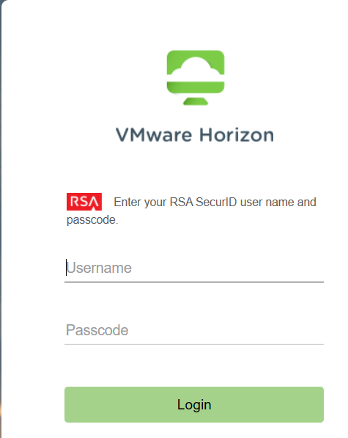
3. The username should be populated already so just enter your BHF domain
Password and click login
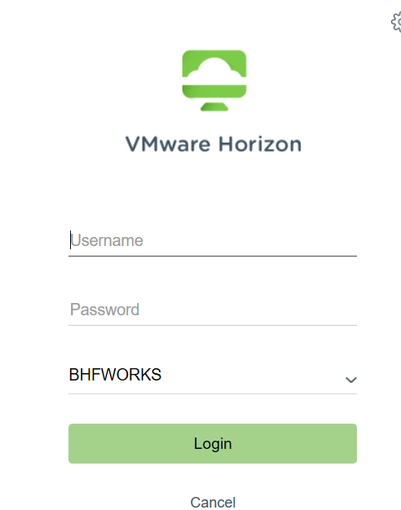
4. Double click the icon that looks like the one below.
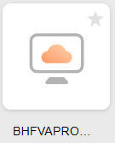
5. It will now launch your vdi.

VPN Client Connection
BHF Owned Laptop user accessing the BHF environment via Cisco AnyConnect using RSA token and AD Credential.

CyberArk Portal Access
CyberArk Portal can be access using RSA token and 2FA authentication.
URL for cyberark : https://pvwa-prod.bhfworks.net
Login with the brighthouse account with the RSA token
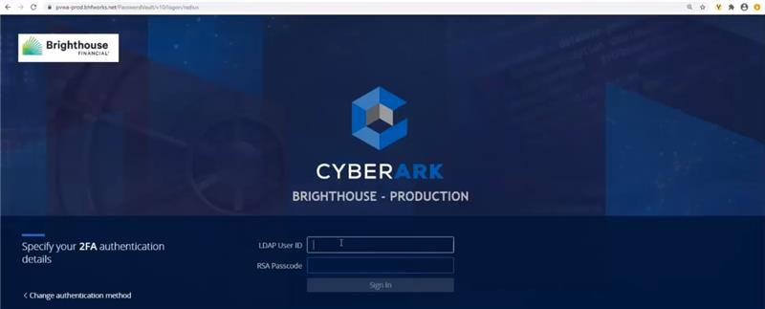

Azure Portal Access
Access to the subscriptions (Azure portal) can be granted only thru BHF’s VDI or
VPN. Otherwise, the Access is restricted from Internet.

Azure Portal access granted via Azure AD PIM and required the MFA setup for Privilege access.

Azure AD PIM mapped to Conditional Access Policy demands to provide MFA and time
duration.

How to activate a role in Azure Portal.

  - Sign in to the BHF Azure portal.
  - Open Azure AD Privileged Identity Management -> My Roles -> Eligible Assignments then click on Activate.
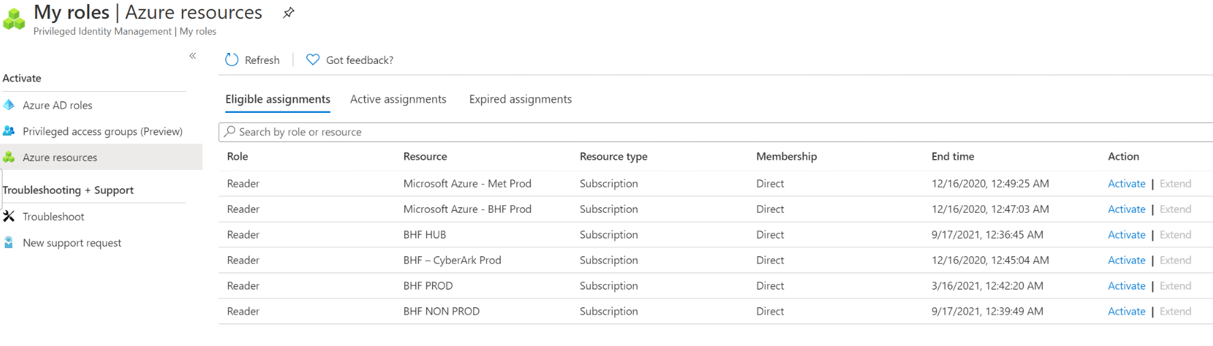
  - If your role requires multi-factor authentication, you need to give additional Security Verification.
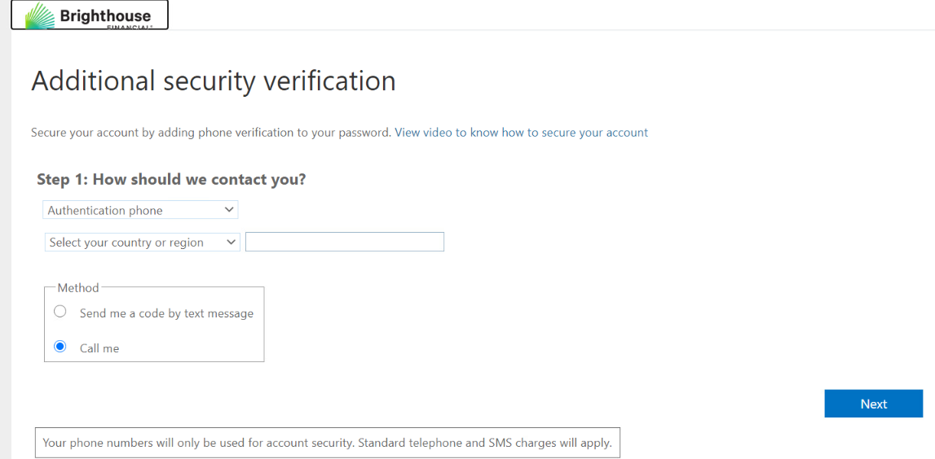

Server Admin Access
In BHF, CyberArk is being used for server privilege access. CyberArk act as a proxy [ PSM (Privilege session manager) and PSMP] to connecting to the endpoint server (target server).
- Login to CyberArk Portal https://pvwa-prod.bhfworks.net
- After logged in. We can see all the administrative account we have access.
Note: Administrative credentials not required for VM.

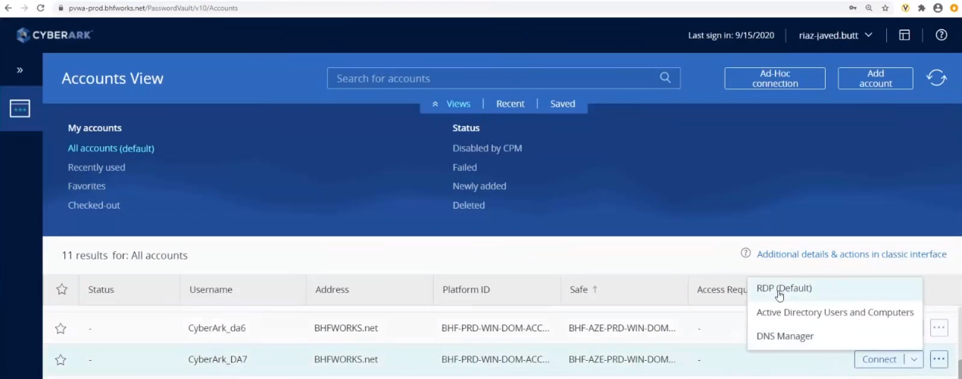

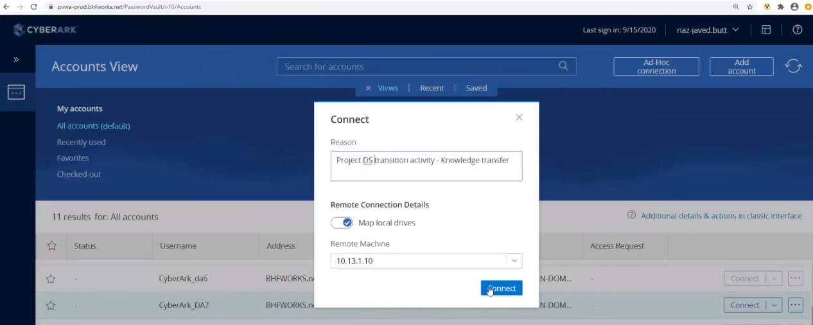

Network High Level Diagram
As per our understanding, we have given below the network high level architecture diagram for EA Azure Subscription.
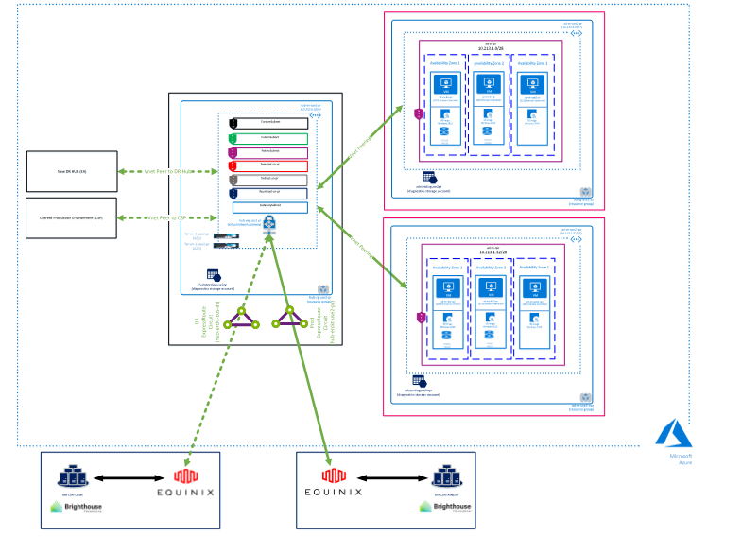

The high level network details are given below.
Dedicated IP space:
10.213.0.0/24 & 10.214.0.0/16
HUB VNET: 10.213.0.0/24
- This contains various /27 subnets (including Gateway subnet).
- This VNET is peered with the VNETs of New Production, New Non-Production, New DR HUB (EA)
- New Prod VNET contains Windows 2019 Domain Controllers (in AZ1 & AZ2) have been already deployed & Azure AD connect VM is created in AZ1.
- The Data centers Virginia (Prod) & Texas (DR) are connected to the Hub through Azure ExpressRoute via Equinox cloud exchange

Azure Subscription Structure
The details of EA subscriptions and tenants.
Tenant Name | Environment
Brighthousefinancial.onmicrosoft.com | PROD
brighthousefindevtst.onmicrosoft.com | UAT

Subscription Name | Environment
BHF HUB | HUB
BHF PROD | PROD
BHF NON PROD | NON PROD

Azure VM provisioning process flow
As per our understanding, following are the process flow for provisioning a VM to project team. VM provisioning will be fully automated using ARM template in EA subscription.

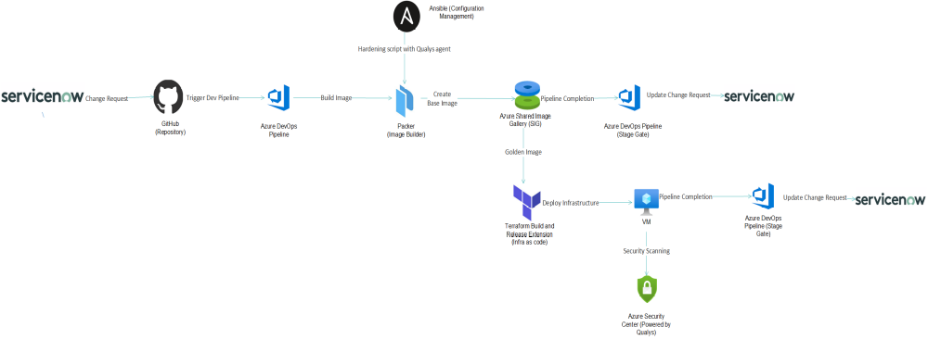

BHF is planning to automate the entire VM provisioning through Infra as a Code ( IaaC) automation and image management. The high level process flow as follows ;
- Submit a Change Request
- CI/CD pipeline will trigger to build an image
- Azure DevOps pipeline will store the built image in Azure managed disks.
- Once its stored, pipeline will trigger Terraform to provision a new VM as per project team’s requirement
- Azure Log Analytics and Security center will collect the logs

Key Benefits:
- Infrastructure configuration consistency and versioning
- Image would be ready for repurposing and auto scaling is much easier

2.1 Documentation

Following table provides the link/documents pertaining to the customer environment
Category | Link/ Document location
Naming standards
Application details
Emergency contact list | 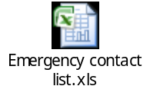
Disaster Recovery plan and procedure | Will be updated later.

Alert Management Guidelines

Alert Management Workflow
<Detailed workflow diagram of an alert Lifecycle>

Alert Monitoring Process
<Detailed workflow diagram of alert Monitoring>

Alert Severity Level Definitions
Severity Level means the severity designation assigned to an operational support activity based upon the criteria as defined below:
Severity Level | Definition
Urgent Severity | Emergency situation with serious user and business impact.
High Severity | Incidents that severely affect an individual system but has a limited functionality to continue at a reduced level of business.
Medium Severity | Incidents that affect the day-to-day operations/business function of a few users.
Low Severity | Incidents with low impact on the day to day operation of the business.

Error Messages Vs Severity
<Error Messages Vs Severity Definitions>

Escalation Process Overview
To ensure the issues identified at all levels are attended to and resolved in a timely manner ,both parties share adhere to the following process to escalate or engage the next level for resolution purposes. The Process shall ensure adequate time is allocated at each level, from initial contact to resolution, and to ensure fair and collaborative approach from both parties in seeking mutually acceptable resolution on the reported or escalated issues.
Operational:
Level | Name of the Person | Contact Details | Role
1st Level | Rama Baru | Rama.Baru@cognizant.com | Cloud Tower Lead
2nd Level | Service Delivery Manager – Onsite | KarthikS.Moorthy@cognizant.com | Service Delivery Manager – Onsite
3rd Level | Program Manager | Randy.Mulheron@cognizant.com | Program Manager

Functional: << TBD >>
Level | Name of the Person | Contact Details | Role
1st Level
2nd Level
3rd Level

KPI’s and SL’s

Critical Alert Management
<Detail the process for handling critical alerts if any>

Incident Management Guidelines
<Add description around the service specific Incident Management Activities>

Incident Management Workflow
<Detailed workflow diagram of an Incident Lifecycle>

Severity Levels Definitions
Severity Level means the severity designation assigned to an operational support activity based upon the criteria as defined below:

Severity Matrix

Tower | Service Level Name | Description | Calculation Methodology | Service Level Type | Service Level Target | Pool Percentage

Cloud | Time to Resolve P1 | This Service Level measures the percentage of P1 Incidents Resolved by Vendor within 4 hours of assignment to the Cloud Tower | (Number of P1 Incidents Resolved within 4 hours of assignment to Cloud Tower during the calendar month)  divided by  (Total number of P1 Incidents assigned to Cloud Tower during the calendar month)  multiplied by one hundred (100)  Notes:  - “Resolved” means the function or Service is operationally restored without degradation of functionality.  - This Service Level only measures Incidents in the Production environment.  - This Service Level measures Incidents only and does not include Service Requests. | CSL | >=95% | >=95% | >=95% | >=95% | >=95% | {TBD]
Cloud | Time to Resolve P2 | This Service Level measures the percentage of P2 Incidents Resolved by Vendor within 8 hours of assignment to the Cloud Tower | (Number of P2 Incidents Resolved within 8 hours of assignment to Cloud Tower during the calendar month)  divided by  (Total number of P2 Incidents assigned to Cloud Tower during the calendar month)  multiplied by one hundred (100)  Notes:  - “Resolved” means the function or Service is operationally restored without degradation of functionality.  - This Service Level only measures Incidents in the Production environment.  - This Service Level measures Incidents only and does not include Service Requests. | CSL | >=95% | >=95% | >=95% | >=95% | >=95% | {TBD]
Cloud | Time to Resolve P3 | This Service Level measures the percentage of P3 Incidents Resolved by Vendor within 24 hours of assignment to the Cloud Tower | (Number of P3 Incidents Resolved within 24 hours of assignment to Cloud Tower during the calendar month)  divided by  (Total number of P3 Incidents assigned to Cloud Tower during the calendar month)  multiplied by one hundred (100)  Notes:  - “Resolved” means the function or Service is operationally restored without degradation of functionality.  - This Service Level only measures Incidents in the Production environment.  - This Service Level measures Incidents only and does not include Service Requests. | KM | >=95% | >=95% | >=95% | >=95% | >=95% | N/A
Cloud | Not Caught by Monitoring | This Service Level measure the percentage of P1 Incidents that were reported by a user and not caught by the monitoring systems. | (Number of P1 Incidents assigned to Cloud that were reported by a user on a monthly basis and not reported by the monitoring tool during the calendar month)  divided by  (Total number of P1 Incidents assigned to Cloud during the calendar month)  multiplied by one hundred (100)  Notes:  - Only those P1 Incidents reported by a user that arise due to a monitoring parameter not set in the element manager tool will be counted in the numerator for purposes of calculating this Service Leve. | CSL | <=20% | <=20% | <=20% | <=20% | <=20% | {TBD]
Cloud | Net Promoter Score | This Service Level measure the likelihood of users recommending Cloud Services based on survey responses. | Calculation of all completed responses via web, email, popup, text, chat, or voice ServiceNow incident surveys for Cloud managed solutions on a quarterly basis to determine the likelihood of a user recommending the Cloud Services to someone else based on a scale of 0 to 10.  .  Subtract percentage of detractors (scores 0-6) from the percentage of promoters (scores 9-10)  For example, if 10% of respondents are Detractors, 20% are Passives and 70% are Promoters, your NPS score would be 70-10 = 60 | CSL | >=0 to 30 | >=0 to 30 | >=0 to 30 | >=0 to 30 | >=0 to 30 | {TBD]
Cloud | Uptime | This Service Level measures the availability of the Cloud production systems. | (Total Uptime of Cloud production systems)  divided by  (Total Scheduled Uptime for Cloud production systems)  multiplied by one hundred (100)  Notes:  - “Total Uptime” is the number of minutes during the calendar month less Downtime for Cloud production systems during the calendar month.  - “Total Scheduled Uptime” is the number of minutes during the calendar month less Scheduled Downtime during the calendar month.  - “Downtime” is the total number of minutes any portion of the Cloud production systems is not Available during the calendar month. Downtime includes Scheduled Downtime.  - “Scheduled Downtime” is the total number of minutes of scheduled time required and actually used to perform system maintenance on the Cloud production systems; provided, that such time has been mutually agreed to and is scheduled to minimize impact to the Brighthouse business.  - “Available” means the Cloud production systems are working and functional in all material respects with no more than a trivial amount of degradation in performance.  - Cloud production systems includes all systems as defined in-scope in Schedule B (i.e. including but not limited to Active Directory, Azure AD, DNS, Express Route/Direct Connect, Cloud Firewall, Virtual Machines, Cloud Load Balancers) | CSL | >=95% | >=97% | >=97% | >=99% | >=99% | {TBD]
Cloud | Shift Left – Self Service | This Service Level measures users use of self-service rather than calling Service Desk | (Total number of self-service requests via service catalog assigned to the Cloud Tower in the calendar month)  divided by  (Total number of self-service requests and calls to Service Desk that are assigned to the Cloud Tower in the calendar month)  multiplied by one hundred (100) | KM | <=40% | <=50% | <=60% | <=70% | <=80% | N/A
Cloud | Time to Resolve P4 | This Service Level measures the percentage of P4 Incidents Resolved by Vendor within 10 business days of assignment to the Cloud Tower | (Number of P4 Incidents Resolved within 10 business days of assignment to the Cloud Tower during the calendar month)  divided by  (Total number of P4 Incidents assigned to the Cloud Tower during the calendar month)  multiplied by one hundred (100)  Notes:  - “Resolved” means the function or Service is operationally restored without degradation of functionality.  - This Service Level only measures Incidents in the Production environment.  - This Service Level measures Incidents only and does not include Service Requests. | KM | >=95% | >=95% | >=95% | >=95% | >=95% | N/A
Cloud | Capacity Management | This Service Level measures the percentage of Cloud Incidents caused by capacity management issues | (Number of Incidents assigned to the Cloud Tower during the calendar month caused by capacity-related issues during the calendar month)  divided by  (Total number of Incidents assigned to the Cloud Tower during the calendar month)  multiplied by one hundred (100)  Notes:  - Capacity-related incidents include, for example, out-of-express route/direct connect bandwidth, out=of-compute, out-of-disk space and insufficient licensing or devices to meet demand. | KM | <=5% | <=5% | <=5% | <=5% | <=5% | N/A
Cloud | Incident and Request Handoffs | This Service Level measures the average number of handoffs required to resolve Cloud Incidents | (Total number of handoffs required to resolve each Incident assigned to the Cloud Tower during the calendar month)  divided by  (Total number of Incidents assigned to the Cloud Tower during the calendar month)  multiplied by one hundred (100) | KM | <=4 | <=3 | <=3 | <=2 | <=2 | N/A
Cloud | Automation | This Service Level measures the percentage of Incidents and Requests fulfilled by automation | (Total number of Cloud Incidents Resolved and Cloud Service Requests fulfilled through automation during the calendar month)  divided by  (Total number of Incidents and Service Requests assigned to the Cloud Tower during the calendar month)  multiplied by one hundred (100)  Notes:  - Resolved means the function or Service is operationally restored without degradation of functionality. | KM | >=30% | >=40% | >=50% | >=60% | >=70% | N/A
Cloud | Patch Level Compliance | This Service Level measures the compliance level of patch updates to Cloud Devices | (Total number of Cloud Devices whose patch updates meet Brighthouse patch compliance requirement as measured on the last day of the calendar month)  divided by  (Total number of Cloud Devices on the on the last day of the calendar month)  multiplied by one hundred (100)  Notes:  - Cloud Devices includes all devices as defined in-scope in Schedule B (including but not limited to virtual machines, virtual firewalls, virtual load balancers).  - Brighthouse patch compliance requirement means patches are at least n-1 levels as defined by Brighthouse  - A patch, bug fix, and firmware updates are considered successfully applied when Device/ or service is functioning per the design and operating requirement and successfully tested and approved post change. | KM | >=90% | >=90% | >=90% | >=90% | >=90% | N/A

Escalation Matrix
Operational:
Level | Name of the Person | Contact Details | Role
1st Level | Rama Baru | Rama.Baru@cognizant.com | Cloud Tower Lead
2nd Level | Service Delivery Manager – Onsite | KarthikS.Moorthy@cognizant.com | Service Delivery Manager – Onsite
3rd Level | Program Manager | Randy.Mulheron@cognizant.com | Program Manager

Functional:
Level | Name of the Person | Contact Details | Role
1st Level
2nd Level
3rd Level

KPIs & SLs for Incident Management
<List the KPIs applicable for the project and the associated Service Levels for the same>

Critical Incident Management
<Detail the process for handling critical incidents>

Problem Management
<Add description around the service specific Problem Management Activities>

Problem Management Workflow
<Detailed workflow diagram of a Problem>

KPIs & SLs for Problem Management
<List the KPIs applicable for the project and the associated Service Levels for the same>

Change Management
<Add description around the service specific Change Management Activities>

Change Management Workflow
<Detailed workflow diagram of a Change Ticket>

Change Approval Board
<List the members involved in CAB along with their contact details>

Emergency Change Handling
<Detail the process for handling urgent changes>

KPIs & SLs for Change Management
<List the KPIs applicable for the project and the associated Service Levels for the same>

Release Management
<Add description around the service specific Release Management Activities>

Release Management Workflow
<Detailed workflow diagram of a Change Ticket>

KPIs & SLs for Change Management
<List the KPIs applicable for the project and the associated Service Levels for the same>

Knowledge Management
<Add description around the service specific Release Management Activities>

Knowledge Management Workflow
<Detailed workflow diagram for Knowledge Management>

KEDB
Please provide the procedures to handle,
Incidents - job failures/ long or late running jobs etc
Service requests - holding jobs, killing jobs, restart, force run etc.
Change requests - schedule changes and requests for report collection etc.

Incidents:
Error: Job xxx is not yet started as per schedule
Description: Job xxx is scheduled to run at 10:00 AM EST and still not yet started. Please investigate.
Reason: Job’s predecessor job 123 failed
Solution: Fix the job 123 failure and rerun it or mark the job to success. It will trigger job xxx.

Service Requests:
Request: Please force run the job xxx.
Description: Please re-run the job xxx on PRD environment.
Process: Check the current status of the job. Run the job and also update the job log with the comments. If it’s already running then inform the requester.

Change Requests:

Request: Schedule a new job xxx on PRD environment.
Description: Please schedule a new job for application 123 on PRD environment. Attached is the job definition.
Process: Check the pre-requisites like ,
- Agent machine should have agent s/w installed.
- User should exist on that machine.
- Command should have execute permissions etc.

Check for the syntax errors and follow the naming standards.
Define the job and update the request and notify the requestor.

Roles and Responsibilities
<Detailed the R&R for Knowledge Management>

Operator & Production control Analyst level Checklists
The following table provides various checklists that are applicable for the engagement. These will be reviewed on a periodic basis depending on engagement needs.
Category | Location / Document
Shift begin checklists
Hourly checklists
Weekly checklists
Monthly checklists
Quarter end checklists
Year end checklists

KPIs & SLs for Change Management
<List the KPIs applicable for the project and the associated Service Levels for the same>

Appendix

Change Log

Please note that this table needs to be maintained even if separate Change item status log is maintained in the tool / document and the version history needs to be given here. But reference can be given to details of the changes if it is not given here.

Version Number | Changes Made
V1.0.0 | Initial baseline created on <dd-Mmm-yyyy> by <Name of Author>
V X.Y.Z | <Please refer the configuration control tool / change item status form if the details of changes are maintained separately. If not, the template given below needs to be followed>
V X.Y.Z | Section No. | Changed By | Effective Date | Changes Effected
V X.Y.Z | NA | NA | NA | NA

