AI FitTrack Brainstorming and Ideation
  - Phase 1

This document explains the problem selection, solution exploration and evidence-based decision to build a secure backend for workout tracking and AI-assisted guidance.
Field | Value
Project | AI FitTrack
Submission | SmartBridge Naan Mudhalvan
Project scope | Backend-only REST API
Technology | Node.js, Express.js, MongoDB, Mongoose, JWT and Google Gemini AI
Source baseline | Latest uploaded backend ZIP and supplied verification evidence
Document status | Submission-ready content; student metadata and final video links remain pending

Prepared for academic evaluation. Secrets, credentials, private environment files and unverified claims are excluded.

Document contents
1. Problem discovery
2. Target user and needs
3. Ideas considered
4. Selected concept
5. Scope and success criteria
6. Risks and open details

Problem discovery
Fitness learners may record exercises in notebooks or spreadsheets. That approach makes workout history difficult to organize, search and protect. It also does not transform basic activity data into personalized workout suggestions or progress insights.
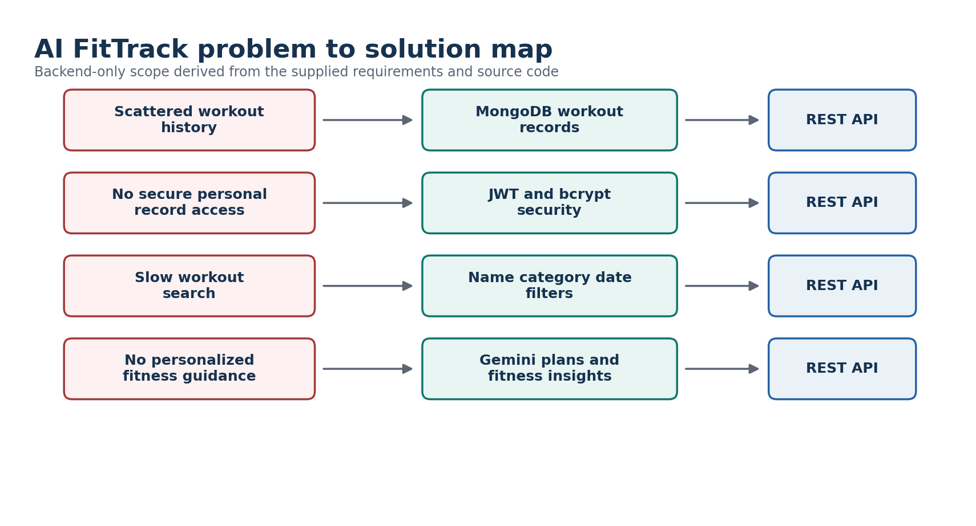
Figure 1 Problem statements mapped to the implemented backend capabilities

Target user and core needs
User need | Observed problem | Backend response
Secure access | Personal records should not be visible to another user. | JWT middleware, fresh user lookup and owner-scoped MongoDB queries.
Reliable history | Manual records are inconsistent and hard to update. | Validated workout documents with CRUD endpoints and timestamps.
Fast discovery | A long history is difficult to browse. | Search by partial name, canonical category and UTC calendar date.
Useful guidance | The user lacks a personalized routine and progress interpretation. | Structured Gemini recommendation and insight endpoints.
Future integration | A frontend or mobile application may be added later. | Standardized REST JSON contracts and CORS configuration.

Ideas considered
Idea | Strength | Limitation | Decision
Spreadsheet tracker | Quick to start | Weak authentication, search and automation | Rejected
Frontend-only local storage app | Simple demonstration | No central database or secure multi-user API | Rejected
Basic workout CRUD API | Clear and practical | No intelligent guidance | Partial option
Secure CRUD plus Gemini backend | Meets tracking, security and personalization goals | Requires external AI configuration | Selected

Selected concept
AI FitTrack is a backend-only REST API. A user registers, logs in, receives a JWT and then manages only their own workout records. The same authenticated user can request a structured workout recommendation or ask Gemini to interpret submitted statistics or statistics computed from their MongoDB workout history.

Project objectives
- Implement secure registration, login and profile retrieval.
- Protect workout and AI routes using Bearer-token authentication.
- Provide complete workout CRUD and search by name, category and date.
- Store users and workouts in MongoDB through validated Mongoose schemas.
- Generate safe, structured workout recommendations and fitness insights through Google Gemini AI.
- Return predictable JSON success and error responses that can support a future frontend.
- Verify normal, negative, security, retry and ownership behavior.

Scope
Included | Excluded from this backend submission
Authentication, profile, workout CRUD, search, AI recommendation, AI insights, validation, tests and Postman collection | React user interface, charts, nutrition tracking, wearable integration, payment, reminders and production analytics dashboard

Initial success criteria
- Every protected request rejects a missing or invalid JWT.
- A workout is always assigned from the verified token, never from a client-supplied user identifier.
- CRUD and search results remain isolated to the authenticated user.
- Gemini responses follow structured schemas and failures return safe errors.
- No credentials or private environment file are committed to the repository.
- The supplied evidence records 95 automated passes, 17 smoke checks, 19 Atlas checks and 15 live sanitized API records.

Items requiring student confirmation
Pending item | What to provide
Student identity | Name, NM ID, register or roll number and department were not present in the supplied project files.
Institution details | College name, academic year, guide or mentor name and official submission date need confirmation.
Team details | Team name, member list and responsibility allocation were not supplied; no ownership is assigned in these documents.
Repository | Insert the final public GitHub repository URL after upload.
Deployment | Insert the deployed API base URL if the evaluator requires a hosted demonstration.

