AI FitTrack Project Testing
  - Phase 6

This test report consolidates the supplied automated, smoke, Atlas, Postman and live Gemini evidence while separating recorded results from items that still need final visual capture.
Field | Value
Project | AI FitTrack
Submission | SmartBridge Naan Mudhalvan
Project scope | Backend-only REST API
Technology | Node.js, Express.js, MongoDB, Mongoose, JWT and Google Gemini AI
Source baseline | Latest uploaded backend ZIP and supplied verification evidence
Document status | Submission-ready content; student metadata and final video links remain pending

Prepared for academic evaluation. Secrets, credentials, private environment files and unverified claims are excluded.

Document contents
1. Test strategy
2. Automated coverage
3. Live verification
4. Detailed cases
5. Evidence excerpts
6. Observations and final re-test

Test strategy
Testing is layered so that pure validation and service behavior are checked quickly, HTTP routes are tested against isolated MongoDB instances, smoke and Atlas scripts verify real integration, and sanitized live calls prove the main end-to-end flows including Gemini.
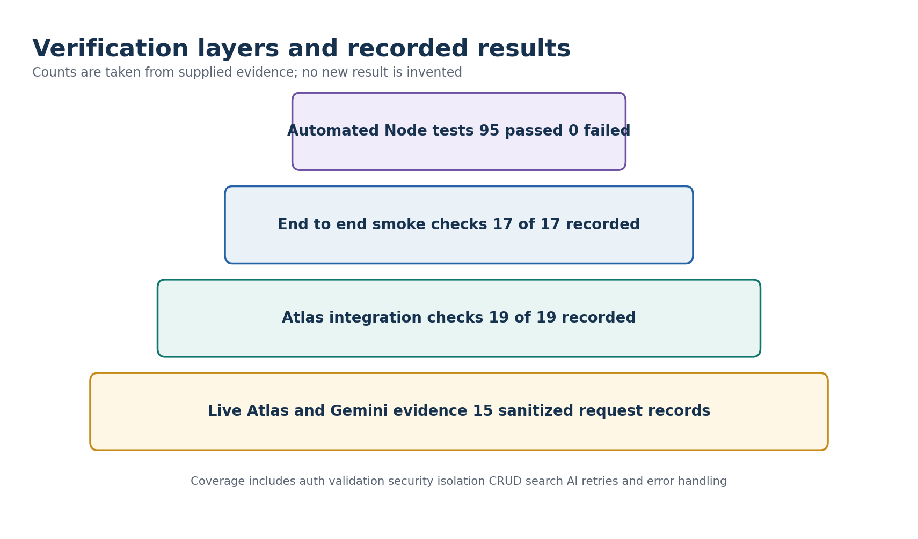
Figure 1 Verification layers and result counts recorded in the supplied evidence

Recorded result summary
Verification layer | Recorded result | Evidence status
Automated Node tests | 95 passed, 0 failed | Recorded in verification files; 95 test definitions are present in six test files.
End-to-end smoke checks | 17 of 17 | Recorded in README verification.
Atlas checks | 19 of 19 | Recorded in README and requirements verification.
Live authentication | 4 sanitized records | 201, 200, 200 and 401 results supplied.
Live workouts | 8 sanitized records plus negative follow-ups | CRUD and three search filters supplied.
Live Gemini | 3 sanitized records | Recommendation, submitted insights and database insights supplied.
Postman collection | 12 requests | Health, three auth, six workout and two AI requests.

Automated test distribution
Test file | Cases | Coverage
ai.test.js | 23 | AI validation, structured responses, database stats, failures, rate limiting and regression
auth.test.js | 23 | Registration, login, profile, token failures, duplicate and password behavior
geminiRetry.test.js | 13 | Transient retries, Retry-After, bounded backoff, non-retryable failures and parsing
security.test.js | 8 | CORS, ownership, secret handling, password exposure and security boundaries
validation.test.js | 16 | Authentication, workout and AI input normalization and validation
workouts.test.js | 12 | CRUD, search, ordering, isolation, validation and UTC date behavior
Total | 95 | Recorded automated run: 95 passed and 0 failed

Live API evidence register
Area | Case | Endpoint | Status | Verified outcome
Authentication | Register | POST /api/auth/register | 201 | Pass - token returned and password omitted
Authentication | Login | POST /api/auth/login | 200 | Pass - same account returned
Authentication | Authorized profile | GET /api/auth/profile | 200 | Pass - profile returned
Authentication | Missing token | GET /api/auth/profile | 401 | Pass - no user data returned
Workouts | Create | POST /api/workouts | 201 | Pass - owner matched authenticated user
Workouts | List | GET /api/workouts | 200 | Pass - count and record matched
Workouts | Get by ID | GET /api/workouts/:id | 200 | Pass
Workouts | Update | PUT /api/workouts/:id | 200 | Pass - changed values persisted
Workouts | Search name | GET /api/workouts/search?name= | 200 | Pass - count 1
Workouts | Search category | GET /api/workouts/search?category= | 200 | Pass - count 1
Workouts | Search date | GET /api/workouts/search?date= | 200 | Pass - UTC day match
Workouts | Delete | DELETE /api/workouts/:id | 200 | Pass - follow-up GET returned 404
Gemini | Recommendation | POST /api/ai/workout-recommendation | 200 | Pass - 7-day structured response
Gemini | Submitted insights | POST /api/ai/fitness-insights | 200 | Pass - supplied metrics referenced
Gemini | Database insights | POST /api/ai/fitness-insights | 200 | Pass - exact 3, 38.3 and 780 calculation

Detailed test cases
ID | Case | Input or condition | Expected | Recorded result
T01 | Valid registration | Unique name, email and password | 201 and safe user plus JWT | Pass recorded
T02 | Duplicate registration | Existing email | 409 conflict | Pass recorded
T03 | Valid login | Correct email and password | 200 and JWT | Pass recorded
T04 | Invalid login | Wrong or unknown credentials | Generic 401 | Pass recorded
T05 | Protected profile | Valid Bearer token | 200 and safe profile | Pass recorded
T06 | Profile without token | No Authorization header | 401 | Pass live
T07 | Create workout | Valid workout fields | 201 and JWT owner | Pass live
T08 | Invalid workout | Missing or invalid fields | 400 field errors | Pass recorded
T09 | List own workouts | Authenticated request | 200 newest first | Pass live
T10 | Cross-user isolation | User B requests user A data | No foreign record | Pass recorded
T11 | Search by name | Partial case-insensitive term | Only matching own records | Pass live
T12 | Search by category | Running | Exact canonical category | Pass live
T13 | Search by date | Valid calendar date | UTC-day match | Pass live
T14 | Get by ID | Owned ObjectId | 200 correct workout | Pass live
T15 | Invalid ID | Malformed identifier | 400 | Pass recorded
T16 | Update workout | Duration and calories | 200 changed values | Pass live
T17 | Delete workout | Owned ObjectId | 200 then 404 | Pass live
T18 | Recommendation | Age, goal and experience | Structured Gemini plan | Pass live
T19 | Recommendation validation | Unsupported age or goal | 400 | Pass recorded
T20 | Submitted insights | Workout summary metrics | Structured analysis | Pass live
T21 | Database insights | useDatabaseStats true | Exact owner-only aggregate | Pass live
T22 | No workouts insights | Empty owner history | 200 with insights null | Pass recorded
T23 | AI burst limit | Requests over configured limit | 429 and Retry-After | Pass recorded
T24 | Gemini transient failure | Retryable service error | Bounded retry | Pass recorded
T25 | Gemini bad key | Non-retryable auth error | Single attempt and safe error | Pass recorded
T26 | Malformed AI output | Invalid JSON from provider | Safe 502 | Pass recorded
T27 | CORS denied origin | Origin outside CLIENT_URL | 403 | Pass recorded
T28 | Unknown route | Unregistered API path | 404 standard envelope | Pass recorded

Sanitized evidence excerpts
Registration
POST /api/auth/register -> HTTP 201
success: true
message: Registration successful
verified: token present; password and hash absent
Unauthorized profile
GET /api/auth/profile without token -> HTTP 401
success: false
message: Authentication required: missing Authorization header
Workout flow
POST /api/workouts -> 201 and owner match true
GET /api/workouts -> 200 count 1
PUT /api/workouts/:id -> 200 duration 45 calories 400
Search name/category/date -> 200 count 1 for each
DELETE /api/workouts/:id -> 200
Follow-up GET -> 404
Gemini database insights
POST /api/ai/fitness-insights { "useDatabaseStats": true } -> 200
totalWorkouts: 3
averageWorkoutDuration: 38.3
totalCaloriesBurned: 780
verified calculation: (30 + 45 + 40) / 3 = 38.3; 280 + 320 + 180 = 780

Observations and evidence limitations
Observation | Impact | Required action
No screenshot images or raw terminal logs are included in the evidence ZIP. | The text evidence is detailed, but some portals expect visual proof. | Capture fresh Postman, terminal test and Atlas screenshots without revealing secrets.
Delete evidence shows data:null; uploaded controller returns data.workout. | Core delete result remains verified; exact response shape is not synchronized. | Re-run delete on the frozen source and replace the evidence capture.
Submitted insights evidence uses statsSource manual; uploaded source uses submitted. | AI computation is verified; one label differs. | Re-run the submitted-statistics request and capture the current label.
No deployment URL is supplied. | A local demo is possible; hosted verification is not documented. | Add a public base URL only if the course requires deployment.

Final re-test checklist
- Freeze the GitHub commit and install dependencies from package-lock.json.
- Run npm test and capture the final 95-test summary.
- Run npm run test:smoke and npm run test:atlas with temporary test data.
- Run the Postman collection from health through Gemini in order.
- Re-capture delete and submitted-statistics responses from the exact frozen commit.
- Remove temporary users and workouts, then confirm cleanup counts.
- Review every image for hidden tokens, keys, passwords, connection strings and personal data before submission.

Items requiring student confirmation
Pending item | What to provide
Student identity | Name, NM ID, register or roll number and department were not present in the supplied project files.
Institution details | College name, academic year, guide or mentor name and official submission date need confirmation.
Team details | Team name, member list and responsibility allocation were not supplied; no ownership is assigned in these documents.
Repository | Insert the final public GitHub repository URL after upload.
Deployment | Insert the deployed API base URL if the evaluator requires a hosted demonstration.
Demonstration video | Record the video using Phase 8 and insert the final shareable video URL.

