AI FITTRACK

AI-AUGMENTED FITNESS TRACKING BACKEND

PROJECT DOCUMENTATION
Submitted By:
Team ID: SWTID-2026-8100
Team Leader: Parthiban M
Team Member: Naveen J
Team Member: Nidesh N S
Team Member: Nithish Kumar P
Programme: SmartBridge Naan Mudhalvan
College: DRBCCC Hindu College
Department: B.Sc. Computer Science with Artificial Intelligence
Academic Year: 2024-2027
Faculty Guide: Prof. D Saraswathy
Submission Date: ____________________

1. ABSTRACT
AI FitTrack is a backend-only REST API for secure workout tracking and AI-assisted fitness guidance. The application is implemented with Node.js, Express.js, MongoDB Atlas and Mongoose. Registered users authenticate with JSON Web Tokens, maintain private workout histories and search their own records by workout name, category or date.
Google Gemini is integrated through the official Google GenAI SDK. It produces structured workout recommendations from age, fitness goal and experience level, and structured fitness insights from either submitted statistics or statistics calculated from the authenticated user’s stored workouts. The service validates AI output and includes bounded timeouts, retries and per-user request limiting.
The final backend exposes 13 endpoints: health, authentication, workout management, workout search and AI operations. Previously verified project evidence records 95 passing automated tests, 17 passing smoke checks and 19 passing MongoDB Atlas checks. Historical Gemini evidence records successful structured responses; live execution depends on a valid current provider credential.

2. INTRODUCTION
Fitness records are useful only when they remain organized, private and easy to interpret. People often record workouts in disconnected notes or spreadsheets and then struggle to understand consistency, duration and energy expenditure. A reusable backend service can centralize these records and provide a secure foundation for future web or mobile interfaces.
AI FitTrack combines conventional REST API development with Generative AI. Express handles HTTP routing and middleware, Mongoose maps JavaScript objects to MongoDB documents, JWT protects private routes, and bcryptjs hashes passwords. Gemini converts a validated profile or workout statistics into structured guidance rather than unrestricted free-form output.
The submitted project is intentionally backend-only. Thunder Client or Postman acts as the client during development and demonstration; no completed frontend, dashboard, mobile application or deployed website is claimed in this report.

3. PROJECT TITLE

AI FitTrack - AI-Augmented Fitness Tracking Backend

Project Theme
Secure workout-record management and structured fitness guidance through a modular Node.js REST API with MongoDB Atlas and Google Gemini AI.

4. PROJECT DESCRIPTION
AI FitTrack provides a secure API through which users can create accounts, log in, retrieve a protected profile and manage workout records that belong only to them. Each workout stores a name, category, duration, calories burned and workout date. Records can be listed, retrieved individually, updated, deleted and searched.
The AI module exposes two protected operations. Workout Recommendation accepts age, a supported fitness goal and experience level. Fitness Insights accepts either manual totals or useDatabaseStats=true, in which case the server calculates totals from the authenticated user’s MongoDB records. Both operations return structured JSON validated by the backend.
• Public health, registration, login and email-availability routes.
• JWT-protected profile, workout and AI routes.
• User-owned workout records stored in MongoDB Atlas.
• Consistent success and failure response envelopes.
• Manual demonstration through Thunder Client or Postman.

5. PROBLEM STATEMENT
Fitness tracking requires secure storage, consistent record structures and useful interpretation. The project addresses the following confirmed problems.

5.1 Fragmented Workout Records
Workout details stored in notebooks, messages or unrelated files are difficult to retrieve and compare.

5.2 Manual Fitness Planning
Users may not know how to translate a broad fitness goal and experience level into a balanced weekly routine.

5.3 Inconsistent Progress Interpretation
Totals such as workout count, average duration and calories burned are harder to interpret without a clear summary and practical suggestions.

5.4 Privacy and Ownership
A workout API must prevent one authenticated user from reading or changing another user’s records.

5.5 Search Limitations
Long workout histories need focused retrieval by name, supported category and calendar date rather than manual scanning.

5.6 AI and Provider Reliability
External AI calls can time out, exceed quota, return malformed data or fail authentication. The backend must expose controlled errors and must not fabricate a successful recommendation.

6. PROPOSED SOLUTION
AI FitTrack implements a centralized backend platform that combines authenticated workout management with structured AI guidance. The proposed and implemented system provides:
• User registration and login with bcrypt password hashing.
• JWT authentication and protected profile access.
• Public email-availability checking without returning account details.
• Workout creation, history, individual retrieval, update and deletion.
• Search by workout name, category and UTC calendar date.
• Owner-scoped database queries for data isolation.
• Gemini workout recommendations and fitness insights.
• Structured AI schemas, output validation, timeouts and bounded retries.
• Per-user AI rate limiting and standardized error responses.
• Automated, smoke and MongoDB Atlas verification workflows.

7. OBJECTIVES

7.1 Primary Objectives
1. To develop a backend-only REST API for fitness tracking.
2. To implement secure user authentication using JWT.
3. To store password hashes rather than plain-text passwords.
4. To provide complete owner-scoped workout CRUD operations.
5. To search workouts by name, category and date.
6. To integrate Google Gemini for structured workout recommendations.
7. To generate fitness insights from submitted or database-derived statistics.
8. To validate input, normalize errors and protect sensitive configuration.

7.2 Secondary Objectives
1. To maintain a modular code structure suitable for academic review.
2. To keep API response envelopes consistent across modules.
3. To support reliable testing through isolated and live verification scripts.
4. To provide a backend that can later serve a web or mobile client.
5. To document confirmed limitations without claiming unfinished features.

8. PROJECT SCOPE
The completed scope is the Express and MongoDB backend. It includes authentication, workout management, search, Gemini recommendations, Gemini fitness insights, validation, error handling and tests. A frontend, wearable-device integration, notifications, charts, deployment and production monitoring are outside the completed submission and are listed only as future enhancements.

9. SYSTEM REQUIREMENTS

9.1 Software Requirements
Component | Requirement
Operating System | Windows 10/11, macOS or Linux
Runtime | Node.js 20 or later
Backend Framework | Express.js 5.2.1
Database | MongoDB Atlas
ODM | Mongoose 9.10.1
Authentication | jsonwebtoken 9.0.3
Password Security | bcryptjs 3.0.3
AI SDK | @google/genai 2.24.0
API Testing | Thunder Client or Postman
IDE | Visual Studio Code

9.2 Hardware Requirements
• A modern 64-bit processor; Intel Core i5 class or equivalent is sufficient.
• Minimum 8 GB RAM; 16 GB is recommended for comfortable local testing.
• At least 1 GB of free storage for source code and installed packages.
• An internet connection for MongoDB Atlas and Google Gemini.

10. TECHNOLOGY USED

10.1 Node.js
Provides the JavaScript runtime. package.json requires Node.js 20 or later.

10.2 Express.js
Defines REST routes, parses requests, applies middleware and sends HTTP responses.

10.3 MongoDB Atlas
Provides the cloud-hosted document database used for users and workouts.

10.4 Mongoose
Defines schemas, validation, indexes, model hooks and database queries.

10.5 JSON Web Tokens
Signs and verifies bearer tokens with issuer and expiry checks.

10.6 bcryptjs
Hashes passwords with a cost factor of 12 and verifies login passwords.

10.7 Google Gemini
Generates structured recommendations and fitness insights through the official SDK.

10.8 JavaScript
Implements the complete backend in CommonJS modules.

10.9 Thunder Client and Postman
Support manual API execution, response inspection and demonstration.

10.10 Node Test Tools
node:test, Supertest and mongodb-memory-server support automated verification.

11. SYSTEM ARCHITECTURE
The API follows a layered backend architecture. Requests arrive from an API client, pass through Express routing, CORS, parsing, authentication and validation, and then reach controllers. Controllers invoke Mongoose models or the Gemini service and return a standard JSON envelope.
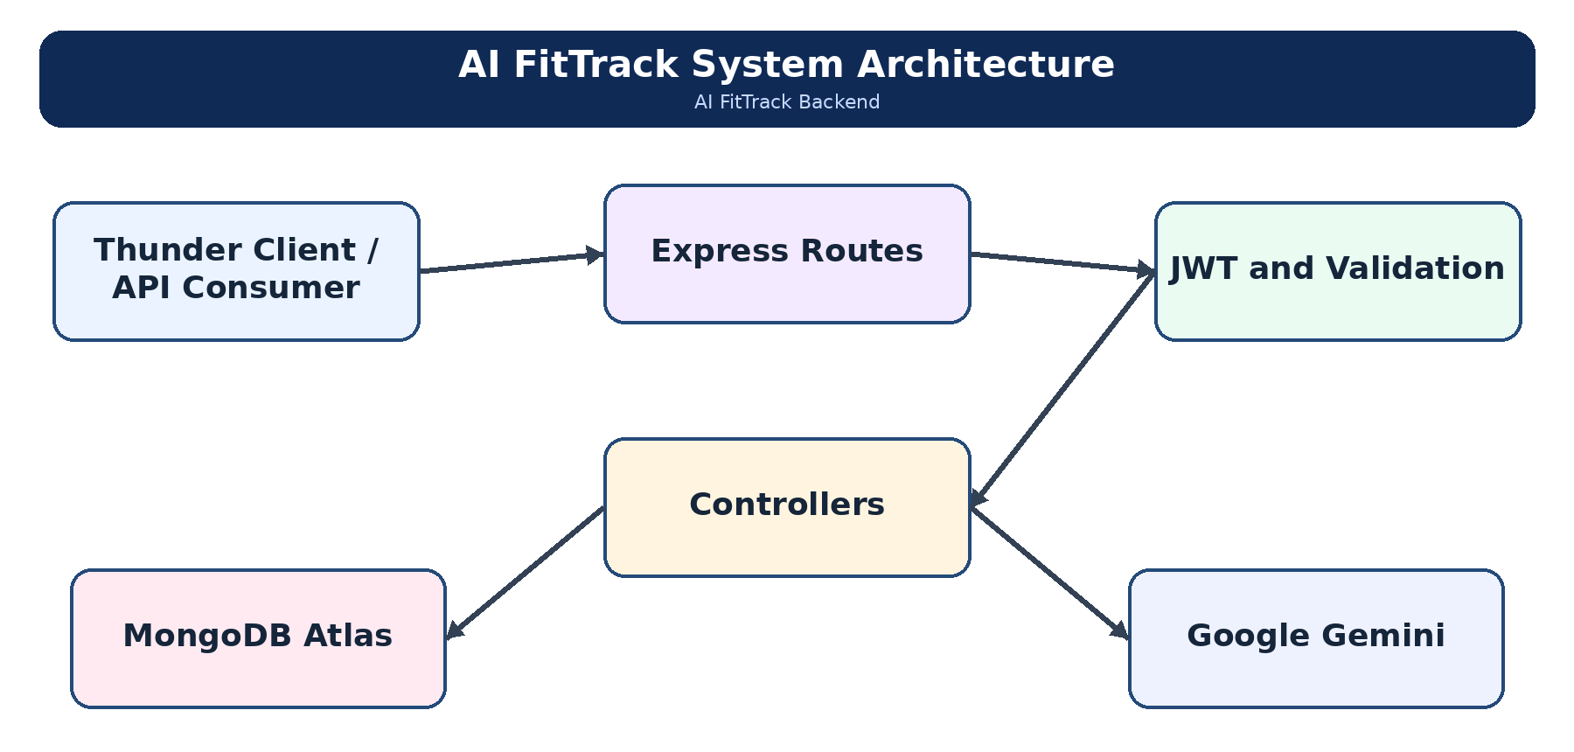
Figure 1: System architecture of AI FitTrack
MongoDB Atlas persists user and workout documents. Google Gemini is external to the application and is called only by protected AI endpoints. The server starts listening only after the database connection succeeds.

12. MODULAR BACKEND ARCHITECTURE
AI FitTrack uses an MVC-inspired structure with separate services and validation utilities.

12.1 Model Layer
User.js and Workout.js define schemas, constraints, indexes and safe response representations. The User model also owns password hashing and comparison.

12.2 Controller Layer
The authentication, workout and AI controllers validate requests, execute use cases and send standardized responses.

12.3 Routing and Middleware Layer
Route modules declare methods and paths. protect verifies bearer tokens and reloads the user. The centralized error middleware maps validation, authentication, database, JSON and provider failures.

12.4 Service and Utility Layer
jwtService centralizes signing and verification. geminiService owns prompts, schemas, timeouts, retries and provider-error normalization. Utility modules perform pure request validation and response formatting.
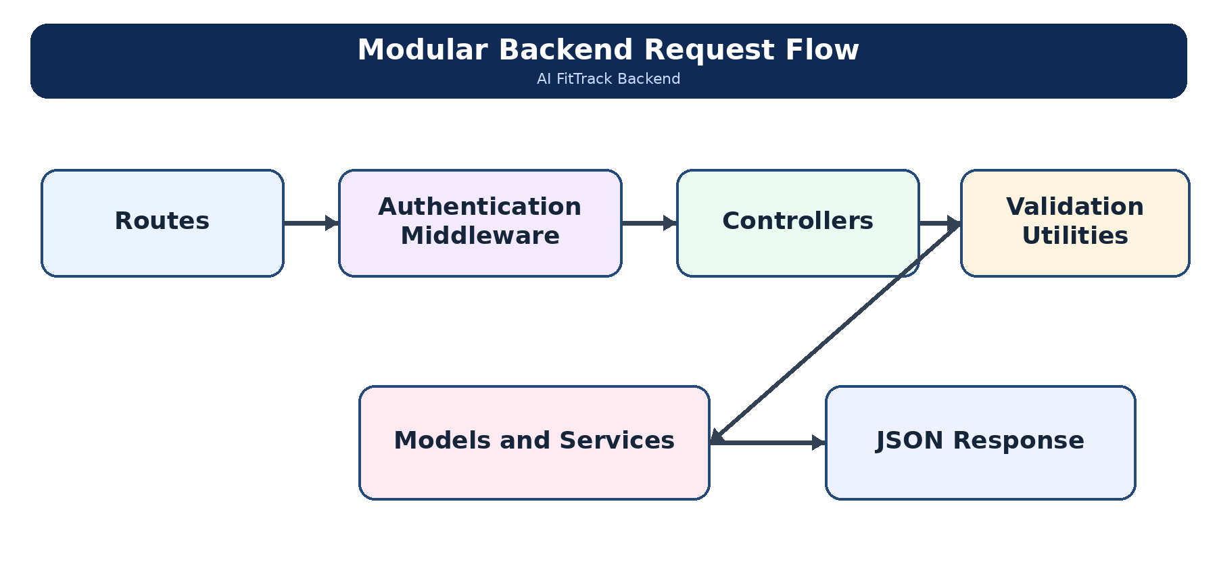
Figure 2: Modular request-processing flow
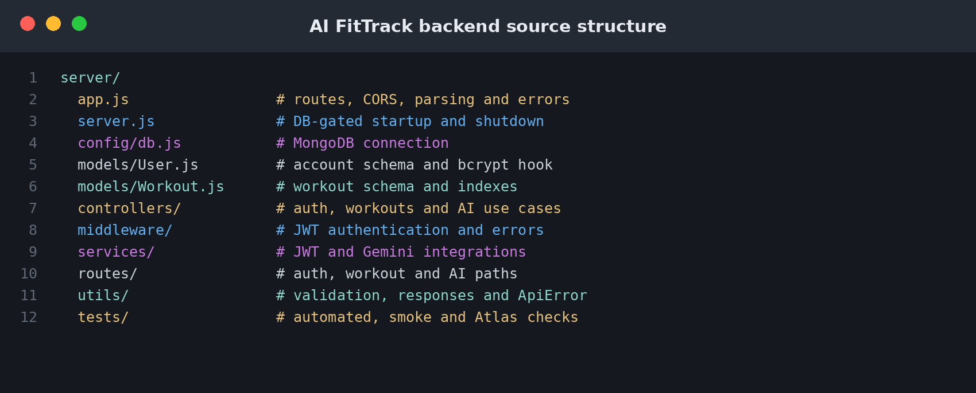
Figure 3: AI FitTrack backend source structure

13. DATABASE DESIGN
MongoDB Atlas is accessed through Mongoose. The application uses two collections: users and workouts. Workout.user stores the owning User ObjectId. No Category, Comment, Embedding or role collection exists in the final implementation.
• users - account identity, password hash and timestamps
• workouts - owner reference, workout measurements and timestamps

14. USER ENTITY
The User entity stores registered account information. Password is excluded from normal queries and removed from serialized objects.
Field | Description
_id | MongoDB user identifier
name | Trimmed name, 2 to 80 characters
email | Required normalized email with a unique index
password | bcrypt hash; select false
createdAt | Creation timestamp
updatedAt | Last update timestamp

15. WORKOUT ENTITY
The Workout entity stores one exercise-session record owned by one user.
Field | Description
_id | MongoDB workout identifier
user | Required reference to the owning User
workoutName | Required name, 2 to 120 characters
category | Cardio, Strength Training, Yoga, Running, Cycling or Walking
duration | Required number from 1 to 1440 minutes
caloriesBurned | Required number from 0 to 20000
workoutDate | Required valid date
createdAt | Creation timestamp
updatedAt | Last update timestamp

16. SCHEMA VALIDATION AND INDEXES
Controller validation rejects invalid payloads before database writes, while Mongoose remains the final schema guard. Workout categories are normalized case-insensitively to the canonical list. Aliases supported by the code include name, calories and date for workout inputs.
Constraint | Implemented Rule
Email | Normalized lowercase format and unique index
Password | Minimum six characters; bcrypt cost 12
Workout order | Newest workoutDate, then newest createdAt
Compound history index | { user: 1, workoutDate: -1, createdAt: -1 }
Category index | { user: 1, category: 1 }
List/search limit | Default 100; bounded from 1 to 500

17. USER-WORKOUT OWNERSHIP
Every create operation assigns user from req.user._id. Read, update and delete operations include both the requested workout identifier and the authenticated user identifier in the MongoDB query. A record belonging to another account is therefore not returned or modified.
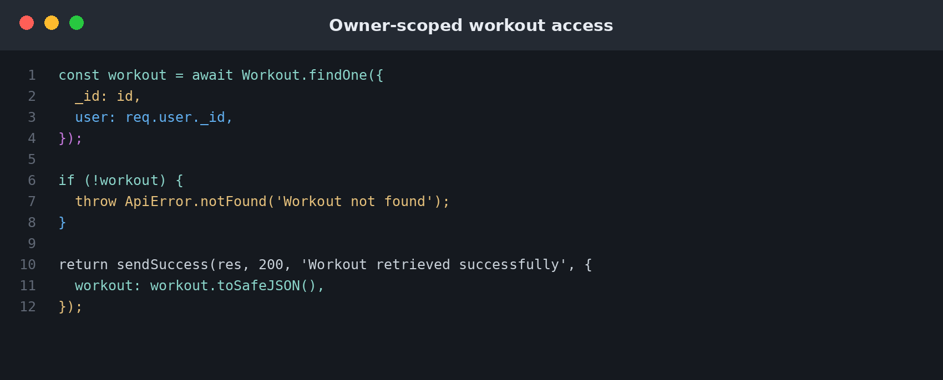
Figure 4: Owner-scoped workout query from the final controller

18. RESPONSE AND ERROR MODEL
Successful controllers return success, message and data. Failures return success=false, message and an errors array. Centralized middleware maps Mongoose validation, duplicate keys, cast errors, malformed JSON and unknown routes. Operational Gemini codes may also include attempts and retryAfterSeconds.
{
"success": true,
"message": "Workout created successfully",
"data": { "workout": { "_id": "<id>", "user": "<owner>", "workoutName": "Morning Run" } }
}
{
"success": false,
"message": "Validation failed",
"errors": [ { "field": "duration", "message": "Duration must be greater than zero (minutes)" } ]
}

19. ENTITY RELATIONSHIP DIAGRAM
The implemented database has one direct relationship: one User can own many Workout documents. A workout belongs to exactly one authenticated user through the required user reference.
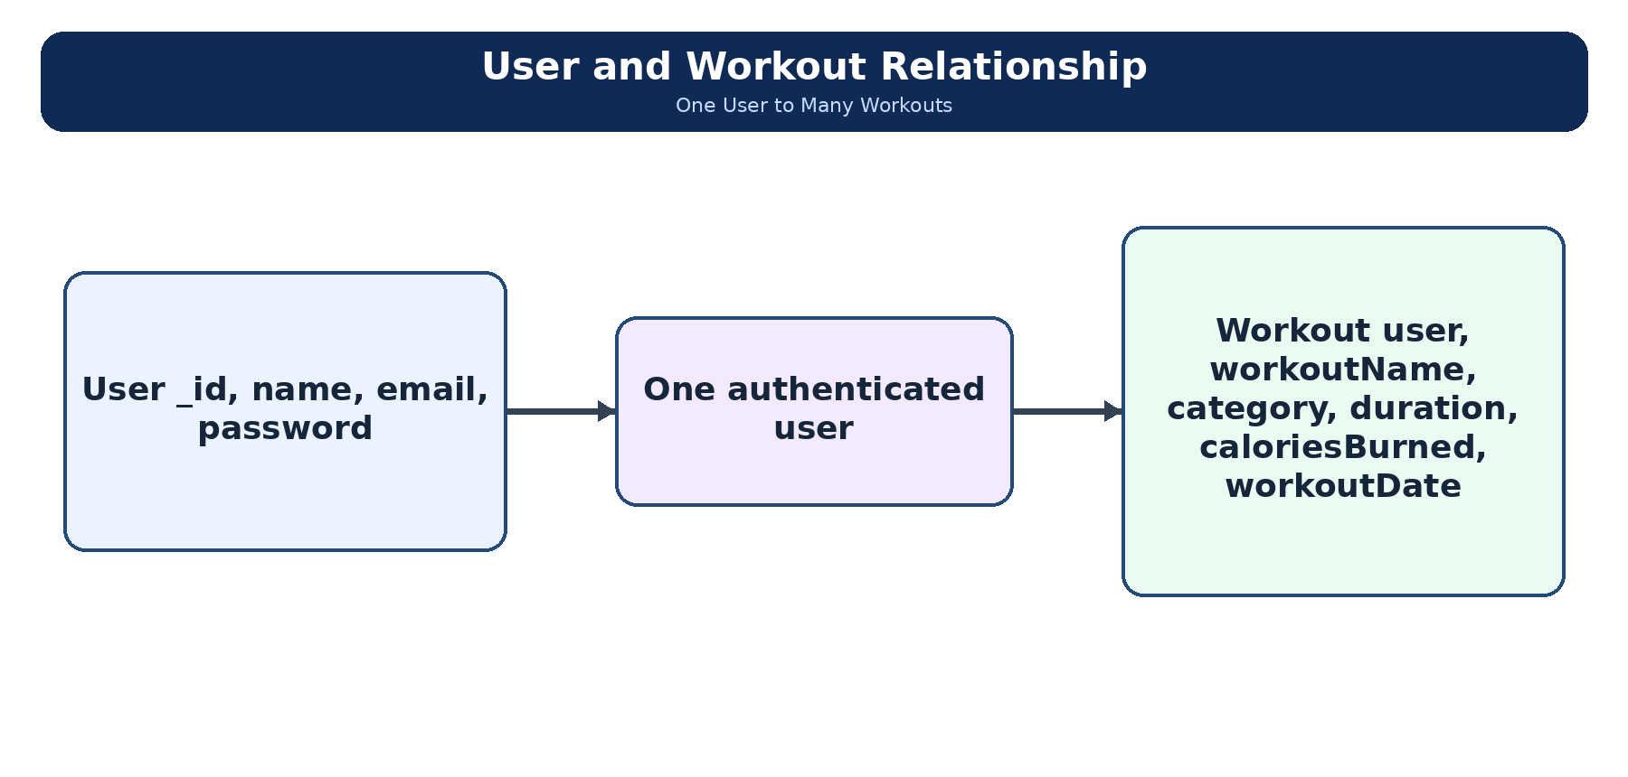
Figure 5: User-to-Workout database relationship

Relationship Explanation
• One user can create multiple workout records.
• Each workout stores exactly one owning user identifier.
• Owner-scoped queries enforce isolation without a separate role collection.
• Deleting a workout does not delete the user account.

20. TEAM ROLES AND RESPONSIBILITIES
The project team contains four students. The following responsibilities are preserved exactly as confirmed for the final submission.
Student | NM ID | Register Number | Role and Confirmed Responsibility
Parthiban M | 28538B1DB05060E8D804CDAA88169909 | 222401226 | Team Leader - Project architecture, complete backend development, MongoDB integration, Gemini AI implementation, and final delivery.
Naveen J | 53C2DC1753C6DFDAF8649841B4630C80 | 222401223 | Requirements review, organizing the eight phases of documentation, and checking submission guidelines.
Nidesh N S | FDE55A8DA9135F6AB7347C01AD1B8A17 | 222401224 | Reviewing Postman API results, verifying testing evidence, and checking that APIs satisfy project requirements.
Nithish Kumar P | BFBD9AD8CEC72229F374877DB82CC0B8 | 222401225 | Final report review, demonstration preparation, and organizing GitHub and SkillWallet submission materials.

21. OWNER-BASED ACCESS CONTROL
AI FitTrack does not implement administrative, editor, author or reader roles. Access is based on authentication and resource ownership. Public routes are limited to health, registration, login and email availability. The profile, all workout routes and both AI routes require a valid bearer token.
Operation | Public | Authenticated User | Owner Filter
Health, register, login, email availability | Yes | Yes | Not applicable
Profile | No | Yes | Current token user
Create workout | No | Yes | Owner assigned by server
List/search/get/update/delete workout | No | Yes | user=req.user._id
Gemini recommendation and insights | No | Yes | Per-user rate key and data

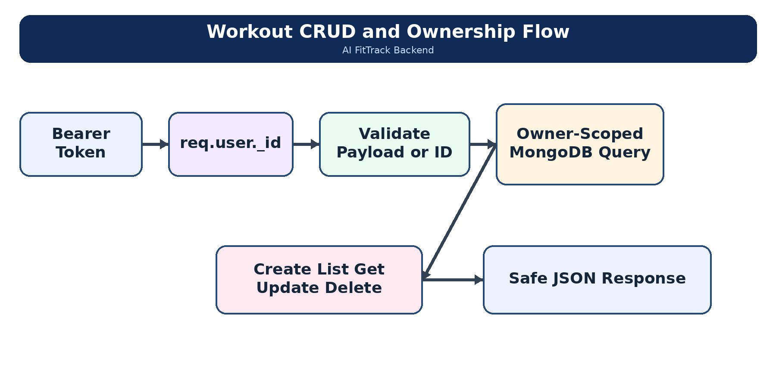
Figure 6: Owner-based workout access workflow

22. AUTHENTICATION AND JWT
Registration validates name, email and password, rejects duplicate email addresses, stores a bcrypt hash and returns a JWT. Login uses one generic error for an unknown email and a wrong password. JWTs use the issuer ai-fittrack-api and default to a one-day expiry unless configured otherwise.

Registration
POST /api/auth/register
{ "name": "Demo User", "email": "demo@example.com", "password": "<password>" }

Login
POST /api/auth/login

Protected Profile
GET /api/auth/profile with Authorization: Bearer <token>. The middleware verifies signature, expiry and issuer, then reloads the user from MongoDB.
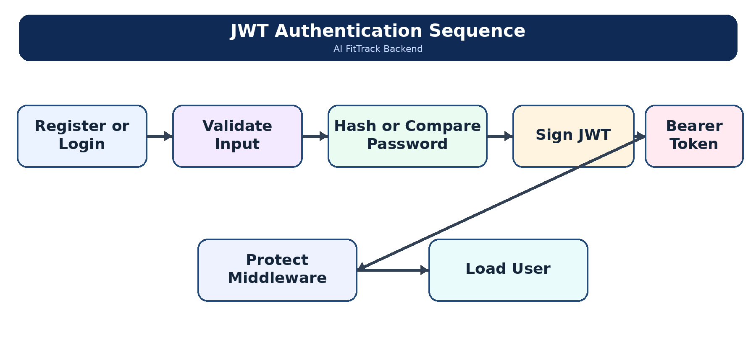
Figure 7: JWT authentication sequence

23. WORKOUT MANAGEMENT
The workout controller implements create, list, individual retrieval, partial update and deletion. Create requires all five workout fields. Update accepts one or more supported fields and runs Mongoose validators on the returned document.

Workout APIs
• POST /api/workouts - create a workout.
• GET /api/workouts - retrieve history and optional filters.
• GET /api/workouts/:id - retrieve one owned workout.
• PUT /api/workouts/:id - update one or more fields.
• DELETE /api/workouts/:id - delete and return the deleted workout in data.workout.

24. WORKOUT SEARCH
Search is available through GET /api/workouts/search and through optional filters on GET /api/workouts. name performs a regex-escaped case-insensitive partial match, category is normalized to the supported list, and date is converted to a half-open UTC day range. Results remain owner-scoped and sorted newest first.

25. WORKOUT UPDATE AND DELETION VERIFICATION
Update rejects an empty body and invalid identifiers. Delete uses findOneAndDelete with both _id and user. The final implementation returns HTTP 200 with the deleted workout inside data.workout. A later retrieval of that identifier returns HTTP 404 Workout not found.

26. GOOGLE GEMINI AI INTEGRATION
Both AI routes are protected. The Gemini service uses the official @google/genai SDK and defaults to gemini-3.6-flash unless GEMINI_MODEL overrides it. It requests application/json with a response schema and validates required fields again after parsing.
• Default per-attempt timeout: 30 seconds; configurable up to 120 seconds.
• Default maximum attempts: three; configurable up to five.
• Retries only transient timeouts, rate limits and service-unavailable errors.
• Authentication, missing-key, unknown-model and malformed-output errors are not retried.
• Per-process user limit defaults to 10 AI requests per minute.
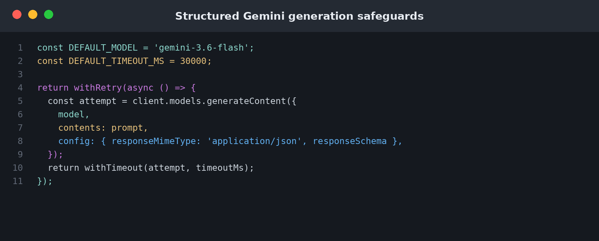
Figure 8: Structured Gemini request safeguards

27. AI WORKOUT RECOMMENDATION
POST /api/ai/workout-recommendation accepts age, fitnessGoal and experienceLevel. The compatibility alias experience is also accepted. Age must be a whole number from 13 to 100. Goals and experience levels are checked against allow-lists.

Request
{
"age": 19,
"fitnessGoal": "Weight Loss",
"experienceLevel": "Beginner"
}

Response Structure
• workoutPlan overview
• weeklySchedule with day, focus, exercises and optional duration
• experienceRecommendations
• trainingTips
• restAndRecovery
• safetyGuidance
• motivation
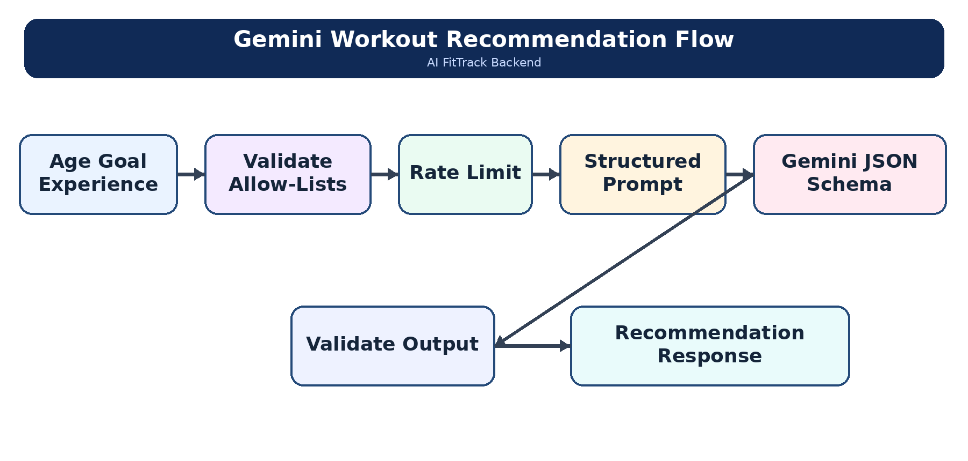
Figure 9: Gemini workout-recommendation workflow

28. PROMPT ENGINEERING AND STRUCTURED OUTPUT
Prompts define the user profile, required output sections and safety boundaries. The recommendation prompt requests common moderate exercises and directs the model not to assume medical conditions. The insights prompt prohibits invented workout history. Both prompts require JSON only and are paired with SDK response schemas.
A response is rejected when it is empty, lacks a JSON object, contains malformed JSON or omits required fields. The API returns an error instead of inventing a replacement response.
Input profile or statistics
↓
Validated structured prompt
↓
Google Gemini with responseSchema
↓
Parse JSON and validate required fields
↓
Standard AI FitTrack response envelope

29. FITNESS INSIGHTS
POST /api/ai/fitness-insights supports two modes. Submitted-statistics mode accepts totalWorkouts, averageWorkoutDuration and totalCaloriesBurned and returns statsSource="submitted". Database mode accepts useDatabaseStats=true, calculates statistics from the authenticated user’s workouts and returns statsSource="database".

Submitted Statistics Request
{ "totalWorkouts": 12, "averageWorkoutDuration": 38, "totalCaloriesBurned": 4200 }

Database Statistics Request
{ "useDatabaseStats": true }
When the database contains no workouts, the controller returns zero statistics and insights:null without calling Gemini. The averageDuration alias is accepted, but averageWorkoutDuration is canonical.
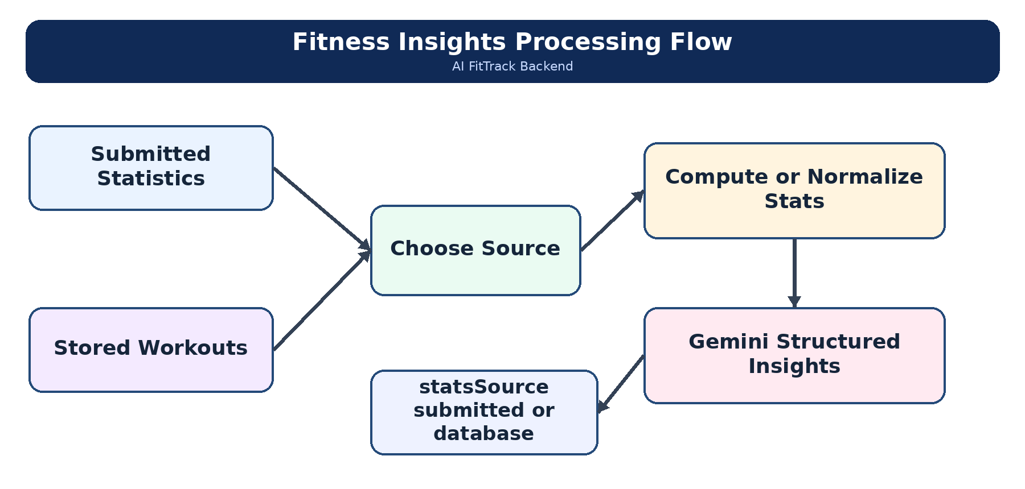
Figure 10: Fitness-insights processing workflow

30. MONGODB ATLAS CONNECTION AND INDEXES
config/db.js validates MONGO_URI, applies a 15-second server-selection timeout, a 45-second socket timeout and a maximum pool size of 10. Optional DNS servers, IPv4 forcing and separate MongoDB credentials are supported. The server starts listening only after connectDB succeeds and closes the database during graceful shutdown.
Mongoose strictQuery and autoIndex are enabled. The User email unique index and Workout compound indexes support the actual access patterns. Sensitive configuration is managed through environment variables and should not be exposed in public documentation.

31. SEARCH BY NAME CATEGORY AND DATE
GET /api/workouts/search?name=&category=&date=&limit= accepts any combination of the implemented filters. Name input is escaped before it becomes a regular expression. Category rejects values outside the six supported categories. Date uses UTC day boundaries to avoid host-time-zone differences. An empty search is valid and returns the user’s recent history up to the bounded limit.
Query Parameter | Rule | Example
name | Partial case-insensitive match | name=run
category | Exact canonical category | category=Running
date | Valid UTC calendar day | date=2026-09-18
limit | Integer clamped to 1-500 | limit=20

32. DATABASE-DERIVED FITNESS STATISTICS
When useDatabaseStats=true, the controller retrieves only workouts whose user equals req.user._id. It calculates totalWorkouts, averageWorkoutDuration rounded to one decimal place and totalCaloriesBurned. These verified database totals are then passed to Gemini with source="database". This is not vector search or semantic search; no embeddings are implemented.
totalWorkouts = workouts.length
averageWorkoutDuration = round(totalDuration / totalWorkouts, 1)
totalCaloriesBurned = sum(workout.caloriesBurned)
statsSource = "database"

33. SECURITY FEATURES

Password Security
bcrypt cost 12; password select:false; safe JSON transforms.

JWT Security
Required secret, issuer check, expiry and fresh user lookup.

Owner Authorization
All workout record queries include req.user._id.

Input Validation
Authentication, workout and AI payloads are validated before use.

Query Safety
Search text is regex-escaped and identifiers are checked as ObjectIds.

CORS and Parsing
Configured origin allow-list and 1 MB JSON request limit.

AI Safeguards
Timeouts, bounded retries, rate limiting and structured-output checks.

Error Handling
Production responses omit stacks and never return configured secrets.
These controls are appropriate for an academic backend, but the project does not claim a professional penetration test, deployed HTTPS termination, distributed rate limiting or production monitoring.

34. API MODULE SUMMARY

Health and Authentication
Method | Endpoint | Purpose
GET | /api/health | Service status
POST | /api/auth/register | Register user
POST | /api/auth/login | Login and issue JWT
GET | /api/auth/email-available?email= | Check normalized email
GET | /api/auth/profile | Retrieve protected profile

Workout
Method | Endpoint | Purpose
POST | /api/workouts | Create workout
GET | /api/workouts | List history and optional filters
GET | /api/workouts/search | Search by name, category and date
GET | /api/workouts/:id | Retrieve one owned workout
PUT | /api/workouts/:id | Update one owned workout
DELETE | /api/workouts/:id | Delete and return workout

Google Gemini AI
Method | Endpoint | Purpose
POST | /api/ai/workout-recommendation | Generate structured workout plan
POST | /api/ai/fitness-insights | Generate submitted or database-statistics insights

Authentication: profile, workout and AI routes require Authorization: Bearer <token>. Common status codes are 200, 201, 400, 401, 403, 404, 409, 429, 500, 502, 503 and 504 according to the executed path.

35. API TESTING
API testing covers the health route, authentication, owner-scoped workout operations, search and both AI endpoints. Each successful request uses the same structured response envelope, while validation, authentication, authorization and provider failures are returned through the centralized error handler.
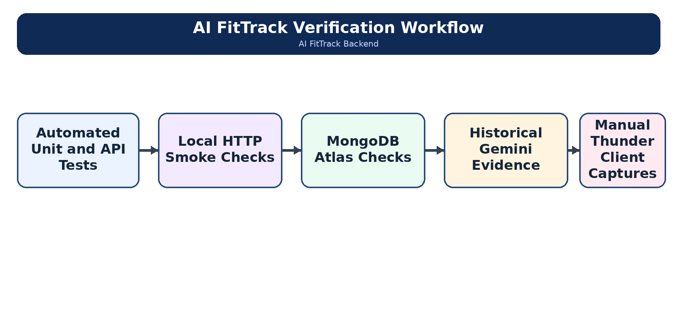
Figure 11: AI FitTrack testing workflow

35.1 Authentication and Health API Testing
Method | Endpoint | Purpose | Auth | Important Request Fields | Success | Controller Behaviour
GET | /api/health | Check service health | No | None | 200 | Returns service status and runtime metadata.
POST | /api/auth/register | Register user | No | name, email, password | 201 | Validates input, enforces unique email, hashes the password and issues a JWT.
POST | /api/auth/login | Login user | No | email, password | 200 | Verifies the bcrypt hash and returns the authenticated user with a JWT.
GET | /api/auth/profile | Protected profile | Yes | Authorization: Bearer <token> | 200 | Verifies the token and loads the current user without exposing the password.
The expected status represents the successful path. Invalid input, duplicate registration, incorrect credentials or a missing token produces the appropriate structured error response.

35.2 Workout and AI API Testing
Method | Endpoint | Purpose | Auth | Important Request Fields | Success | Controller Behaviour
POST | /api/workouts | Create workout | Yes | workoutName, category, duration, caloriesBurned, workoutDate | 201 | Validates all required fields and assigns ownership from the authenticated user.
GET | /api/workouts | Get all workouts | Yes | Optional: name, category, date, limit | 200 | Returns only the user’s matching history, sorted newest first.
GET | /api/workouts/:id | Get workout by ID | Yes | Path parameter: id | 200 | Validates the identifier and retrieves one owner-scoped workout.
PUT | /api/workouts/:id | Update workout | Yes | id and at least one workout field | 200 | Applies partial validation and returns the updated owned workout.
GET | /api/workouts/search | Search workouts | Yes | Optional: name, category, date, limit | 200 | Uses escaped name matching, canonical category matching and UTC date boundaries.
DELETE | /api/workouts/:id | Delete workout | Yes | Path parameter: id | 200 | Deletes only an owned workout and returns it in data.workout.
POST | /api/ai/workout-recommendation | Workout recommendation | Yes | age, fitnessGoal, experienceLevel | 200 | Validates input, applies rate limiting and requests a structured Gemini workout plan.
POST | /api/ai/fitness-insights | Fitness insights | Yes | Submitted statistics or useDatabaseStats: true | 200 | Returns structured insights with statsSource set to submitted or database.
Gemini integration is implemented and historical successful responses are included in the verified project evidence. A current live request additionally requires valid provider authentication and service availability.

36. TESTING RESULTS
The following results were executed and recorded on 27 September 2026 and are retained as previously verified project evidence.
Test Group | Recorded Result | Coverage
Automated Node tests | 95 passed, 0 failed | Authentication, workouts, search, validation, security, AI and retries
Local HTTP smoke checks | 17 passed, 0 failed | End-to-end API flow
MongoDB Atlas checks | 19 passed, 0 failed | Live connection, persistence and cleanup
Historical live Gemini | Three HTTP 200 responses | Recommendation, submitted insights and database insights
Later Gemini retest | Reported HTTP 401 | Live execution requires a valid current provider credential

37. MONGODB CONNECTION
Previously recorded MongoDB Atlas evidence shows successful startup connectivity and 19 passing integration checks. The checks created temporary users and workouts, verified persistence and owner-scoped retrieval, and removed the test data after execution.

38. SYSTEM FUNCTIONALITY SUMMARY
Module | Main Functionality
Health | Runtime status, version, environment, uptime and timestamp
Authentication | Registration, login, email availability and protected profile
Workout | Owner-scoped create, list, get, update and delete
Search | Name, category, date and bounded limit
Gemini Recommendation | Age, goal and experience to structured workout plan
Fitness Insights | Submitted or database-derived statistics to structured insights
Security | bcrypt, JWT, validation, ownership, CORS and safe errors
Testing | Automated, smoke, Atlas and historical live Gemini evidence

39. ADVANTAGES
1. Centralizes workout records in a consistent database structure.
2. Protects each user’s workouts through owner-scoped queries.
3. Uses one predictable JSON envelope across controllers.
4. Provides focused search without requiring a separate search service.
5. Combines stored facts with structured AI guidance.
6. Separates routes, controllers, models, services, middleware and validators for maintainability.
7. Includes extensive automated and integration-oriented evidence.

40. LIMITATIONS
• The completed submission has no frontend, dashboard or mobile interface.
• The AI rate limiter is in-process and is not shared across multiple server instances.
• Workout history has a bounded limit but no cursor or page-based pagination.
• No wearable-device import, notifications or live progress charts are implemented.
• Live Gemini execution depends on a valid provider credential and provider availability; a later authentication-related HTTP 401 was recorded.
• Sensitive configuration is managed through environment variables and should not be exposed in public documentation.

41. FUTURE ENHANCEMENTS
• Develop a responsive web or mobile client that consumes the existing API.
• Add progress charts and trend analysis based on stored workout history.
• Add cursor pagination, date ranges and advanced reporting exports.
• Introduce reminder and notification features through an approved service.
• Expand tracked measurements while keeping schema validation explicit.
• Evaluate optional wearable integration with user consent and privacy controls.
• Use distributed rate limiting, production monitoring and CI deployment checks.

42. CONCLUSION
AI FitTrack successfully implements the confirmed backend scope for an AI-augmented fitness tracking system. It provides secure authentication, protected profiles, owner-scoped workout CRUD, search by name, category and date, and two structured Gemini operations. MongoDB Atlas and Mongoose provide persistence and schema enforcement, while validation utilities and centralized error handling make API behaviour consistent.
The implementation and previously recorded evidence support the principal functional requirements. The verified project records show 95 passing automated tests, 17 passing smoke checks and 19 passing MongoDB Atlas checks. Historical Gemini evidence confirms successful structured responses, while live provider access continues to depend on a valid current credential. These results demonstrate that AI FitTrack meets its confirmed backend-only academic scope while retaining clear operational limits.
Project Repository: https://github.com/parthi525855-oss/AI-FitTrack-Naan-Mudhalvan

