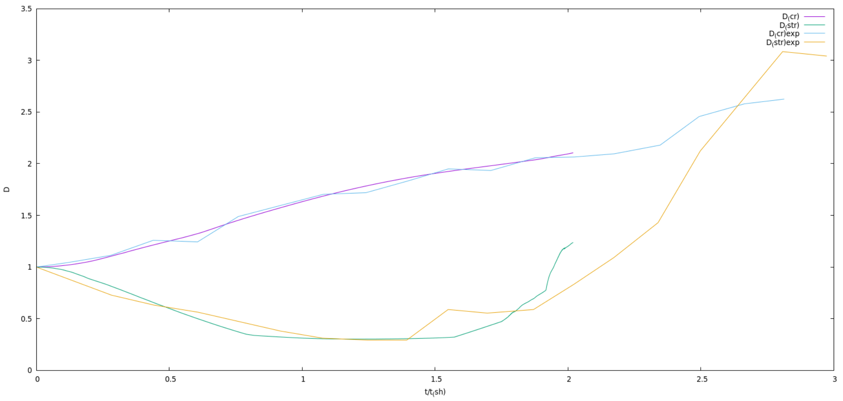

diameter-p4-u2-f2-ff2

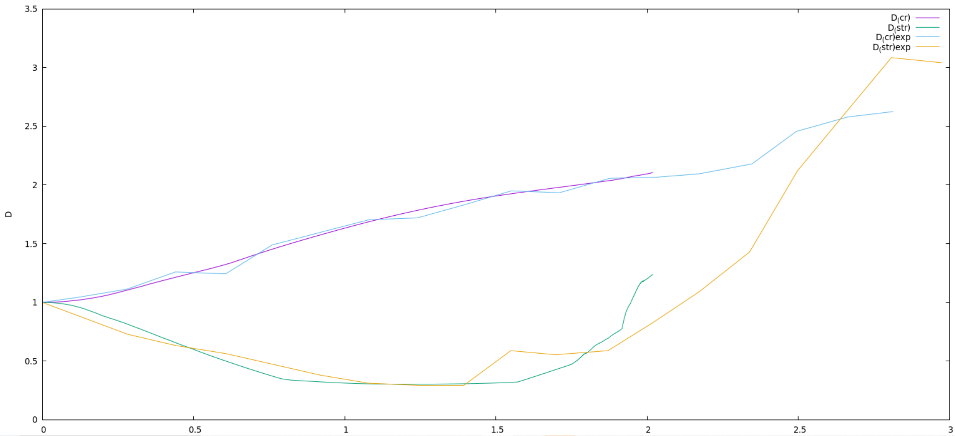

diameter-p6-u2-f3-ff3

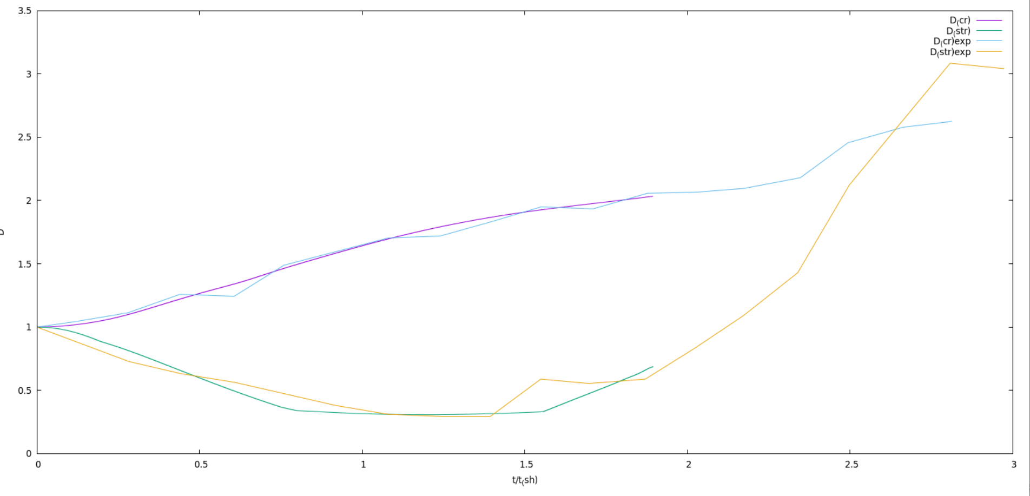

diameter-p6-u3-f3

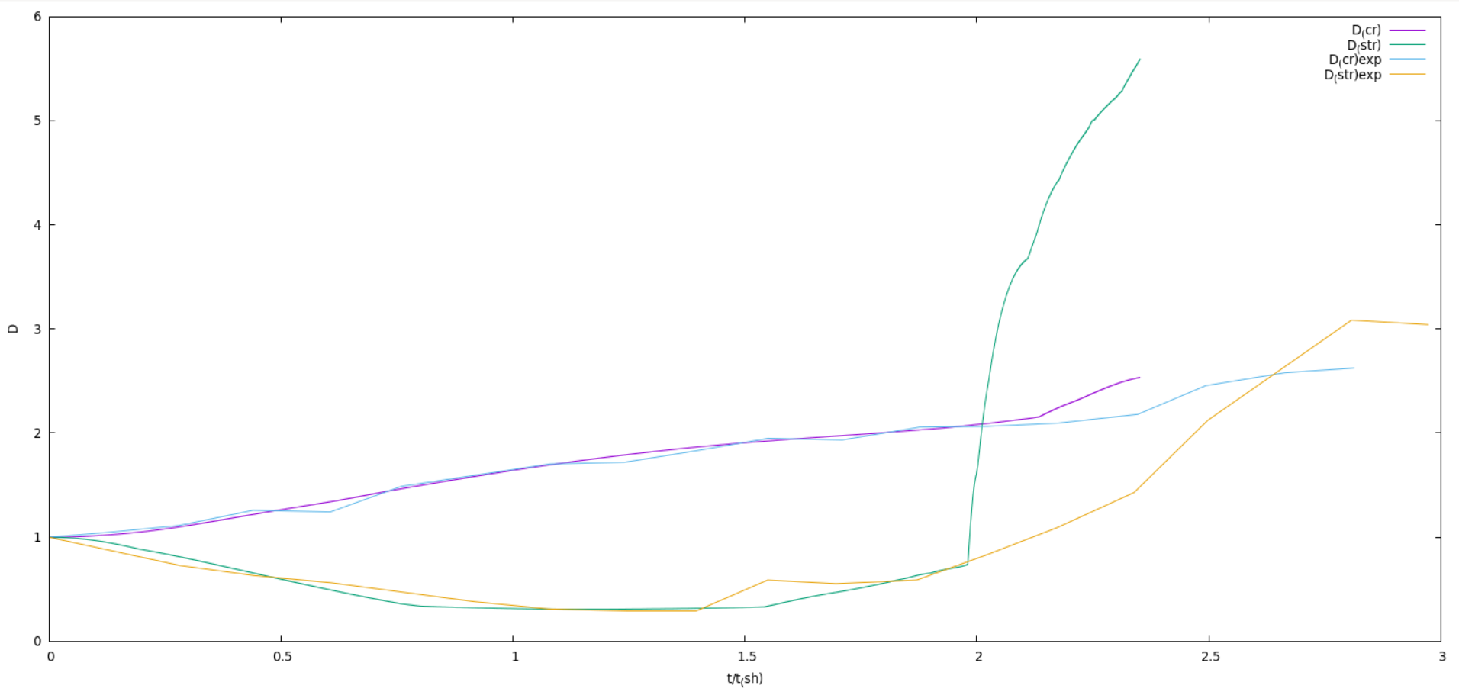

diameter-p4-u2-f3