READ :
List of customers in customersdb

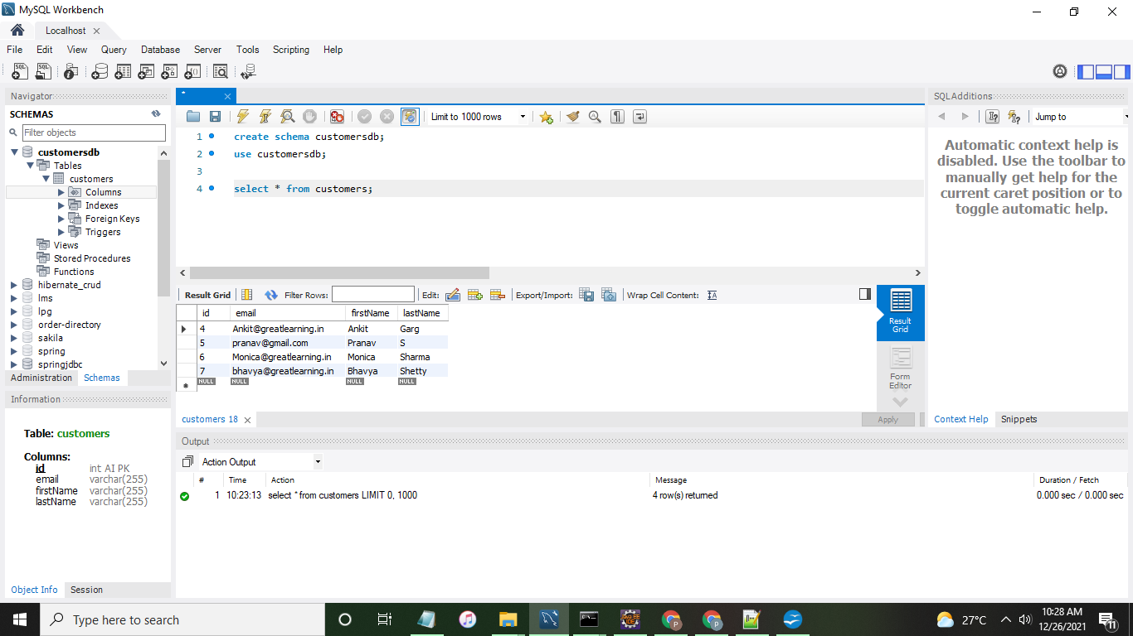

UI

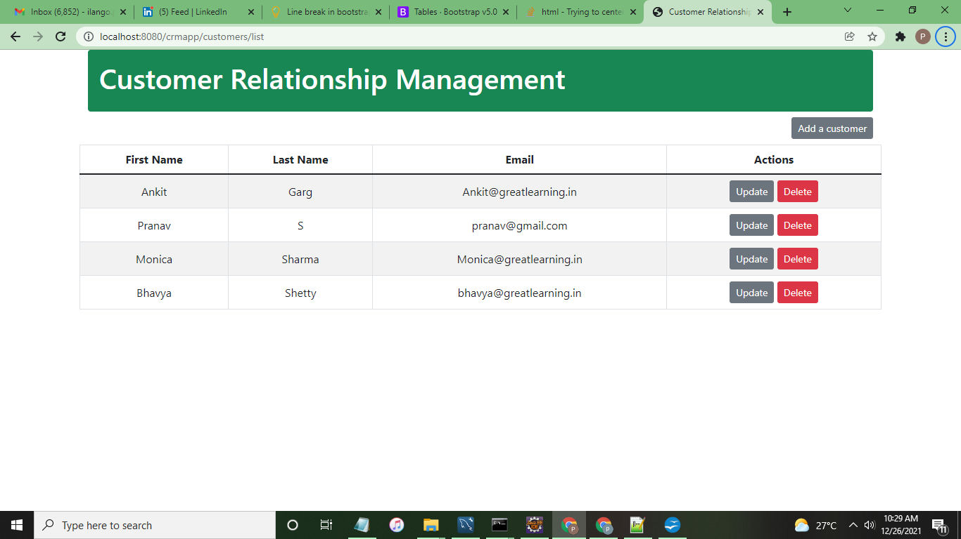

ADD:
Add Harshit Choudary as new Customer

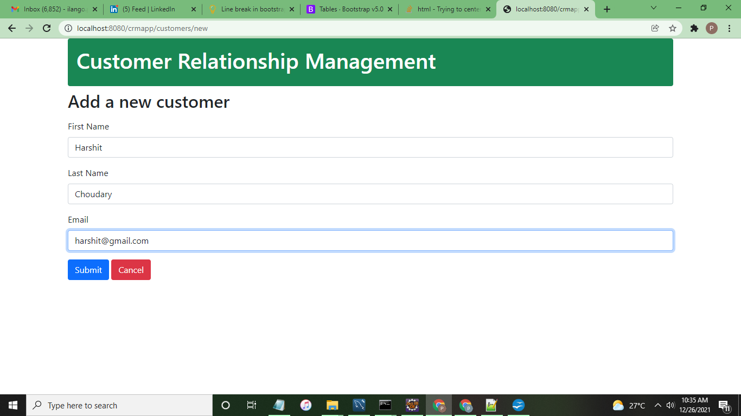
Updated list of customers after adding a new customer Harshit
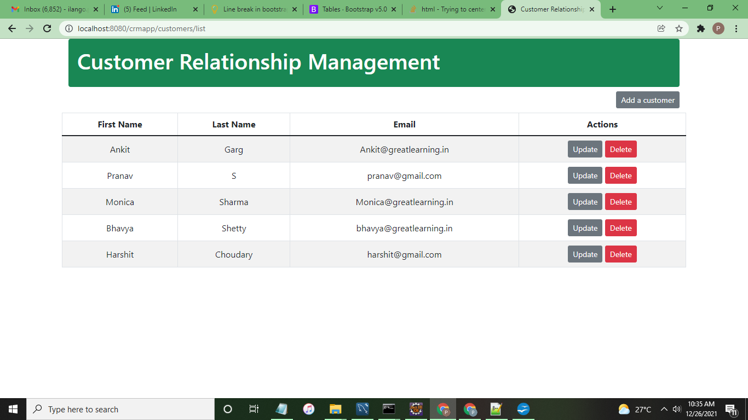
After adding Harshit – db screenshot

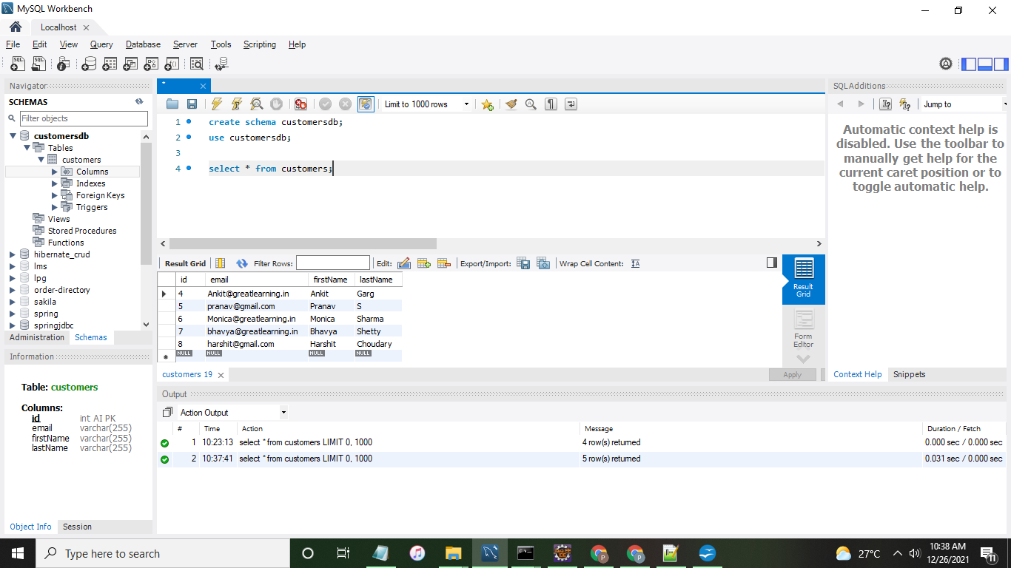
UPDATE: update email of Harshit to harsit@gl.in
update customer screen with prepoluated details

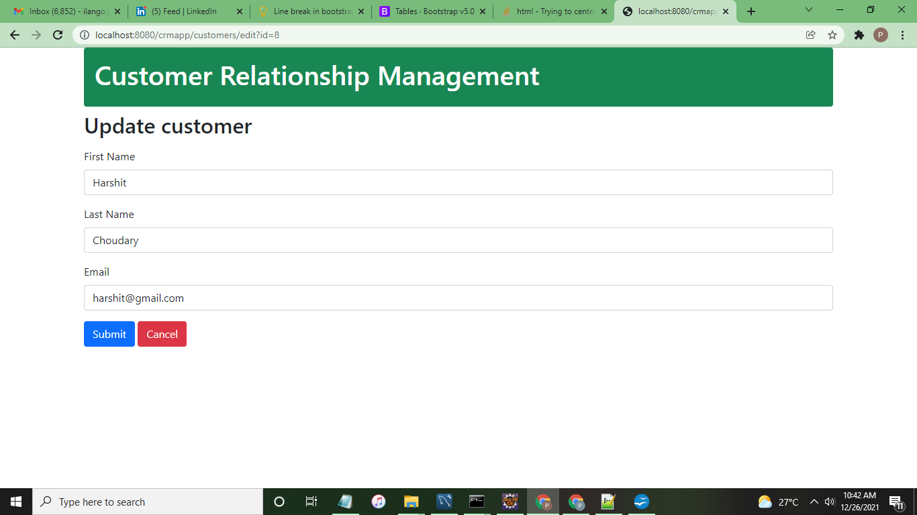

Edit email id of harshit in update screen
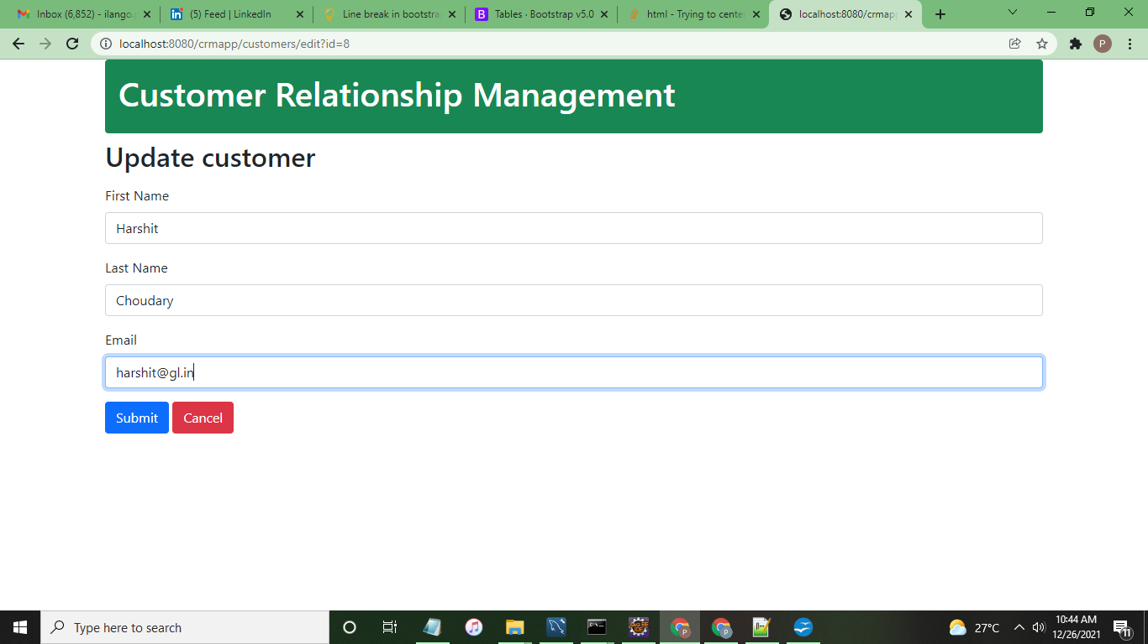
Updated customer shown in list screen

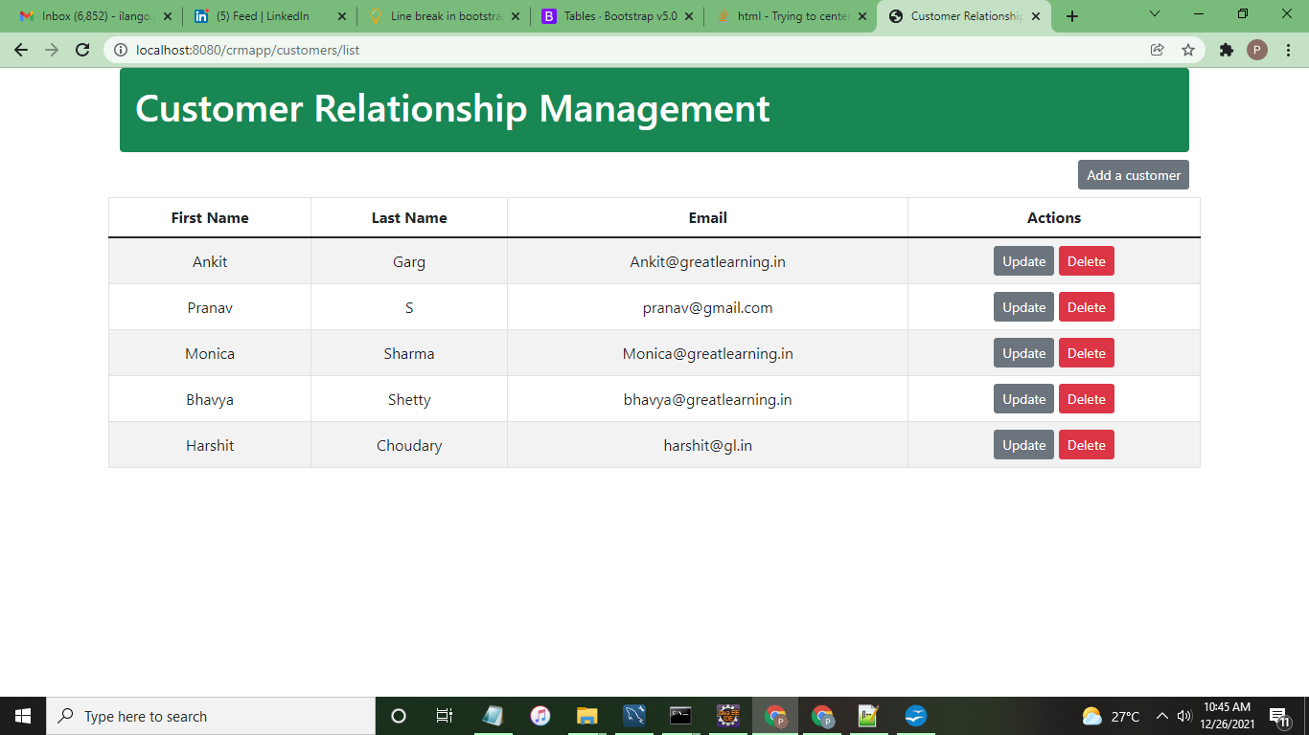

Update customer details persisted in DB
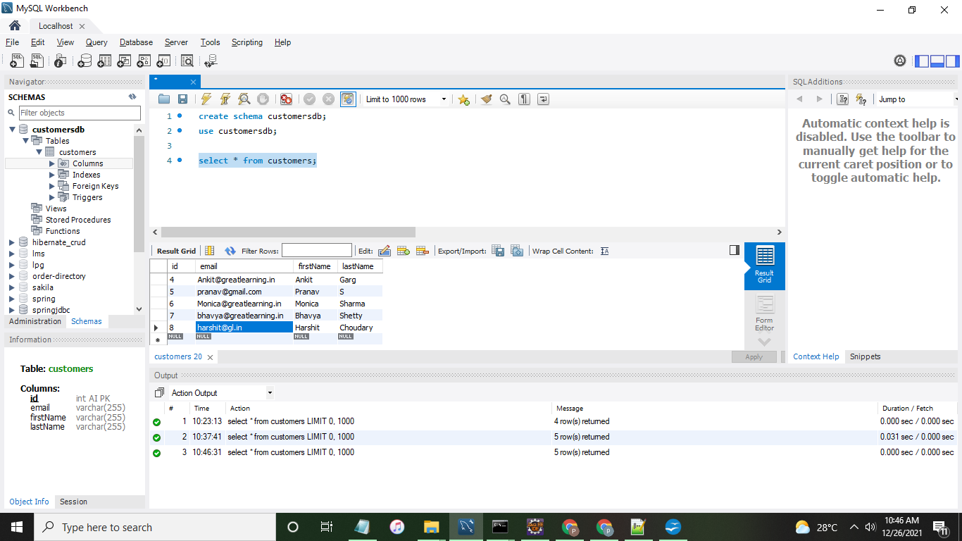
DELETE : Delete Harshit Choudhary

Upon clicking delete button a pop up shows

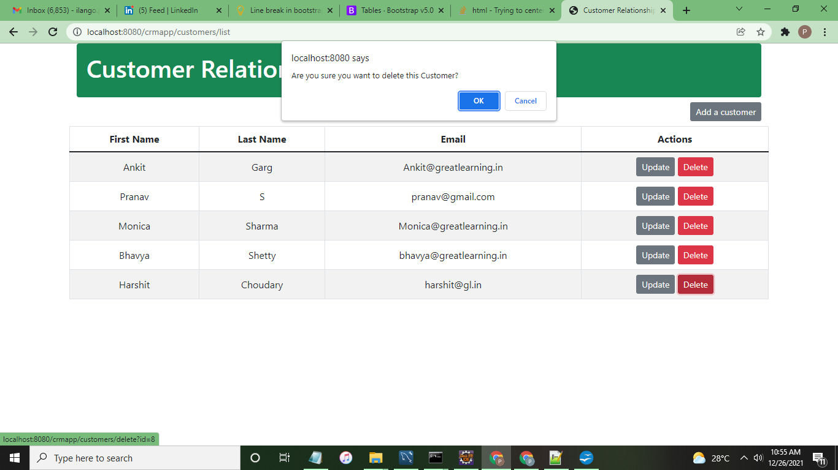
After clicking ok on popup, Updated list of employees upon deleting customer Harshit Choudhary
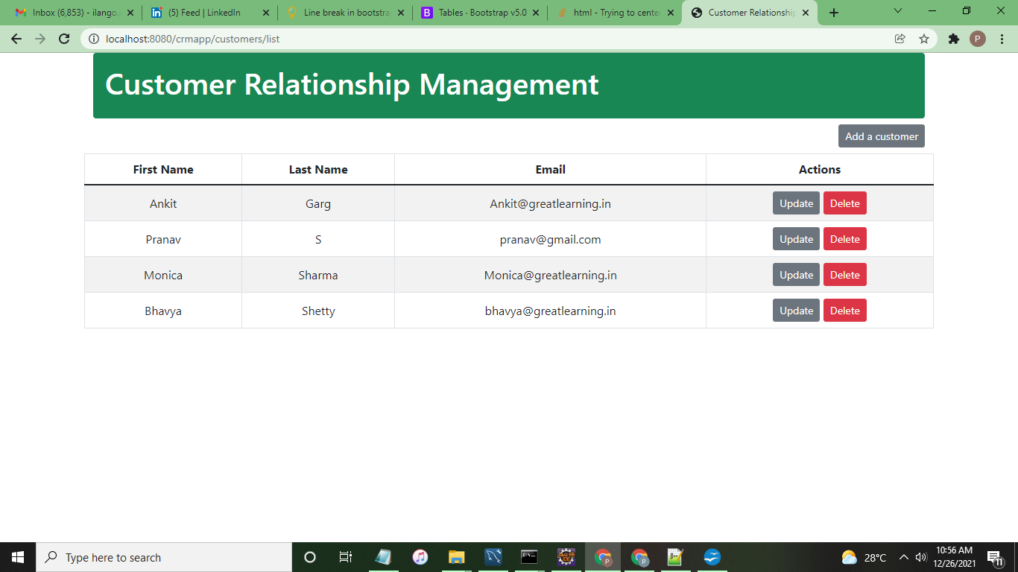
Updated list of employees in DB after deleting customer Harshit Choudhary

