**Execution of ReferenceData:**

**Input Location:** All the input data are available in the below location. ..\volpayui\VolPaydata\ReferenceData

|  |  |  |  |
| --- | --- | --- | --- |
| **SNO** | **Modules** | **Browser** | **Execute(YES/NO)** |
| Login | VolPayLogin | Firefox | YES |
| Calendar | ExecuteCalendar | Continue | YES |
| Region | ExecuteRegion | Continue | YES |

Sno: This column defines the sheet name

Modules: This Column values defines the method to be executed.

Browser: This column in which browser the module should be executed.

* “Firefox” refers to Firefox browser.
* “Chrome” refers to chrome browser.
* “Continue” refers to continue with previously opened browser.

Execute: This column defines whether to execute the module or not.

**Output Locations:** All the generated reports are available in the below location... \volpayui\VolPayoutput\Reports.

**Execution:**

..\volpayui\testexecution\ReferenceData

This xml file defines where the output reports have to be generated & the location of the input data file.

**Test:**

In all the executable testNG files values (locations) for the parameters ***Report*** & ***driverPath*** should be changed respectively.

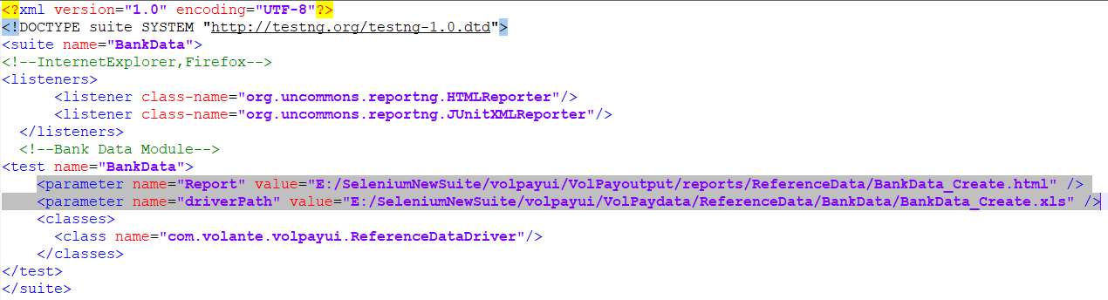

**Note:-**

Change only till regression suite’s root directory “***volpayui***”

**Class:**

1. **ReferenceDataDriver**

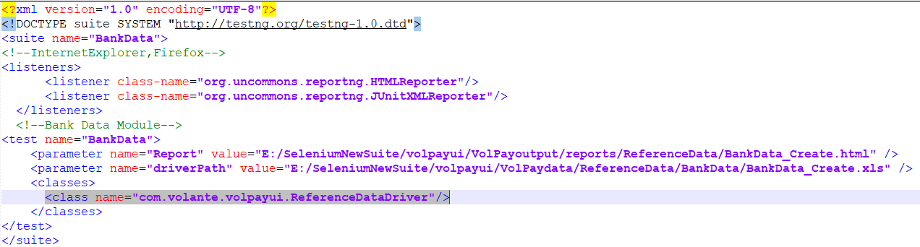

* This is used by all the reference data for Create operation.

1. **VolPayDriver**

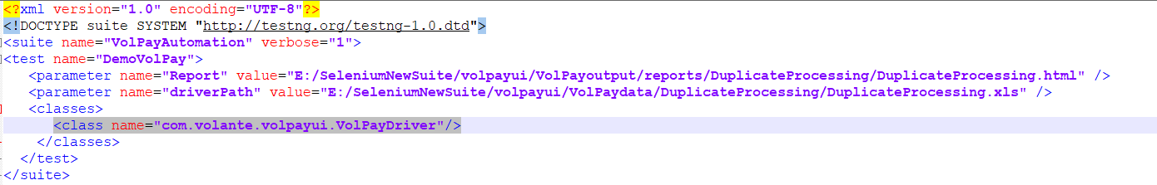

* This is used by all the modules except reference data create operation.

**Order to execute the Reference Data modules**:

1. Create Bank Data
2. Create Onboarding Data
3. Create Distribution Data
4. Create System Data
5. Edit Bank Data
6. Edit Onboarding Data
7. Edit Distribution Data
8. Edit System Data
9. Delete System Data
10. Delete Distribution Data
11. Delete Onboarding Data
12. Delete Bank Data