**Object Repository**

**What is Object Repository?**

An object repository is a common storage location for all objects. In Selenium Web Driver context, objects would typically be the locators used to uniquely identify web elements.

The major advantage of using object repository is the segregation of objects from test cases. If the locator value of one web element changes, only the object repository needs to be changed rather than making changes in all test cases in which the locator has been used. Maintaining an object repository increases the modularity of framework implementation.

**Object Repository Using XML File**

XML stands for Extensible Markup Language. An XML File uses Document Object Model(DOM) as the basic structure.

# 1 .Creating an XML file in Object Repository

* Go to src-->main-->resources-->objectRespository
* Right-click on the objectRespository folder, select New -> Other

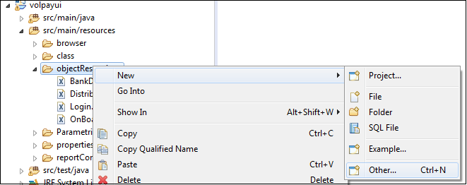

* Select the XML File within the XML folder and click on 'Next' button

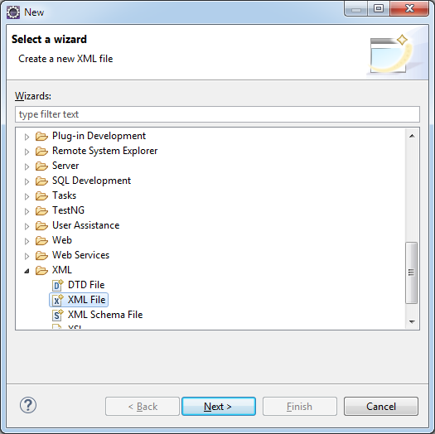

* Enter a valid XML File name and click on 'Finish' button

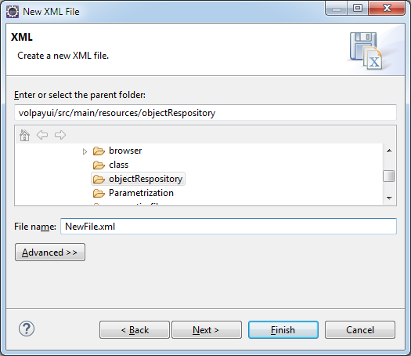

# 2. Storing data onto XML file

Data can be stored in XML file in the form of Document Object Model (DOM).The below is the format of XML File to be used.

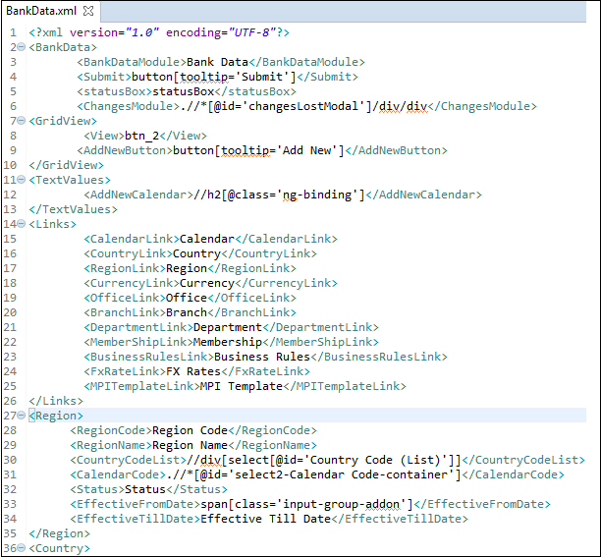

# 3 .Reading data from XML file



# 4 .Using XML file in test scripts

