WEEK 3 INTERNSHIP REPORT
Advanced Data Analysis and Visualization in Logistics
DataCo SMART SUPPLY CHAIN Dataset

1. Objective
The objective of Week 3 was to deepen logistics analytics skills through exploratory data analysis (EDA), descriptive statistics, correlation analysis, visualization, and interpretation of operational performance. The cleaned DataCo SMART SUPPLY CHAIN dataset prepared during Week 2 was used as the analytical dataset.

2. Dataset and Methodology
The analysis used 180,519 logistics records. The Week 2 preprocessing workflow handled missing values, duplicate records, date fields, text consistency, potential outliers, and numerical normalization.
Analysis workflow: load the cleaned dataset; calculate descriptive statistics; compare actual and scheduled shipping time; analyze delivery status and shipping modes; measure late-delivery risk; calculate correlations; generate visualizations; interpret results; and provide recommendations.

3. Exploratory Data Analysis Results
Metric | Result
Dataset records | 180,519
Average actual shipping time | 3.50 days
Average scheduled shipping time | 2.93 days
Average shipping delay | 0.57 days
Average sales per record | 203.77
Overall late-delivery risk | 54.83%

4. Delivery Performance Analysis
Average actual shipping time was 3.50 days, compared with 2.93 days scheduled. The average gap was therefore 0.57 days, indicating that actual shipment duration was higher than scheduled on average.
Overall late-delivery risk was 54.83%, indicating that delivery reliability is an important operational area for improvement.

5. Correlation Analysis
Correlation coefficients were calculated between key numerical variables and the late-delivery-risk indicator.
Variable | Correlation
Days for shipping (real) | 0.401
Days for shipment (scheduled) | -0.369
Sales per customer | -0.004
Order Item Total | -0.004
Order Profit Per Order | -0.004
Benefit per order | -0.004
Sales | -0.004
Product Price | -0.002
Order Item Discount | -0.001
Order Item Quantity | -0.000
Actual shipping duration had the strongest positive correlation with late-delivery risk (0.401). Scheduled shipping time had a moderate negative correlation (-0.369). Sales, price, discount, quantity, and profit variables had correlations very close to zero in this analysis.

6. Visualizations and Their Purpose
- Delivery Status Distribution — Bar chart: compares the number of records in each delivery-status category.
- Distribution of Actual Shipping Days — Histogram: shows the spread and common values of delivery time.
- Sales Distribution — Histogram: shows the distribution and concentration of sales values.
- Orders by Shipping Mode — Bar chart: compares shipment volume across shipping modes.
- Late-Delivery Risk by Shipping Mode — Bar chart: compares late-risk percentages across shipping modes.
- Correlation Heatmap — Heatmap: summarizes relationships among key numerical logistics variables.

7. Evidence of Python Analysis Output
The following screenshot records the final notebook output containing the calculated correlations and Week 3 summary metrics.
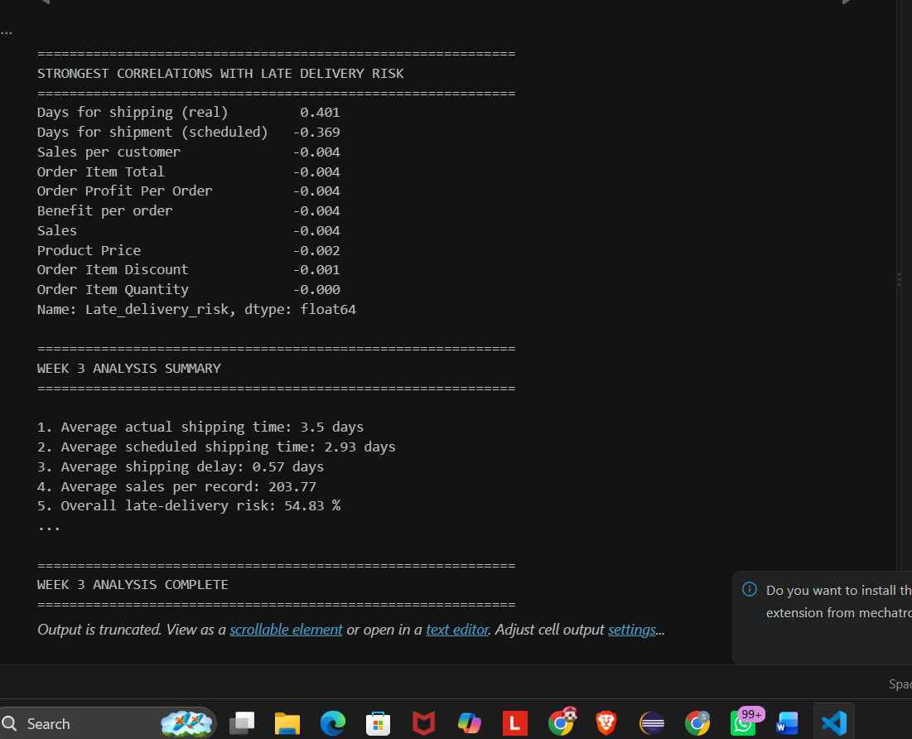
Figure 1. Week 3 Python analysis summary and correlation results.

8. Operational Insights
- Actual shipping duration is the strongest positive relationship observed with late-delivery risk.
- The 0.57-day average gap between actual and scheduled shipping time indicates an opportunity to improve schedule accuracy and execution.
- The 54.83% late-delivery-risk level suggests delivery reliability deserves management attention.
- The near-zero correlations of sales, price, quantity, discount, and profit suggest these variables alone are weak linear indicators of delivery risk.
- Shipping-mode comparisons can help identify transportation options that require deeper operational investigation.

9. Potential Bottlenecks
The main potential bottleneck identified is shipment duration. Since actual shipping days are positively associated with late-delivery risk, transportation, fulfillment, handoff, or related execution stages may contribute to late orders. The analysis does not prove the exact cause, so further analysis by region, market, product category, and shipping mode is recommended.

10. Recommendations
- Monitor actual versus scheduled shipping time as a core logistics KPI.
- Investigate shipping modes with comparatively high late-delivery risk.
- Analyze route, region, market, and product information to identify geographic or operational bottlenecks.
- Build a late-delivery prediction model using multiple relevant features.
- Review extreme observations individually before removing them from future analyses.
- Use normalized numerical variables when appropriate for machine-learning models.

11. Python Techniques Used
# Shipping delay
df["Shipping Delay"] = (
df["Days for shipping (real)"]
- df["Days for shipment (scheduled)"]
)
# Descriptive statistics
df[analysis_columns].describe()
# Correlation analysis
correlation_matrix = df[correlation_columns].corr()
# Visualization
plt.hist(df["Days for shipping (real)"], bins=20)
plt.title("Distribution of Actual Shipping Days")
plt.savefig("../visualizations/shipping_days.png", dpi=300)

12. Conclusion
Week 3 successfully extended the Week 2 data-preparation work into advanced logistics analysis. Analysis of 180,519 records showed an average actual shipping time of 3.50 days, scheduled shipping time of 2.93 days, an average shipping delay of 0.57 days, and overall late-delivery risk of 54.83%. Actual shipping duration showed the strongest positive relationship with late-delivery risk. The visualizations communicate delivery performance, shipping patterns, sales distribution, and relationships among logistics variables.

13. Reference
Mendeley Data. DataCo SMART SUPPLY CHAIN FOR BIG DATA ANALYSIS, Version 5. Published 12 March 2019. DOI: 10.17632/8gx2fvg2k6.5. License: CC BY 4.0.
Official dataset page: https://data.mendeley.com/datasets/8gx2fvg2k6/5

