The website looks old fashioned. I want it to be a bit more fresh and refreshing.

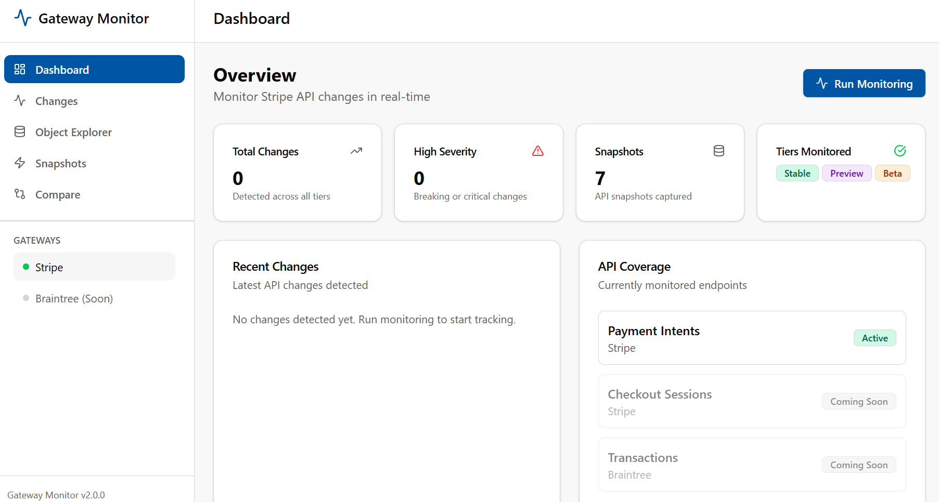

- In Dashboard, numbers / stats need to be made hyperlink which should go to Changes page with appropriate filters
- Clicking on specific “Tiers Monitored”, it should take to Object Explorer with that specific tab (For example, Beta should take to Beta tab)

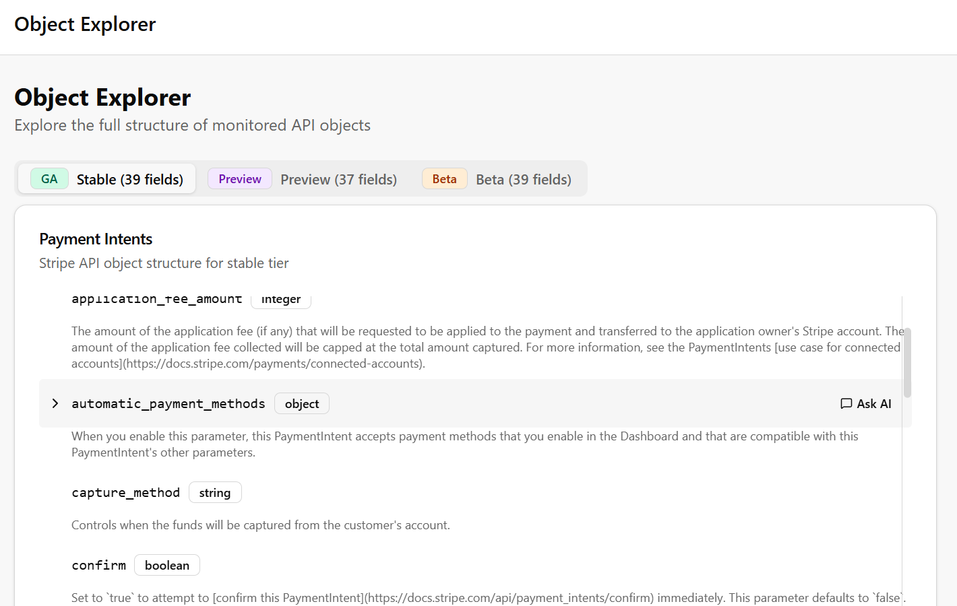

- Clicking on “Ask AI”, should open a chat popup at the right bottom like in Facebook or like Intercom chat window in many websites
- I want to link the chat to Open AI for users to get more details about that particular field. Need to define system prompt for the Open AI chat assistant to be an SME on Payments and use the information on Stripe API doc, field description, Stripe help doc to explain it much better to the users and also provide better info on the feature or payment capability this feature can be used. For example, the Capture method is helpful in holding on authorizations which could be used in businesses like hotel booking or before providing services to make sure the user has enough money etc.

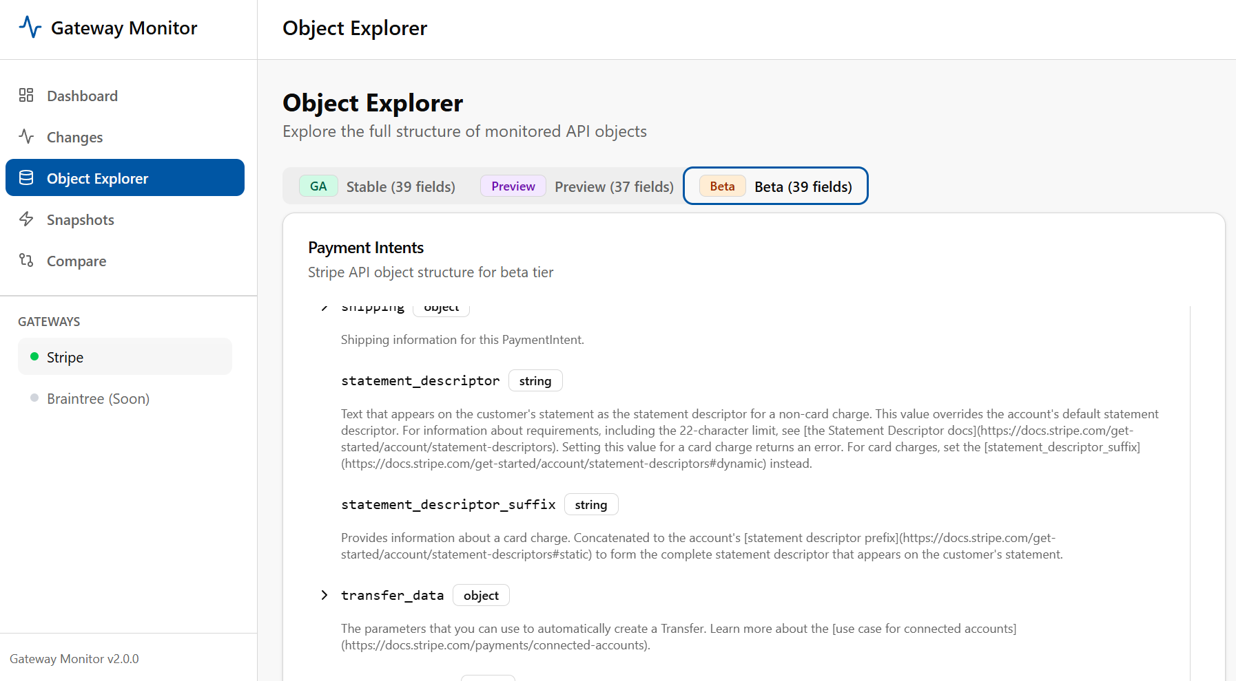
- I want to highlight the fields that are only available in beta; Same is the case in Preview too

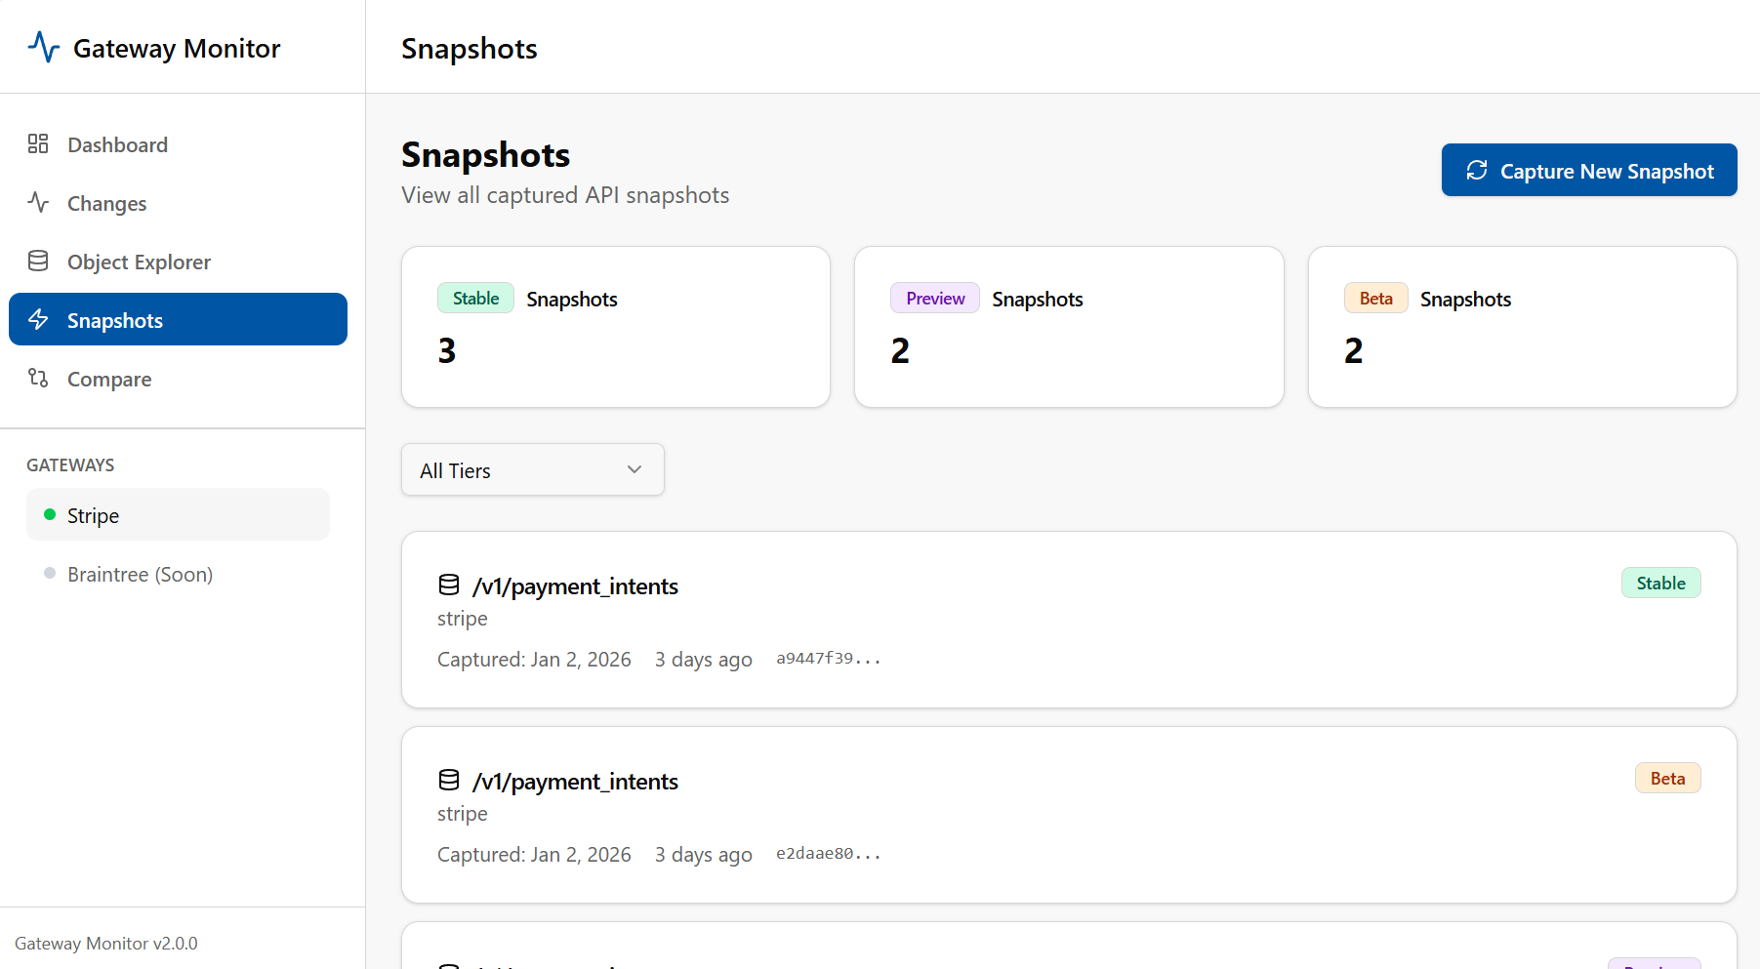

- Clicking on each snapshot should open up to see the full object captured during that snapshot with all the details like date captured, Tier type etc.

New feature:
- I also want to add a subscribe option (both in the dashboard top nav and also in the left nav)
- Subscribe should get the user’s email, name and store in the DB
- This periodically check for changes and send email alert to the users subscribing for it with the summary of changes and link to get back to the website for further changes,
- Email has to be elegant and professional

