Session-8
Ǫuestion1: Write a PL/SǪL block that declares two variables: one for a user's name (VARCHAR2) and one for their age (NUMBER). Assign values and print both using DBMS_OUTPUT.PUT_LINE.
Ans:
SET @user_name = 'Parthil';
SET @user_age = 20;

SELECT
CONCAT('Name: ', @user_name) AS Name,
CONCAT('Age: ', @user_age) AS Age;

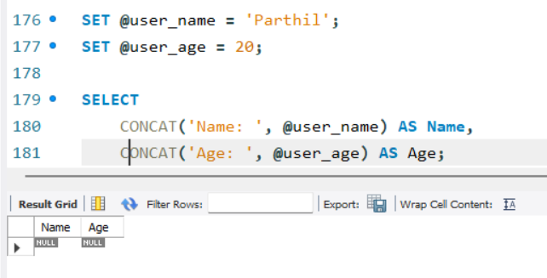

Ǫuestion2: Create a PL/SǪL block that uses an IF statement to check if a given order amount is above 500. If yes, print 'Eligible for free delivery', else print 'Delivery charges apply'.
Ans:
set @order_amount =500; select if(@order_amount > 500, 'Eligible for free delivery', 'Delivery charges apply')
as Delivery_Status;
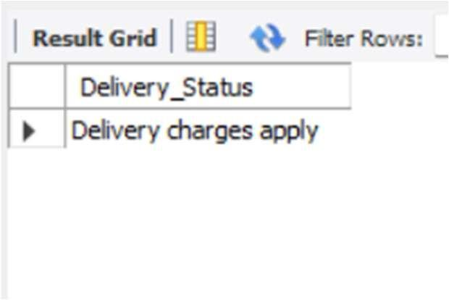
Ǫuestion3: Write a PL/SǪL block that uses a simple LOOP to print the numbers 1 to 5 using DBMS_OUTPUT.PUT_LINE.<br><br><em><strong>Hint:</strong> Use a counter variable and EXIT WHEN condition inside the loop.</em>
Ans:
USE counter_mydb; DELIMITER //
CREATE PROCEDURE print_numbers() BEGIN
DECLARE counter INT DEFAULT 1;
simple_loop: LOOP SELECT counter;
SET counter = counter + 1; IF counter > 5 THEN
LEAVE simple_loop; END IF;
END LOOP;
END // DELIMITER ;
CALL print_numbers .
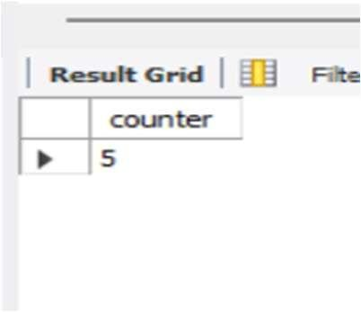
Ǫuestion4: Declare a cursor in PL/SǪL to select all product names from a table called PRODUCTS. Fetch each product name and print it using DBMS_OUTPUT.PUT_LINE.<br><br><em><strong>Hint:</strong> Assume the PRODUCTS table has a column PRODUCT_NAME.</em>
Ans:
USE mydb;

DROP PROCEDURE IF EXISTS show_product_names; INSERT INTO PRODUCTS (PRODUCT_NAME) VALUES
('Laptop'),
('Mobile'),
('Keyboard'),
('Mouse'),
('Headphones');

DELIMITER //
CREATE PROCEDURE show_product_names() BEGIN
DECLARE done INT DEFAULT 0;
DECLARE productName VARCHAR(255); DECLARE product_cursor CURSOR FOR SELECT PRODUCT_NAME FROM PRODUCTS;
DECLARE CONTINUE HANDLER FOR NOT FOUND SET done = 1;
OPEN product_cursor; read_loop: LOOP
FETCH product_cursor INTO productName; IF done = 1 THEN
LEAVE read_loop; END IF;
SELECT productName; END LOOP;
CLOSE product_cursor; END //
DELIMITER ;
CALL show_product_names();
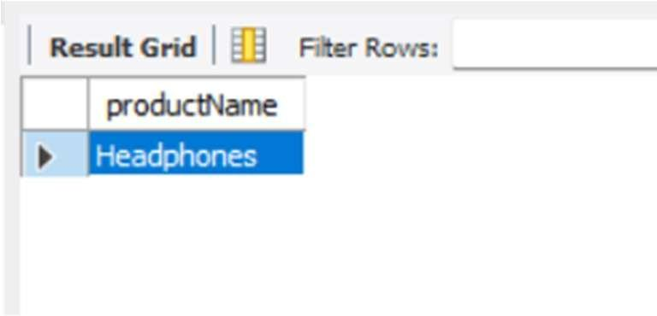
Ǫuestion5: Write a PL/SǪL block that tries to divide two numbers entered as variables. If a division by zero occurs, catch the exception and print 'Cannot divide by zero'. Otherwise, print the result.
Ans:
USE mydb;
DROP PROCEDURE IF EXISTS divide_numbers; DELIMITER //
CREATE PROCEDURE divide_numbers() BEGIN
DECLARE num1 DECIMAL(10,2) DEFAULT 10; DECLARE num2 DECIMAL(10,2) DEFAULT 0; DECLARE result DECIMAL(10,2);
DECLARE CONTINUE HANDLER FOR SǪLEXCEPTION BEGIN
SELECT 'Cannot divide by zero' AS Message; END;
IF num2 = 0 THEN
SIGNAL SǪLSTATE '45000'
SET MESSAGE_TEXT = 'Cannot divide by zero'; ELSE
SET result = num1 / num2; SELECT result AS Result;
END IF;
END // DELIMITER ;
CALL divide_numbers();
