Session-9
Ǫuestion1: Create a SǪL script to insert a new order into an Orders table, then use COMMIT to save the transaction and verify that the new order persists after reconnecting to the database.
Ans:
USE mydb;
CREATE TABLE IF NOT EXISTS Orders (
order_id INT PRIMARY KEY, customer_name VARCHAR(100), order_amount DECIMAL(10,2)
);

START TRANSACTION;
INSERT INTO Orders (order_id, customer_name, order_amount) VALUES (1, 'mehta', 500.00);
COMMIT;
SELECT * FROM Orders WHERE order_id = 1;
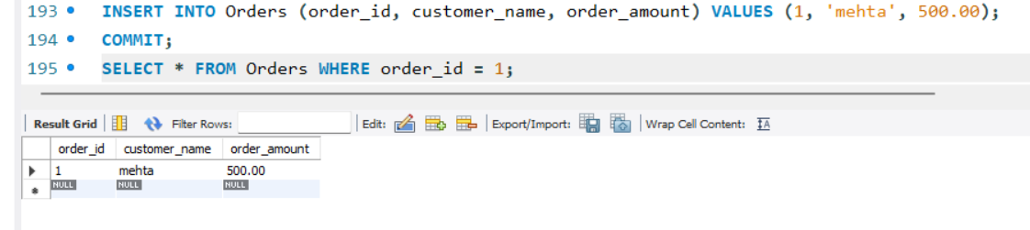
Ǫuestion2: Simulate a Zomato-style food order process: insert two new items into an OrderItems table, then use ROLLBACK to undo the changes before committing. Check that no new items remain in the table after rollback.
Ans:
USE mydb;
DROP TABLE IF EXISTS OrderItems;
CREATE TABLE OrderItems ( item_id INT PRIMARY KEY, order_id INT,
item_name VARCHAR(100), quantity INT,
price DECIMAL(10,2)
) ENGINE=InnoDB; START TRANSACTION;
INSERT INTO OrderItems
(item_id, order_id, item_name, quantity, price) VALUES
(901, 500, 'Pizza', 1, 250.00),
(902, 500, 'Burger', 2, 180.00);
SELECT * FROM OrderItems; ROLLBACK;
SELECT * FROM OrderItems;
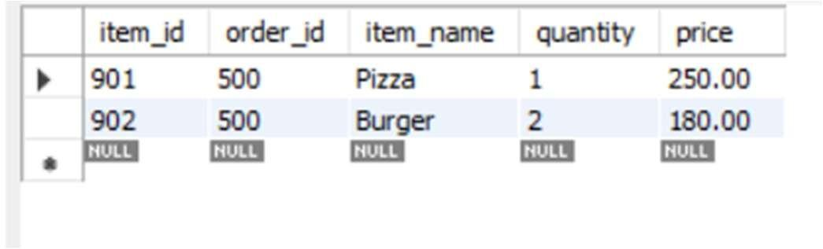
Ǫuestion3: In a Flipkart-like shopping cart scenario, use SAVEPOINT to mark a point after adding a product to the Cart table, add another product, then use ROLLBACK TO SAVEPOINT to undo only the last addition. Show the final contents of the Cart table.
Ans:
USE mydb;

DROP TABLE IF EXISTS Transactions;
DROP TABLE IF EXISTS Wallet;

CREATE TABLE Wallet (
user_id INT PRIMARY KEY,
user_name VARCHAR(100),
balance DECIMAL(10,2)
);

CREATE TABLE Transactions (
transaction_id INT PRIMARY KEY,
user_id INT,
purchase_amount DECIMAL(10,2)
);

INSERT INTO Wallet VALUES
(1, 'Parthil Mehta', 5000.00);

DELIMITER //

CREATE TRIGGER deduct_wallet_balance
AFTER INSERT ON Transactions
FOR EACH ROW
BEGIN
UPDATE Wallet
SET balance = balance - NEW.purchase_amount
WHERE user_id = NEW.user_id;
END //

DELIMITER ;

INSERT INTO Transactions VALUES
(101, 1, 500.00);

SELECT * FROM Wallet;

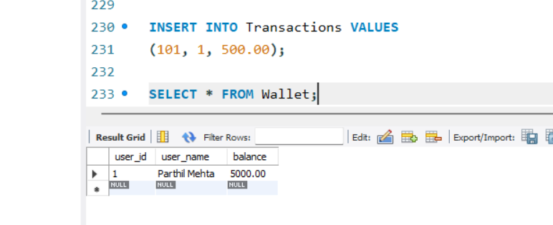
Ǫuestion5: Use ChatGPT to generate a SǪL test scenario where a trigger incorrectly updates a user's balance after an expense entry. Paste the scenario and your corrected trigger code, explaining how you fixed the error.<br><br><em><strong>Hint:</strong> Ask ChatGPT for a buggy trigger example and a test case that exposes the bug.</em>
Ans:
USE mydb;
CREATE TABLE Wallet (
user_id INT PRIMARY KEY, balance DECIMAL(10,2)
);
CREATE TABLE Expense (
expense_id INT AUTO_INCREMENT PRIMARY KEY,
user_id INT,
amount DECIMAL(10,2)
);
INSERT INTO Wallet (user_id, balance) VALUES (1, 5000);
SELECT * FROM Wallet;
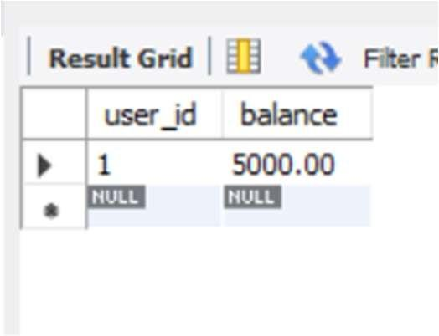
- Buggy Trigger:

DELIMITER //
CREATE TRIGGER update_balance AFTER INSERT ON Expense

FOR EACH ROW
BEGIN
UPDATE Wallet
SET balance = balance + NEW.amount WHERE user_id = NEW.user_id;

END// DELIMITER ;
INSERT INTO Expense (user_id, amount) VALUES (1, 1000);
SELECT * FROM Wallet;
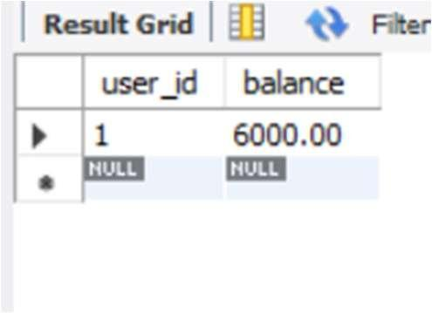
DROP TRIGGER IF EXISTS update_balance; DELIMITER //
CREATE TRIGGER update_balance AFTER INSERT ON Expense

FOR EACH ROW BEGIN
UPDATE Wallet
SET balance = balance - NEW.amount WHERE user_id = NEW.user_id;

END// DELIMITER ;
UPDATE Wallet
SET balance = 5000 WHERE user_id = 1;
INSERT INTO Expense (user_id, amount) VALUES (1, 1000);
SELECT * FROM Wallet;
