Session 01 Introduction to DatabasesTrainer Coverage:What is a database, DBMS, RDBMS (with examples).Difference between MySQL, PostgreSQL, Oracle, SQLite.Tables, rows, columns, and relationships.Demo: Show data stored in MySQL Workbench.

Q:-01 Install MySQL Workbench on your computer, connect to the local MySQL server, and take a screenshot of the default databases shown in the Schemas panel.

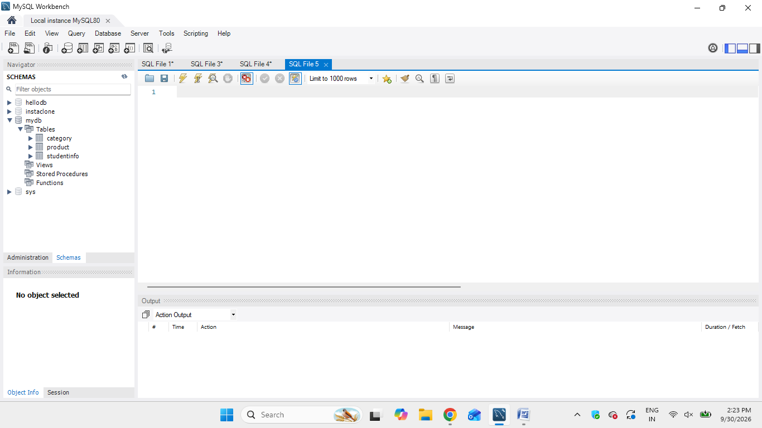

Q:-02 Create a new database called InstaClone in MySQL Workbench, then create a table named Users with columns: user_id (INT, primary key), username (VARCHAR), email (VARCHAR), and followers_count (INT).

create table users(
user_id integer primary key auto_increment,
username VARCHAR(100),
email VARCHAR(100),
followers_count integer);

Q:-03 Insert 3 sample users into the Users table you created, using realistic Instagram-style usernames and follower counts.
INSERT INTO users(username, email, followers_count) VALUES
('Parthil', 'parthil@gmail.com', 450),
('Aarav', 'aarav@gmail.com', 320),
('Kavya', 'kavya@gmail.com', 180);

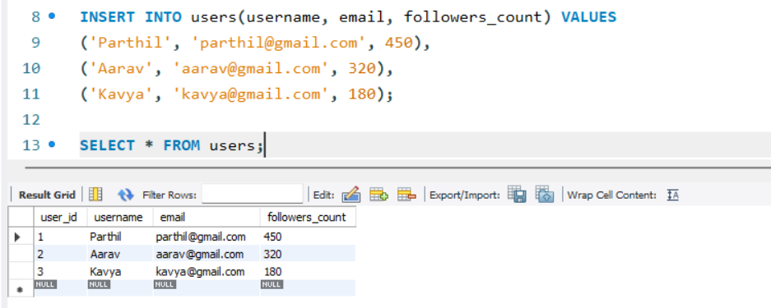

Q:-04 Create another table in the InstaClone database called Posts with columns: post_id (INT, primary key), user_id (INT), caption (VARCHAR), and post_date (DATE). Add a foreign key from Posts.user_id to Users.user_id to establish a relationship.

create table posts(
post_id integer primary key auto_increment,
user_id integer,
caption varchar(500),
post_date date,
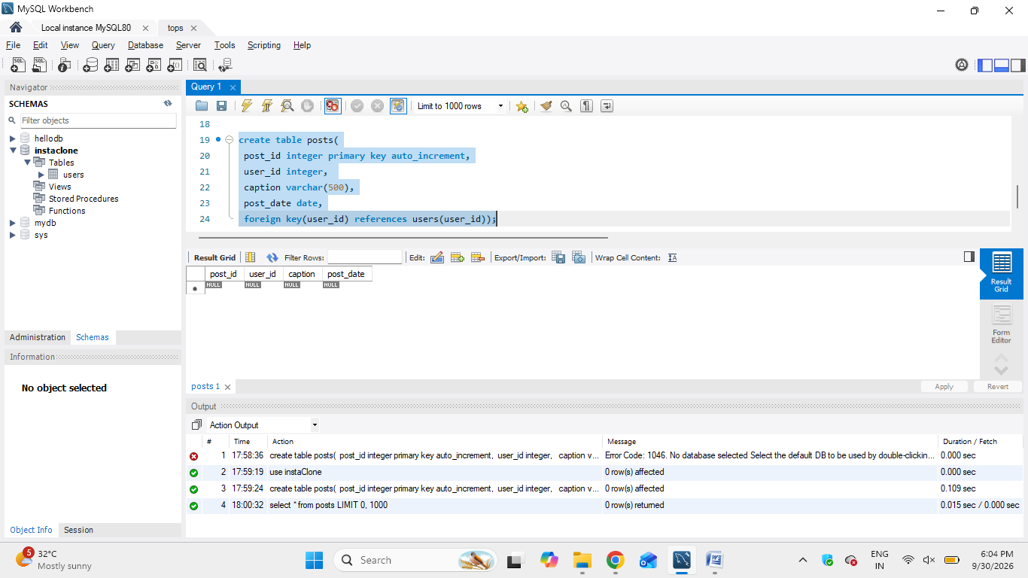 foreign key(user_id) references users(user_id));

Q:-05 Write a short comparison (3-4 lines each) of MySQL, PostgreSQL, Oracle, and SQLite, focusing on where each one is commonly used (for example: web apps, mobile apps, enterprise systems, etc.).

1. MySQL
- Commonly used for web applications and websites.
- Popular with PHP, Java, Python, and Node.js applications.
- Used for e-commerce, content management systems, and business applications.
- Easy to learn and widely supported.
2. PostgreSQL
- Commonly used for modern web applications and data-intensive systems.
- Strong support for complex queries and advanced data types.
- Used in analytics, SaaS applications, and large-scale applications.
- Known for reliability and standards compliance.
3. Oracle Database
- Commonly used in large enterprise systems.
- Used by banks, insurance companies, governments, and large organizations.
- Designed for high-volume transactions, security, and complex business systems.
- Often used where advanced enterprise database features are required.
4. SQLite
- Commonly used in mobile apps, desktop applications, and embedded systems.
- The database is stored directly in a single local file.
- Widely used in Android/iOS apps for local data storage.
- No separate database server is required.
Top of Form
Bottom of Form

