

HANDLING MISSING DATA USING MEAN AND REGRESSION IMPUTATION: A COMPREHENSIVE ANALYSIS

TPD3353 INTRODUCTION TO DATA ANALYTICS

NAME: MAGENDREN A/L PARTHIBAN
MATRIC NUMBER : 2240312
LECTURER NAME: TS DR.SYARIFAH BAHIYAH RAHAYU

Abstract
Missing data is a critical issue in data analysis that can significantly affect the performance of statistical models and machine learning algorithms. This report explores two widely used imputation techniques—Mean Imputation and Regression Imputation—applied to a housing dataset. Through visualization techniques such as heatmaps and histograms, the study evaluates the effectiveness of both methods. The findings indicate that while mean imputation is simple and computationally efficient, regression imputation provides more accurate and realistic estimates by preserving relationships between variables. This report also includes step-by-step explanations of the Python implementation used to perform the analysis.

1. Introduction
In real-world datasets, missing values are unavoidable due to various reasons such as data entry errors, system failures, or incomplete data collection. Handling missing data is essential because it directly impacts the quality of analysis and predictive modeling.
There are several approaches to handling missing data, including deletion methods and imputation techniques. This report focuses on two imputation methods:
- Mean Imputation
- Regression Imputation
The objective of this study is to:
- Apply both imputation techniques to the dataset
- Compare their effectiveness using visualizations
- Evaluate their advantages and limitations
- Provide justification for method selection

2. Literature Review
Handling missing data has been extensively studied in statistics and data science. According to Little & Rubin (2019), improper handling of missing data can lead to biased results and incorrect conclusions.

2.1 Mean Imputation
Mean imputation is one of the simplest techniques where missing values are replaced with the mean of the observed data. According to Schafer (1997), this method is easy to implement but may reduce variance and distort data distribution.

2.2 Regression Imputation
Regression imputation uses relationships between variables to estimate missing values. As highlighted by Allison (2001), this method is more accurate because it preserves the correlation structure within the dataset.

2.3 Comparison from Literature
Studies suggest:
- Mean imputation is suitable for quick analysis
- Regression imputation is better for predictive modeling
- Advanced methods (e.g., multiple imputation) outperform both but are more complex

3. Methodology

3.1 Dataset Description
The dataset contains housing-related variables such as:
- life_sq (living area)
- full_sq
- num_room
- Other structural and demographic features
Missing values were observed in multiple columns, especially in life_sq.

3.2 Tools and Libraries
The analysis was performed using Python with the following libraries:
- pandas
- numpy
- matplotlib
- seaborn
- sklearn (LinearRegression)

3.3 Data Preprocessing Steps

Step 1: Load Dataset
The dataset is loaded using pandas and missing values are identified.

Step 2: Visualize Missing Data (Before Cleaning)
A heatmap is used to identify missing patterns.

Step 3: Apply Imputation Methods
Two approaches are implemented:
- Mean Imputation
- Regression Imputation

Step 4: Visualize Results
- Heatmaps after imputation
- Histograms before and after imputation

4. Implementation (Python Code Explanation)

4.1 Mean Imputation Code Explanation
df['life_sq'].fillna(df['life_sq'].mean(), inplace=True)
Explanation:
- df['life_sq'].mean() calculates the average value
- fillna() replaces missing values with the mean
- inplace=True updates the dataset directly

4.2 Regression Imputation Code Explanation
from sklearn.linear_model import LinearRegression

# Select features without missing values
train_data = df[df['life_sq'].notnull()]
test_data = df[df['life_sq'].isnull()]

X_train = train_data[['full_sq']]
y_train = train_data['life_sq']

model = LinearRegression()
model.fit(X_train, y_train)

X_test = test_data[['full_sq']]
predicted_values = model.predict(X_test)

df.loc[df['life_sq'].isnull(), 'life_sq'] = predicted_values
Explanation:
- Split data into:
  - Training set (non-missing values)
  - Testing set (missing values)
- Train regression model:
  - Predict life_sq using full_sq
- Predict missing values:
  - Replace missing values with predicted results

5. Results and Analysis

5.1 Missing Data Visualization

Before Imputation:
- Heatmap shows multiple missing values (yellow lines)
- Missing values distributed across several variables

After Imputation:
- Heatmap becomes fully blue
- Indicates successful removal of missing values

5.2 Histogram Analysis

Before Imputation:
- Right-skewed distribution
- Presence of outliers

After Mean Imputation:
- High spike around mean value
- Reduced variability
- Artificial distribution distortion

After Regression Imputation:
- Distribution closer to original
- Smooth curve without spikes
- Better representation of real data

6. Discussion

6.1 Mean Imputation

Advantages:
- Simple and easy to implement
- Fast computation
- Suitable for large datasets

Limitations:
- Reduces variance
- Distorts distribution
- Ignores relationships between variables

6.2 Regression Imputation

Advantages:
- Preserves relationships between variables
- Produces realistic values
- Maintains data distribution

Limitations:
- More complex
- Requires model assumptions
- Computationally expensive

7. Comparison of Methods
Aspect | Mean Imputation | Regression Imputation
Complexity | Low | High
Accuracy | Low | High
Variance Preservation | No | Yes
Distribution Preservation | No | Yes
Speed | Fast | Moderate

8. Justification of Method Selection
Regression imputation is preferred because:
- It maintains relationships between variables
- It produces more realistic values
- It improves model accuracy
Mean imputation is still useful:
- For quick preprocessing
- As a baseline comparison method

9. Conclusion
This study demonstrates that handling missing data is crucial for accurate analysis. While both methods successfully removed missing values, regression imputation provided superior results by preserving the dataset’s structure and variability.

Final Insight:
- Use mean imputation for simplicity
- Use regression imputation for accuracy and modeling

10. Recommendations
- Use regression imputation for predictive modeling tasks
- Consider advanced methods like multiple imputation for future work
- Perform data visualization before and after imputation
- Appendix

Mean Imputation

import pandas as pd
import numpy as np
import seaborn as sns
import matplotlib.pyplot as plt

missing_values = ["n/a", "na", "--"]
df = pd.read_csv('sberbank.csv', na_values=missing_values)
total_cells = np.prod(df.shape)
missing_before = df.isnull().sum().sum()
pct_missing_before = (missing_before / total_cells) * 100
print("--- BEFORE CLEANING ---")
print(f"Total Missing Values: {missing_before}")
print(f"Percentage of Missing Data: {pct_missing_before:.2f}%\n")
plt.style.use('ggplot')
plt.figure(figsize=(12, 5))
cols = df.columns[:30]
colours = ['#000099', '#ffff00']
sns.heatmap(df[cols].isnull(), cmap=sns.color_palette(colours), cbar=False)
plt.title('1. Heatmap of Missing Data (BEFORE CLEANING)')
plt.show()
col_to_visualize = 'life_sq'
plt.figure(figsize=(8, 5))
sns.histplot(df[col_to_visualize].dropna(), kde=True, color='red', bins=30)
plt.title(f'2. Histogram of {col_to_visualize} (BEFORE CLEANING)')
plt.xlabel('Values')
plt.ylabel('Frequency')
plt.show()
df_clean = df.copy()
df_numeric = df_clean.select_dtypes(include=[np.number])
for col in df_numeric.columns:
if df_clean[col].isnull().any():
df_clean[col] = df_clean[col].fillna(df_clean[col].mean())
df_non_numeric = df_clean.select_dtypes(exclude=[np.number])
for col in df_non_numeric.columns:
if df_clean[col].isnull().any():
df_clean[col] = df_clean[col].fillna("unknown")
df_clean.drop_duplicates(inplace=True)
total_cells_after = np.prod(df_clean.shape)
missing_after = df_clean.isnull().sum().sum()
pct_missing_after = (missing_after / total_cells_after) * 100
print("--- AFTER CLEANING ---")
print(f"Total Missing Values: {missing_after}")
print(f"Percentage of Missing Data: {pct_missing_after:.2f}%\n")
plt.figure(figsize=(12, 5))
sns.heatmap(df_clean[cols].isnull(), cmap=sns.color_palette(colours), cbar=False)
plt.title('3. Heatmap of Missing Data (AFTER CLEANING)')
plt.show()
plt.figure(figsize=(8, 5))
sns.histplot(df_clean[col_to_visualize], kde=True, color='green', bins=30)
plt.title(f'4. Histogram of {col_to_visualize} (AFTER MEAN IMPUTATION)')
plt.xlabel('Values')
plt.ylabel('Frequency')
plt.show()

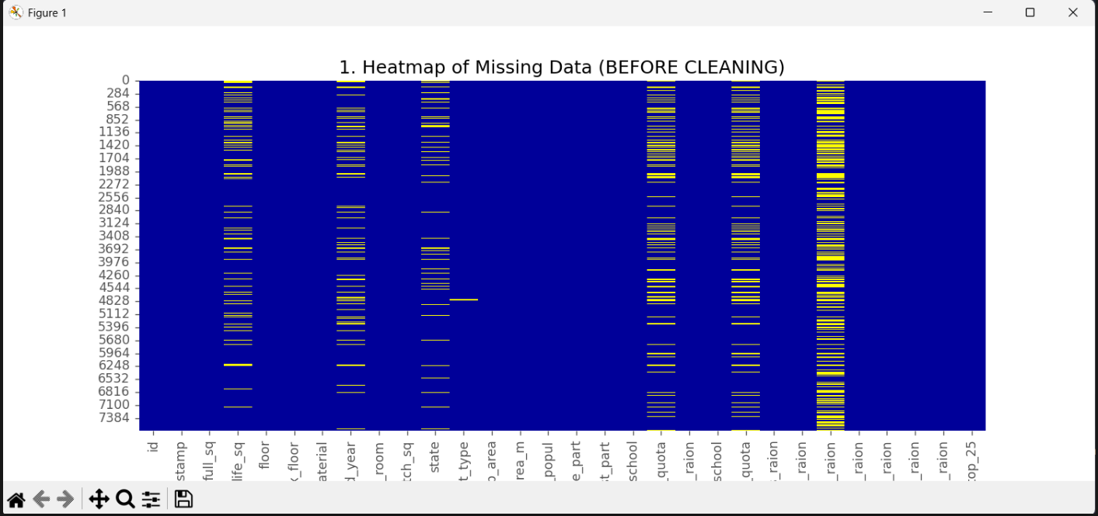

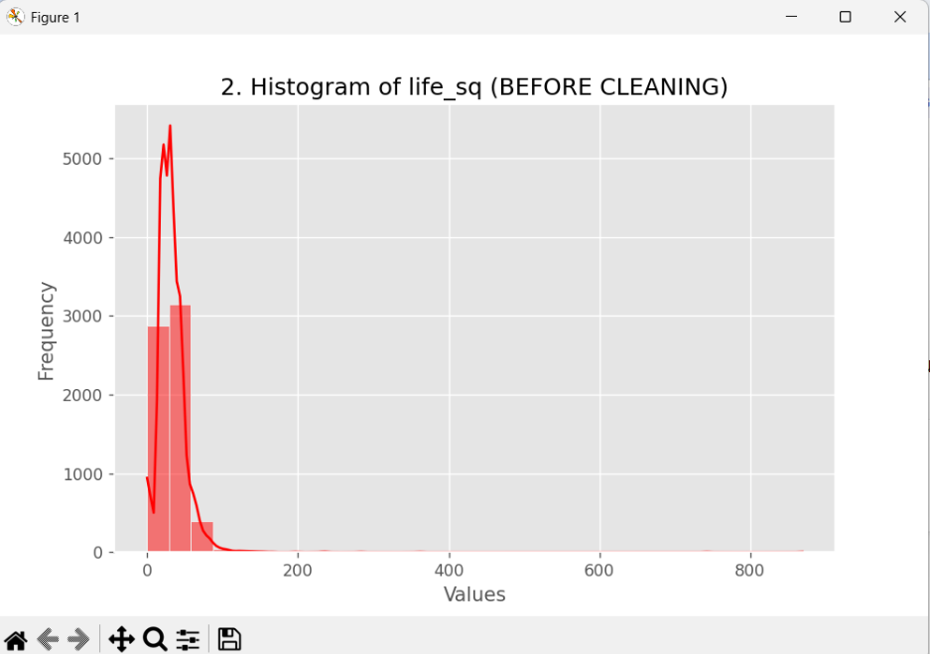

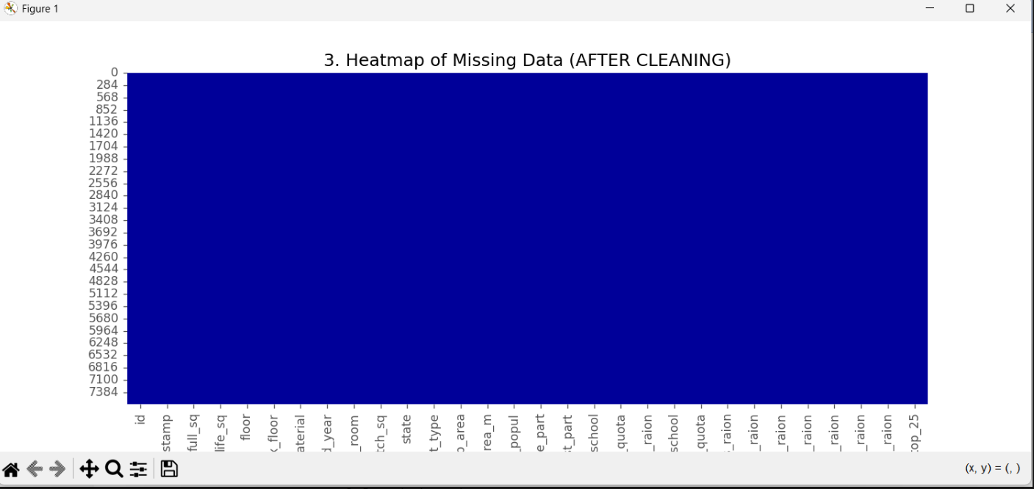

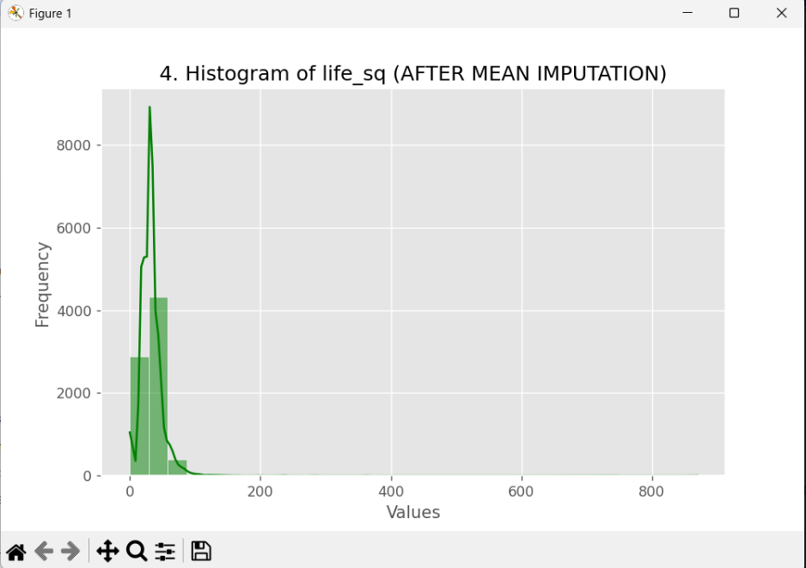

Regression Imputation

import pandas as pd
import numpy as np
import matplotlib.pyplot as plt
import seaborn as sns
from sklearn.linear_model import LinearRegression
missing_values = ["n/a", "na", "--", "NA", "?", ""]
df = pd.read_csv(
r"C:\Users\USER\Downloads\New folder\sberbank.csv",
na_values=missing_values
)
print("===== ORIGINAL DATA =====")
print(df.head())
print(f"\nDataset Shape: {df.shape}")
df = df.drop(columns=['id', 'timestamp'], errors='ignore')
plt.figure(figsize=(12,6))
sns.heatmap(df.isnull(),
yticklabels=False,
cbar=False,
cmap=['blue', 'yellow'])
plt.title("Missing Data (Before Regression Imputation)")
plt.show()
=
if 'life_sq' in df.columns:
plt.figure()
plt.hist(df['life_sq'].dropna(), bins=30)
plt.title("Histogram of life_sq (BEFORE REGRESSION)")
plt.xlabel("Values")
plt.ylabel("Frequency")
plt.show()
df.drop_duplicates(inplace=True)
def regression_impute(df, target_col):
df_not_null = df[df[target_col].notnull()]
df_null = df[df[target_col].isnull()]
if df_null.shape[0] == 0:
return df
df_not_null_num = df_not_null.select_dtypes(include=np.number)
df_null_num = df_null.select_dtypes(include=np.number)

if target_col not in df_not_null_num.columns:
return df
X_train = df_not_null_num.drop(columns=[target_col])
y_train = df_not_null_num[target_col]
X_test = df_null_num.drop(columns=[target_col])
X_train = X_train.fillna(X_train.mean())
X_test = X_test.fillna(X_train.mean())
valid_cols = X_train.columns[
(X_train.isnull().sum() == 0) &
(X_test.isnull().sum() == 0)
]
X_train = X_train[valid_cols]
X_test = X_test[valid_cols]
if X_train.shape[1] == 0:
print(f"Skipped: {target_col}")
return df
model = LinearRegression()
model.fit(X_train, y_train)
predicted = model.predict(X_test)
df.loc[df[target_col].isnull(), target_col] = predicted
print(f"Filled: {target_col}")
return df
df_numeric = df.select_dtypes(include=np.number)
for col in df_numeric.columns:
if df[col].isnull().sum() > 0:
df = regression_impute(df, col)
df_non_numeric = df.select_dtypes(exclude=np.number)
for col in df_non_numeric.columns:
if df[col].isnull().sum() > 0:
if not df[col].mode().empty:
df[col].fillna(df[col].mode()[0], inplace=True)
else:
df[col].fillna("Unknown", inplace=True)
print("\nRemaining missing values:", df.isnull().sum().sum())
plt.figure(figsize=(12,6))
sns.heatmap(df.isnull(),
yticklabels=False,
cbar=False,
cmap=['blue', 'yellow'])
plt.title("Missing Data (After Regression Imputation)")
plt.show()
if 'life_sq' in df.columns:
plt.figure()
plt.hist(df['life_sq'], bins=30)
plt.title("Histogram of life_sq (AFTER REGRESSION IMPUTATION)")
plt.xlabel("Values")
plt.ylabel("Frequency")
plt.show()
df.to_csv("sberbank_regression_cleaned.csv", index=False)
print("\nCleaned dataset saved as sberbank_regression_cleaned.csv")

