PLACEMENT MANAGEMENT SYSTEM

Submitted by

PARTHIPAN P (1P18MC037)

In partial fulfillment of the requirements for the award of the Degree of
Master of Computer Applications from Bharathiar University, Coimbatore.

Under the internal supervision of Dr.G.Purusothaman ,M.Sc.,M.Phil.,Ph.D., Associate Professor




School of Computer Studies, Department of MCA
Rathnavel Subramaniam College of Arts and Science (Autonomous), Sulur, Coimbatore – 641 402.
December 2020 - March 2021.
RATHNAVEL SUBRAMANIAM COLLEGE OF ARTS AND SCIENCE
(AUTONOMOUS)

Sulur, Coimbatore-641 402

Department of Computer Applications (MCA) Project work & Viva voce
BonaFide Certificate

This is to certify that this a bonafide record of work done by Mr PARTHIPAN P Register No. 1P18MC037 during the academic year 2020 - 2021 and submitted for the End Semester Project viva voce held on ……………….

HEAD OF THE DEPARTMENT STAFF – IN CHARGE

INTERNAL EXAMINER EXTERNAL EXAMINER

Certificates
Certificate
This is to certify that the dissertation entitled PLACEMENT MANAGEMENT SYSTEM, submitted to the School of Computer Studies, Rathnavel Subramaniam College of Arts and Science in partial fulfillment of the requirements for the award of the Degree of Master of Computer Applications is a record of original project work done by PARTHIPAN P during the period December 2020-March 2021 of their study on MCA in the Rathnavel Subramaniam College of Arts and Science, under my internal supervision and the dissertation has not formed the basis for the award of any Degree/Diploma/Associate ship/Fellowship or other similar title to any candidate of any University.

Internal Supervisor

Declaration

Declaration

I, PARTHIPAN P, hereby declare that the dissertation, entitled PLACEMENT MANAGEMENT SYSTEM submitted to the School of Computer Studies, Rathnavel Subramaniam College of Arts and Science, in partial fulfillment of the requirements for the award of the Degree of Master of Computer Applications is a record of original project work done by we during the period December 2020–March 2021 under the internal supervision of Dr.G.Purusothaman , Associate Professor, Department of Computer Applications and it has not formed the basis for the award of any Degree/Diploma/Associateship/Fellowship or other similar title to any candidate of any University.

Signature of the Candidate

Acknowledgements

Acknowledgements

We express our sincere thanks to our Managing trustee Dr.K.Senthil Ganesh MBA (USA)., MS (UK)., Ph.D., for providing us with the adequate of faculty and laboratory resources for completing my project successfully.

We take this as a fine opportunity to express our sincere thanks to Dr. T. Sivakumar M.Sc., M. Phil., Ph.D., Principal, Rathnavel Subramaniam College of Arts And Science (Autonomous) for giving me the opportunity to undertake this project.

We express our sincere thanks to Dr.D.Francis Xavier Christopher., M.Sc(CS)., M.Phil.,Ph.D., Director (Administration), Department of Computer Science for the help and advice throughout the project.

We express our sincere thanks to Dr. S. Yamini., M. Sc(CC)., M. Phil., Ph.D., Director (Academic), Department of Computer Science for her valuable guidance and prompt correspondence throughout the curriculum to complete the project.

We express our sincere thanks to Mrs. C.Grace Padma., MCA., M.Phil., MBA., Head of the Department for her support and advice throughout the project.

We express our gratitude to Dr.G.Purusothaman ,M.Sc.,M.Phil.,Ph.D., for his valuable guidance, support, encouragement and motivation rendered by his throughout this project.

Finally, We express our sincere thanks to all other staff members and my dear friends, and all dear and near for helping me to complete this project.

PARTHIPAN P

PLACEMENT MANAGEMENT SYSTEM

( HOD Login Module )

Abstract
ABSTRACT

Placement management system – HOD login Module
In that Every Department HOD will Login by using User name and Password. Else Register the HOD Detail by sign up to create login ID. After login HOD can view the certain department Students placement details & performance in Interviews. HOD can overview the department activities, department staff and course details.

Frontend Tools/ Technology: React Js and React Native

Backend Tools/ Technology: Node Js DataBase Technology: Mongo DB

Hosting Environment:
Node : Heroku

React : Heroku

React Native: React Native

MongoDB: MongoDB Atlas

Module Description

MODULE DESCRITION

HOD LOG IN MODULE

LOGIN:

The login page allows a user to gain access to an application by entering their User Name and password or by authenticating.

HOME PAGE:

The Home page shows are things in the application available for the user. It displays the welcome the user.

USER LIST:
The User list can add other Department HOD to sign up and maintain other department placement details.

STUDENT LIST:
The Student list shows placed students details and their information. We can also add the
Placed Student.

COURSE LIST:
The course list shows the department course under the HOD control and also add options to add in
it.

EXAM LIST:
The Exam list shows that students performance in interview and their average of the student by
their performance

User Manual

User Manual

Login:
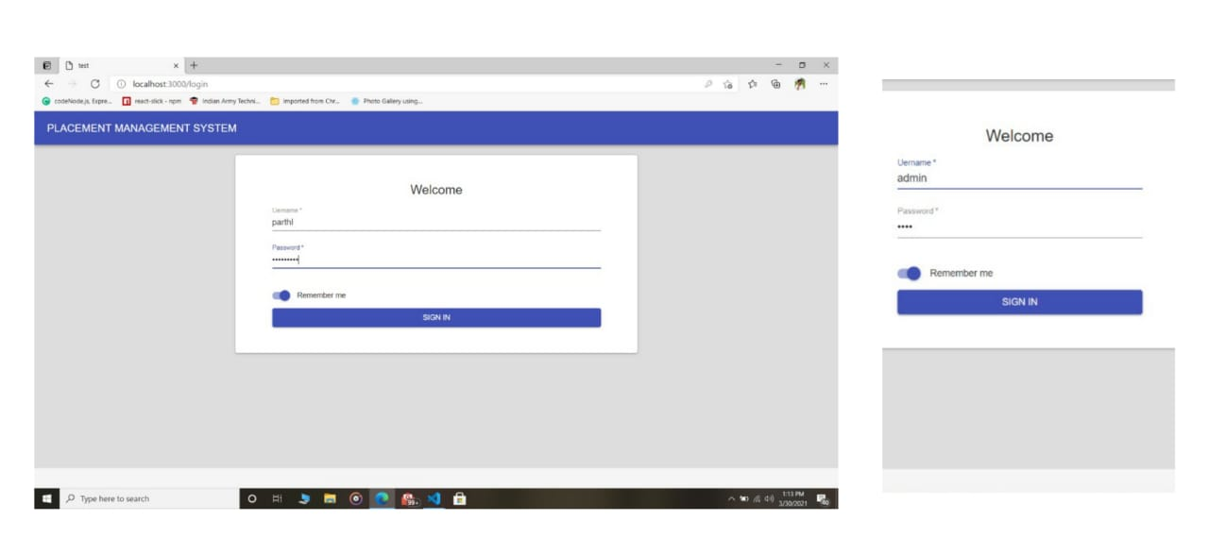

HOME PAGE:

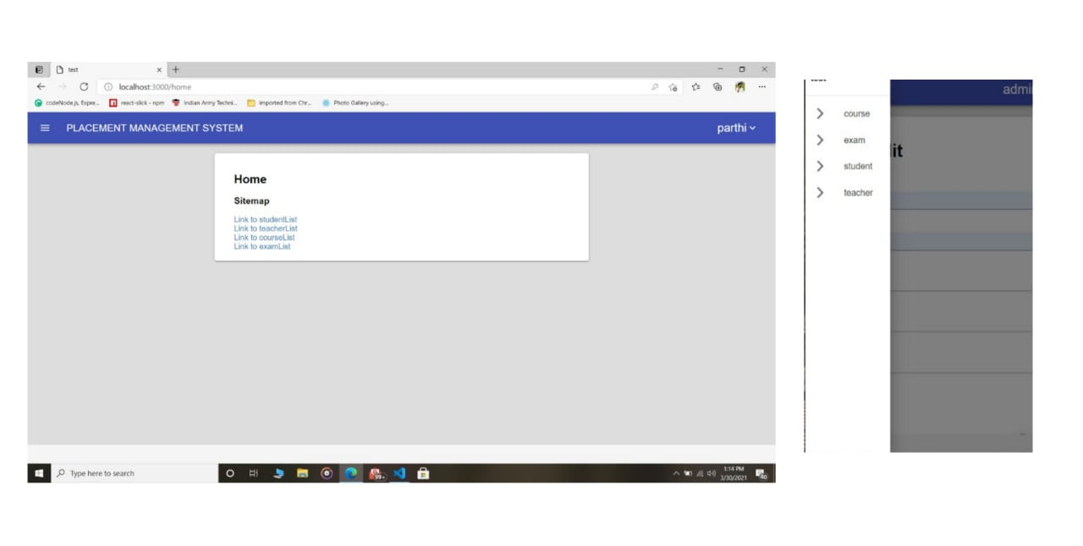

USER LIST:

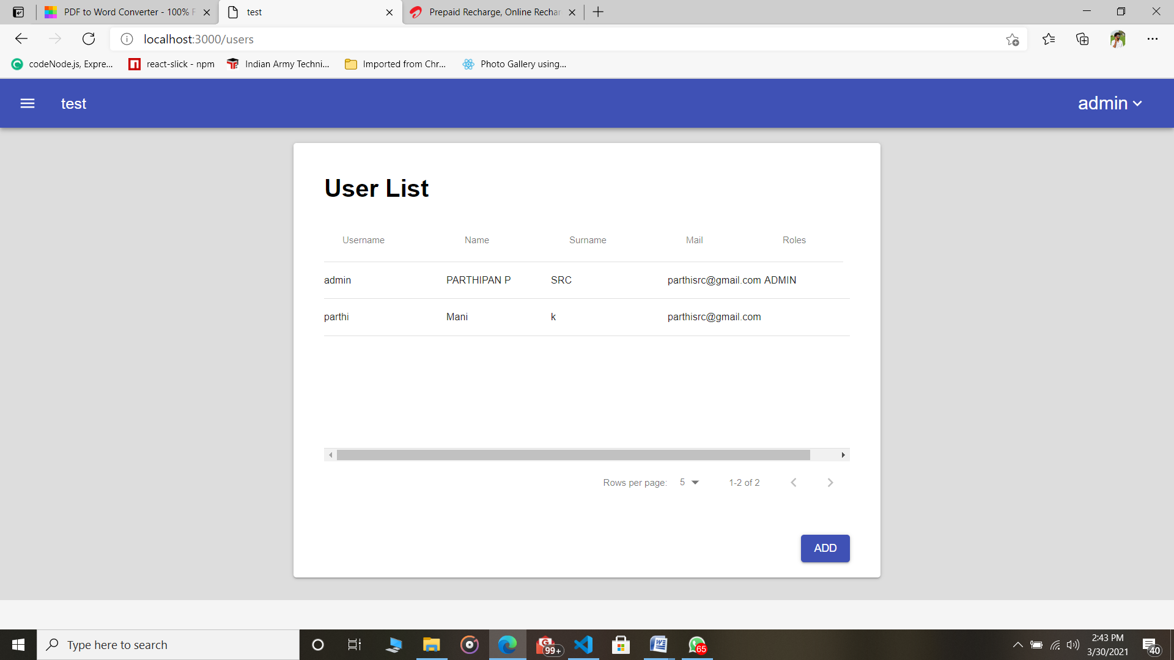

STUDENT LIST:
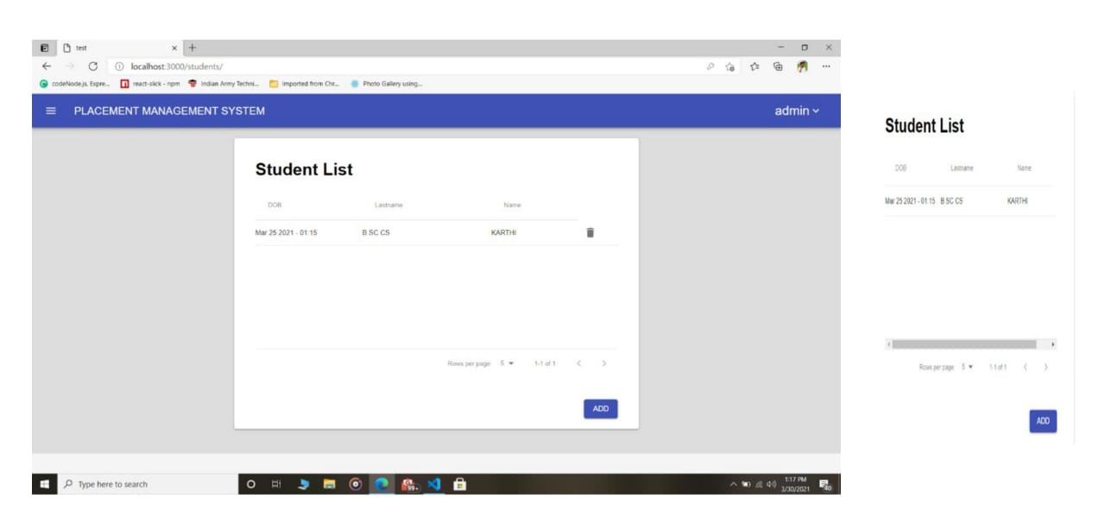

TEACHER LIST:
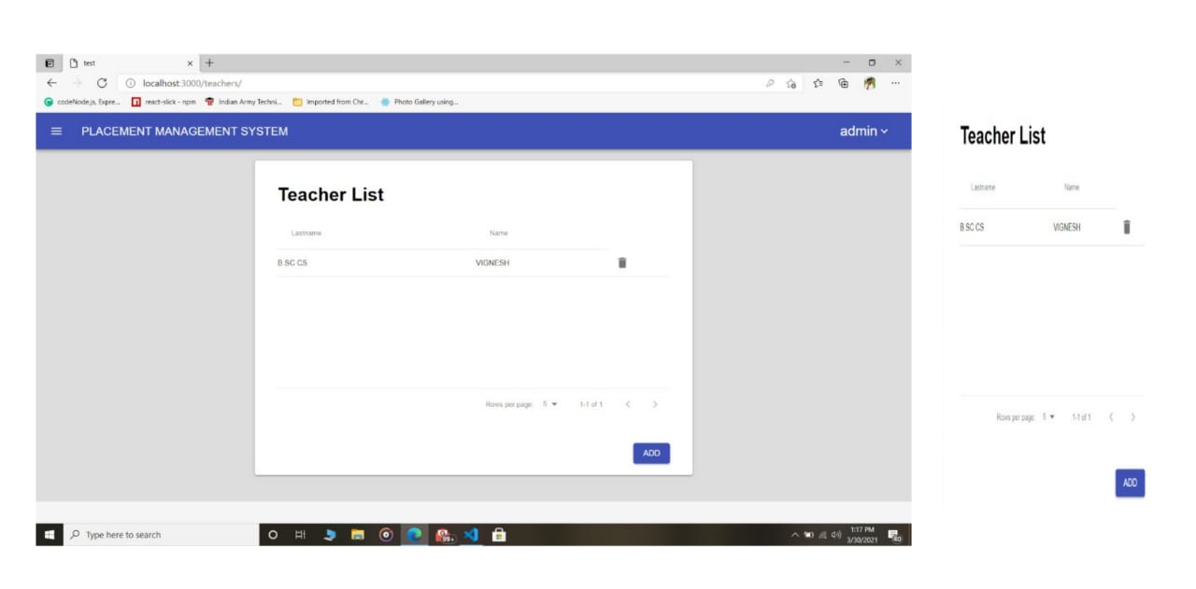

COURSE LIST:
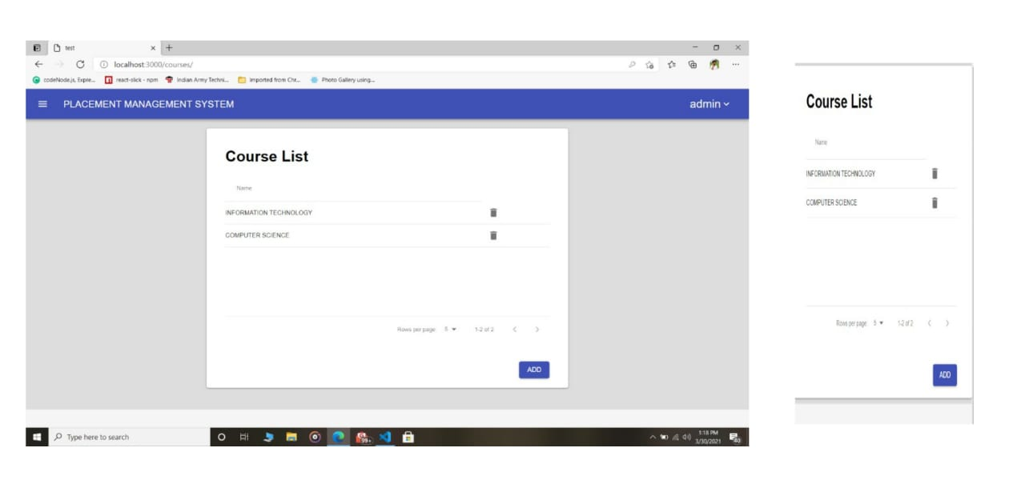

EXAM LIST:
