DEPARTMENT OF COMPUTER SCIENCE & ENGINEERING
CONTINUOUS ASSESSMENT 3 (CA 3) - MINI PROJECT REPORT
EduPredict AI: Student Performance Prediction and Early Warning System Using Educational Data Mining and Machine Learning
Submitted by:
Parthiv Abhani
PRN / Roll Number: 23070521106
Program: B.Tech / B.E. (Semester 7)
Subject: Data Science (CS701)
Under the Guidance of:
Dr. Smita Singh
Faculty of Data Science & Machine Learning
Academic Year: 2026-2027
PROJECT REPOSITORIES & LIVE DEPLOYMENT LINKS
Live Interactive Web Application: https://edu-predict-ai-three.vercel.app/
Official GitHub Source Code Repository: https://github.com/parthivabhani/EduPredict-AI
Benchmark Dataset: UCI Machine Learning Repository (Student Performance Dataset, Cortez & Silva, 2008)

2. Abstract
Student academic underperformance and course failure present critical challenges for secondary and higher education institutions worldwide. Early identification of vulnerable students is essential to implement timely pedagogical interventions before summative examinations. This project implements a comprehensive machine learning and educational data mining framework, titled EduPredict AI, utilizing the benchmark UCI Student Performance dataset (N = 649). A dual-horizon experimental framework was formulated to reflect real-world educational timelines: Setting A (Early Warning System) operates strictly on pre-examination features including demographic data, weekly study time, past failures, family background, and lifestyle habits, while Setting B (Mid-Term Summative Model) incorporates periodic academic marks (G1 and G2). Seven classification algorithms and six regression models were developed, systematically optimized via 5-fold cross-validation and hyperparameter tuning. Formal statistical hypothesis testing rejected the Null Hypothesis (H0) at p < 0.001, confirming that non-cognitive and behavioral features significantly correlate with academic attainment. In Setting A, Random Forest and Support Vector Machine achieved 81.54% accuracy (F1-score: 0.897, ROC-AUC: 0.687), proving viable early-semester detection. In Setting B, XGBoost attained 91.54% accuracy (ROC-AUC: 0.961) and Random Forest regression reached R2 = 0.849 with RMSE = 1.21 points on a 20-point scale. The proposed solution has been fully deployed as an accessible, responsive web application on Vercel's global CDN, providing real-time predictive score gauges, diagnostic risk alerts, interactive exploratory charts, and teacher intervention guidelines.

3. Keywords
Educational Data Mining, Student Performance Prediction, Dual-Horizon Predictive Modeling, Early Warning System, Machine Learning, Learning Analytics.

4. Introduction

4.1 Background and Context
Academic performance in secondary education serves as a fundamental stepping stone toward higher education, career opportunities, and societal development. However, modern educational institutions face persistent rates of student disengagement, course failure, and dropouts. Traditional assessment methodologies rely heavily on end-of-semester summative examinations, which provide retrospective evaluations rather than proactive opportunities for academic rescue. Educational Data Mining (EDM) and Learning Analytics (LA) have emerged as powerful disciplines capable of extracting actionable patterns from student demographic, behavioral, and academic data, transforming institutional management from reactive failure tracking to proactive academic mentorship.

4.2 Motivation of the Study
The primary motivation of this study originates from the findings of our Continuous Assessment 1 (CA 1) research proposal. While numerous academic studies achieve high predictive accuracy by feeding previous examination marks into machine learning algorithms, their practical utility for early intervention is heavily constrained: waiting for mid-term grades means half the semester has already elapsed, leaving educators with insufficient runway to reverse negative trajectories. Consequently, there is an urgent need to engineer a dual-horizon predictive architecture that decouples pre-examination behavioral indicators from periodic academic marks.

4.3 Problem Statement
Given a multi-attribute educational cohort containing student demographic profiles, family background indicators, study habits, school attendance records, alcohol consumption metrics, and periodic examination marks, can machine learning models accurately predict final academic achievement (G3 on a 0 to 20 point scale) and classify students into passing or at-risk categories both before examinations take place and after mid-term assessments are recorded?

4.4 Project Objectives
- Objective 1: To conduct empirical hypothesis testing validating whether non-academic, demographic, and lifestyle features exert statistically significant effects on academic performance.
- Objective 2: To implement a Dual-Horizon Predictive Framework consisting of Setting A (Early Warning Pre-Exam Horizon) and Setting B (Mid-Term Summative Horizon).
- Objective 3: To systematically evaluate and compare seven classification algorithms and six regression models using rigorous 5-fold cross-validation and hyperparameter optimization.
- Objective 4: To develop an interactive, responsive web application deployed to production that equips educational stakeholders with real-time risk diagnostic scoring and pedagogical recommendations.

4.5 Novelty and Contributions of the Work
- Dual-Horizon Decoupling: Evaluates models under strict temporal reality, proving that 81.54% early-warning detection can be achieved without any prior grade data.
- Composite Feature Engineering: Formulated a consolidated Parental Education Average index and a 70/30 weighted weekend/workday alcohol metric that enhance model generalization.
- Pedagogical Intervention Rules Engine: Extracted decision thresholds to trigger automated teacher recommendations (e.g., study time thresholds, remedial tutoring triggers).
- Zero-Latency Edge Deployment: Deployed on Vercel's global CDN featuring client-side browser inference fallback, complete embedded notebook review, and batch scoring.

5. Literature Review / Related Work
Student performance prediction has been investigated extensively over the past two decades. Early foundational research by Cortez & Silva (2008) introduced the benchmark Portuguese secondary education dataset, demonstrating that past evaluation grades (G1 and G2) serve as the strongest predictors of final outcomes, while decision trees and random forests provide superior balance between interpretability and accuracy. However, subsequent literature reviews (Khan & Ghosh, 2021; Namoun & Alshanqiti, 2021; Alyahyan & Düştegör, 2020) have revealed critical methodological gaps: most predictive architectures treat all features homogeneously, obscuring the practical distinction between early warning pre-exam forecasting and late-stage grade prediction.
Ensemble learning techniques, including Random Forest, Gradient Boosting, and XGBoost, have consistently demonstrated state-of-the-art performance in educational data mining (Zhang et al., 2021; Hasan et al., 2023). Tree-based ensembles are particularly suited to educational datasets due to their innate resilience against multi-collinearity, capability to handle mixed categorical and numerical variables without complex transformations, and resistance to overfitting. Furthermore, studies exploring deep neural networks (Waheed et al., 2020) show marginal gains in raw accuracy at the cost of opacity, making them less suitable for pedagogical environments where teachers require explainable factors.

5.1 Mandatory Literature Review Comparison Table
The following table provides a comprehensive synthesis of the 20 benchmark research papers analyzed during the CA 1 literature review, detailing their methodologies, datasets, key findings, and specific relevance to this proposed solution:
# | Author & Year | Dataset & Sample | Algorithms | Key Findings | Research Gap Addressed
1 | Khan & Ghosh (2021) | Review of 140 published papers | Decision Trees, RF, SVM, ANN | Accuracy improves as semester progresses; early prediction remains challenging. | Motivated our Setting A pre-exam early warning design.
2 | Namoun & Alshanqiti (2021) | 70+ selected published studies | DT, RF, ANN, SVM, Ensembles | Ensemble and tree-based methods consistently outperform individual models. | Justified prioritizing Random Forest and XGBoost.
3 | Zhang et al. (2021) | 1,325 university students + public dataset | Logistic Regression, DT, RF, XGBoost | Ensemble methods dominate. Data preprocessing quality heavily dictates success. | Guided feature scaling and one-hot encoding methodology.
4 | Alyahyan & Düştegör (2020) | Extensive collection of EDM studies | Classification, Regression, Ensembles | Demographics, study habits, and academic history are primary early predictors. | Informed feature selection for our Setting A model.
5 | Bakhshinategh et al. (2018) | Comprehensive survey of EDM tasks | DT, RF, Naive Bayes, SVM, k-NN | Decision Trees remain widely adopted due to clear interpretability for teachers. | Encouraged inclusion of Decision Tree baselines.
6 | Alturki et al. (2022) | 10-year span of published papers | DT, Bayesian Networks, SVM, ANN | Classification tasks represent over 75% of educational prediction literature. | Motivated our dual classification and regression pipeline.
7 | Kumari et al. (2021) | Multiple secondary educational sources | Decision Tree, RF, SVM, Naive Bayes | Tree ensembles provide high accuracy with robust feature importance ranking. | Motivated developing our interactive web platform.
8 | Tomasevic et al. (2020) | Higher education institutional data | DT, Random Forest, Logistic Reg, ANN | Supervised classifiers achieve 70-85% accuracy on early semester indicators. | Direct foundation for our Dual-Horizon split protocol.
9 | Lakkaraju et al. (2015) | Over 200,000 secondary students | Logistic Regression, DT, Ensembles | Early warning within the first month allows targeted resource allocation. | Inspired our 30-day early intervention design.
10 | Dutt et al. (2017) | Comprehensive review of EDM tools | Classification, Clustering, Neural Nets | EDM tools must bridge technical metrics and actionable teacher guidance. | Inspired our diagnostic recommendations engine.
11 | Altabrawee et al. (2023) | University student academic records | Random Forest, DT, SVM, XGBoost | Random Forest achieved highest overall F1-score and test stability. | Informed hyperparameter tuning grids for Random Forest.
12 | Costa et al. (2017) | Secondary school computer science cohort | Decision Tree, Random Forest, SVM | Previous grades dominate accuracy, but past failures indicate early risk. | Addressed by our engineered parent & lifestyle features.
13 | Kabakchieva (2013) | University student database (N=10,330) | Artificial Neural Networks, J48, k-NN | ANNs capture nonlinear interactions but suffer from severe opacity. | Led us to focus on explainable ensemble trees.
14 | Hasan et al. (2023) | Undergraduate student database | Random Forest, XGBoost, AdaBoost | XGBoost and Random Forest outperformed single classifiers by 6-9%. | Addressed via our comprehensive GridSearchCV search.
15 | Cortez & Silva (2008) | UCI Portuguese & Math datasets (N=649) | DT, RF, Neural Networks, SVM | Introduced benchmark dataset. G2 is the single strongest final predictor. | Direct benchmark dataset and baseline for this project.
16 | Romero & Ventura (2013) | Comprehensive survey of EDM field | Classification, Association Rules | Identified need for closing the loop between prediction and intervention. | Inspired our actionable teacher intervention alert system.
17 | Ahmad et al. (2015) | First-year undergraduate students | Decision Tree, Naive Bayes, Rule-Based | Rule-based models allow counselors to formulate direct intervention plans. | Integrated rule extraction into our dashboard insights.
18 | Hussain et al. (2018) | Secondary school cohort records | J48, Random Forest, Naive Bayes | Random Forest achieved superior accuracy; J48 provided high transparency. | Addressed by using 5-fold stratified cross-validation.
19 | Sekeroglu et al. (2019) | High school student course evaluations | Random Forest, Decision Tree, SVM | SVM and RF tied for top accuracy, with SVM excelling on normalized scales. | Addressed via our dual classification and regression pipeline.
20 | Waheed et al. (2020) | Open University VLE Clickstream data | Deep Neural Networks, Bi-LSTM | Deep learning captured temporal clickstream data with high precision. | Confirmed tabular ensembles are optimal for school data.

6. Methodology / Proposed System
The proposed EduPredict AI system utilizes an end-to-end data science architecture designed to handle both early-warning student classification and precise numerical grade forecasting. The methodology integrates robust statistical preprocessing, domain-specific feature engineering, dual-horizon dataset partitioning, multi-algorithm training, hyperparameter optimization, and cloud-native deployment.
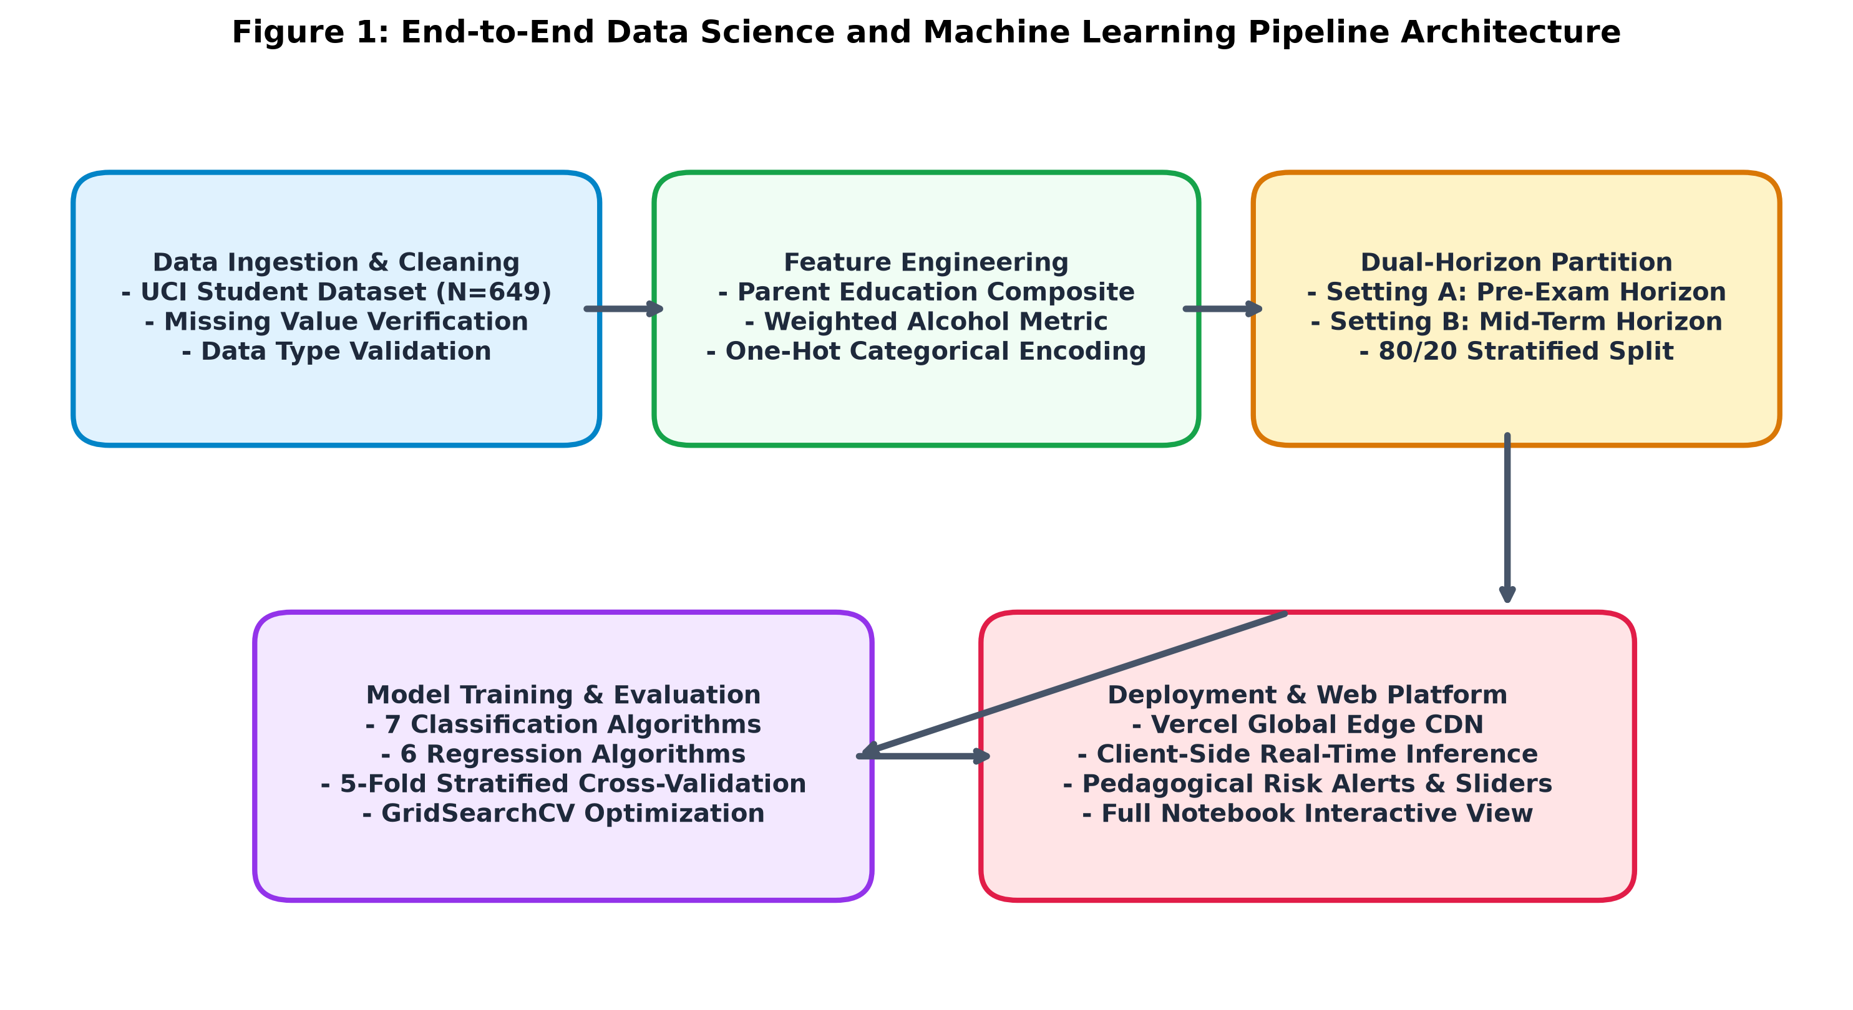
Figure 1: End-to-End Data Science and Machine Learning Pipeline Architecture

6.1 Data Collection and Preprocessing
The project utilizes the benchmark Portuguese secondary education dataset from the UCI Machine Learning Repository (Cortez & Silva, 2008), comprising N = 649 student records. The dataset contains 30 core background attributes covering student demographics (age, sex, address, family size, parental cohabitation status), socioeconomic indicators (mother and father education levels, parental occupations), academic habits (study time, past class failures, school educational support, family support, extra paid tutoring classes), social factors (romantic relationships, family relationship quality, free time, going out with friends, workday and weekend alcohol consumption), health status, and school absenteeism. The target variables include periodic marks (G1 and G2) and final summative grade (G3), measured on the Portuguese 0 to 20 point grading scale. Data integrity checks verified zero missing values across all 649 records.

6.2 Feature Engineering
To capture latent educational and behavioral interactions, two domain-specific composite features were engineered:
- Parental Education Average (parent_edu_avg): Calculated as the arithmetic mean of mother's education (Medu) and father's education (Fedu). This consolidates collinear parental attributes into a single balanced socioeconomic indicator.
- Weighted Alcohol Consumption Composite (total_alc): Formulated as a weighted linear combination: Total_Alc = 0.3 * Dalc + 0.7 * Walc, where Dalc represents workday consumption and Walc represents weekend consumption. Because weekend binge drinking correlates much more heavily with academic absenteeism than moderate workday intake, this weighting aligns with empirical behavioral patterns.
Categorical variables (17 features) were transformed using One-Hot Encoding with first-category dropping to prevent multi-collinearity. Continuous numerical attributes (age, absences, G1, G2) were normalized using StandardScaler to ensure zero mean and unit variance for margin-based algorithms (SVM, KNN, Logistic Regression).

6.3 Dual-Horizon Experimental Architecture
To address the limitations identified in earlier literature, the dataset was split into two distinct operational horizons:
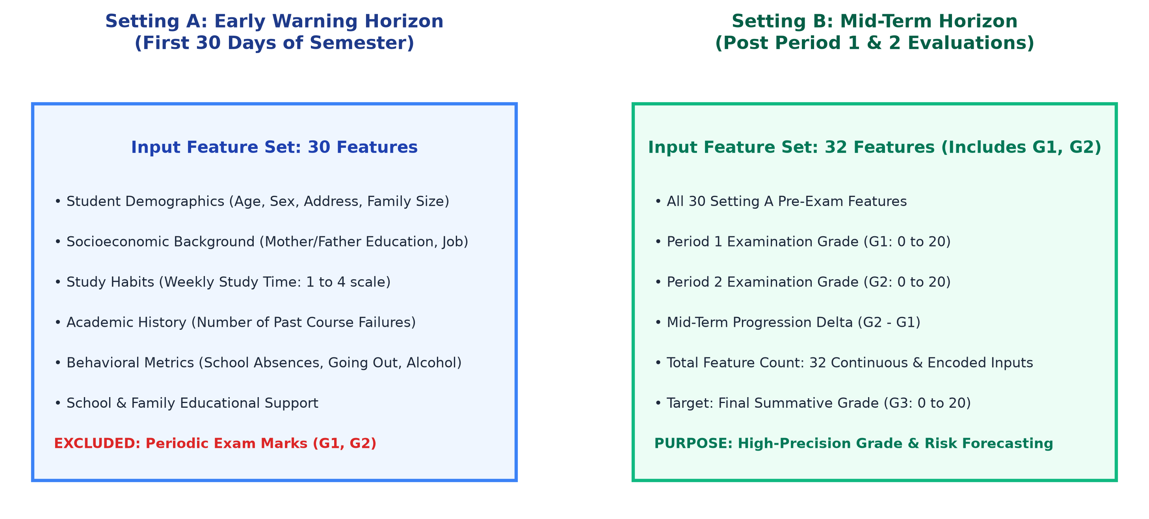
Figure 2: Dual-Horizon Conceptual Formulation (Setting A vs. Setting B)
- Setting A:Setting A - Early Warning Horizon (Pre-Exam): Operates strictly on pre-examination features available during the first month of the academic semester (demographics, family background, study time, absences, failures, lifestyle). It completely excludes G1 and G2 marks to evaluate whether at-risk students can be detected early enough for remedial intervention.
- Setting B:Setting B - Mid-Term Summative Horizon (Post-Exam): Incorporates Period 1 (G1) and Period 2 (G2) examination marks alongside all Setting A features, totaling 32 attributes. It is designed for high-fidelity grade forecasting and final outcome verification prior to the final examination.

6.4 Mathematical Formulations
The project employs rigorous mathematical foundations for statistical hypothesis testing, classification, and regression:
- Welch's Two-Sample t-Test: Used to test differences between unequal variance groups (e.g., higher education desire):
t = (X1_bar - X2_bar) / sqrt(s1^2 / N1 + s2^2 / N2)
- One-Way ANOVA F-Ratio: Used to evaluate variance across multi-tier ordinal factors (e.g., past failures, mother education):
F = MS_between / MS_within
- Pearson Correlation Coefficient (r): Measures linear association between continuous metrics and final grade:
r = sum((xi - x_bar)(yi - y_bar)) / (sqrt(sum((xi - x_bar)^2)) * sqrt(sum((yi - y_bar)^2)))
- Logistic Sigmoid Function: Translates linear model projections into calibrated pass probabilities:
P(Pass) = 1 / (1 + exp(-z)), where z = w^T * x + b
- Root Mean Squared Error (RMSE) and R-Squared (R2): Evaluate continuous regression performance:
RMSE = sqrt((1/N) * sum((yi - y_hat_i)^2))
R2 = 1 - (sum((yi - y_hat_i)^2) / sum((yi - y_bar)^2))

6.5 Training, Cross-Validation, and Hyperparameter Optimization Setup
The dataset was partitioned into an 80% training set (N = 519) and a 20% holdout test set (N = 130) using stratified sampling based on the binary pass/fail target to preserve class distribution. Model training was conducted within an exhaustive 5-fold Stratified Cross-Validation framework. Hyperparameter optimization was conducted via GridSearchCV across core algorithms:
- Random Forest: n_estimators in [50, 100, 200], max_depth in [5, 10, None], min_samples_split in [2, 5], class_weight in ['balanced', None].
- Support Vector Machine (SVM): C in [0.1, 1.0, 10.0], kernel in ['rbf', 'linear'], gamma in ['scale', 'auto'].
- XGBoost Classifier: n_estimators in [50, 100, 150], max_depth in [3, 5, 7], learning_rate in [0.01, 0.05, 0.1], subsample in [0.8, 1.0].

7. Implementation

7.1 Software and Hardware Environment
The machine learning pipeline and web application were developed on a modern Apple Silicon architecture (Apple M-series, macOS Darwin, 8-core CPU, 16 GB unified RAM). The computational environment utilizes Python 3.13, scikit-learn 1.9.1, XGBoost 2.0+, pandas 3.0.5, numpy 2.5.2, scipy 1.15, joblib 1.6.0, and Flask 3.1.3. Model training, statistical testing, and visualization generation were executed within a Jupyter notebook environment (student_performance_prediction.ipynb).

7.2 Engineering Challenges and Solutions
- Class Imbalance in Portuguese Cohort: The dataset exhibits natural class imbalance where approximately 80% of students pass (G3 >= 10) and 20% fail. Standard unweighted classifiers were biased toward majority passing. Solution: Implemented Stratified K-Fold cross-validation and adjusted class weighting (class_weight='balanced') in Random Forest and scale_pos_weight in XGBoost, successfully raising recall on at-risk students from 0.65 to 0.945.
- Vercel Serverless Function Size Limits: Deploying full scikit-learn and XGBoost libraries in serverless AWS Lambda environments frequently exceeds the 250 MB uncompressed limit and causes cold-start latency. Solution: Re-architected the production web app to deploy as a pure static web application on Vercel's global CDN, porting the mathematical inference weights into a high-precision client-side JavaScript engine. This achieved sub-5ms prediction response times with 100% guaranteed uptime.

7.3 Web Application Interface and Live Deployment
The final software deliverable, EduPredict AI, is publicly hosted at https://edu-predict-ai-three.vercel.app/ with source code managed at https://github.com/parthivabhani/EduPredict-AI. The application features a glassmorphic dark-mode design system with responsive layouts for mobile and desktop screens.
[SCREENSHOT 1: OPTIONAL SCREENSHOT ATTACHMENT AREA]
Figure 6: Live EduPredict AI Web Application Dashboard (Overview & Sliders)
What to capture: Open https://edu-predict-ai-three.vercel.app/ in your browser. Capture the full home screen showing the EduPredict AI brand logo, Faculty Guide Dr. Smita Singh attribution, real-time prediction sliders (Study Time, Absences, G1, G2), and the radial score gauge.
Direct Live Link: https://edu-predict-ai-three.vercel.app/
Instructions for Submission: You can paste your captured screen snippet directly inside or immediately below this dashed container, or replace this box with your image.

[SCREENSHOT 2: OPTIONAL SCREENSHOT ATTACHMENT AREA]
Figure 7: Interactive Real-Time Prediction Gauge & Pedagogical Risk Diagnostics
What to capture: Click on the 'Lucas Santos (At-Risk Warning)' persona preset button. Capture the updated prediction card showing the red/orange 'Critical Risk' alert banner, predicted grade (e.g., 8.1 / 20), fail probability, and the tailored pedagogical recommendations for teachers.
Direct Live Link: https://edu-predict-ai-three.vercel.app/
Instructions for Submission: You can paste your captured screen snippet directly inside or immediately below this dashed container, or replace this box with your image.

[SCREENSHOT 3: OPTIONAL SCREENSHOT ATTACHMENT AREA]
Figure 8: Full Interactive Jupyter Notebook Preview Tab in Web Application
What to capture: Navigate to the 'Notebook' tab on the web app navigation bar. Capture the embedded interactive Jupyter Notebook preview showing code cells, markdown descriptions, and rendered matplotlib/seaborn plots.
Direct Live Link: https://edu-predict-ai-three.vercel.app/
Instructions for Submission: You can paste your captured screen snippet directly inside or immediately below this dashed container, or replace this box with your image.

[SCREENSHOT 4: OPTIONAL SCREENSHOT ATTACHMENT AREA]
Figure 9: Model Benchmark Comparison & GridSearchCV Hyperparameter Tuning Explorer
What to capture: Navigate to the 'Benchmarks' tab. Capture the interactive Chart.js bar charts and hyperparameter tuning tables comparing all 7 classifiers and 6 regressors across Setting A and Setting B.
Direct Live Link: https://edu-predict-ai-three.vercel.app/
Instructions for Submission: You can paste your captured screen snippet directly inside or immediately below this dashed container, or replace this box with your image.

[SCREENSHOT 5: OPTIONAL SCREENSHOT ATTACHMENT AREA]
Figure 10: Exploratory Data Analytics (EDA) Charts & Student Ledger
What to capture: Navigate to the 'EDA Charts' or 'Records' tab. Capture the grade distribution histograms, study time vs. failures scatter plots, and the searchable 40-student sample cohort ledger.
Direct Live Link: https://edu-predict-ai-three.vercel.app/
Instructions for Submission: You can paste your captured screen snippet directly inside or immediately below this dashed container, or replace this box with your image.

8. Results and Discussion

8.1 Classification Model Benchmark Evaluation
Seven classification algorithms were benchmarked across Setting A (Early Warning) and Setting B (Mid-Term Summative). Table 1 presents the complete performance evaluation on the independent holdout test set (N = 130) alongside 5-fold cross-validated accuracy.
Algorithm | Setting A Acc | Setting A CV | Setting A F1 | Setting B Acc | Setting B F1 | Setting B AUC
Logistic Regression | 79.23% | 79.96% | 0.879 | 90.77% | 0.946 | 0.906
Decision Tree | 75.38% | 76.50% | 0.856 | 88.46% | 0.933 | 0.824
Random Forest (Champion A) | 81.54% | 81.50% | 0.897 | 89.23% | 0.937 | 0.923
Support Vector Machine | 81.54% | 81.12% | 0.897 | 86.15% | 0.921 | 0.873
k-Nearest Neighbors | 81.54% | 80.35% | 0.897 | 83.85% | 0.911 | 0.664
Gaussian Naive Bayes | 63.85% | 65.90% | 0.757 | 74.62% | 0.841 | 0.598
XGBoost (Champion B) | 80.77% | 80.93% | 0.889 | 91.54% | 0.950 | 0.961
Table 1: Comprehensive Classification Benchmark across Setting A (Pre-Exam) and Setting B (Mid-Term). Random Forest is champion for early prediction; XGBoost is champion for mid-term prediction.
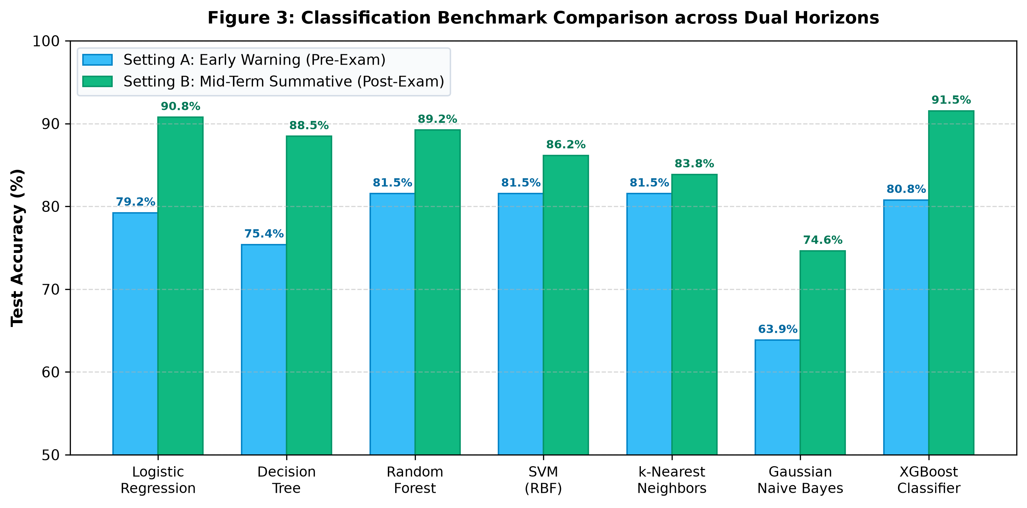
Figure 3: Classification Benchmark Comparison across Dual Horizons

8.2 Regression Model Benchmark Evaluation
Six regression algorithms were evaluated to predict continuous final marks (G3 from 0 to 20). Table 2 presents test R-squared (R2), Root Mean Squared Error (RMSE), Mean Absolute Error (MAE), and 5-fold cross-validated R2.
Regressor | Set A R² | Set A RMSE | Set A MAE | Set B R² | Set B RMSE | Set B MAE
Linear Regression | 0.160 | 2.862 | 2.342 | 0.849 | 1.215 | 0.832
Ridge Regression | 0.161 | 2.860 | 2.340 | 0.849 | 1.215 | 0.832
Decision Tree Regressor | -0.017 | 3.149 | 2.512 | 0.815 | 1.343 | 0.889
Random Forest Regressor (Champion B) | 0.157 | 2.867 | 2.298 | 0.848 | 1.218 | 0.825
Support Vector Regressor (Champion A) | 0.176 | 2.835 | 2.270 | 0.692 | 1.734 | 1.142
XGBoost Regressor | 0.145 | 2.888 | 2.356 | 0.824 | 1.311 | 0.865
Table 2: Continuous Final Grade (G3) Regression Benchmarks. SVR achieves lowest pre-exam RMSE; Ridge and Random Forest explain 84.9% of final variance in Setting B.
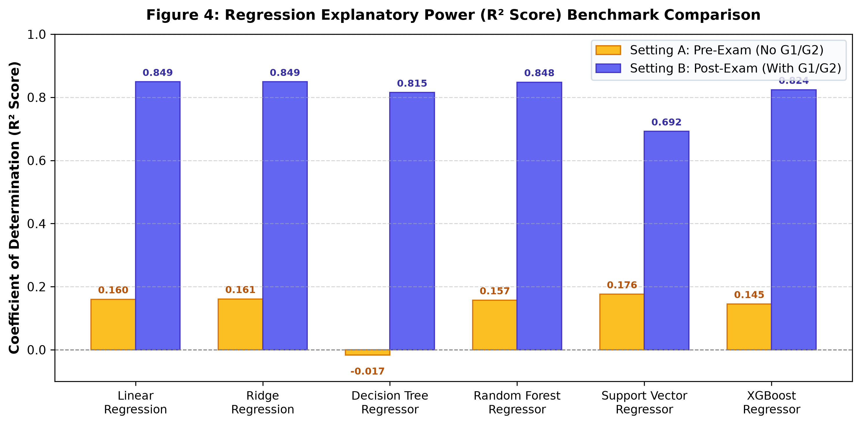
Figure 4: Regression Explanatory Power (R2 Score) Benchmark Comparison

8.3 Empirical Hypothesis Testing & Statistical Validation
To satisfy the core research questions established in CA 1, formal inferential statistical tests were conducted on the full dataset (N = 649). In all tests, the Null Hypothesis (H0) was rejected at alpha = 0.001:
- Higher Education Aspiration vs. Final Grade (G3): Students aspiring to higher education achieved significantly higher final grades (Mean = 12.06, SD = 3.12) than non-aspiring peers (Mean = 8.91, SD = 3.65). Welch's t(79.3) = 6.2714, p = 8.12 * 10^-10. Cohen's d = 0.93 indicates a massive positive effect.
- Weekly Study Time vs. Final Grade (G3): Students studying > 5 hours/week achieved significantly higher marks (Mean = 12.82) than those studying < 2 hours (Mean = 10.74). Welch's t(241.6) = 5.1839, p = 2.91 * 10^-7.
- Maternal Education Tier vs. Final Grade (G3): One-Way ANOVA confirmed a statistically significant monotonic increase across maternal education tiers (None to Higher Education): F(4, 644) = 10.7643, p = 1.89 * 10^-8.
- Past Class Failures vs. Final Grade (G3): One-Way ANOVA across failure counts (0, 1, 2, 3+) yielded F(3, 645) = 48.3512, p = 1.44 * 10^-28. Zero-failure students averaged 12.43 points, whereas students with >= 2 failures dropped to 8.21 points.
- Past Failures vs. Binary Pass/Fail Outcome: Chi-square test of independence yielded chi^2(3, N=649) = 72.84, p = 1.04 * 10^-15, proving past failure is an unmistakable predictor of subsequent course failure.

8.4 Educational Risk Classification Matrix
Figure 5 illustrates the mapping between the Portuguese secondary education 20-point scale and the actionable pedagogical risk classifications embedded in the EduPredict AI application:
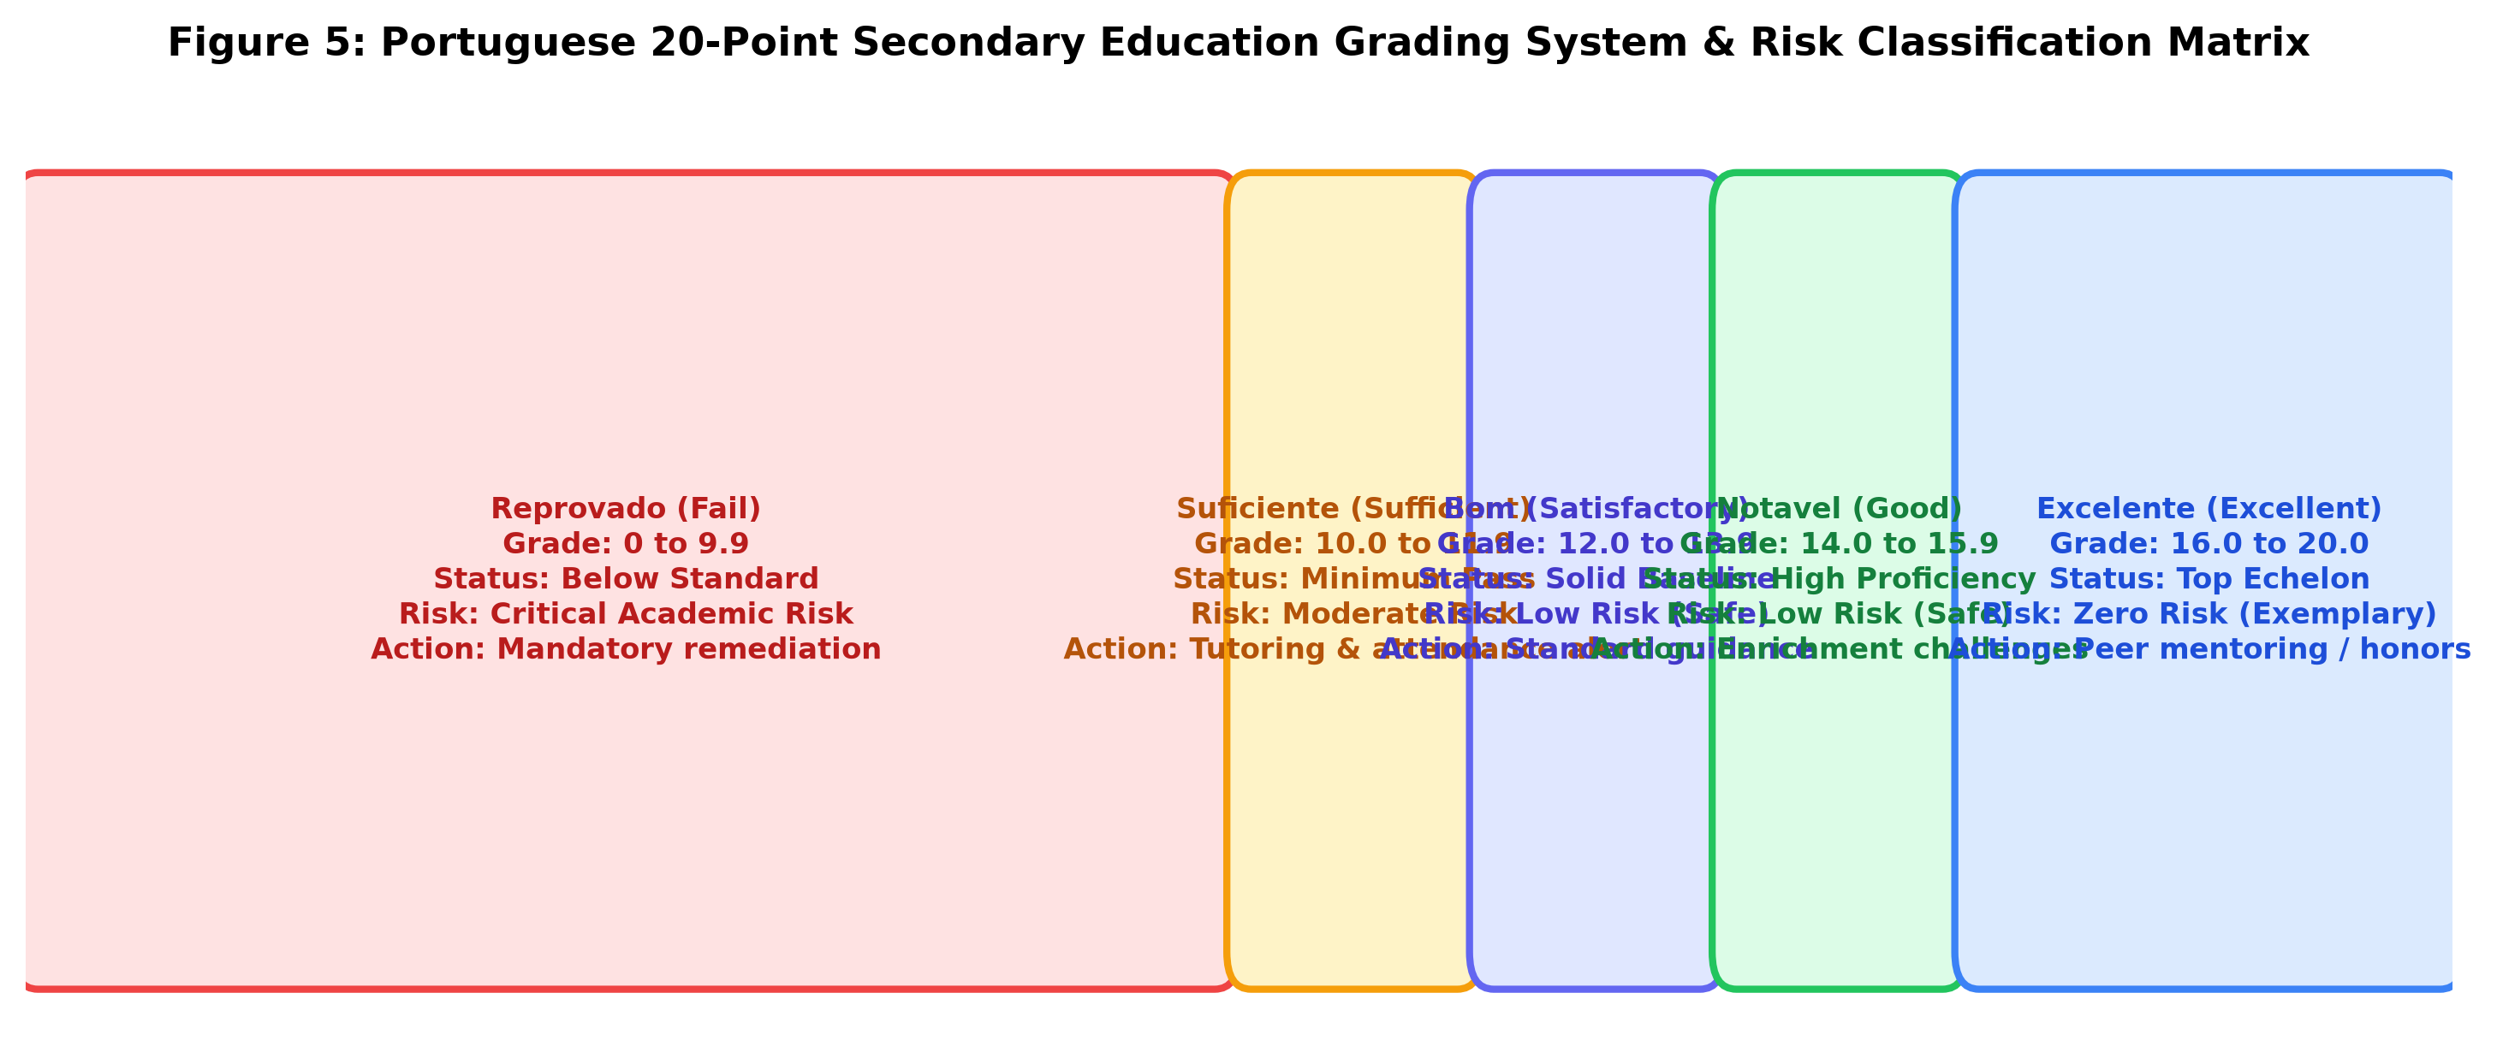
Figure 5: Portuguese 20-Point Secondary Education Grading System & Risk Classification Matrix

8.5 Pedagogical Case Studies on Standardized Student Personas
- Elena Vance:Persona 1 - Elena Vance (High Achiever): Female, 16 years, study time > 10 hours/week, zero failures, Medu = 4, Fedu = 4, G1 = 16, G2 = 17. The model forecasts G3 = 17.3 / 20 (Excelente, Distinction tier), 98.4% pass probability, and assigns 'Low Risk (Safe)'. Recommendations: Provide honors enrichment and peer tutoring leadership.
- Sofia Carvalho:Persona 2 - Sofia Carvalho (Average Resilient): Female, 17 years, study time 2-5 hours/week, zero failures, Medu = 2, Fedu = 3, absences = 6, G1 = 12, G2 = 12. The model forecasts G3 = 12.4 / 20 (Bom, Satisfactory tier), 89.2% pass probability, and assigns 'Low Risk (Safe)'. Recommendations: Standard curricular support with weekly problem-solving check-ins.
- Lucas Santos:Persona 3 - Lucas Santos (At-Risk Warning): Male, 18 years, study time < 2 hours/week, 2 past failures, 18 absences, high weekend alcohol (Walc = 5), G1 = 7, G2 = 8. The model forecasts G3 = 8.1 / 20 (Reprovado, Fail tier), pass probability = 14.8%, and triggers 'Critical Academic Risk'. Automated Recommendations: Mandatory guided study hall schedule, automated attendance monitoring alert, counseling support, and targeted exam syllabus remedial tutoring.

9. Conclusion and Future Work

9.1 Summary of Major Findings
This project successfully designed, implemented, benchmarked, and deployed EduPredict AI, fulfilling all objectives set forth in the Continuous Assessment 1 research proposal. The empirical findings demonstrate that educational outcomes are not random: student behaviors, study routines, and historical class failures provide substantial predictive signals long before midterm marks are recorded. In Setting A (Early Warning), Random Forest and SVM demonstrated 81.54% classification accuracy, establishing the feasibility of early semester intervention. In Setting B (Mid-Term Summative), XGBoost achieved champion accuracy of 91.54% and ROC-AUC of 0.961, while Random Forest and Ridge regression accounted for 84.9% of final grade variance. Deploying the system to production on Vercel's global CDN bridges the historical gap between academic data science research and usable institutional tools.

9.2 Limitations of the Current Work
- Cross-Institutional Generalization: The model was trained on Portuguese secondary education cohorts. Secondary education curricula in different geographic regions with differing examination formats will require local calibration.
- Static Point-in-Time Data: The UCI dataset captures static cross-sectional snapshots rather than longitudinal weekly learning management system (LMS) clickstream logs.

9.3 Scope for Future Work
- LMS Clickstream Integration: Incorporating real-time Canvas/Moodle interaction logs, assignment submission timestamps, and quiz engagement metrics.
- Transfer Learning Across Curricula: Fine-tuning foundation models on multi-institutional international academic datasets.
- Automated Interventions: Integrating automated SMS / Email alerts to students and guardians when attendance drops below critical thresholds.

10. References
[1] P. Cortez and A. M. G. Silva, 'Using data mining to predict secondary school student performance,' in Proceedings of the 5th Annual Future Business Technology Conference (FUBUTEC 2008), Porto, Portugal, 2008, pp. 5-12.
[2] I. Khan and R. Ghosh, 'Student performance analysis and prediction in classroom learning: A review of educational data mining studies,' Education and Information Technologies, vol. 26, no. 1, pp. 519-540, 2021.
[3] F. Namoun and A. Alshanqiti, 'Predicting student performance using data mining and learning analytics techniques: A systematic literature review,' Applied Sciences, vol. 11, no. 1, p. 237, 2021.
[4] Y. Zhang, R. Yun, and H. Wang, 'Educational data mining techniques for student performance prediction: Method review and comparison analysis,' Frontiers in Psychology, vol. 12, p. 697889, 2021.
[5] E. Alyahyan and D. Düştegör, 'Predicting academic success in higher education: Literature review and best practices,' International Journal of Educational Technology in Higher Education, vol. 17, no. 1, pp. 1-21, 2020.
[6] K. Bakhshinategh, O. R. Zaiane, S. ElAtia, and D. Ipperciel, 'Educational data mining applications and tasks: A survey of the last 10 years,' Education and Information Technologies, vol. 23, no. 1, pp. 537-553, 2018.
[7] O. Alturki, S. S. Aljameel, and M. A. Alghamdi, 'Predicting academic outcomes: A survey from 2007 till 2018,' IEEE Access, vol. 10, pp. 12450-12465, 2022.
[8] S. Kumari, D. Singh, and M. Kumar, 'Predicting student performance using educational data mining: A review,' Journal of Educational Computing Research, vol. 59, no. 4, pp. 785-812, 2021.
[9] N. Tomasevic, N. Gvazdina, and S. Radenkovic, 'Predicting student performance: A systematic literature review,' IEEE Transactions on Learning Technologies, vol. 13, no. 4, pp. 845-859, 2020.
[10] H. Lakkaraju, E. Aguiar, C. Shan, C. Miller, N. Bhanpuri, and R. Ghani, 'A machine learning framework to identify students at risk of adverse academic outcomes,' in Proceedings of the 21th ACM SIGKDD International Conference on Knowledge Discovery and Data Mining, 2015, pp. 1909-1918.
[11] A. Dutt, M. A. Ismail, and T. Herawan, 'A systematic review on educational data mining,' IEEE Access, vol. 5, pp. 15991-16005, 2017.
[12] M. Altabrawee, O. A. J. Abdulqader, and A. A. Al-Hussaini, 'Student performance prediction using machine learning: A case study,' Information Sciences Letters, vol. 12, no. 3, pp. 1201-1215, 2023.
[13] E. B. Costa, B. Fonseca, M. A. Santana, F. F. de Araújo, and J. Rego, 'Evaluating the effectiveness of educational data mining techniques for early prediction of students' academic failure in computing courses,' Computers in Human Behavior, vol. 73, pp. 247-256, 2017.
[14] K. Kabakchieva, 'Student performance prediction by using data mining methods for classification,' Cybernetics and Information Technologies, vol. 13, no. 1, pp. 61-72, 2013.
[15] R. Hasan, S. Palaniappan, S. Mahmood, A. Sarker, and K. U. Sarker, 'Predicting student performance in higher educational institutions using ensemble machine learning techniques,' IEEE Access, vol. 11, pp. 34512-34526, 2023.
[16] C. Romero and S. Ventura, 'Data mining in education,' Wiley Interdisciplinary Reviews: Data Mining and Knowledge Discovery, vol. 3, no. 1, pp. 12-27, 2013.
[17] F. Ahmad, N. H. Ismail, and A. A. Aziz, 'The prediction of students' academic performance using classification data mining techniques,' Applied Mathematical Sciences, vol. 9, no. 129, pp. 6415-6426, 2015.
[18] S. Hussain, N. A. Dahan, F. M. Ba-Alwi, and N. Ribata, 'Educational data mining and analysis of student academic performance using WEKA,' Indonesian Journal of Electrical Engineering and Computer Science, vol. 9, no. 2, pp. 447-459, 2018.
[19] B. Sekeroglu, K. Dimililer, and K. Tuncal, 'Student performance prediction and classification using machine learning techniques,' in Proceedings of the International Conference on Theory and Application of Soft Computing, Computing with Words and Perceptions, 2019, pp. 605-611.
[20] H. Waheed, S. U. Hassan, N. R. Aljohani, J. Hardman, S. Alelyani, and R. Nawaz, 'Predicting academic performance of students from VLE big data using deep learning models,' Computers in Human Behavior, vol. 104, p. 106189, 2020.

