

School of Future Tech

Case Study Report

on

Fuel Consumption Monitoring System

by

Parthiv Kumar

150096725095

Index
- Introduction to the Case Study.
- Problem Statement / Case Background (Abstract).
- Problem Statement / Case Study Design.
- Methods & Algorithms Technology Applied in the Problem Statement / Case Study.
- Problem Statement / Case Study Implementation Details and Snapshots.
- Problem Statement / Case Study Results and Conclusion.
- References

1. Introduction to the Case Study
Managing fuel expenses and monitoring vehicle efficiency is a critical task for logistics, transportation businesses, and individual vehicle owners. Without a structured system, tracking fuel costs, mileage, and driver performance over time becomes disorganized and prone to errors.
This case study focuses on the design and implementation of a Fuel Consumption Monitoring System using C++. The application is a console-based management tool that allows users to log fuel fill-ups, track odometer readings, and automatically calculate fuel efficiency (mileage) for various vehicles. By transitioning from manual logs to a digital C++ implementation, the system provides accurate data analysis and persistent storage for long-term monitoring.

2. Problem Statement / Case Background (Abstract)
Background :
Traditional methods of tracking fuel—such as paper logs or simple spreadsheets—often fail to provide real-time insights into vehicle health or fuel efficiency trends. Manual calculations of "km per litre" are tedious and often inconsistent. A software-based approach ensures that every drop of fuel and every kilometer traveled is accounted for, allowing for the identification of "poor" performing vehicles that may require maintenance.
Abstract :
This case study presents a Fuel Consumption Monitoring System developed in C++. The system utilizes a structured data approach to store vehicle information, fuel types (Petrol/Diesel/CNG), and cost details. Key features include data persistence via file handling, an analysis module to compute mileage between fill-ups, and a reporting tool that categorizes vehicle efficiency as "Good," "Average," or "Poor." The implementation demonstrates the use of C++ Standard Template Library (STL) vectors, file I/O operations, and algorithmic sorting to manage and process vehicle data efficiently.

3. Case Study Design
The Fuel Consumption Monitoring System is designed as a modular pipeline with the following stages:
- Data Acquisition & Entry: User inputs vehicle details, driver name, fuel quantity, price, and current odometer reading.
- Data Storage (In-Memory & Persistent): Uses a struct to organize data and a vector<FuelEntry> for active processing. Data is saved to and loaded from fuel_data.txt.
- Analysis Engine:
  - Sorts entries by odometer reading to ensure chronological distance calculation.
  - Calculates distance traveled between fill-ups.
  - Computes mileage using the formula: $Mileage = \frac{\Delta Odometer}{Litres \ Filled}$
- Reporting & Categorization: Generates a summary report for all vehicles, applying logic to determine efficiency status based on mileage thresholds.
- Search & Retrieval: Allows users to filter and view logs for a specific vehicle number.

4. Methods & Algorithms Technology Applied in the Problem Statement / Case Study
Key Methods and Algorithms:
- Linear Search: Used for searching specific vehicle records within the log.
- Sorting (std::sort): Utilizes a lambda function to sort vehicle entries based on odometer readings to accurately calculate distance between consecutive logs.
- File I/O: Implementation of ifstream and ofstream for reading and writing pipe-delimited (|) data files.
- Formatting: Use of iomanip (setw, fixed, setprecision) to generate clean, tabular console reports.
Technology Stack Used:
- Programming Language: C++
- Libraries:
  - iostream & iomanip: For input/output formatting.
  - vector & algorithm: For data storage and sorting.
  - fstream & sstream: For persistent file storage and string parsing.
  - ctime: For automated date stamping.
- Environment: Any C++ Compiler (GCC/Clang) or IDE (VS Code, Dev-C++, Code::Blocks).

5. Problem Statement / Case Study Implementation Details and Snapshots.
The implementation is contained within a single robust C++ file (fuel_monitoring.cpp) organized into functional modules:
- addFuelEntry(): Captures and validates user input.
- consumptionAnalysis(): The core logic module that calculates mileage and cost per km.
- efficiencyReport(): Aggregates data for all vehicles to provide a "Grand Total" summary.
- saveToFile() / loadFromFile(): Handles the persistence of data across program sessions.

SnapShots :
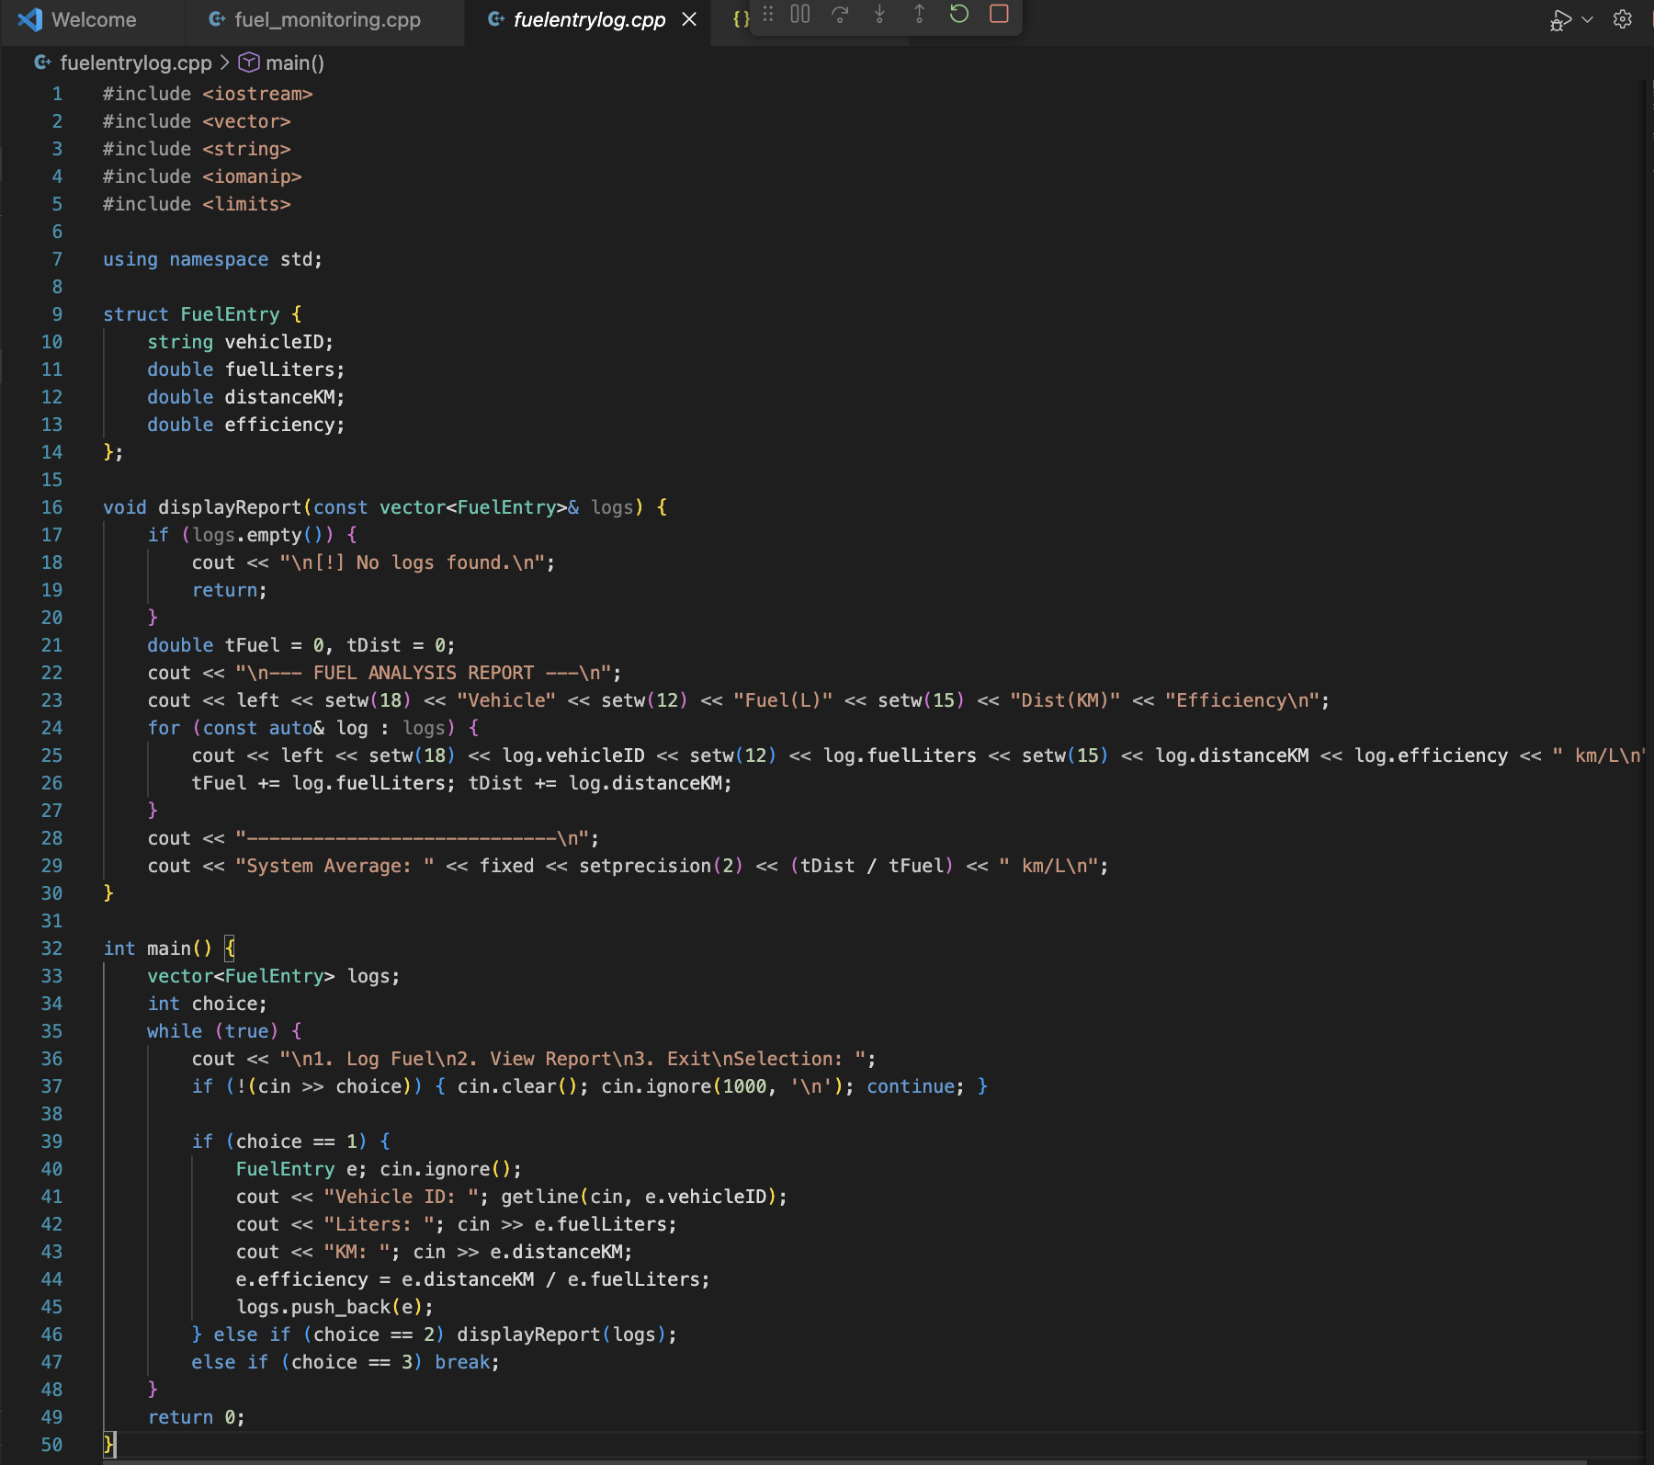
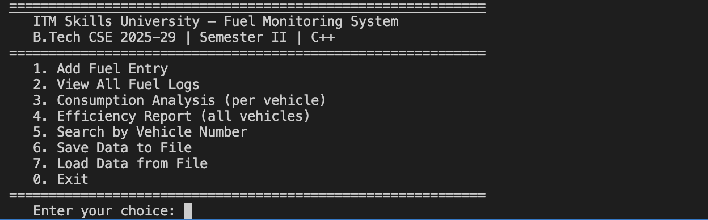

6. Problem Statement / Case Study Results and Conclusion.

Findings

Sorting is Essential: Without sorting by odometer reading, mileage calculations would be incorrect if entries were entered out of chronological order.

Data Validation: Implementing input checks (preventing negative fuel or distance) significantly reduces system crashes.

Efficiency Insights: The system successfully identifies low-efficiency vehicles, providing a clear "POOR" status for vehicles performing below 8 km/L.

Conclusion :

This case study demonstrates a complete management pipeline for a Fuel Monitoring System using C++. It successfully integrates core programming concepts like structures, file handling, and the STL to solve a real-world utility problem. The system provides a strong foundation for future enhancements, such as a Graphical User Interface (GUI) or integration with GPS-based tracking.

7. References
- Standard C++ Documentation (cppreference.com) for std::vector and std::sort.
- C++ File Handling tutorials for fstream operations.
- ITM Skills University Course Material for B.Tech CSE Semester II (C++ Programming).

