**Software Engineering Assignment**

**Module: 1 (SDLC)**

1. **What is software? What is Software Engineering?**

* Software is a set of programs that allows the users to perform a well-defined function or some specified task.
* Software Engineering is all about developing products, using well defined, scientific principles and methods.

1. **Explain types of software?**

* System software
* Programming software
* Application software

1. **What is SDLC? Explain each phase of SDLC?**

* SDLC is System Development life cycle.
* Planning :- (Programming flow)
* Implementation:- (coding )
* Testing:- (debug , csr)
* Documentation: - srs document is used for implementing System.
* Deployment:- Live on store (Play Store, App Store)
* Support & maintenance:- maintenance of product

1. **What is DFD? Create DFD Diagram on Flipkart**

* DFD is Data flow diagram.

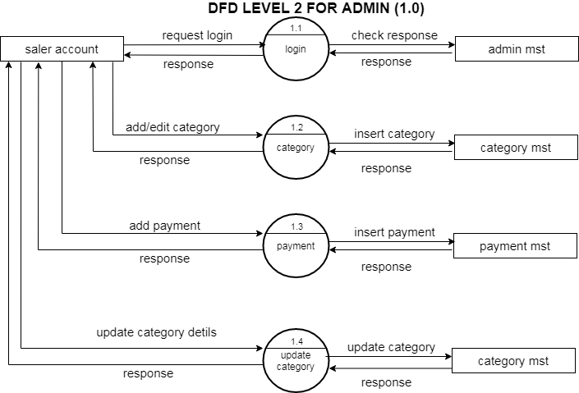

1. **What is Flow chart? Create a flowchart to make addition of two numbers**

* Flowchart is graphical representation of a program.

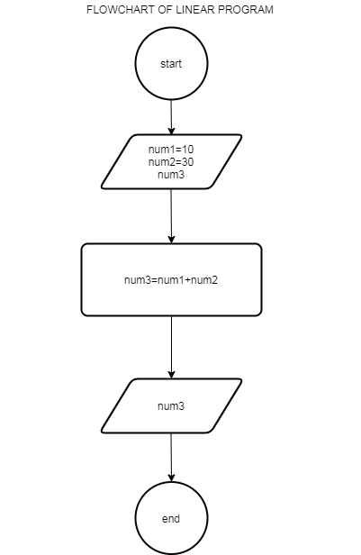

1. **What is Use case Diagram? Create a use-case on bill payment on paytm.**

* use case diagram is a graphical depiction of a user's possible interactions with a system

