1. **INTRODUCTION**

**Company Overview**

[HERE Solutions](https://company.here.com/here/)[4]  is an independent company under the ownership of a consortium of German carmakers (Audi, BMW and Daimler) in December 2015. As an open location platform, its maps are accessible to everyone. It provides automotive grade digital mapping resources to consumers automotive and enterprise sectors.

**Consumer** is enabling smarter urban mobility for people: by combining data from different sources and utilizing location analytics, HERE is delivering beautiful, dynamic maps and relevant information into the hands of millions of people to help them with their journey or discover something new.

**Automotive** is enabling the next stage in the evolution of the car: by creating high definition live maps, cloud-based vehicle sensor processing capabilities and new embedded and companion experiences, HERE powers precise, highly contextual and individually tailored guidance solutions for vehicles as they become increasingly automated and, ultimately, fully autonomous.

Automotive is also enabling a new era of transportation: by making the map the nerve centre of intelligent transportation systems for cities and governments, HERE is helping create new types of cooperative intelligent transportation solutions (C-ITS) which are affordable, effective and scalable.

**Enterprise** is enabling businesses and governments to manage their assets in smarter ways: by providing the most comprehensive offering of map and platform tools, HERE can help organizations analyze their own data with location context to obtain new insights and make decisions that increase the productivity and efficiency of their mobile and fixed assets.

For the delivery of high precision location based services, HERE maintains a massive database of location content. Since this data is used in real world scenarios, the accuracy of the information is of paramount importance. This project mainly deals with the techniques used to achieve the required level of accuracy in big data.

1. **ROLE OF VALIDATIONS IN DIGITAL MAPPING**

The beauty of a digital map is that it can be updated regularly to reflect the constant changes taking place around the world. In fact, HERE makes millions of changes to its maps every day. Fresh data is collected through various sources like satellite imagery, autonomous probes, car sensors, Here true vehicles and the community. This data is uploaded to the central database. But before this can happen, the data must be checked for accuracy. If discrepancies creep into the firm’s database, it could lead to logistical errors and loss of credibility. Hence, it undergoes a process called [data validation](https://en.wikipedia.org/wiki/Data_validation)[6].This process ensures the security, correctness and meaningfulness of data. The simplest kind of data type validation verifies that the individual characters provided through user input are consistent with the expected characters of one or more known primitive data types; as defined in a programming language or data storage and retrieval mechanism. For example, many database systems allow the specification of the following primitive data types: 1) integer; 2) float (decimal); or 3) string. This data is integrated with the database only if it clears this assessment. This validation process is largely automated and is conducted with the help of certain predetermined rules. The computer checks whether each unit of data complies with every rule and publishes the result.

The responsibility of rules creation lie with the [Subject matter experts](https://en.wikipedia.org/wiki/Subject-matter_expert)[5]  (SMEs) as they understand the need and impact of the rules on the business. When it comes to implementation, the developer needs to understand the requirements and the logical functioning of these rules mentioned above and subsequently develop an algorithm to implement them in a computer program. Subject matter experts (SMEs) are the ones who formulate the rules in accordance to business logic.

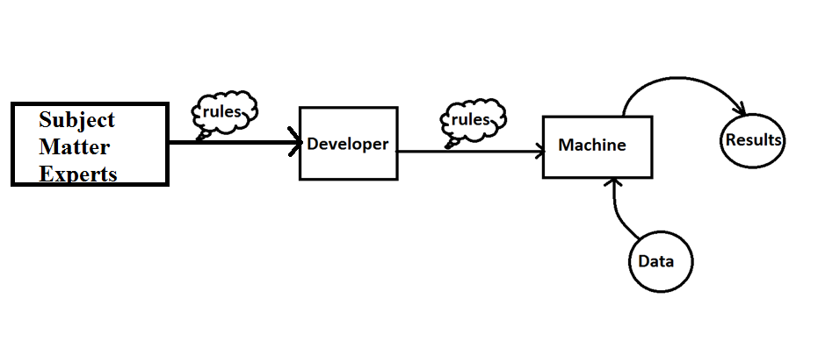

**Fig1: Validation workflow**

1. **DRAWBACKS OF EXISTING VALIDATION PROCESS**

The validation process described earlier eliminates the need for manual verification of data which would have been outright impractical given the amount of data being generated. However, it also has some drawbacks:

1. There is no guarantee that engineering/developer team understands the whole context and the underlying objective behind a validation rule.
2. A very engaged and consistent co-ordination between the engineering team and SMEs is needed.
3. A very high turnaround time is required for the implementation of each rule.
4. Development outcome is often not good enough and a lot of cases require multiple cycles of rework before final acceptance.

Due to these limitations, there is a need to overhaul the current process. An approach redefining creation and managing of validation rules is required. The SMEs need to have full control on rule definition and outcome. There is a dire need for the process to be highly integrated, automated and self-testable.

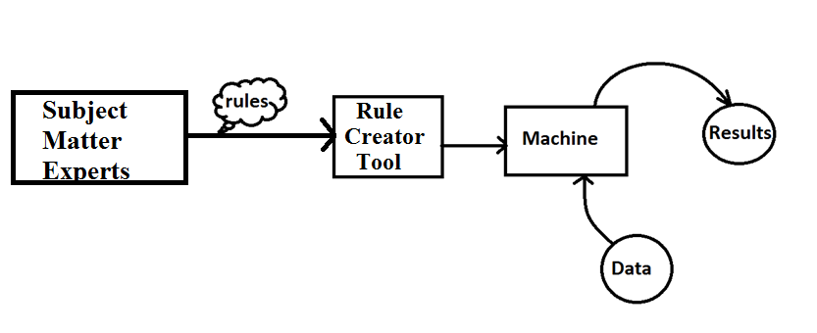

**Fig 2: Automation of validation process**

1. **SOLUTION PROPOSITION**

In order to eliminate the requirement of developers from the validation workflow, we need to enable the SMEs to define, author, test and implement the rules by themselves. This can be done by introducing a Graphical User Interface (GUI). This GUI would convert the rule into the required format.

The GUI identified for this purpose is [Blockly](https://en.wikipedia.org/wiki/Blockly)[3].It is a completely visual programming language that lets you build software without typing a single character. Blockly uses blocks that link together to make writing code easier, and can generate JavaScript, Python, PHP or Dart code. It can also be customized to generate code in any computer language.

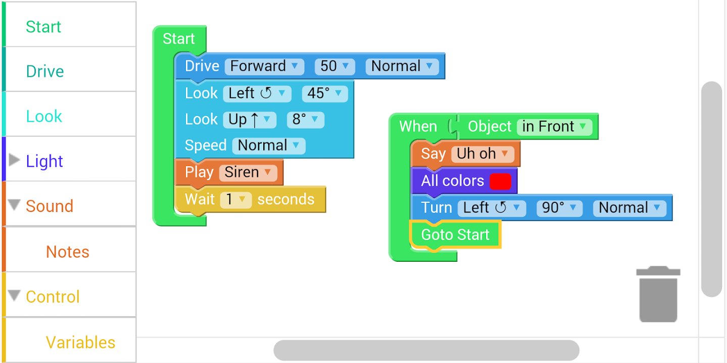

**Fig 3: Blockly**[1]

This tool is free and open-source under the [Apache_License](https://en.wikipedia.org/wiki/Apache_License)[2]. Thus, it can be modified to suite our needs.

Custom blocks are now in development which will form mini-rules and logic blocks. These blocks can then be joined together to form a fully-functional rule. Thus the need of coding and subsequently developers is eliminated. This has the following benefits:

1. SME driven development.
2. Faster turn around time due to less coordination and more automation.
3. **APPLICATION**

This workflow cab be adopted in a wide range of scenarios and is presently being tested on a new project named FCNR.

**FCNR:**

FCNR stands for Fee calculation on Navigable Routes. This is a feature that HERE plans to integrate with its existing offerings. It computes what the total expense would be in the way of toll fees on any route for a particular (user’s) vehicle. We can then compare the cost incurred on alternate routes. This can be useful to plan journeys in advance and decrease the operational costs.

For example, if there are two routes which lead you from your home to your destination. Let us say route ‘A’ has a toll booth while ‘B’ has two of them.

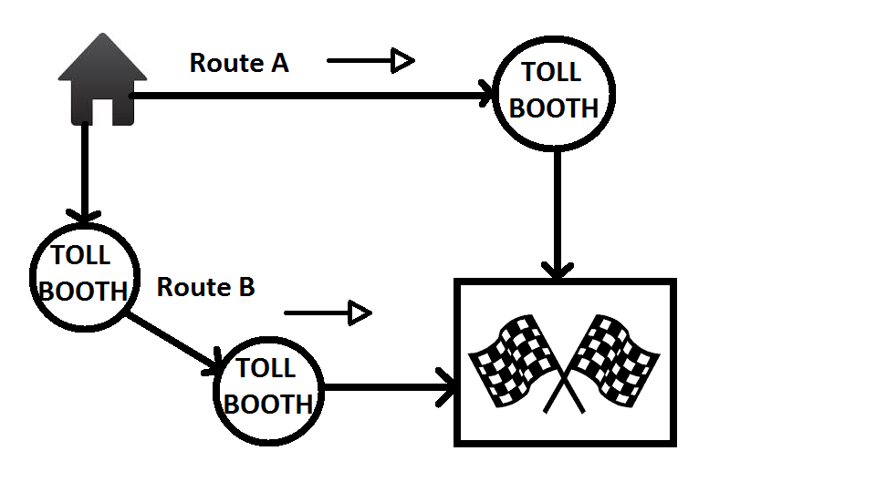

**Fig 4: Toll costs calculation**

In this scenario, the algorithm will compare the toll fees of the booth in route ‘A’ with the sum of toll fees of toll booths in route ‘B’ and indicate the cheapest route of transport. The user can then choose between them according to their preferences keeping in mind the other information like time required, distance, road quality, etc. which is provided by the map or application.

**REFERENCES**

1. [play.google.com](https://play.google.com/store/apps/details?id=com.dcsdb.blocklify)
2. [Apache_License](https://en.wikipedia.org/wiki/Apache_License).
3. [Blockly](https://en.wikipedia.org/wiki/Blockly).
4. [HERE Solutions](https://company.here.com/here/)
5. [Subject matter experts](https://en.wikipedia.org/wiki/Subject-matter_expert)
6. [data validation](https://en.wikipedia.org/wiki/Data_validation)