Ontario Wildfire Prediction Progress Report
Reporting scope Weeks 1 to 5
COMP 385 AI Capstone Project Section 001
Report date October 16 2026
Team name _Group 7
Prepared by
Student name | Student ID | Signature
Parth Kevadiya | 301492239
Manav Chaudhary | 301344184
Rishi Goyal | 301361102
Harsh Eary | 301419409
Jasdish Singh | 301416987

Declaration
We, Group 7, confirm that this work submitted for
assessment is our own and is expressed in our own words. Any uses made within it of
the works of any other author, in any form (ideas, equations, figures, texts, tables,
programs), are properly acknowledged at the point of use.

1 Executive Summary
We have completed the local development work scheduled for Weeks 1 to 4 and built the Week 5 research prototype. The application brings together historical ignition estimates, a separate selected-source study for 2025, fire-spread reconstruction, map inspection and CSV or GeoJSON exports. Live ignition scoring remains unavailable because the current data and moisture-state evidence do not support operational qualification.
The project addresses two different questions: where a new fire start is recorded within a 10 km cell on a calendar day, and how an existing incident progresses across a separate 90 m landscape. Keeping these questions separate helps an analyst interpret the outputs without confusing ignition probability with the area an existing fire could burn.
We compared historical fire rate, logistic regression, histogram gradient boosting and LightGBM on the same corrected historical development data. LightGBM achieved the highest pooled temporal validation average precision and was selected for the historical final experiment. At the fixed illustrative 1% daily alert budget, its 2019 temporal test detected 63 of 509 positive cell-days, with 12.377% recall and 0.353% precision. The separate selected-source 2025 temporal study detected five of 102 positives. Most alerts remain false positives.
The corrected spread reconstruction achieved mean recall of 0.3606, below the even-growth baseline of 0.4018. The complete software suite has 129 passing tests. Browser, export and warm-response checks support the local demonstration; they do not establish field forecasting accuracy. Our implementation differs from the published Cell2Fire engine and retains its own validation limits. The next work is to obtain compatible reference weather and verified observed fire-weather state, and obtain external review of the completed submission evidence. Frozen final results will remain unchanged.

2 Table of Contents
1 Executive Summary 2
2 Table of Contents 3
3 List of Illustrations 3
4 Introduction 4
5 Methodology 5
6 Results Data and Analysis 6
Weekly progress 6
Ignition model results 7
Spread software and live readiness 8
7 Conclusions 9
8 Recommendations 9
9 Bibliography 10
10 Appendices 11
11 List of Acronyms 12
12 Glossary of Terms 12

3 List of Illustrations
Figure 1 Current project workflow 5
Table 1 Progress by development week 6
Table 2 Corrected historical development comparison 7
Table 3 Frozen primary final test results 7
Table 4 Corrected spread reconstruction comparison 8
Table 5 Software and performance checks 8
Table 6 Appendix evidence register 11
Expanded diagrams and evidence index 13

4 Introduction

Problem and project purpose
The project develops a research application for reviewing wildfire ignition risk and incident spread in Ontario. An analyst needs to understand where and when a recorded new start is more likely, which data support that estimate, and how an already burning incident could progress. These tasks have different targets, spatial supports and validation requirements. A daily ignition estimate cannot be used as the initial state of an active-fire simulation.
Our ignition unit is one 10 km grid cell on one local calendar day. The first benchmark uses recorded May to October starts in the Ontario Fire Region from 2010 to 2019. The spread capability operates on separate 90 m incident landscapes and displays completed 1, 3 and 6 hour simulation outputs. The application is intended for retrospective research and demonstration; no emergency-warning or live operational accuracy claim is made.

Summary of the literature review
Cell2Fire provides a published basis for grid-based fire growth and landscape-management experiments (Pais et al., 2021). Kim et al. (2025) show why calibration against known fires must be separated from evidence about forecasting. These studies informed our component boundaries, baseline comparisons and treatment of reconstruction. Our simulator uses a restricted FBP-inspired spread-rate subset and a sixteen-neighbour travel-time algorithm. It is not the published Cell2Fire implementation, so their reported accuracy cannot be assigned to our system.

Summary of data exploration
The retained historical benchmark has 17,798,320 cell-days over 9,673 cells. Source audits identified weather missingness, station-selection limitations, uncertainty in the old grid boundary and date or identity discrepancies in fire records. Corrected historical development weather reduced missingness from 54.0506% to 11.4542%. The independently prepared 2025 panel contains 1,775,232 cell-days over 9,648 cells, with 600 positive cell-days from 624 retained recorded-start instances. These panels have different source contracts and remain separate (Ontario Wildfire Prediction project, 2026a, 2026b).

5 Methodology
We first defined the two capabilities, the selected 10 km ignition grid and the historical calendar-day target. We then documented the seven-source scope: Ontario fire points and areas, VIIRS, ERA5-Land, HRDPS, FBP Fuel Types 2024, SCANFI v1.2 for 2020, and MRDEM. The legacy historical benchmark separately retains NFDB, CDEM and CWFIS provenance.
Next, we investigated source structure, coverage, missing values, units, coordinate systems and time rules. Raw inputs and exclusion decisions were preserved. The Week 2 work added requirements, AI use cases, a dependency plan and frozen temporal and geographic evaluation roles. Week 3 added architecture decisions, training and inference components, five exchanged-data contracts and a common four-candidate comparison.
During Week 4, we corrected historical weather joins and built a separate provincial weather, fuel, forest, terrain and label panel for 2025. Preprocessing was fitted only on permitted training data. Historical temporal training used 2010 to 2017, calibration used 2018, and the final test used 2019 after model and alert choices were frozen. The separate 2025 study used July validation, August calibration and September to October final testing. Earlier exploratory exposure to these archives is disclosed.
Week 5 connected saved results to the dashboard, verified model reloads and first-day explanations, regenerated versioned spread inputs, completed the corrected reconstruction comparison and tested application failure paths. The latest review changed presentation and request handling without retraining or retuning on final outcomes.
Figure 1 Current project workflow
Historical records and weather -> frozen model -> 2019 map
Selected 2025 sources -> separate model -> 2025 map
Existing incident state -> spread engine -> reconstruction
HRDPS and research FWI -> readiness failure -> no live score
|
v
Dashboard and result exports

6 Results Data and Analysis

Weekly progress
Table 1 records local development outputs. Completion means the listed implementation or document exists with evidence. It does not imply independent approval or operational forecasting acceptance. The week labels organize the course work rather than assert calendar deadlines.
Table 1 Progress by development week
Week | Work completed | Current position
1 | Problem, separate capabilities, 10 km ignition contract, local repository and iterative development plan. | Local development complete.
2 | Seven-source audits and representative EDA, literature review, requirements, AI use cases, dependency plan and evaluation reservations. | Local deliverables complete. Native Microsoft Project verification remains deferred.
3 | Architecture and component flows, five data contracts, four candidate comparison, six decisions and critical spread review. | Local design complete. Team and professor sign-off remain unverified.
4 | Corrected historical weather, selected 2025 provincial join, native fuel shares, sampled forest and terrain, research HRDPS and FWI adapter. | Local preparation complete. Forecast-derived FWI remains untrusted operationally.
5 | Frozen final experiments, maps, corrected reconstruction, exports, provenance, failure handling, 129 tests and technical evidence. | Local research prototype complete. Live M2 acceptance remains unmet.

All eight repository branches were previously inventoried and cross-referenced. That review showed that the shared historical panel and spread implementation were further developed than the earlier local pilot. The 2.5 km pilot remains reference material; the active ignition decision is 10 km. No remote branch merge or push is represented as part of this report.
The dated packages, current acceptance record and test log provide the evidence for this progress summary. The required report appendices are identified in Table 6 and included in the expanded evidence section.

Ignition model results
All four candidates were compared on corrected historical development validation. Precision and recall below use an illustrative alert budget of the top 1% of eligible cells each day. Average precision (AP) measures ranking across thresholds and is reported on a 0 to 1 scale, not as accuracy.
Table 2 Corrected historical development comparison
Candidate | AP | Precision | Recall
Historical fire rate | 0.000368 | 0.048% | 1.299%
Logistic regression | 0.002712 | 0.331% | 9.015%
Histogram gradient boosting | 0.005489 | 0.350% | 9.549%
LightGBM selected | 0.005998 | 0.359% | 9.778%

LightGBM led pooled temporal development AP. This choice did not establish superior performance on every geographic test. The historical and selected-source studies were fitted separately; a CWFIS-trained model was not applied directly to ERA5 or HRDPS features.
Table 3 Frozen primary final test results
LightGBM study | AP | Precision | Recall | Brier
Historical temporal 2019 | 0.003522 | 0.353% | 12.377% | 0.000285728
Selected temporal Sep to Oct 2025 | 0.000497 | 0.0845% | 4.902% | 0.000173328

The historical temporal test detected 63 of 509 positive cell-days. The selected-source test detected five of 102. Precision is the fraction of alerts associated with a recorded start; recall is the fraction of positive cell-days reached by the alerts. Most alerts were false positives. Brier score measures probability error, with lower values preferred; its small absolute value must be interpreted against the very low event prevalence.
The separate historical geographic final test had 6.757% recall and 0.194% precision. The selected geographic final test reached one of 14 positives. These results limit geographic and live-use claims. No model, feature, calibrator or alert rule was selected again after viewing the final results (Ontario Wildfire Prediction project, 2026b).

Spread software and live readiness
Table 4 Corrected spread reconstruction comparison
Measure | Simulator | Even growth
Mean recall | 0.3606 | 0.4018
Mean IoU | 0.1019 | 0.1039

The corrected reconstruction scored 150 steps from 22 fires with usable observations. It remained below even growth overall. The replay uses retrospective weather and final-perimeter assistance, and its previously inspected holdout is not a pristine forecast test. The 1, 3 and 6 hour controls demonstrate simulation outputs; suitable horizon-specific forecast validation is still absent.
Table 5 Software and performance checks
Check | Recorded result
Combined automated suite | 129 tests passed
Warm historical map initialization | 20 reloads; p95 0.4078 seconds
Current cell detail API | 20 requests; p95 0.1142 seconds
Load plus six hour simulation | 20 recorded cases; p95 0.1143 seconds
Actual selected date CSV download | 9,648 unique cells on September 2 2025

Map timing includes browser-control overhead and waits for the initialized cell and date summary. It excludes cold data rebuilding and pixel-paint certification. Spread totals combine sequential loading and simulation times from the existing timing record; they are not a new scientific replay. Tests and timings establish bounded software behavior, not forecast accuracy.
Live qualification remains unmet. The available ERA5 and HRDPS archives have zero common reference dates, the recorded state contains zero trusted observed-state cells, and no accepted source or issue-time compatibility decision exists. The live API returns HTTP 503 with probability null. Missing local files also return an explicit unavailable response; duplicate or nonfinite saved scores are rejected, and date or cell changes clear old displayed factors.

7 Conclusions
The project has progressed from source inspection and design to a working local research application. The two ignition studies, corrected incident reconstruction, map inspection, provenance and exports are implemented. The retained evidence supports local development completion through Week 5, within the retrospective scope described here.
LightGBM was selected from corrected historical temporal validation, but its final precision remains low. The selected 2025 study does not establish cross-year robustness, and geographic results remain weak. The corrected simulator performs below even growth overall. Passing 129 software tests does not change these scientific results.
Operational live scoring has not passed acceptance. Missing matched reference weather, trusted moisture state and source-compatible validation prevent its qualification. Independent user, field, team and professor acceptance are unverified. Author signatures, external acceptance and deferred Microsoft Project verification remain separate from this local prototype.

8 Recommendations
Preserve the frozen model and replay results. Any proposed model improvement should use a separately versioned development experiment and a new evaluation design, with no retuning on the final outcomes already inspected.
Before enabling live ignition scores, obtain independently matched forecast and reference weather over a justified evaluation period, verified observed or overwintered FWI state, and evidence that the issue-time and feature-source contracts are compatible.
Arrange an independent user task review and professor feedback on the demonstration and acceptance record. Record obstacles and required changes rather than treating implementer checks as external approval.
Review the attached class and interaction diagrams, UI evidence, deployment description and ML operations summary with the professor. Keep optional spread ensembles and treatment-priority methods as later research. Resume native Microsoft Project verification only when the deferred planning check is taken up.

9 References
Kim, M., Pais, C., & Gonzalez, M. C. (2025). Fire spread simulations using Cell2Fire on synthetic and real landscapes. Scientific Reports, 15, 25173. https://doi.org/10.1038/s41598-025-05706-6
Natural Resources Canada. (n.d.). SCANFI: The Spatialized CAnadian National Forest Inventory data product. Open Government Portal. https://doi.org/10.23687/18e6a919-53fd-41ce-b4e2-44a9707c52dc
Ontario Wildfire Prediction project. (2026a, October 16). Week 4 completed local development package and source audits. Local project evidence. reports/week_4_data_2026-10-16/
Ontario Wildfire Prediction project. (2026b, October 16). Final local technical review and acceptance record. Local project evidence. reports/week_5_final_review_2026-10-16/
Pais, C., Carrasco, J., Martell, D. L., Weintraub, A., & Woodruff, D. L. (2021). Cell2Fire: A cell-based forest fire growth model to support strategic landscape management planning. Frontiers in Forests and Global Change, 4, 692706. https://doi.org/10.3389/ffgc.2021.692706

Supporting project records
Research review and source register: reports/research_review_2026-10-14/README.md. This contains the broader slide review, two-paper synthesis, source links and tool assessments.
Historical final evaluation: reports/week_5_prototype_2026-10-16/final_evaluation.json. Selected-source final evaluation: reports/week_5_completion_2026-10-16/selected_2025_results.json.
Corrected spread comparison: reports/week_5_completion_2026-10-16/corrected_spread_results.json. Current software tests, HTTP/browser checks and performance: reports/week_5_final_review_2026-10-16/.
Paths in this report are relative to the local CAPSTONE workspace. The code submission includes the saved predictions and required runtime caches. Full national raw archives and complete training rebuild inputs are excluded.

10 Appendices
Table 6 identifies the submission evidence. The extended appendices contain current diagrams, requirements, use cases, tests and deployment details; the code ZIP retains the underlying source and dated records.
Table 6 Appendix evidence register
Appendix group | Current material | Report status
Requirements and AI use cases | Week 2 SRS, use-case diagram, four detailed AI templates, 16 functional and 12 quality requirements. | Summaries embedded; full SRS in code ZIP.
AI design and components | Week 3 capability descriptions, workflow/component diagrams, five interfaces and six decisions. | Current diagrams embedded.
Data and literature | Seven-source audits, data dictionary, exclusions and peer-reviewed study synthesis. | Available in dated evidence.
Project plan | Prepared dependency schedule with CSV/XML; supplied native AI Capstone.mpp. | Native Project verification remains deferred.
Tests and application | Unit/integration evidence, current acceptance record, maps and export checks. | Current tests and UI evidence embedded.
Class and interaction diagrams | Template requests class diagrams and up to two AI interaction diagrams. | Class and two interaction diagrams embedded.
Deployment and ML operations | Loopback run procedure, environment, artifacts and provenance records. | Local deployment and ML operations embedded.
Stakeholder and author information | Student names, IDs, signatures, declaration and stakeholder register. | Requires team completion or confirmation.

Evidence is organized under the Week 2 development, Week 3 design, Week 4 data, Week 5 completion and final review folders. The current development checklist is reports/week_1_to_5_checklist.md. Existing scientific packages and final results remain preserved.

11 List of Acronyms
Term | Meaning
AP | Average precision
CRS | Coordinate reference system
ERA5 Land | Retrospective land-surface reanalysis weather source
FBP | Canadian Fire Behaviour Prediction System; Fuel Types denotes the categorical map
FWI | Fire Weather Index
HRDPS | High Resolution Deterministic Prediction System
IoU | Intersection over union
MRDEM | Medium Resolution Digital Elevation Model
NFDB | Canadian National Fire Database
SCANFI | Spatialized Canadian National Forest Inventory
SHAP | Shapley additive explanations
VIIRS | Visible Infrared Imaging Radiometer Suite

12 Glossary of Terms
Term | Meaning in this project
Calibration | Fitting a probability map on a reserved calibration period, separate from final evaluation.
Cell day | One grid cell on one calendar date, the ignition unit of analysis.
Hindcast | Retrospective estimate using historical archives, without proof of original publication availability.
Precision | Fraction of flagged cell-days associated with recorded new starts.
Recall | Fraction of positive cell-days reached by the selected alerts.
Reconstruction | Simulation assisted by retrospective incident information; not proof of future forecast skill.

Expanded Diagrams and Evidence Index
The following appendices describe the implemented research prototype and its submission evidence. Diagram arrows show actual data or control relationships. Training and scientific evaluation are offline activities; the browser serves saved evaluated outputs.
Ref | Content
A | AI capabilities and software architecture page 14
B | Data flow and logical data relationships pages 15 to 16
C | Use cases and exception handling pages 17 to 19
D | Class components and AI interactions pages 20 to 22
E | Exploratory data analysis page 23
F | Functional and quality requirements pages 24 to 25
G | Real tests and dashboard evidence pages 26 to 28
H | Local deployment and ML operations pages 29 to 30
I | Code iteration and reproduction page 31

Figures 2 to 8 and 13 are exported from the eight-page Lucid document Ontario Wildfire Project Diagrams. Native shapes and connectors match the source diagrams. The code ZIP includes the Draw.io import source, Lucid PNGs and page inventory in docs/diagrams/lucid. The data relationships describe files rather than a deployed relational database.
Lucid document https://lucid.app/lucidchart/24bb58c8-fb97-479c-a0a8-9434caf9e283/edit
The package retains the original DOT and SVG diagrams, experiment records, test logs, HTTP checks and browser evidence. Current acceptance summaries supersede older design plans.

Appendix A AI Capabilities and Architecture
Figure 2 Implemented research architecture
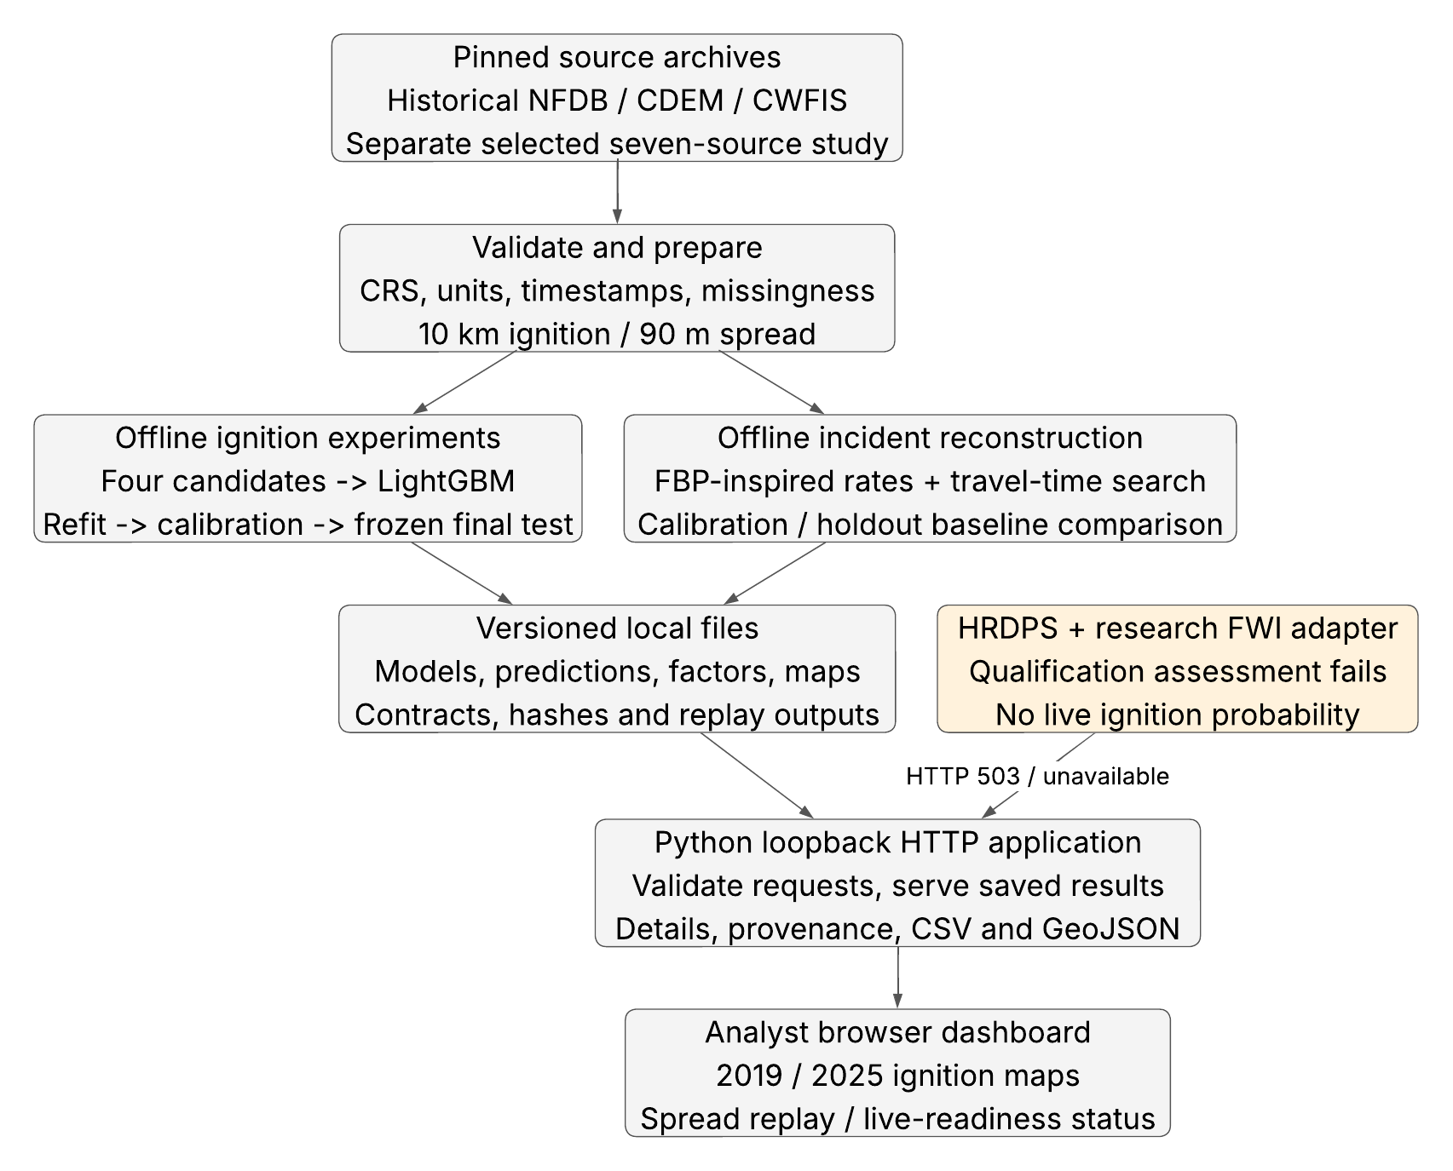
The application uses supervised binary ignition classification and a separate empirical spread simulator. No LLM, generative AI service or paid AI API is used. LightGBM supplies the selected calibrated ignition models. The spread module implements a restricted FBP-inspired rate model and a travel-time search, not the published Cell2Fire engine.
The historical and selected 2025 studies retain separate data contracts. HRDPS ingestion and research FWI calculations are implemented, but the live-readiness assessment returns unavailable. There is no qualified live warning service.

Appendix B Data Flow
Figure 3 Data preparation and result delivery flow
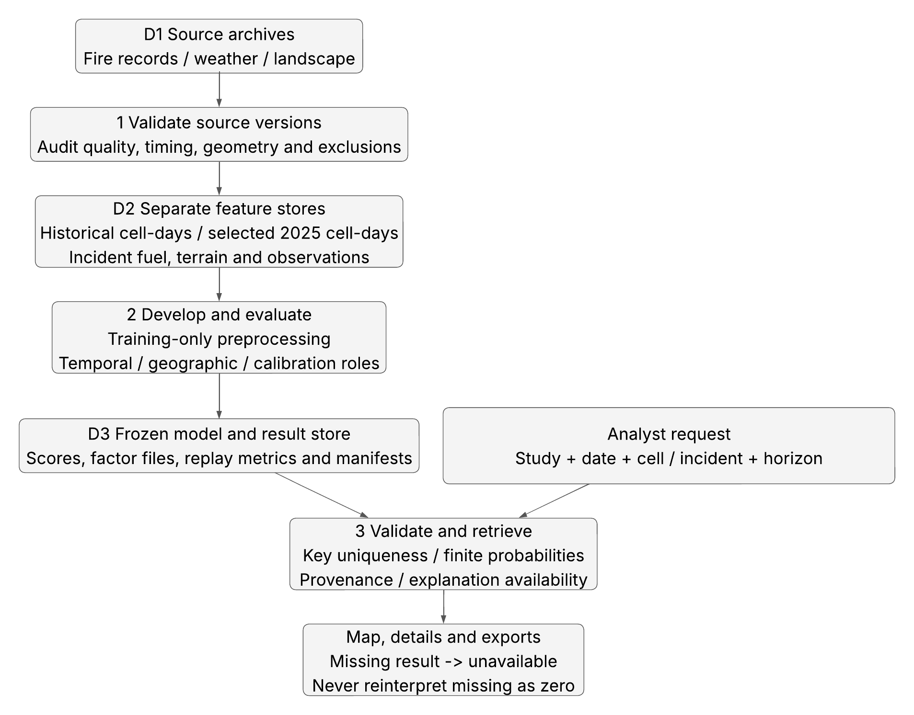
Source validation preserves unknown or missing coverage. Dynamic ignition inputs precede the target day under the documented historical issue-time contract. Model fitting and calibration use separate permitted partitions. The dashboard reads frozen scores rather than retraining a model when a user chooses a date.

Logical Data Relationships
Figure 4 Logical relationships between stored research records
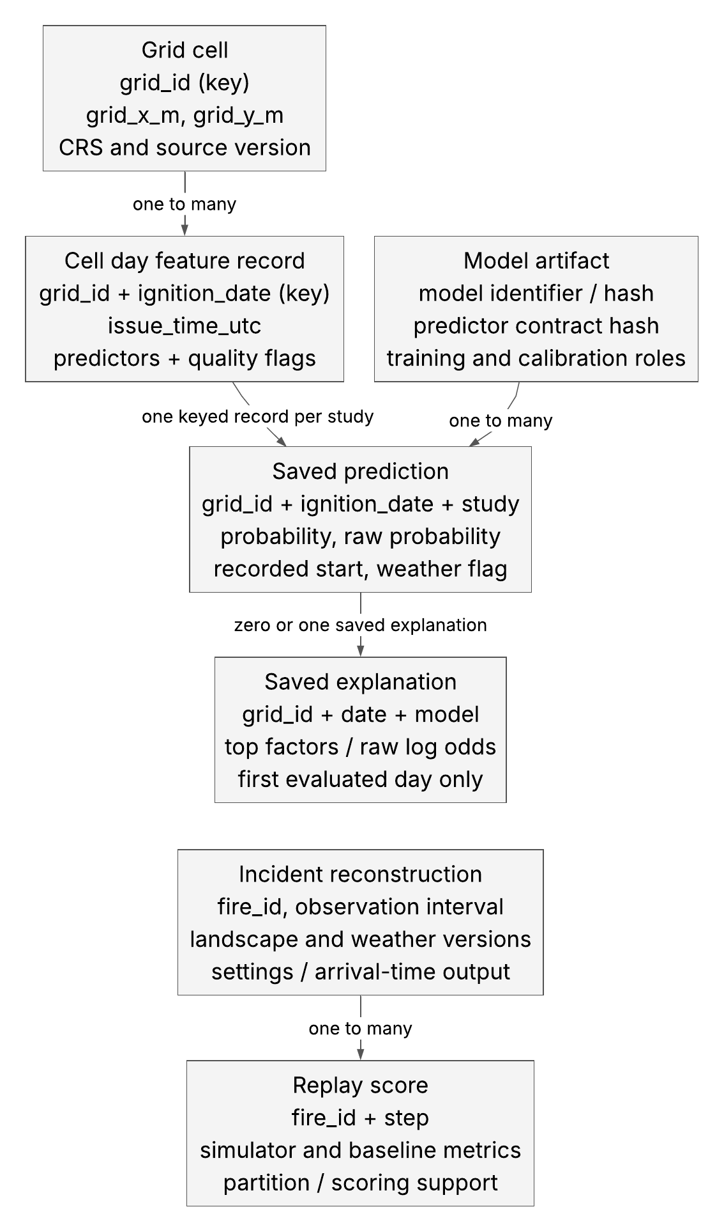
This is a logical ER-style view of Parquet, JSON and model files. Each study has one saved prediction per grid and date; model and feature-contract hashes identify the source. Explanation records exist only for supported first-day keys. Incident and replay records belong to the separate spread capability.

Appendix C End User Use Cases
Figure 5 Research application use cases
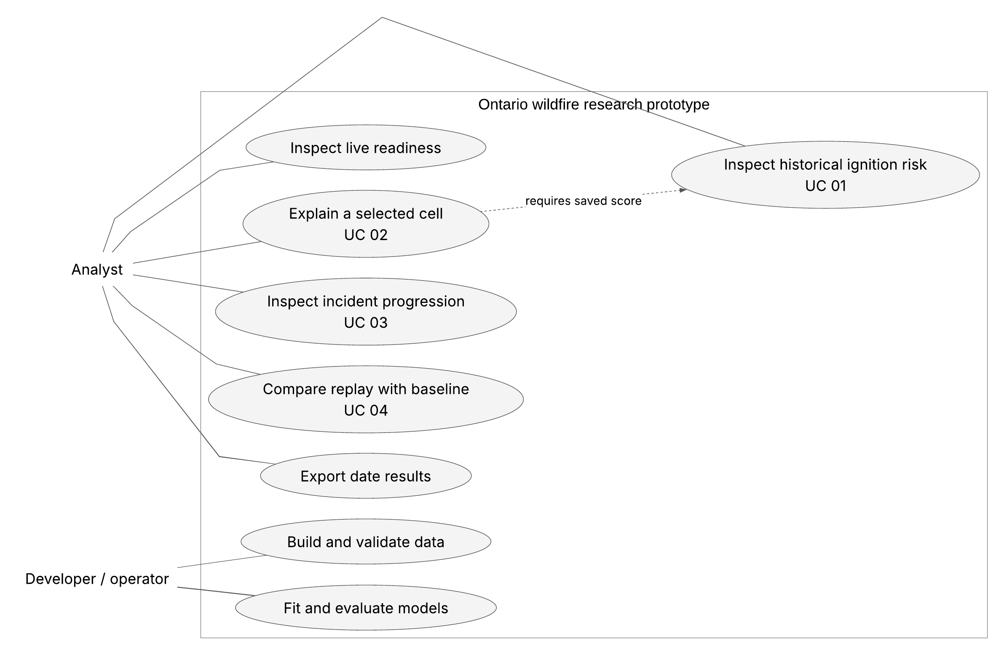
The analyst inspects saved ignition estimates and incident progression, requests available factor details, compares replay outputs and exports results. The developer prepares versioned data and runs controlled offline experiments. The supported incident viewer does not accept arbitrary live initial states.

Ignition Use Case Specifications

UC 01 Inspect daily ignition risk
Actor Analyst. Goal Locate cells ranked by the evaluated model on a supported historical date. Trigger Select a study and date. Preconditions Saved map, prediction table, model and feature contract are available. Priority High. Channel Local web application.
Flow 1 The analyst chooses the historical 2019 or selected 2025 study. 2 The browser loads its date-indexed map. 3 The analyst chooses a date and cell. 4 The application displays the matching probability and quality flags. 5 The analyst requests details or exports the selected date.
Exceptions Unsupported or malformed dates are rejected. Missing or unreadable files return unavailable. Duplicate saved keys and nonfinite probabilities are rejected. No missing result is represented as a zero-risk prediction. Success A supported score is displayed with the correct study, date and cell. Trace FR 01 to 03, 05 and 06.

UC 02 Explain a selected prediction
Actor Analyst. Goal Understand available model factors and data quality. Trigger Request Cell details and provenance after selecting a cell. Preconditions A saved score exists. Priority High. Channel Local web application.
Flow 1 Validate study, date and grid key. 2 Read the exact saved score and model/contract hashes. 3 If the selected date has a saved explanation, read matching feature values and units. 4 Show raw-log-odds contributions and missing flags. 5 Clear displayed details when the selected date or cell changes.
Exceptions Saved factors are available only on the first evaluated day. Other dates retain the probability and provenance with factors explicitly unavailable. Network failures and a 15-second request timeout display an error. Contributions are model attributions and do not establish causation. Trace FR 04, 05 and 13.

Spread Use Case Specifications

UC 03 Inspect an existing fire reconstruction
Actor Analyst. Goal Explore the implemented progression of a supported incident. Trigger Open corrected spread reconstruction and choose one of four incidents. Preconditions The versioned viewer contains that incident and completed arrival-time output. Priority High. Channel Local web application.
Flow 1 Select the incident. 2 Choose replay between satellite observations or the initial six-hour view. 3 Select the displayed horizon or timeline position. 4 Inspect simulated extent, weather and observed detections. 5 Read the reconstruction and validation-limit banner.
Exceptions Arbitrary live-state initialization and live rerunning are outside the submitted dashboard. Empty-state, barrier and corner checks are exercised by engine regression tests. One-, three- and six-hour outputs are simulations; no horizon-specific forecasting accuracy is claimed. Success The chosen completed output and elapsed time are displayed. Trace FR 07, 08 and 10.

UC 04 Compare historical replay
Actor Analyst. Goal Judge simulator value against even growth. Trigger Choose a supported replay interval. Preconditions Candidate and baseline share the target and observation support. Priority High. Channel Local web application.
Flow 1 Choose an incident and eligible interval. 2 Inspect reached and missed satellite cells. 3 Compare candidate and baseline recall and the retained aggregate metrics. 4 Read sample counts, calibration/holdout roles and observation limitations.
Exceptions Missing observations are unknown, not confirmed unburned ground. Aggregate scoring covers 150 steps from 22 fires with usable observations. Final-perimeter assistance and retrospective weather identify reconstruction. The corrected simulator scores below the baseline overall, and the report retains that result. Trace FR 09, 10 and 12.

Appendix D Class and Module Components
Figure 6 Implemented class and module relationships
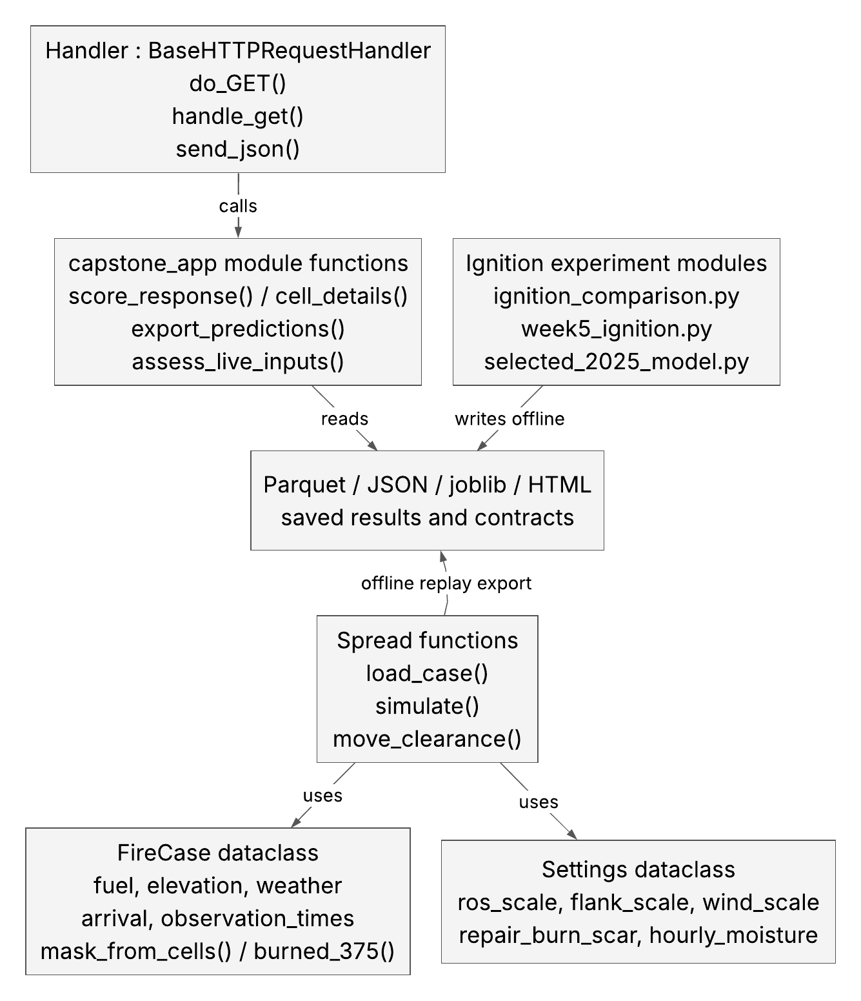
Handler extends Python BaseHTTPRequestHandler and calls the application functions. FireCase and Settings are actual dataclasses in the spread engine. The experiment boxes represent Python modules and functions rather than invented classes. Scientific computation writes versioned artifacts offline; the request handler reads the resulting files.

Ignition Interaction Flow
Figure 7 Ignition inspection and explanation interaction
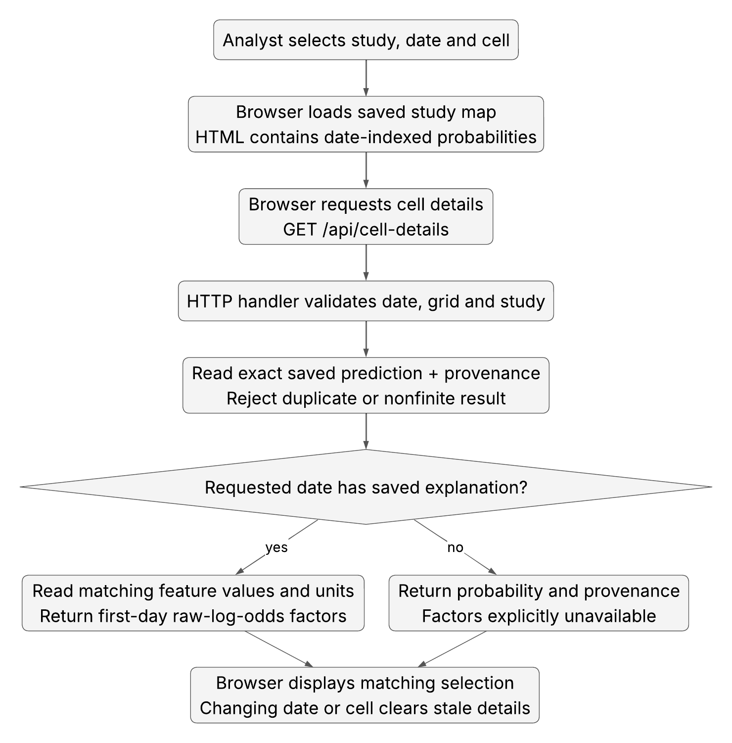
This interaction describes the submitted UI and HTTP routes. Its score is a saved final-evaluation prediction. The route validates the key and attaches model and feature-contract provenance. It does not fit or recompute a real-time model at request time. Changing selection clears stale factors.

Spread Interaction Flow
Figure 8 Offline spread and browser replay interaction
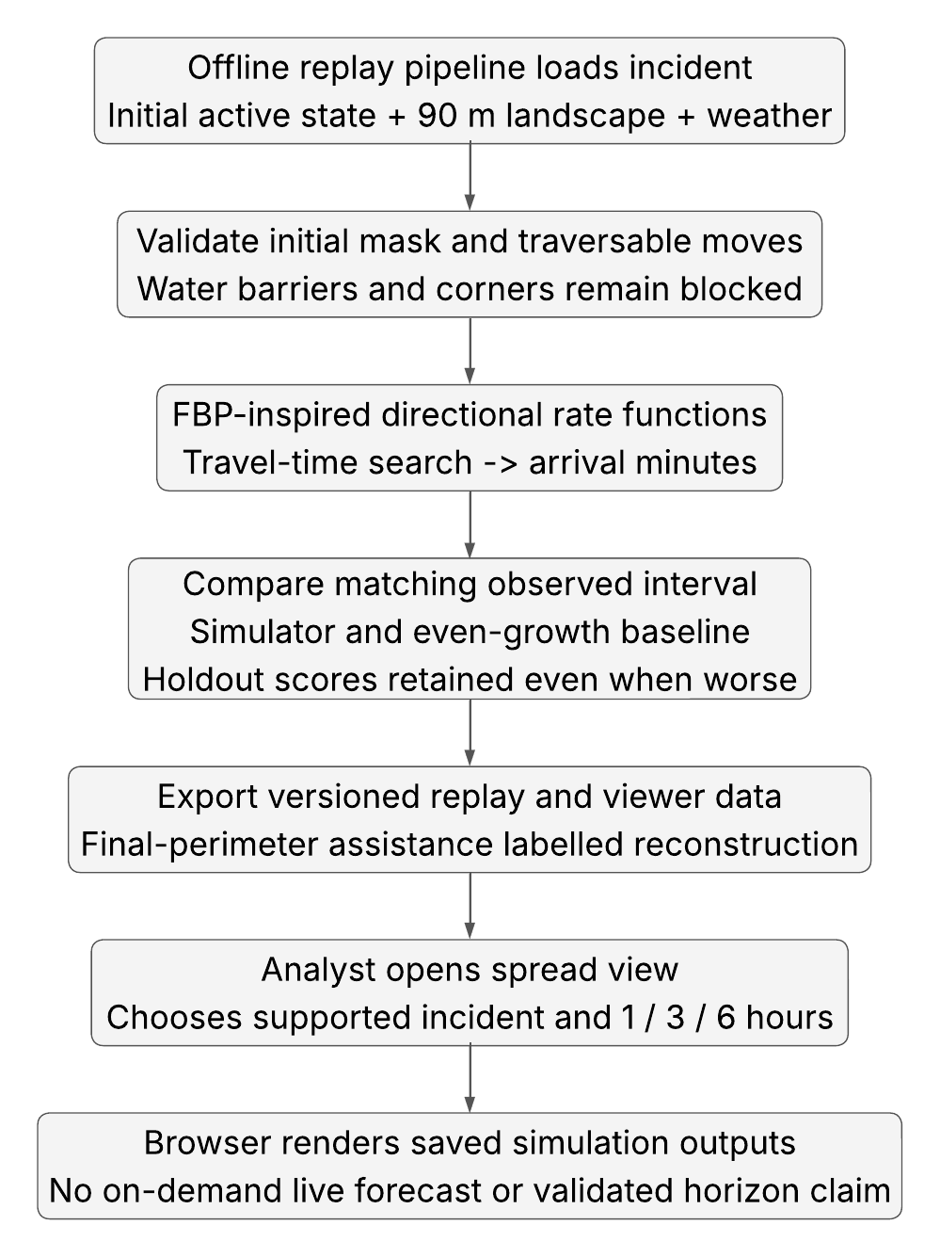
The engine generates arrival-time outputs offline from incident state, landscape and weather. The browser selects among those completed outputs. The baseline comparison uses matched observed intervals; the reconstruction inputs and 6-to-30-hour observation gaps cannot validate one-, three- or six-hour operational forecasts.

Appendix E Exploratory Data Analysis
Figure 9 Corrected historical development weather coverage
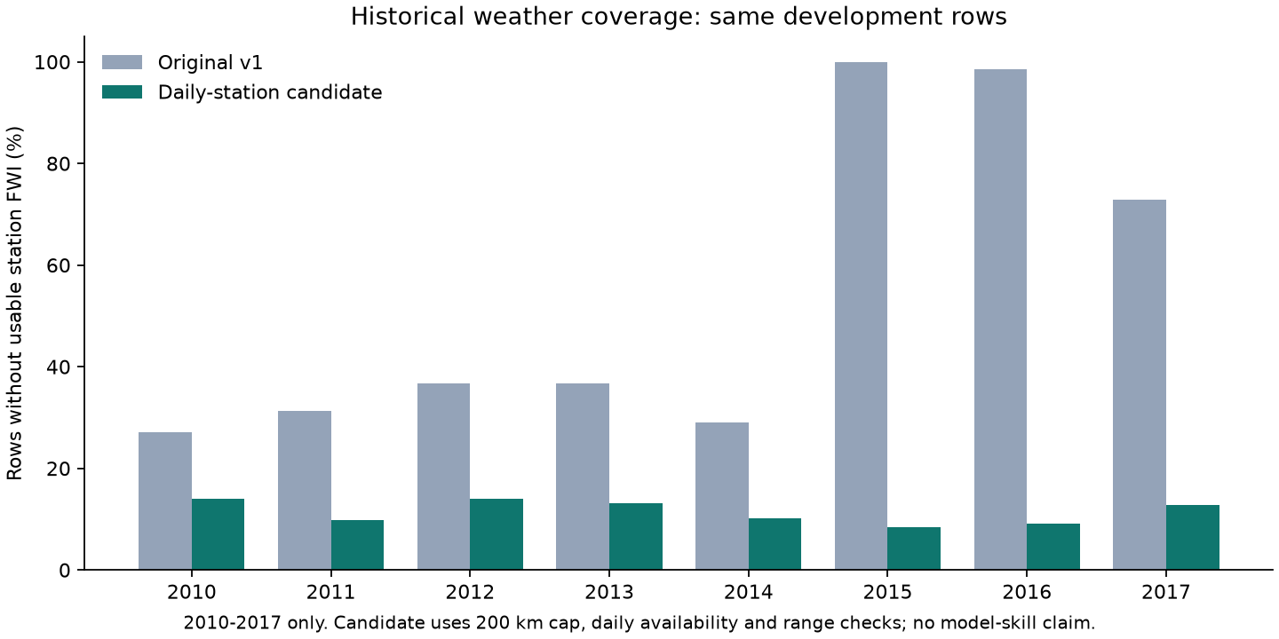
The corrected weather join reduced historical development missingness from 54.0506% to 11.4542% across the same 14,238,656 development rows. Source gaps remain explicit. This correction changes usable weather coverage; it does not demonstrate forecast-source parity.
Study | Cell days | Positive cell days | Positive share
Historical final 2019 | 1,779,832 | 509 | 0.02860%
Selected 2025 panel | 1,775,232 | 600 | 0.03380%
Selected final Sep to Oct | 588,528 | 102 | 0.01733%

These rare event rates explain why accuracy alone would be misleading. AP, fixed-budget precision and recall, Brier score and comparisons with prior/baseline outputs are retained. EDA also checked coordinate systems, duplicates, source exclusions, time ordering, categorical fuel shares and missingness. Historical and selected panels are not pooled.

Appendix F Functional Requirements
ID | Required behavior | Current acceptance
01 | Select supported study and date | Implemented for saved evaluated periods
02 | Return unique bounded ignition scores | Implemented with invalid-result rejection
03 | Map the 10 km grid | Implemented with numeric probability bands
04 | Show model factors | First evaluated day only; otherwise unavailable
05 | Show source and quality provenance | Implemented for supported score/detail routes
06 | Export CSV and GeoJSON | Real packaged exports verified
07 | Initialize and inspect incident spread | Restricted supported reconstruction workflow
08 | Display 1, 3 and 6 hour outputs | Implemented simulation controls; skill unvalidated
09 | Compare replay with baseline | Corrected same-target comparison retained
10 | Distinguish reconstruction from forecast | Explicit banners and report qualification
11 | Build versioned data | Code, contracts, source audits and hashes
12 | Compare candidate models | Four candidates and frozen evaluation roles
13 | Save and reload models | Calibrated bundles and original parity evidence
14 | Qualified live weather scoring | Live M2 acceptance unmet
15 | Trusted live FWI state | Live M2 acceptance unmet
16 | Ensembles and treatment ranking | Optional future research

IDs correspond to FR-01 through FR-16 in the full SRS. This progress report records restricted implemented behavior; it does not silently replace broader original requirements. Full original requirements and the current acceptance record are included in the code ZIP.

Quality Requirements and Acceptance
ID | Quality attribute | Evidence and limit
01 | Time and availability correctness | Guards tested; historical publication times unknown
02 | Units geometry and state | Software contracts tested; no field certification
03 | Reproducibility | Frozen artifacts, contracts and hash manifest
04 | Appropriate metrics | AP, precision/recall and Brier with prevalence
05 | Fair baseline comparison | Weak and negative outcomes retained
06 | Ignition UI response | Warm local map/detail timing targets passed
07 | Spread response | 20-case saved load plus simulation timing
08 | Explicit failure behavior | Unavailable, invalid keys and timeout paths
09 | Usability and accessibility | Implementer checks only; independent acceptance open
10 | Source provenance and access | Public credits, loopback binding and route allowlist
11 | Maintainability and tests | 129 tests; inline dashboard/orchestration debt
12 | Portability and deployment | Relocated-folder checks; clean install unverified

The measured warm map p95 was 0.4078 seconds, current detail API p95 0.1142 seconds and saved load-plus-six-hour simulation p95 0.1143 seconds. These records exclude cold data rebuilding, a full fresh dependency installation and independent accessibility or field validation. Native Microsoft Project verification remains user-deferred.

Appendix G Real Test Evidence
The full automated suite was rerun from the assembled code-iteration layout on October 16, 2026. The existing Python environment was used. It passed 129 tests in 3.81 seconds. The original working project also passed 129 tests in 4.30 seconds during submission preparation.
python -m pytest tests team_repository/tests
team_repository/capability_2_fire_spread/tests -q
129 passed in 3.81s
Check | Actual result
Four application pages | HTTP 200 with complete response bodies
Historical and selected saved scores | Both HTTP 200 with model and contract provenance
First-day detail routes | Feature values, units and factors returned
Later historical date | Probability retained; factors unavailable
Historical CSV | 9,673 data rows
Selected CSV and GeoJSON | 9,648 rows / 9,648 features
Invalid calendar date | HTTP 400
Live ignition | HTTP 503; probability null

Fourteen HTTP smoke checks passed from the relocated package folder. The logs and JSON responses are in evidence/submission_verification. A bulk-read client initially hit a macOS socket buffer error while receiving the large historical map; the streaming-client check then completed all responses. No application logic or model was changed for that check.
Existing regression tests cover weather/time contracts, input schemas, keyed map payloads, score validity, missing artifacts, fuel barriers, diagonal corners and empty active states. Passing software tests verifies these behaviors; it does not establish wildfire prediction skill.

Dashboard Evidence for Ignition
Figure 10 Actual local ignition study capture
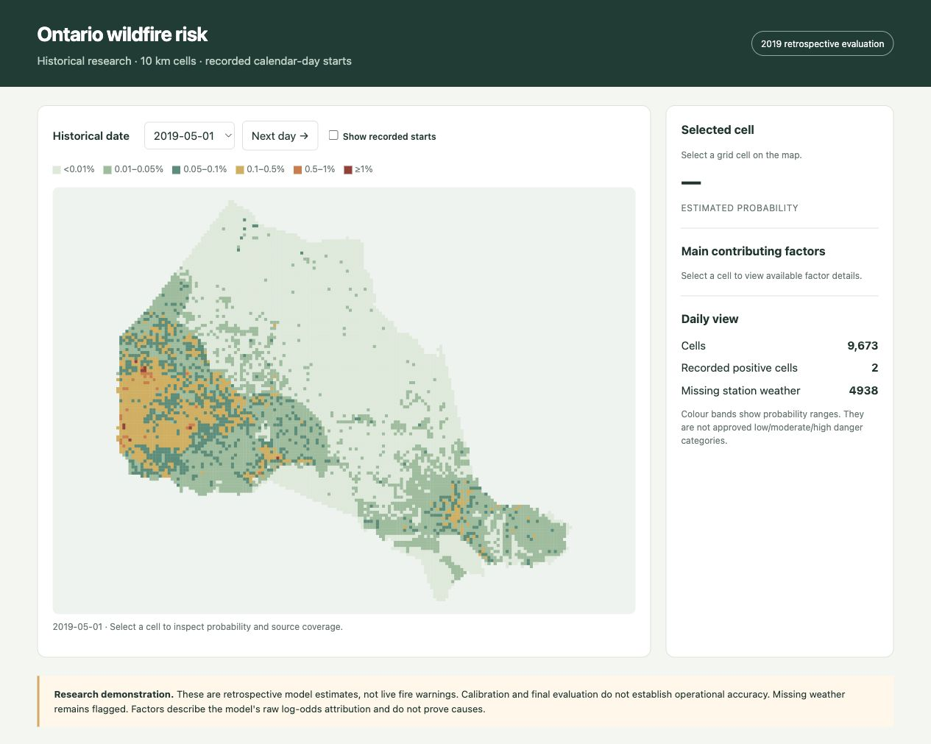
Captured from the running local application during submission preparation. The study view identifies retrospective research and shows the evaluated 2019 ignition map; the dashboard keeps the 2025 study separate. Selecting a cell supports saved probability, source-quality inspection and available factor details. CSV and GeoJSON exports were independently checked over HTTP; the original browser review also records a real CSV download.
The screen capture documents the implemented interface. It is not a synthetic mockup and does not imply independent user acceptance. Model performance is established by the frozen experiment records in the Results section.

Dashboard Evidence for Spread and Live State
Figure 11 Actual corrected spread replay capture
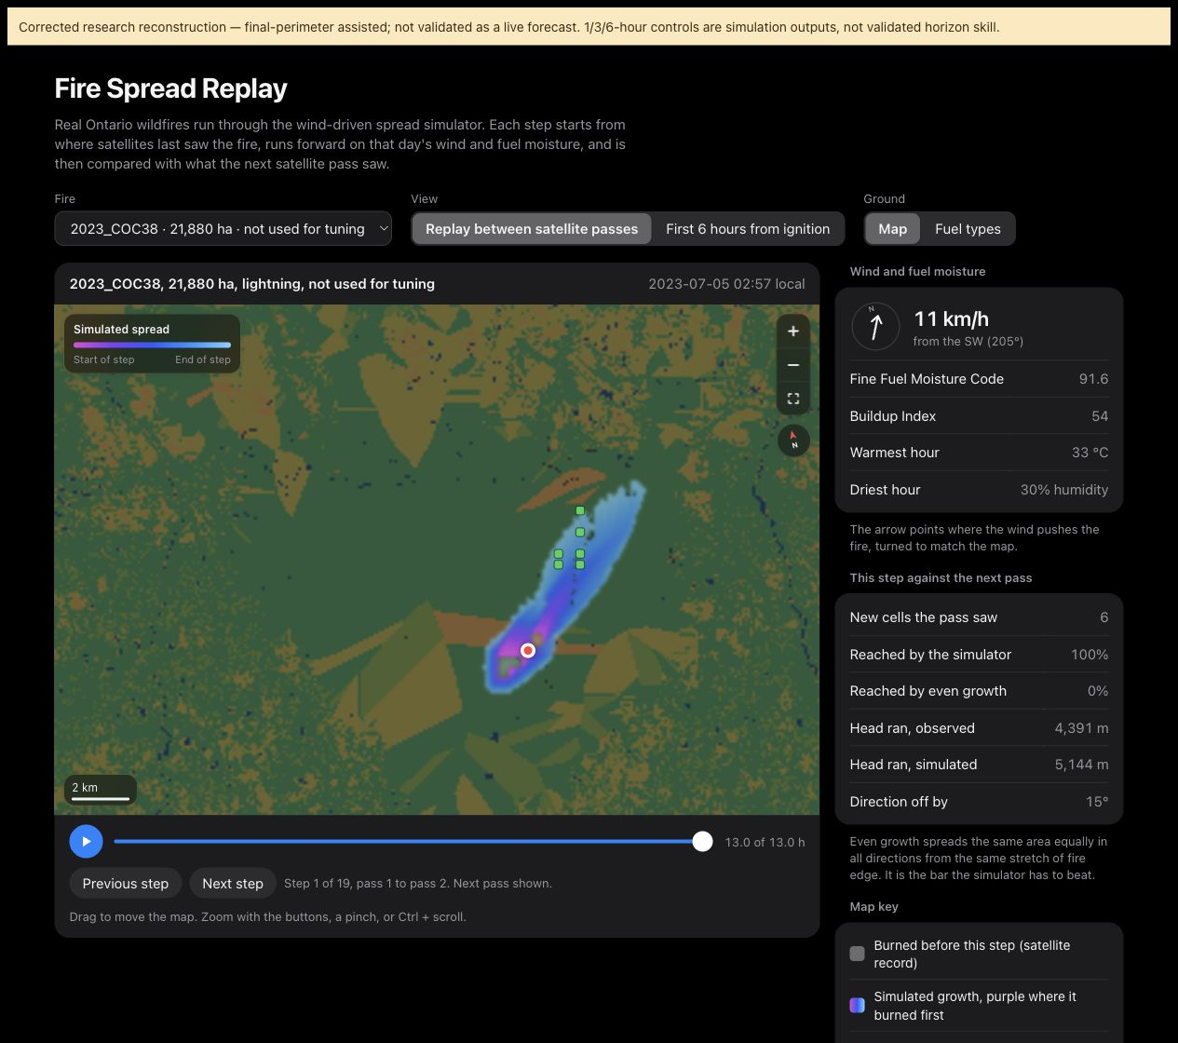
Figure 12 Actual unavailable live ignition capture
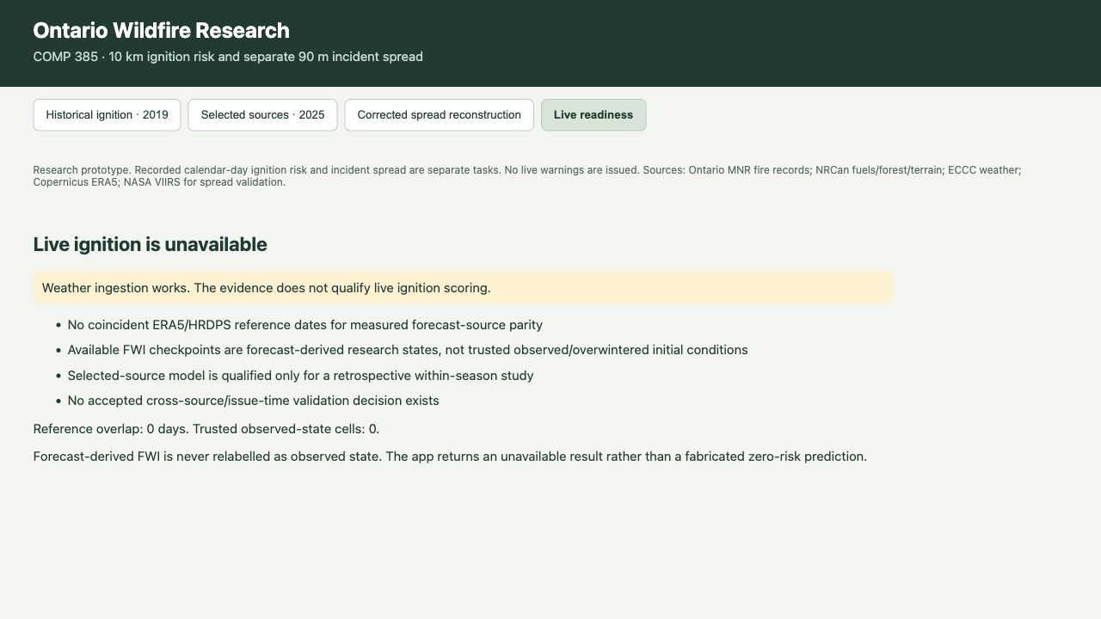
The spread view labels final-perimeter-assisted reconstruction. The live view reports zero matched reference dates and zero trusted observed-state cells. Neither display certifies operational forecasting.

Appendix H Local Deployment
Figure 13 Local deployment topology
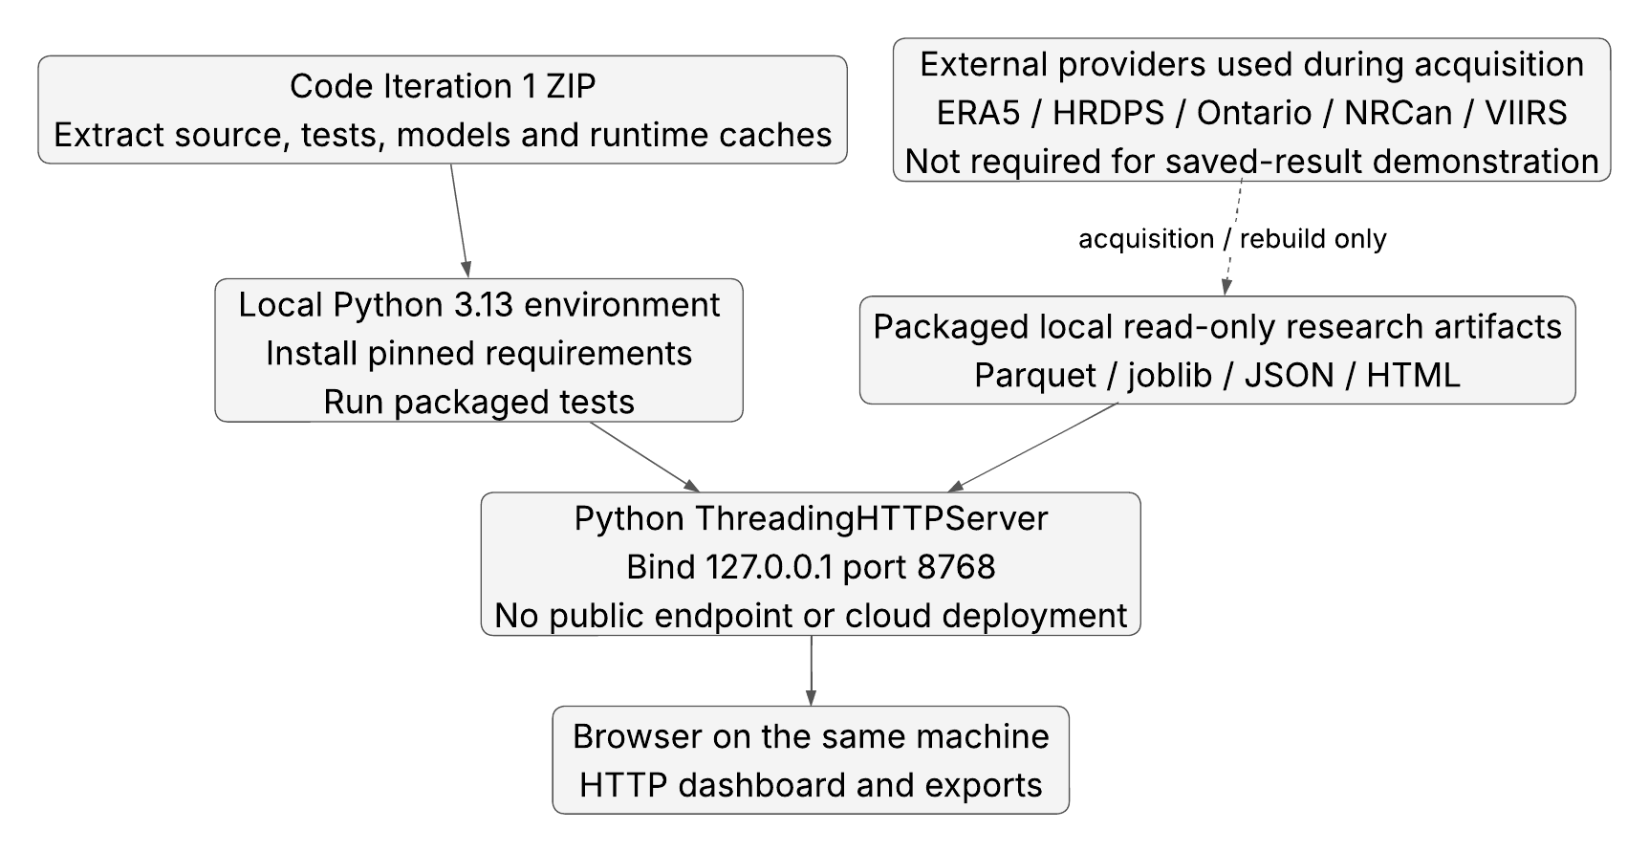
The demonstrated deployment is a Python loopback server and browser on the same Mac. The submitted code package includes saved results and the runtime feature caches required by the score, details and export routes. There is no cloud/public endpoint, hosted inference service or production deployment.
Use Python 3.13 and the supplied dependency lock. Start the server from the extracted code root with python -m scripts.capstone_app serve --port 8768 and open http://127.0.0.1:8768/. Stop it with Ctrl+C. The exact setup and demonstration sequence are in the code README.

ML Operations and Release Procedure
Versioning Each source, feature contract, model and result is associated with stored versions or hashes. The historical and selected-source model families remain separate. The code submission manifest records included-file hashes, while dated experiment records preserve original lineage and exclusions.
Training and calibration Historical final models refit on 2010 to 2017, calibrate on 2018 and evaluate on 2019 after choices are frozen. The selected 2025 study refits on May to July, calibrates on August and evaluates September to October. Prior broad EDA exposure is disclosed. A new idea requires a separately versioned development experiment and a justified new test design.
Release gate Run the full suite, verify runtime artifact hashes and smoke-test the score, details, exports, viewer and unavailable responses. Keep scientific final results unchanged. The current dashboard serves stored outputs and logs requests locally; it does not automatically retrain or issue warnings.
Monitoring The recorded quality ledgers track missing weather, source vintages, data counts and rejected keys. The prototype has no automated production drift monitoring, scheduled retraining or external alerting service. Those require deployment-specific validation and review before implementation.
Rollback Retain the dated code and artifact packages. Restart with the prior verified package only when its source and model contracts match. Never relabel forecast-derived FWI state as observed to make a readiness check pass.
Live qualification Before live scoring, acquire genuinely matched forecast/reference observations, verified observed or overwintered FWI state and an accepted source/issue-time compatibility evaluation. Current readiness fails all of these acceptance needs. Independent team, professor, user and field acceptance remain unverified.

Appendix I Submitted Code Iteration
The separate Code Iteration 1 ZIP contains the source, tests, dependencies, diagrams, saved models and predictions, study HTML pages, runtime feature caches and real verification evidence. Its README provides setup, the demonstration sequence, test commands and the boundary between saved-result reproduction and a complete scientific rebuild.
Folder or file | Submission purpose
scripts | Current local data, modelling and application code
team_repository | Team historical and spread code, tests and metadata
tests | Local preparation, model, schema and API regression tests
data/processed | Frozen runtime models, predictions and detail caches
data/raw/samples and ignition_pilot | Existing test fixtures and earlier pilot history
reports | Dated methods, audits, results and acceptance records
docs/diagrams | Editable and rendered current diagrams
evidence/submission_verification | Current tests, HTTP checks and environment record
requirements-lock.txt and README.md | Pinned environment and exact run instructions
MANIFEST.sha256.json | Hash and size inventory for packaged files

The source and scientific runtime assets are copied without retraining or retuning. Full national raw rasters, complete historical training/calibration archives and all replay landscapes are excluded; full rebuilding requires their pinned sources. This is a runnable saved-result prototype submission, not certification of a clean-machine raw-to-model rebuild.
Before submitting, the student authors complete their names, IDs, program, declaration and signatures on the cover. No professor approval, stakeholder confirmation, native Microsoft Project verification, external submission or production deployment is asserted.

