Question 2.1

1)

|  |  |  |  |  |
| --- | --- | --- | --- | --- |
| Video Clip | Bgr-color | Color-threshhold | Erode/dilation iterations | Minimum radius size |
| ball1.mp4 | 30, 15, 140 | 70 | 1/1 | 10 |
| ball1-quake.mp4 | 30, 15, 140 | 70 | 1/1 | 10 |
| ball1-noise.mp4 | 30, 15, 140 | 70 | 1/1 | 10 |
| ball2-verywatery.mp4 | 30, 15, 140 | 70 | 1/1 | 10 |

2)

ball1.mp4

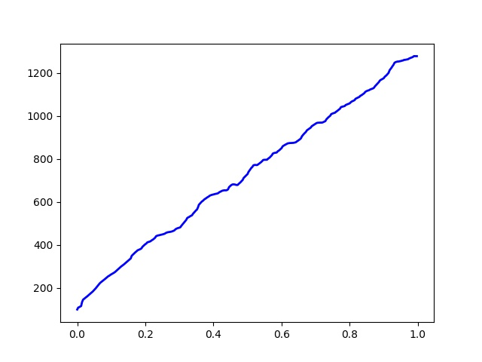

ball2-verywatery.mp4

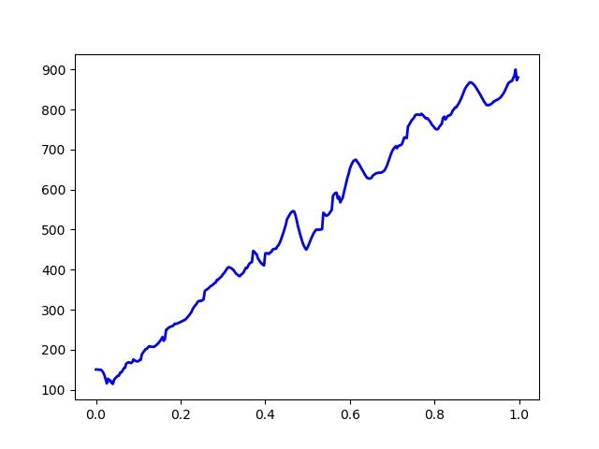

ball1-noise.mp4

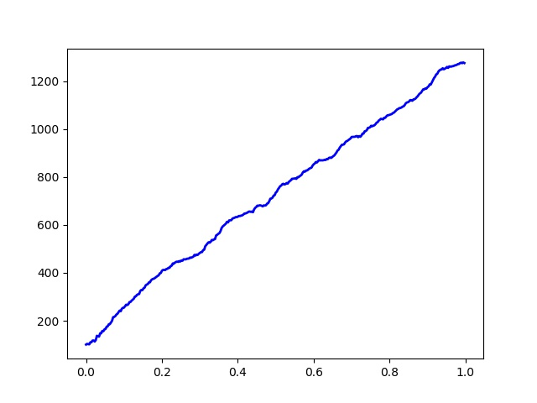

ball1-quake.mp4

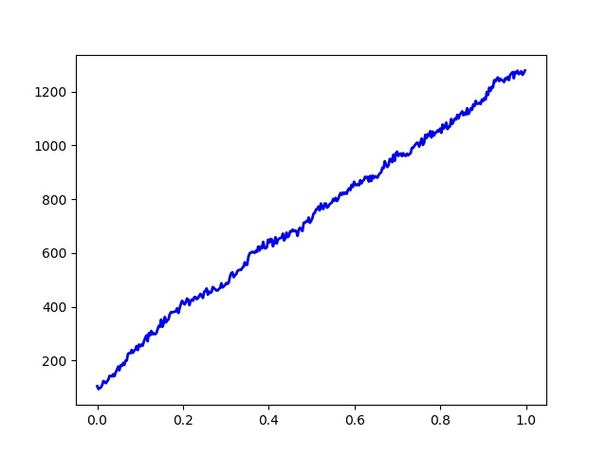

Question 2.2

Ball1.mp4

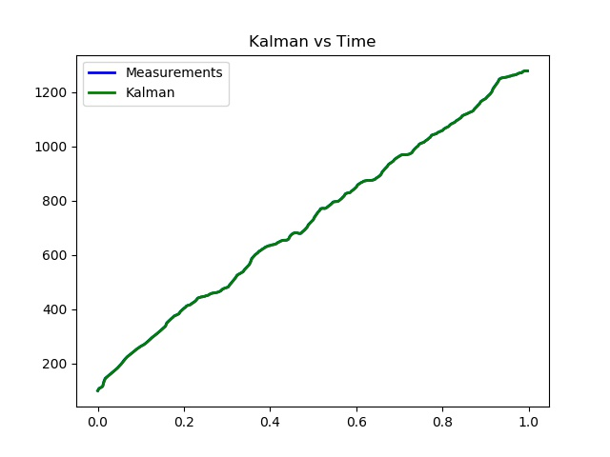

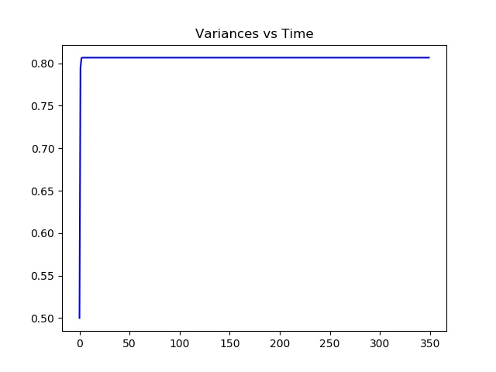

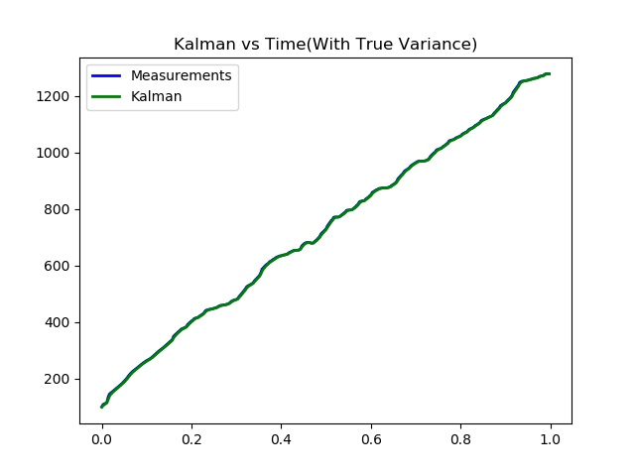

Ball1-quake.mp4

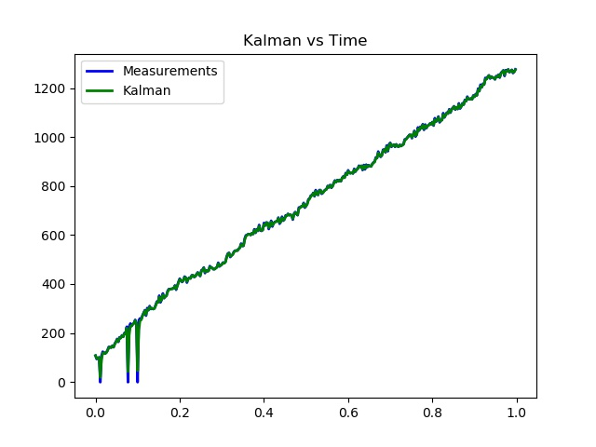

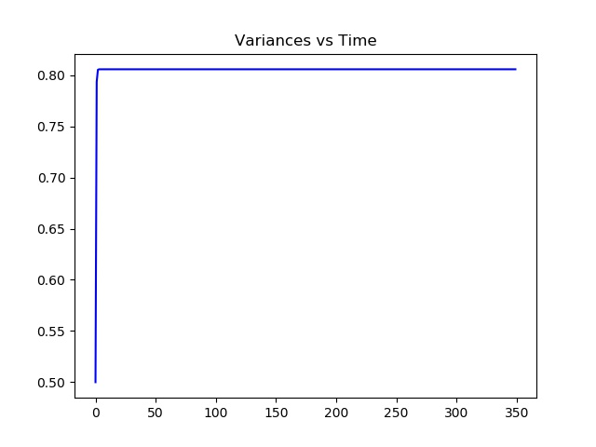

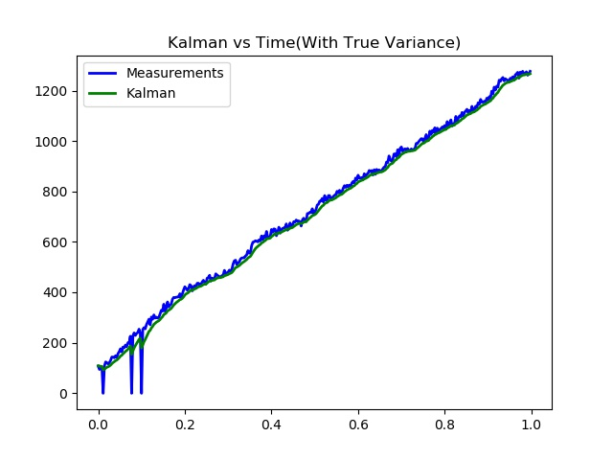

Ball1-noise.mp4

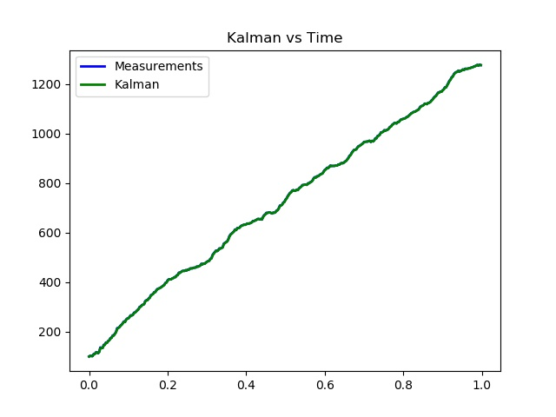

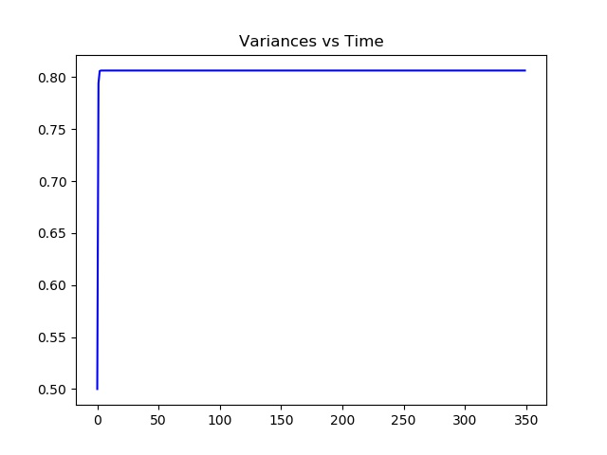

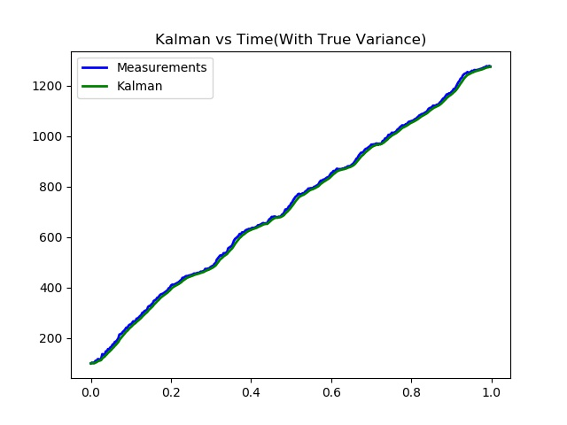

ball2-verywatery.mp4

