1 a)

Planning Phase

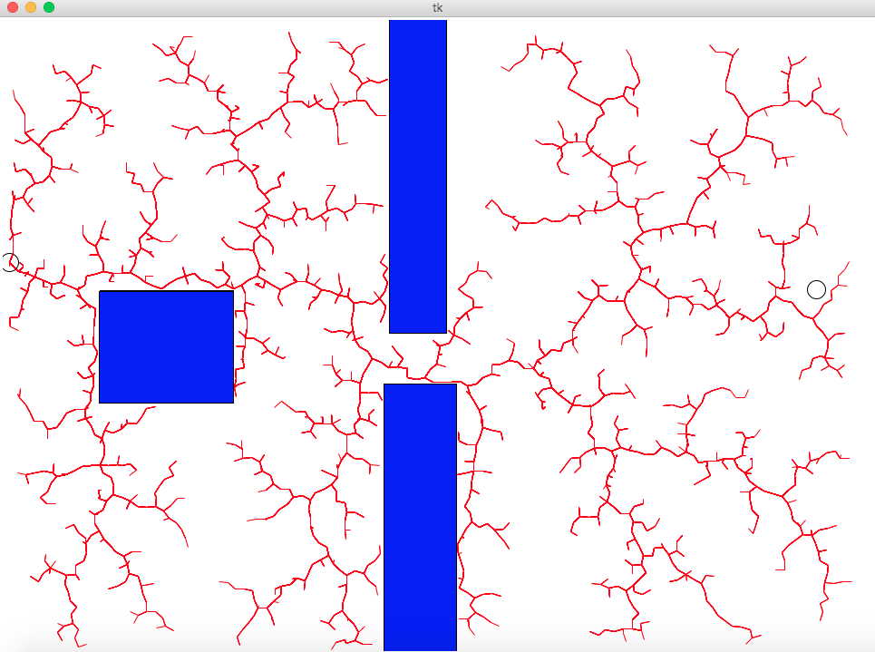

Final Phase

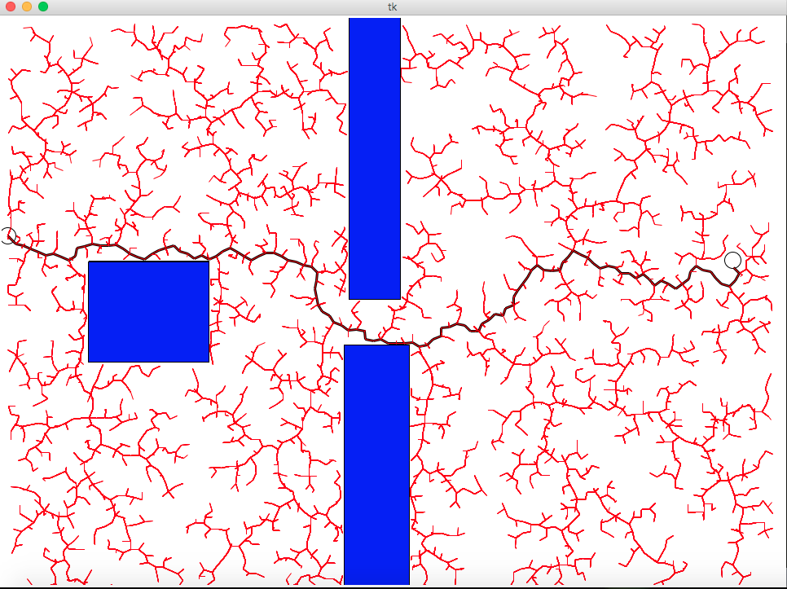

1b)

Planning Phase

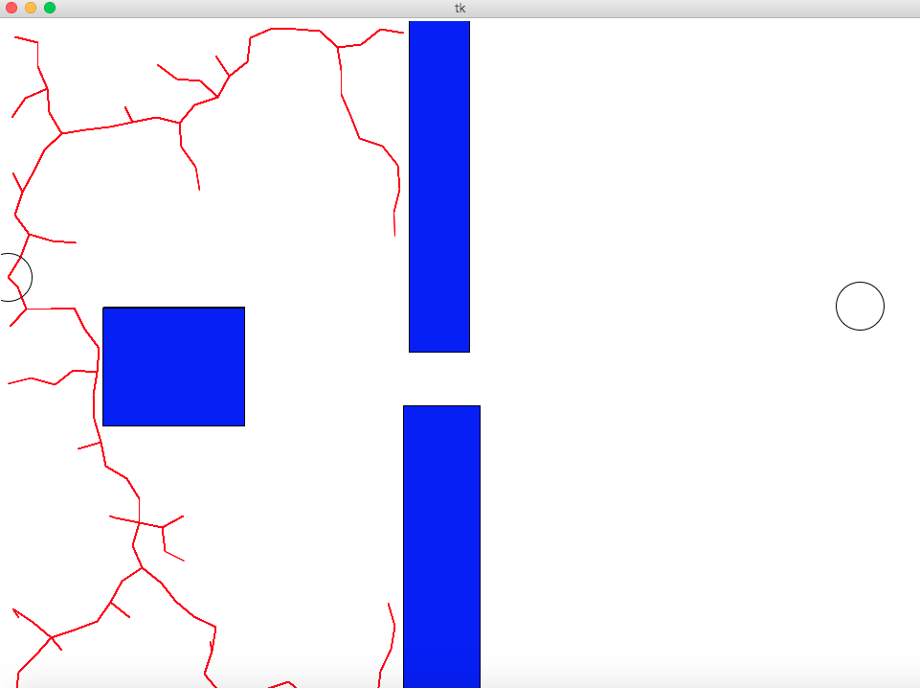

Final Phase

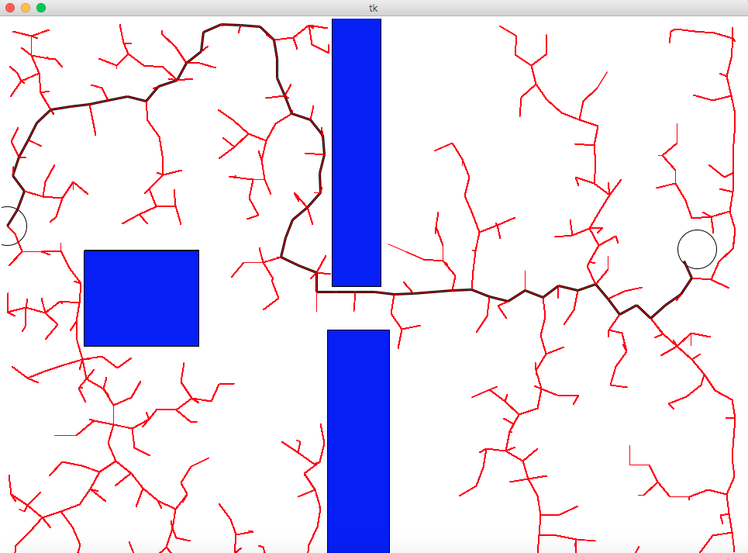

When we sample uniformly, we notice that the tree grows randomly in all the directions possible irrespective of whether it’s getting close to the target or not. In other words, it’s a space filling tree and so will eventually find a path but it will not be optimal.

However, in the case of Gaussian sampling, we notice that the tree grows relatively more optimally in that it grows roughly towards the target. When it hits an obstacle, it takes time to go around it because it’s still trying to find an optimal path to the target and the next points in the sample lie on the other side of the obstacle. Overall it reaches the target more optimally and is not because of the space filling property like it was in the case of uniform sampling.

1 c)

As we can see in the chart plotted below, as the step-size increases, the total number of iterations required to reach the target generally tend to decrease. This is understandable because a bigger step-size will generally allow the robot to travel greater distance and thus reach the target quicker.

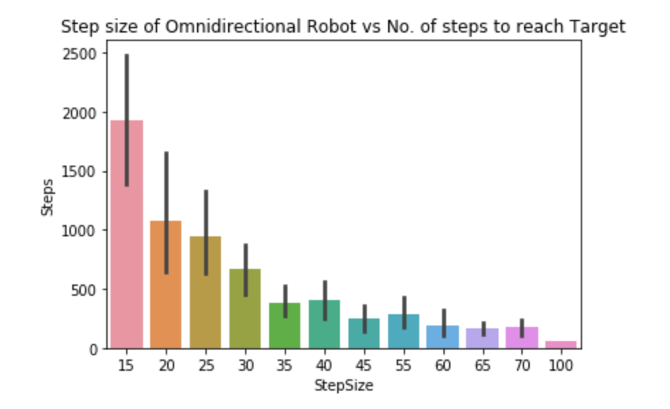

2 a)

Planning Phase

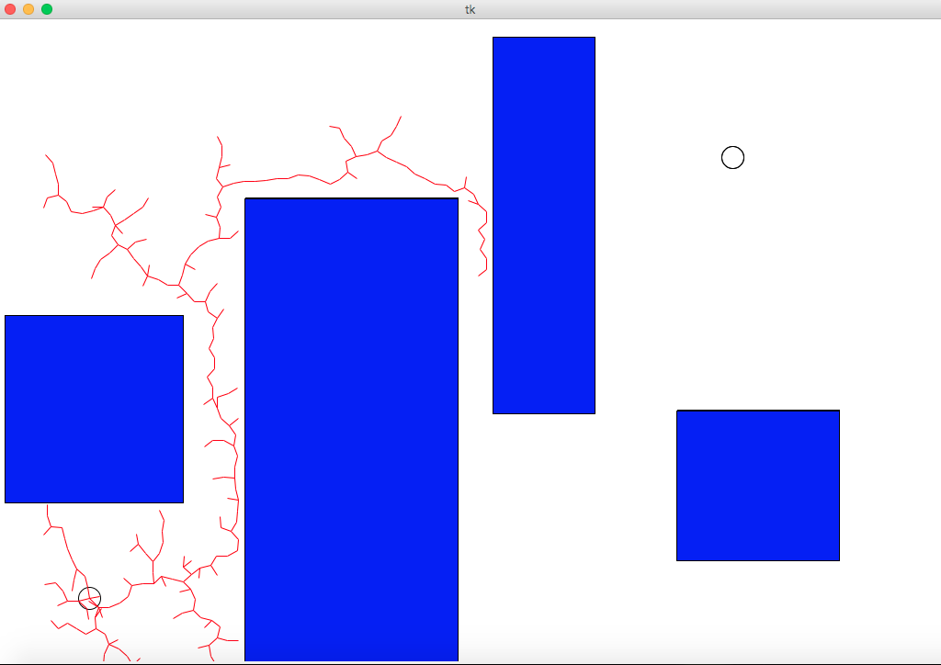

Final Phase

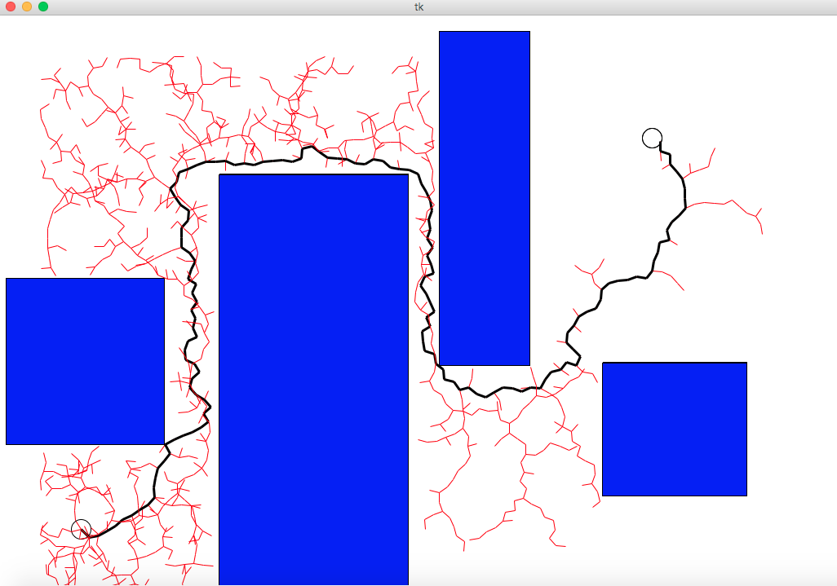

2 b)

As we can see in the chart below, as the length of the line robot increases, the number of iterations to reach the target also tend to increase. Although this relationship isn’t as clear as that of ‘step-size vs number of iterations’, we can think of it in general terms. [Largely, however, it depends on the length of the robot relative to the kind of map we have i.e. how the obstacles are placed.]

This makes sense because as the length of the line robot increases, the number of restrictions to where the robot can go increases due to the obstacles in the map. There become less possible configurations with the growing length, so more points need to be sampled in order to find feasible configurations and this means more steps (iterations).

