MD2201 Data Science
Course Project
S.NoDivBatch NoGroup NoRoll NoGr.NoName of Student1CS-BB3035212111279Sumedh Kate25912111226Dipkul Khandelwal36012110563Arya Khandetod46112110054Siddesh Khaple56212110040Aishwarya KharadeScience

Date of performance:

Project Title: Crop Yield Prediction

Data Set Name: crop_prediction.csv

Data set Link:

https://github.com/uditbsinghal/Recommendation-of-crop-and-yield-prediction

Objective:

The main objective of this project is to predict the crop yield we will get in particular region by applying different algorithms.

Project Description:

In this project we have used crop_prediction dataset for application of the algorithms. This dataset contains information like district name, crop name, season, minimum and maximum values of temperature, rainfall and pH, Production values etc.

. Initially we worked on pre-processing of dataset, we checked for the NA values and duplicate values, removed these values from the dataset, splitted the dataset for training and testing. In the project we applied three algorithms decision tree, random forest and Xg boost and calculated R², RMSE, RMAE values for the given dataset using all three algorithms.

Code:
f1=read.csv("main_dataset.csv")

#installing packages
library(ggplot2)
library(caTools)
library(rpart)
library(rpart.plot)
library(Metrics)
library(randomForest)
library(dplyr)
library(stats)
library(caret)
library(xgboost)
#library(caret)
#library(FSelector)
#data<-lapply(data,as.numeric)
#str(data)

#data visualisation
dim(f1)
head(f1)
sum(duplicated(f1))
data<-subset(f1,!duplicated(f1))
data<-subset(f1,select=-c(1))
sum(is.na(f1))

summary(f1)
#f1=data_test_mean
#f1 = read.csv("main_dataset.csv")
#f2<-read.csv("main_dataset.csv")

#normalization
f1_new<-f1[ ,1:14]
n<- function(b){
(b-min(b)) / (max(b) - min(b))
}
f2 <- as.data.frame(lapply(f1_new,n))
f3 <- cbind(f2,Production = f1$Production)

df2 <- f1[,!names(f1) %in% c( "District_Name", "Season","Crop")]
boxplot(df2)
is.na(f1)
summary(f1)

#splitting
set.seed(1234)
sample_data = sample.split(f1, SplitRatio = 0.8)
train_data <- subset(f1, sample_data == TRUE)
test_data <- subset(f1, sample_data == FALSE)

#linear model
l1<-lm(f1$Production ~ f1$District_Name+f1$Crop+f1$Area+f1$pH_min+f1$pH_max+f1$pH_Req+f1$min_temp+f1$max_temp,data=train_data)
s1<-summary(l1)
print(s1)

#Decision tree

#train the decision tree
model1 = rpart(Production ~ Season+Crop+Area+pH_min_Range+pH_max_Range+pH_min+pH_max+pH_Req+min_temp+max_temp+min_rainfall+max_rainfall, data=train_data)

#prediction
pred1 = predict(model1, train_data)

#tree diagram
rpart.plot(model1)

#R square
SSR_DT <- sum((pred1 - mean(f1$Production)))
SSE_DT <- sum((f1$Production - pred1))
R2_DT <- (SSR_DT)/(SSR_DT+SSE_DT)
print(R2_DT)

#rmse
rmse<-sqrt(mean((f1$Production - pred1)^2))
print(rmse)

#mae
mae<-mean(abs(f1$Production - pred1))
print(mae)

#Random Forest

str(f1)
#train rf
RFM = randomForest(Production~ Season+Crop+Area+pH_min_Range+pH_max_Range+pH_min+pH_max+pH_Req+min_temp+max_temp+min_rainfall+max_rainfall,data=train_data)
print(RFM)

#prediction
pred2 = predict(RFM, train_data)

#R square
SSR_RF <- sum((pred2 - mean(f1$Production)))
SSE_RF <- sum((f1$Production - pred2))
R2_RF <- (SSR_RF)/(SSR_RF+SSE_RF)
print(R2_RF)

#rmse
rmse2<-sqrt(mean((f1$Production - pred2)^2))
print(rmse2)

#mae
mae2<-mean(abs(f1$Production - pred2))
print(mae2)

#xgboost
summary(f1)
head(f1)
sapply(f1,class)

#f1 <- f1[,!names(f1) %in% c( "District_Name", "Season","Crop")]

f1[]<-sapply(f1,as.numeric)
set.seed(678)
indices<-createDataPartition(f1$Production,p=0.8,list=FALSE)
train_new<-f1[indices,]
test_new<-f1[indices,]

grid_tune<-expand.grid(
nrounds=c(500,1000,1500),
max_depth=c(2,4,6),
eta=0.3,
gamma=0,
colsample_bytree=1,
min_child_weight=1,
subsample=1
)
train_control<-trainControl(method="cv",number=3,verboseIter=TRUE,allowParallel=TRUE)
xgb_tune<-train(x=train_new[,-6],
y=train_new[,6],
trControl=train_control,
tuneGrid=grid_tune,
method="xgbTree",
verbose=TRUE)print(xgb_tune)

#predict(xgb_tune,test_data)
pred3<-predict(xgb_tune,test_new)

#R square
SSR_XG <- sum((pred3 - mean(f1$Production)))
SSE_XG <- sum((f1$Production - pred3))
R2_XG <- (SSR_XG)/(SSR_XG+SSE_XG)
print(R2_XG)

#rmse
rmse3<-sqrt(mean((f1$Production - pred3)^2))
print(rmse3)

#mae
mae3<-mean(abs(f1$Production - pred3))
print(mae3)

7. Results: Quantitative findings and Plots.

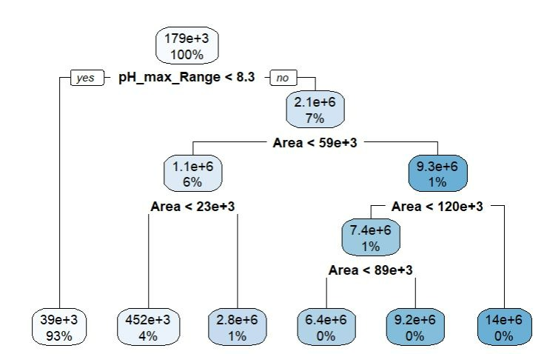

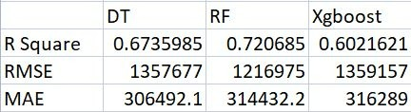

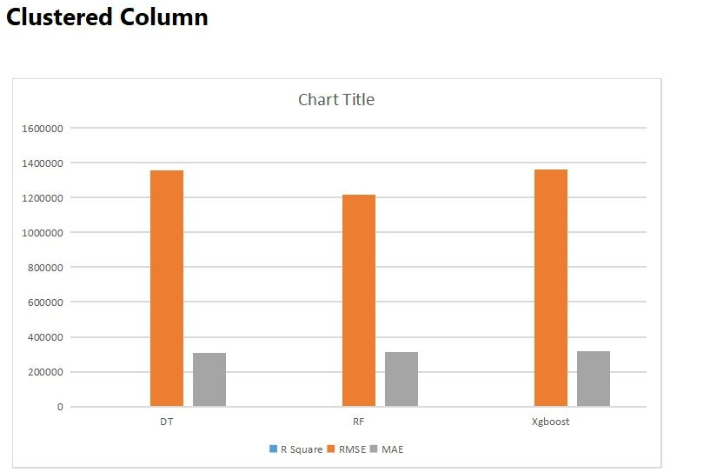

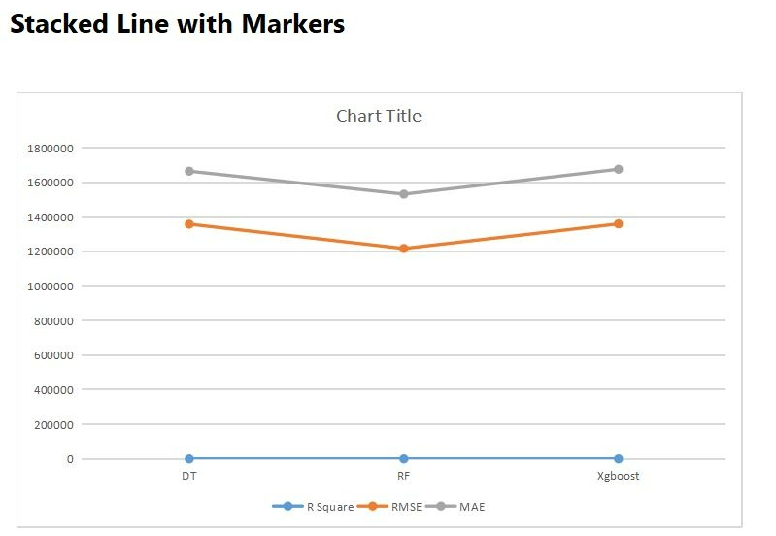

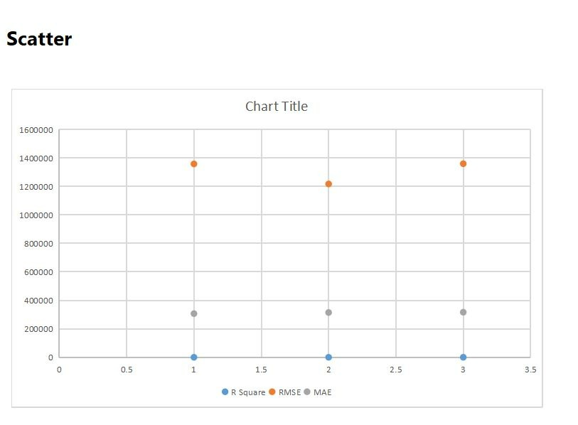

8. Conclusion:

Here in this project, we learnt the application of different algorithms for data prediction and successfully applied Decision tree, Random Forest, Xg-boost on given dataset, calculated summary of dataset and values of R², RMSE, MAE for each algorithm.

Decision Tree:
R²=0.673

RMSE=1357677

MAE=306492.1

Random Forest:

R²=0.7206

RMSE=1216975

MAE=314432.2

Xg-boost:

R²=0.6021

RMSE=1359157

MAE=316289

