**Project_0501_11_Proposal**

**Ching-Hsiang(Andy) Mao, Zhaoyi Li, Parth Kodnani, Heng Zhuang**

* **Topic**: Housing reviews around College Park
* **Brand name**: Data WhereHouse
* **Mission Statements:** 
  + To provide the future residents with more information about the various aspects of reviews and ratings to make their selection task easier and smoother. On the other hand, the residents can also post reviews on the apartment website to improve the transparency for apartment information and the living conditions.
* **Mission Objectives:**

1. To find the apartments with good quality(ex: having average rate over 4)
2. To find the apartment which has the worst quality that the future residents may want to avoid.
3. To find the apartments with a gym, a pool and a club.
4. To find the cheapest apartment units in college park area
5. To find the top 5 longest comments with username and apartment name

* **ER Schema**:

## Entities, Attributes and Primary Keys

Apartment(**aptId**, aptName, aptAddress, -aptStreet, -aptCity, -aptState, -aptZipCode)

Unit(**unitId**, unitBuilding, unitFloor, unitNumber, unitBeds, unitBaths, unitFurnished, unitRent)

Amenity(**amenId**, amenElectricity, amenGas, amenWater, amenMaintenance, amenGym, amenPool, amenClub)

Reviewer(**rwerId**, rwerName)

## Relationships, Attributes, Degrees, Participating Entities and Constraints

Write (revId, revRate, revContent, revDate): binary relationship  
 1 Reviewer to 1 or more Apartments

1 Apartment to 0 or more Reviewers

Have: binary relationship  
 1 Apartment to 1 or more Units  
 1 Unit to 1 Apartment

Own: binary relationship  
 1 Amenity to 1 Apartment  
 1 Apartment to 1 or more Amenities

* **ER diagram**:

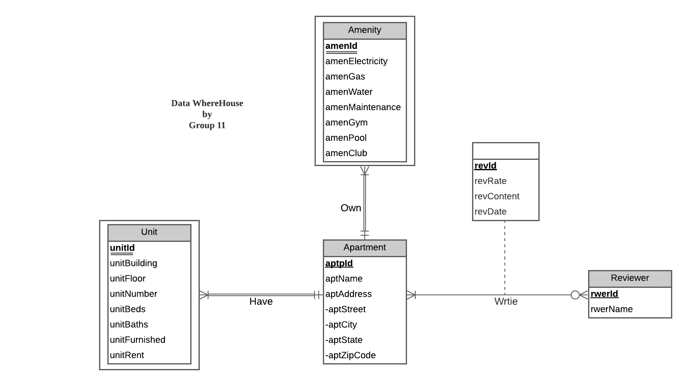

* **Relational Schema**:

## Relations:

Apartment (**aptId**, aptName, aptStreet, aptCity, aptState, aptZipCode)

Unit (**unitId**, ***aptId,*** unitBuilding, unitFloor, unitNumber, unitBeds, unitBaths, unitFurnished, unitRent)

Amenity (**amenId**, ***aptId,*** amenElectricity, amenGas, amenWater, amenMaintenance, amenGym, amenPool, amenClub)

Reviewer (**rwerId**, rwerName)

Write (**revId**, *aptId, rwerId,* revRate, revContent, revDate)

Functional dependency:

aptId → aptName, aptStreet, aptCity, aptState, aptZipCode

unitId, aptId → unitBuilding, unitFloor, unitNumber, unitBeds, unitBaths, unitFurnished, unitRent

amenId, aptId → amenElectricity, amenGas, amenWater, amenMaintenance, amenGym, amenPool, amenClub

rwerId → rwerName

revId → aptId, rwerId, revRate, revContent, revDate

Business rules:

[R1] When the apartment is removed or reconstructed, all the units should be deleted and changed from the database accordingly.

[R2] When the apartment is removed or reconstructed, all the Amenities should be deleted and changed from the database accordingly.

[R3] When the reviewer is writing a review on an apartment, the review, apartment and reviewer can not be deleted or changed in the database.

Referential integrity:

|  |  |  |  |  |  |  |  |
| --- | --- | --- | --- | --- | --- | --- | --- |
| Relation | Foreign Key | Base Relation | Primary Key | Business Rule | Constraint: ON DELETE | Business Rule | Constraint: ON UPDATE |
| Unit | aptId | Apartment | aptId | R1 | CASCADE | R1 | CASCADE |
| Amenity | aptId | Apartment | aptId | R2 | CASCADE | R2 | CASCADE |
| Write | aptId | Apartment | aptId | R3 | NO ACTION | R3 | NO ACTION |
| Write | rwerId | Reviewer | rwerId | R3 | NO ACTION | R3 | NO ACTION |

* **Sample data description**:

We will collect data from websites such as Google reviews and the official website of some apartments around College Park.

Unit Type: Record the units that each apartment has. The most popular unit type might be 2 bedrooms and 2 bathrooms.

Price: The average unit rent per person is around $1100 - $2000 depending on the unit type. Following are the sample data.

Apartment: (**a001**, ‘Vie Tower’, ‘6515 Belcrest Rd’, ‘Hyattsville’, ‘MD’, ‘20782’)

Unit: (**u001**, ***a001***, 6515, 3, 302, 2, 2, ‘Washer, Dryer, appliances and internet’, 2558)

Amenity: (**am001**, ***a001***, 37.5, 20, NULL, 50, TRUE, FALSE, FALSE)

Reviewer: (**r001**, ‘Makailah Gause’)

Write: (**rev001**, *a001*, *r001*, 1, ‘Unsafe living conditions. Maintenance worker yelled at me for reporting him after he walked into my apartment and was disrespectful. colleagues only told me about how he is a “nice” person instead of comforting me for feeling unsafe’, ‘25/10/2021’)