**Project_0501_11_Readme – Data WhereHouse**

**Introduction**

**Data WhereHouse** is a housing reviews system that can help people know the basic information of the apartments located around the College Park Area. The project was created and finished by Ching-Hsiang(Andy) Mao, Zhaoyi Li, Parth Kodnani and Heng Zhuang.

The main purpose of the project is to provide the future residents with more information about the various aspects of reviews and ratings to make their selection task easier and smoother.

We define 4 entities in our ER diagram:

* Apartment: basic information such as the name and address of the apartment
* Unit: the units that the apartment has and the more detail information about the apartment
* Amenity: the amenity information of the apartment such as electricity, water and gym
* Reviewer: the users’ information who write reviews about the apartment on the websites

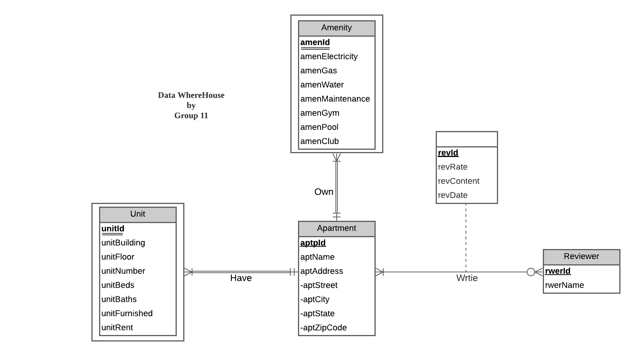**ER diagram**

As we defined, each apartment is described by a unique id and is required to store the name and address (in four fields – street, city, state, and zip code) of the apartment. The unit information of the apartment is identified by a unique id, building, floor, number, beds’ number, bathroom’s number, furnished or not and rent price. The amenity information of the apartment is described by a unique id, electricity status, gas status, water status, maintenance status, gym availability, pool availability and club availability. The information of the reviewer is recorded by a unique id and the name of the reviewer. An apartment could have one or many units and amenities. There could be 0 or more reviewers writing about an apartment. On the other hand, a reviewer can write reviews to 1 or more apartments. The id, rate, review content and date of the reviews that are written by the reviewers should be recorded as well.

The data is collected from six apartments and three different data sources.

* Apartments:
  + Lync at Alterra
  + Vie Towers
  + Seven Springs Apartments
  + Camden College Park
  + Westchester Tower Apartments
  + Verde at Greenbelt Station
* Data Sources:
  + Google Reviews
  + Apartments.com
  + The official website of the apartments

We collect the data from the sources listed above and save it into an excel file.

**Apartment**

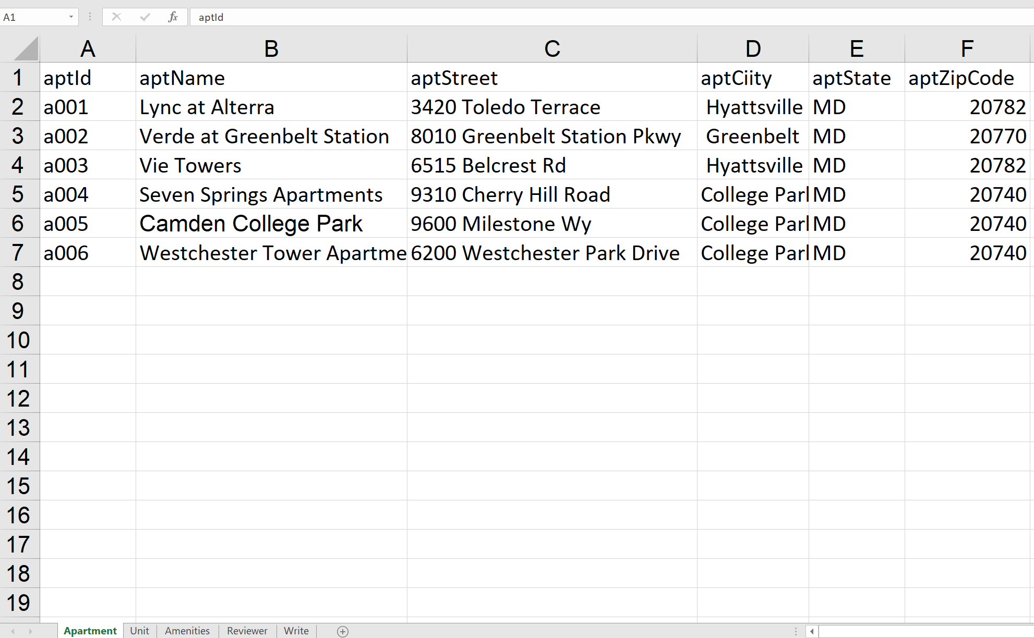

**Unit**

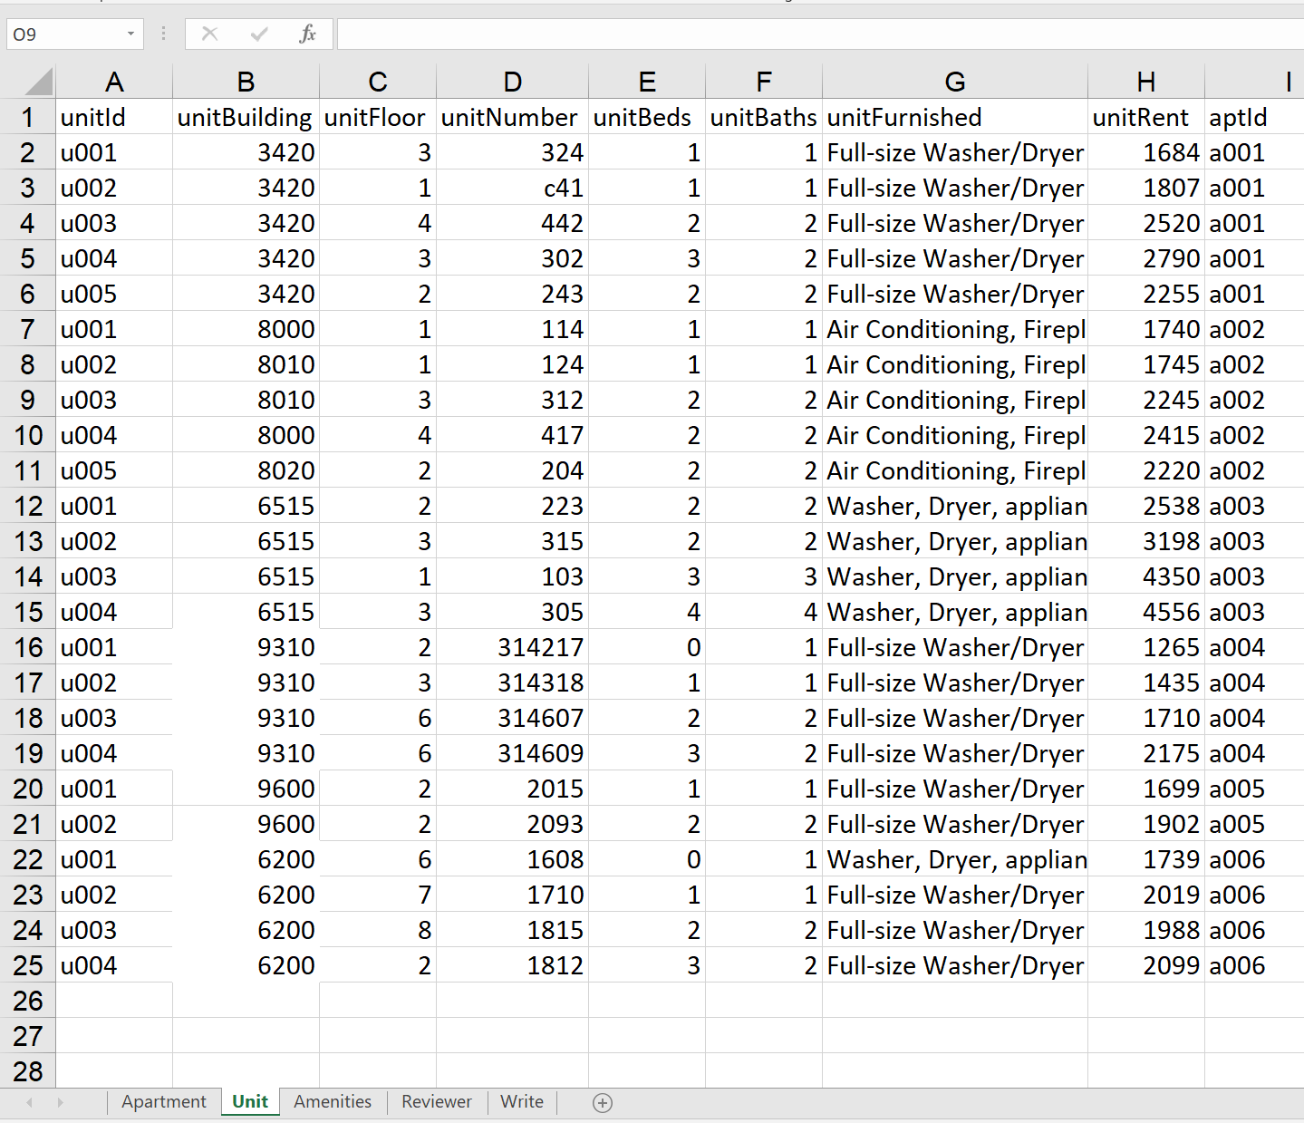

**Amenity**

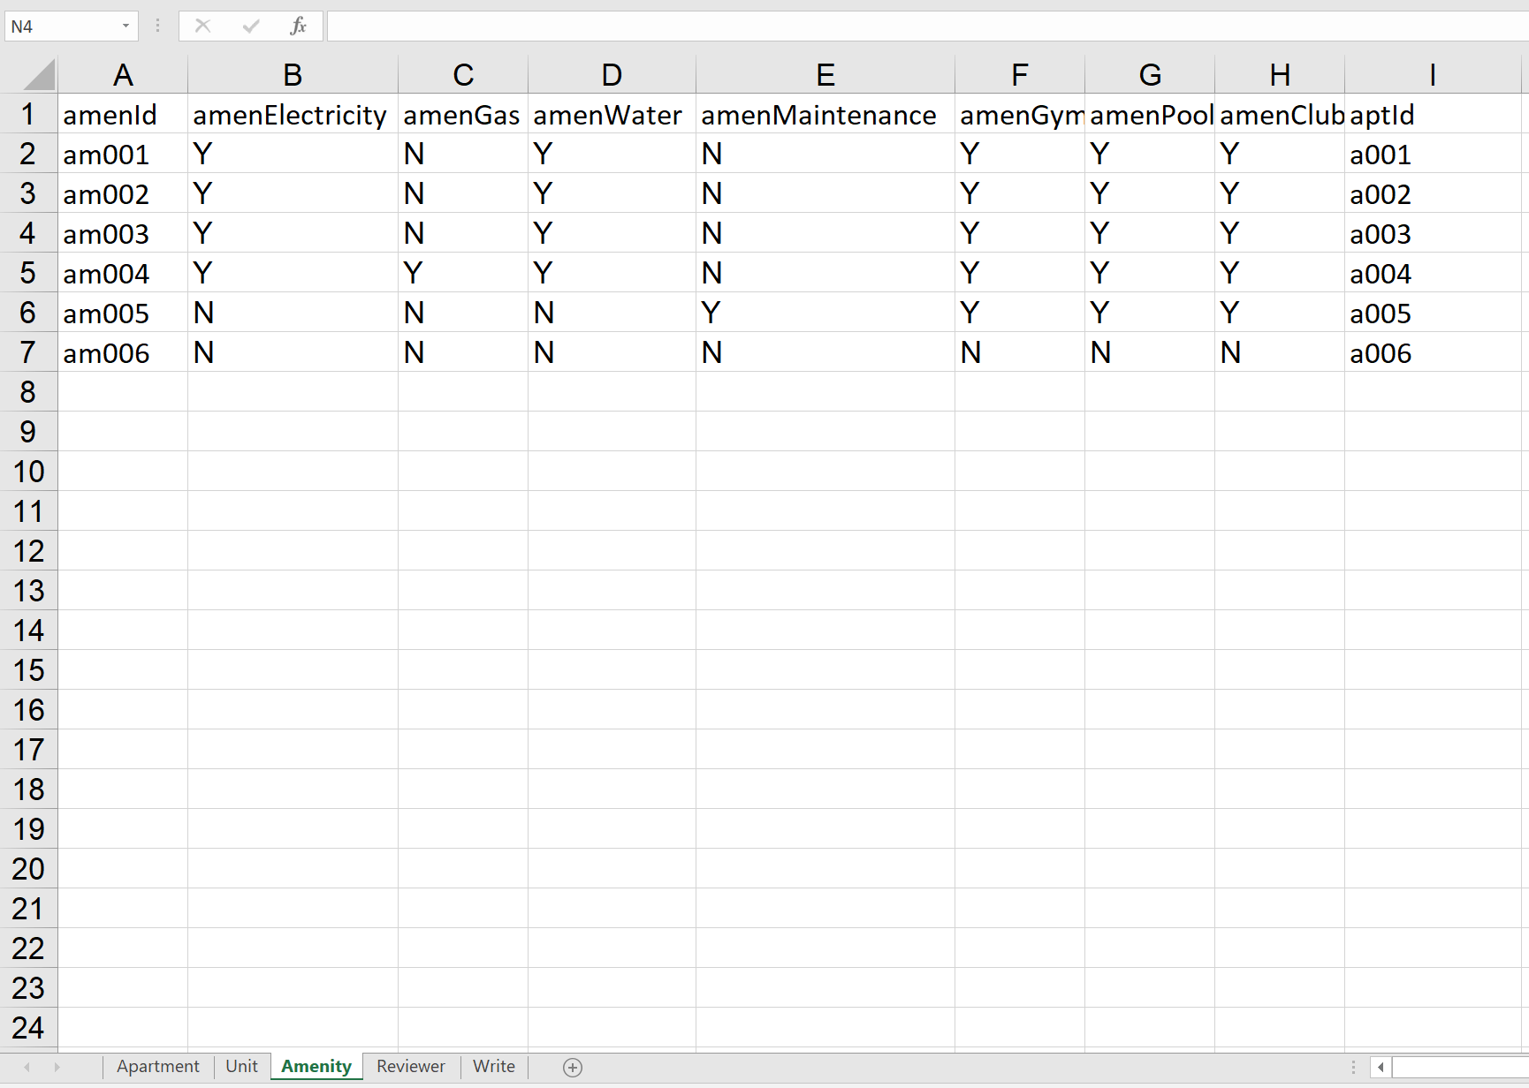

**Reviewer**

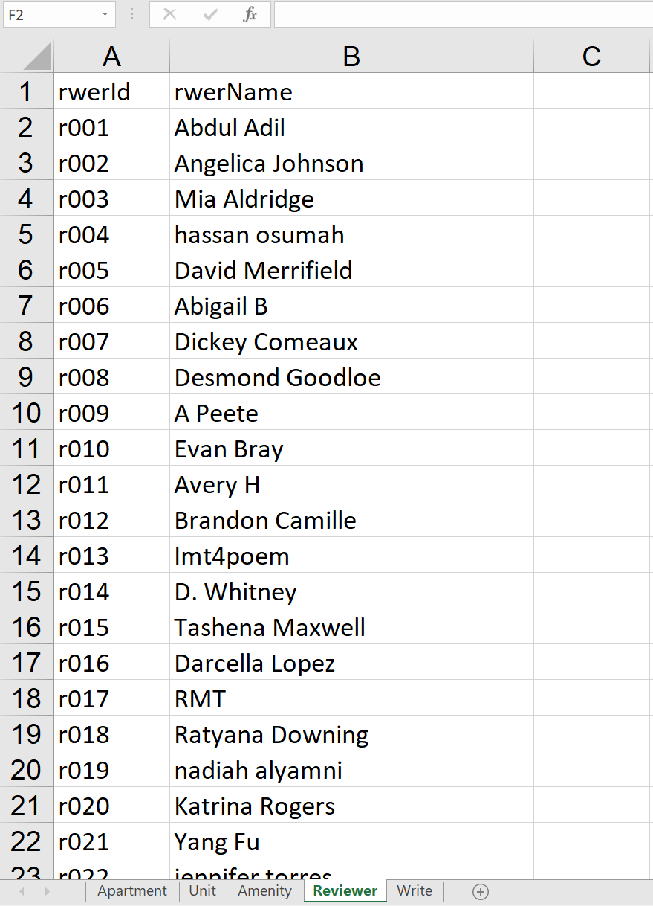

**Write**

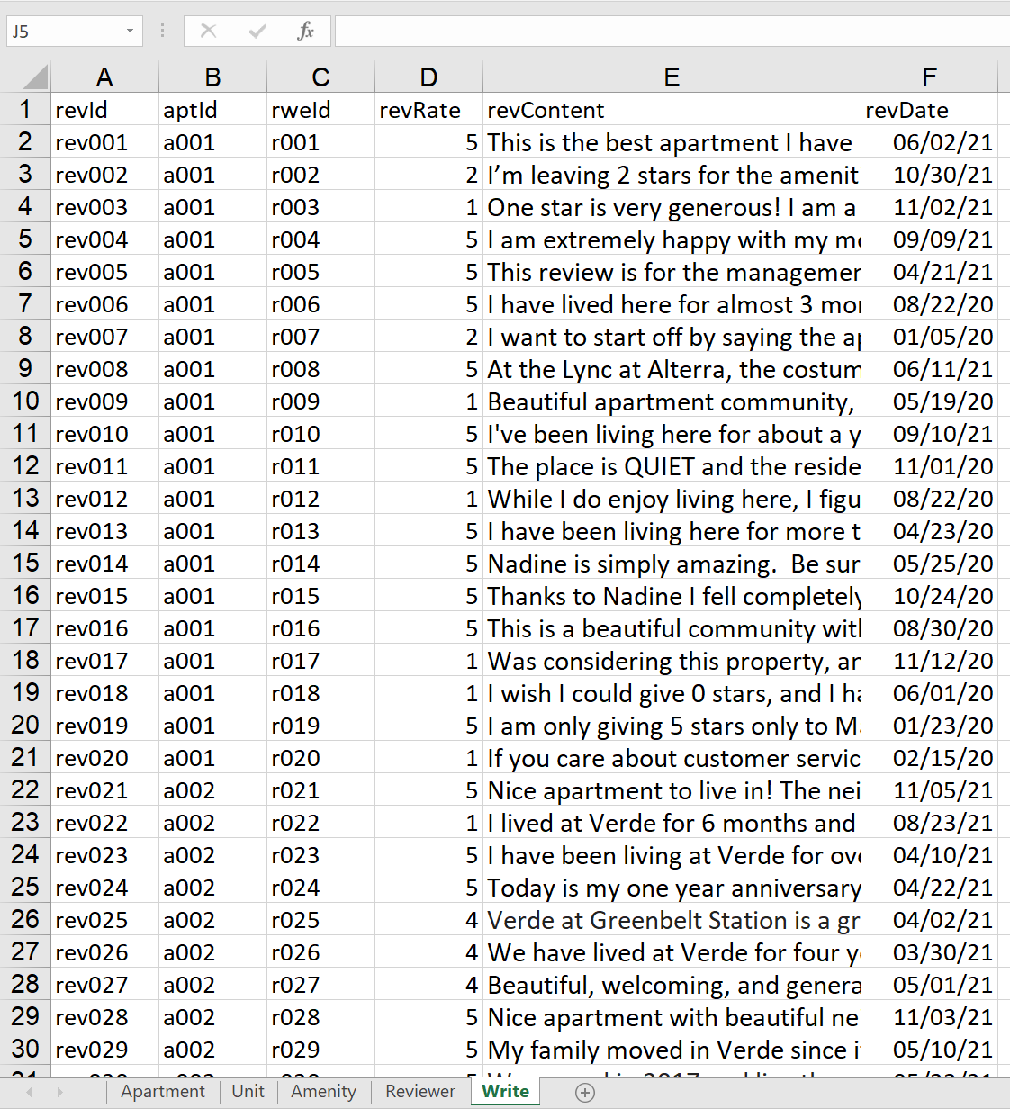

We create the tables in the database and insert the value in the excel file into the database manually. The SQL code about creating and inserting can be refer to the file: **Project_0501_11_Data WhereHouse.sql**

For more detail about the mission statements, mission objectives, ER schema, ER diagram relational schema and sample data description, you can refer to the file: **Project_0501_11_Proposal.docx**

**Potential Use Cases**

To find out the potential use cases of our system in reality, we have created five questions to help the users have a quick look about what our system can do.

1. Which apartments have high quality or satisfaction rate?

* What are the apartment id, apartment name and apartment address of the apartments with average rating over 4?

**Query:**

SELECT a.aptId, a.aptName, a.aptStreet + ' ' + a.aptCity + ' ' + a.aptState + ' ' + a.aptZipCode as 'aptAddress', AVG(w.revRate) as 'Average Rating'  
FROM [Review.Apartment] a, [Review.Write] w  
WHERE a.aptId=w.aptId  
GROUP BY a.aptId, a.aptName, a.aptStreet, a.aptCity, aptState, aptZipCode  
HAVING AVG(w.revRate) > 4

**Result:**

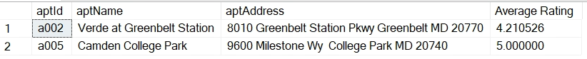

If we want to know the apartments with average rating over 3, we can change HAVING part in the query:

**Query:**

SELECT a.aptId, a.aptName, a.aptStreet + ' ' + a.aptCity + ' ' + a.aptState + ' ' + a.aptZipCode as 'aptAddress', AVG(w.revRate) as 'Average Rating'  
FROM [Review.Apartment] a, [Review.Write] w  
WHERE a.aptId=w.aptId  
GROUP BY a.aptId, a.aptName, a.aptStreet, a.aptCity, aptState, aptZipCode  
HAVING AVG(w.revRate) > **3**

**Result:**

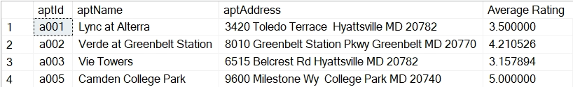

1. Which apartment has the worst quality or satisfaction rate?

* What is the apartment id, apartment name and apartment address of the apartment with the worst average rating?

**Query:**

SELECT a.aptId, a.aptName, a.aptStreet + ' ' + a.aptCity + ' ' + a.aptState + ‘ ‘ + a.aptZipCode as 'aptAddress’, AVG(w.revRate) as 'Average_Rating'  
FROM [Review.Apartment] a, [Review.Write] w, (

SELECT aa.aptId, AVG(ww.revRate) as 'AR'  
FROM [Review.Apartment] aa, [Review.Write] ww  
WHERE aa.aptId=ww.aptId  
GROUP BY aa.aptId) av

WHERE a.aptId = w.aptId  
GROUP BY a.aptId, a.aptName, a.aptStreet, a.aptCity, aptState, aptZipCode  
HAVING AVG(w.revRate) = MIN(av.AR)

**Result:**



1. Which apartments have a gym, a pool and a club?

* What are the apartment names of the apartments that have a gym, a pool and a club?

**Query:**

SELECT a.aptName   
FROM [Review.Apartment] a , [Review.Amenity] am  
WHERE a.aptId = am.aptId and (am.amenGym = ‘Y' and am.amenPool = ‘Y' and am.amenClub = ‘Y')

**Result:**

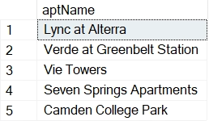

You can change the condition in the WHERE command to find the apartment for the corresponding condition. For example: if you want to find the apartment that provides electricity and water, you can change the condition in the query:

**Query:**

SELECT a.aptName   
FROM [Review.Apartment] a , [Review.Amenity] am  
WHERE a.aptId = am.aptId and (am.amenElectricity = ‘Y' and am.amenWater = ‘Y')

**Result:**

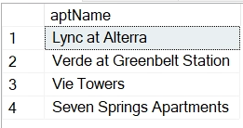

1. What apartment unit is the cheapest unit in the College Park area?

* What is the apartment name and its unit's full detail of the apartment that has the cheapest apartment units in the college park area?

**Query:**

SELECT TOP 1 a.aptName, u.*  
FROM [Review.Apartment] a ,[Review.Unit] u  
WHERE a.aptId=u.aptId  
ORDER BY u.unitRent

**Result:**



If you want to find the most expensive unit case, you can sort the rent price descending to have the most expensive unit on the top and get it by the top 1 query:

**Query:**

SELECT TOP 1 a.aptName, u.*  
FROM [Review.Apartment] a ,[Review.Unit] u  
WHERE a.aptId=u.aptId  
ORDER BY u.unitRent DESC

**Result:** 

1. What are the top 5 longest comments of all the reviews?

* What are the apartment name, user name and the content of the 5 longest reviews?

**Query:**

SELECT TOP 5 a.aptName ,r.rwerName, w.revContent  
FROM [Review.Write] w, [Review.Reviewer] r,[Review.Apartment] a  
WHERE w.rwerId = r.rwerId AND w.aptId = a.aptId  
ORDER BY LEN(w.revContent) DESC

**Result:**

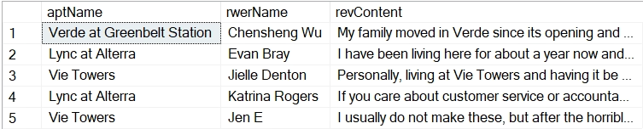

**References**

* **LYNC official website:** <https://www.lyncatalterra.com/>
* **LYNC Google Reviews:** <https://www.google.com/maps/place/Lync+at+Alterra/@38.9708689,-76.9620498,17z/data=!3m1!4b1!4m5!3m4!1s0x89b7c75832b46bd5:0xe6565c027d7915da!8m2!3d38.9708647!4d-76.9598611>
* **LYNC Apartments.com:** <https://www.apartments.com/lync-at-alterra-hyattsville-md/k5m5kk8/>
* **Vie Tower Official website:** <https://www.vietowers.com/>
* **Vie Tower Google Reviews:** <https://www.google.com/maps/place/Vie+Towers/@38.9687146,-76.9539112,13z/data=!4m9!1m2!2m1!1sViw+tower!3m5!1s0x89b7c6faa87226d9:0x8740b7cf4f435ae7!8m2!3d38.9687306!4d-76.9535139!15sCglWaXcgdG93ZXJaCyIJdml3IHRvd2VykgEWc3R1ZGVudF9ob3VzaW5nX2NlbnRlcpoBJENoZERTVWhOTUc5blMwVkpRMEZuU1VOVk1IUTJjQzFSUlJBQg>
* **Vie Tower Apartments.com:** <https://www.apartments.com/vie-towers-hyattsville-md/xv2r96q/>
* **Verde at Greenbelt official website:** <https://www.verdegreenbelt.com/>
* **Verde at Greenbelt Google Reviews:** <https://www.google.com/maps/place/Verde+at+Greenbelt+Station/@39.000298,-76.9205876,17z/data=!3m1!4b1!4m5!3m4!1s0x89b7c3ff56e4b39f:0xf9ba98b571dde59a!8m2!3d39.0002939!4d-76.9183989>
* **Verde at Greenbelt Apartments.com:** [https://www.apartments.com/verde-at-greenbelt-station-greenbelt-md/5y8dyhp](https://www.apartments.com/verde-at-greenbelt-station-greenbelt-md/5y8dyhp/)/
* **Seven Spring Apartments.com:**

<https://www.apartmentratings.com/md/college-park/seven-springs-apartments_301345850020740/>

* **Seven Spring Google.com:**

<https://www.google.com/maps/place/Seven+Springs+Apartments/@39.016786,-76.9413181,17z/data=!3m2!4b1!5s0x89b7c4136d26b82f:0x3a930c8f146898df!4m5!3m4!1s0x89b7c41504efbda9:0x1e84d7d4ac23701d!8m2!3d39.0168295!4d-76.9392396>

* **Seven Spring Official Website:**

<https://www.sevenspringsapts.com/>

* **Camedan College Park Apartments.com**

<https://www.apartments.com/camden-college-park-college-park-md/nljkhyq/>

* **Camedan College Park Google.com**

<https://www.google.com/maps/place/Camden+College+Park+Apartments/@39.0235337,-76.9281013,17z/data=!3m1!4b1!4m5!3m4!1s0x89b7c4716b4d6803:0x6bd9620c8366af6c!8m2!3d39.0235296!4d-76.9259126>

* **Camedan College Park Official Website:**

<https://www.camdenliving.com/apartments/college-park-md/camden-college-park>

* **Westchester Tower Apartment Official Website**

<https://westchestertower.com/>

* **Westchester Tower Apartment Aparments.com:**

<https://www.apartments.com/westchester-tower-college-park-md/vcrschd/>

* **Westchester Tower Apartment Google:**

<https://www.google.com/maps/place/Westchester+Tower+Apartment+Homes/@38.9921081,-76.9014327,17z/data=!3m2!4b1!5s0x89b7c15f6b05fae9:0x8cf7b11beba8e852!4m5!3m4!1s0x89b7c15f1464a2e7:0xffafbcf1fcaf60af!8m2!3d38.992104!4d-76.899244>