SecureNova Inc.
AI Identity Security Capstone
Project 5 — Policy & Presentation: Screenshot Evidence
Prepared by: AI Identity Security Analyst
Date: August 23, 2026
This document contains all 8 required screenshots for Project 5, arranged in the same sequence as the project steps, per the submission instructions.

Screenshot 1: AI Identity Security Policy — Title Page and TOC
Where from: AI_Identity_Security_Policy.docx
What must be visible: Title page and Table of Contents showing all three section headings: Identity Lifecycle, Credential Governance, Incident Response Playbook.
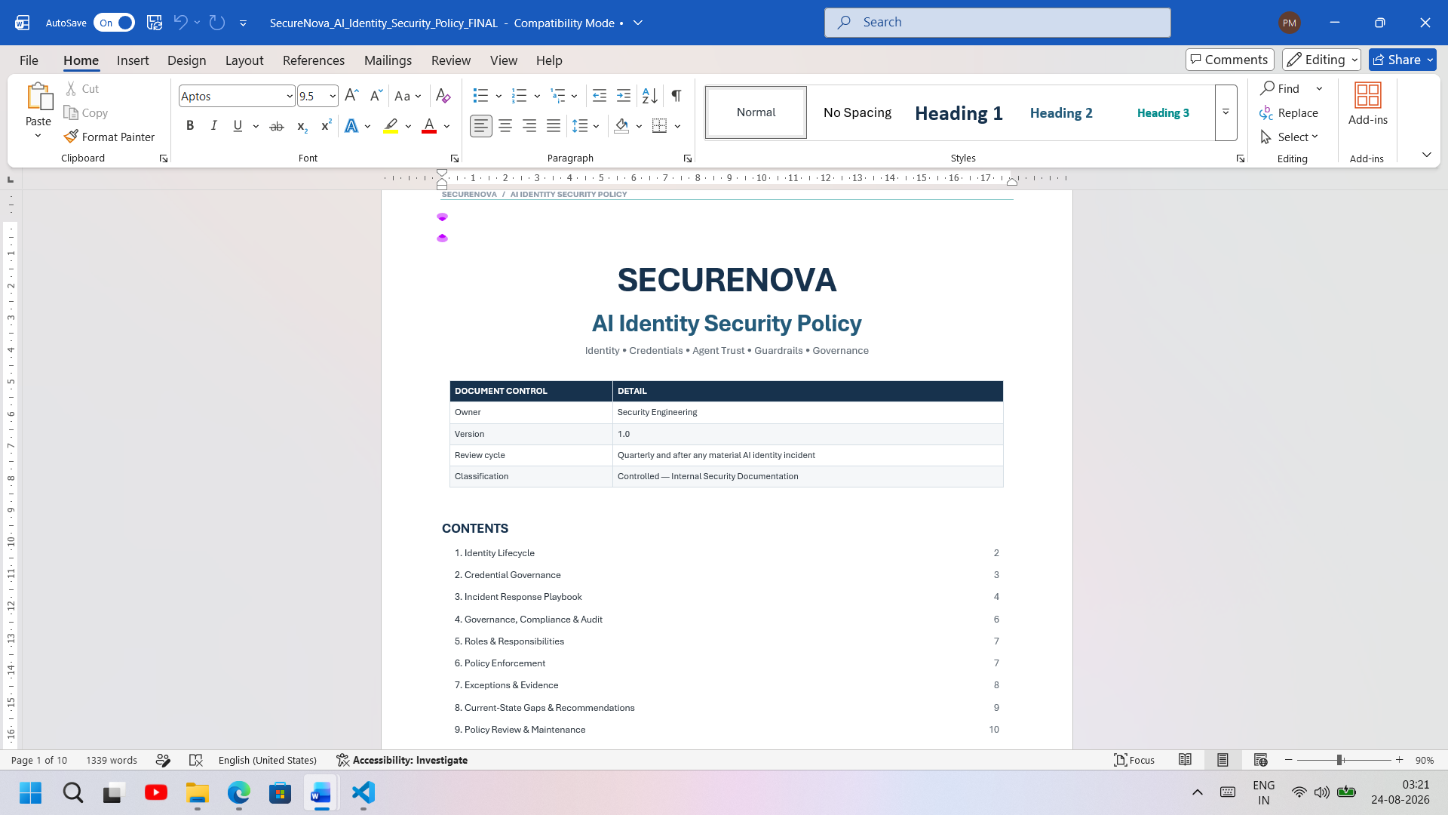
Screenshot 2: Incident Response Playbook Section
Where from: AI_Identity_Security_Policy.docx, Section 3
What must be visible: At least one scenario fully written, showing detection signals and containment steps (e.g. Scenario 2: Compromised Agent Identity).
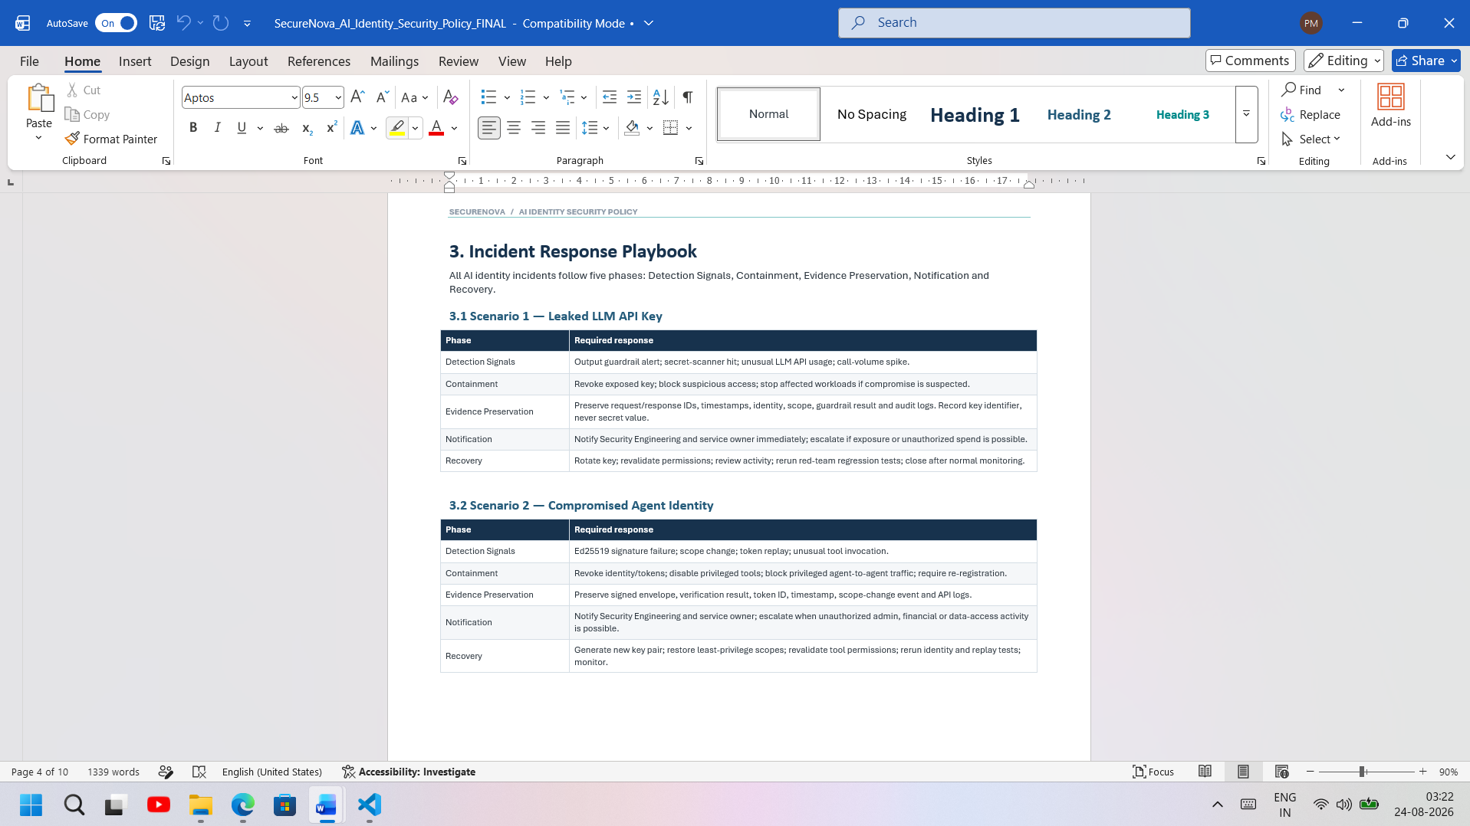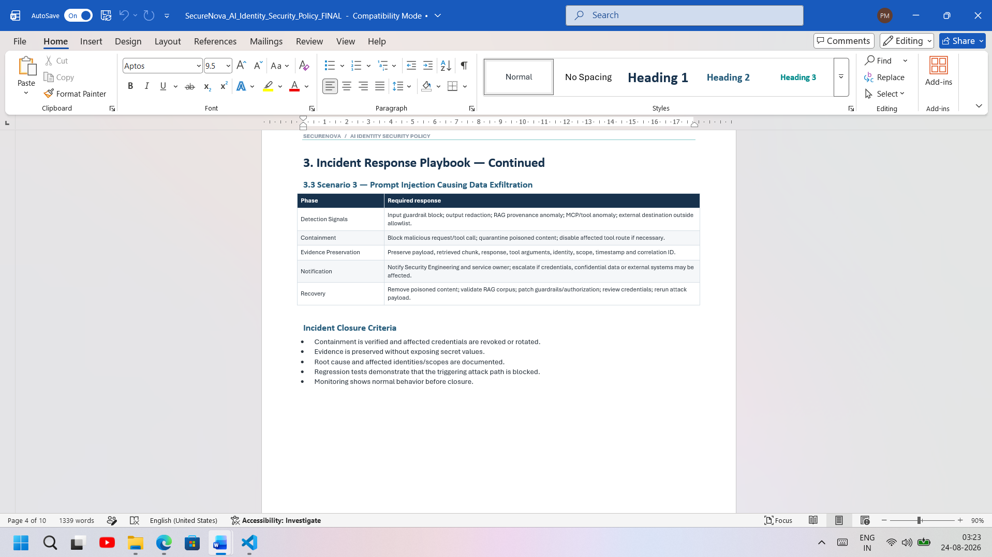
Screenshot 3: NIST AI RMF Tab
Where from: Compliance_Mapping.xlsx, 'NIST AI RMF' tab
What must be visible: All four functions (Govern, Map, Measure, Manage) mapped with evidence artefacts cited.
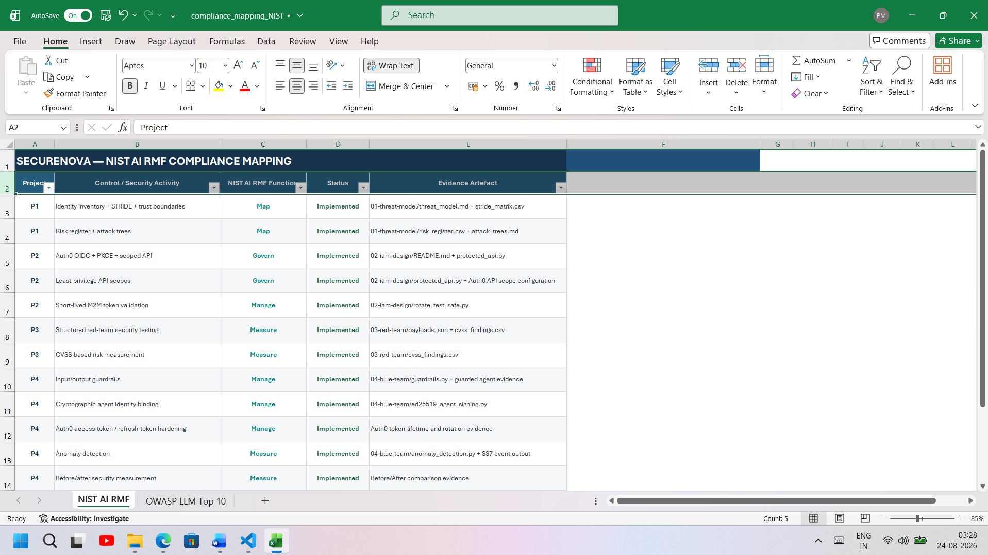
Screenshot 4: OWASP LLM Top 10 Tab
Where from: Compliance_Mapping.xlsx, 'OWASP LLM Top 10' tab
What must be visible: Relevant categories (LLM01, LLM06, LLM07, LLM09) mapped to Project 3 attacks and Project 4 controls.
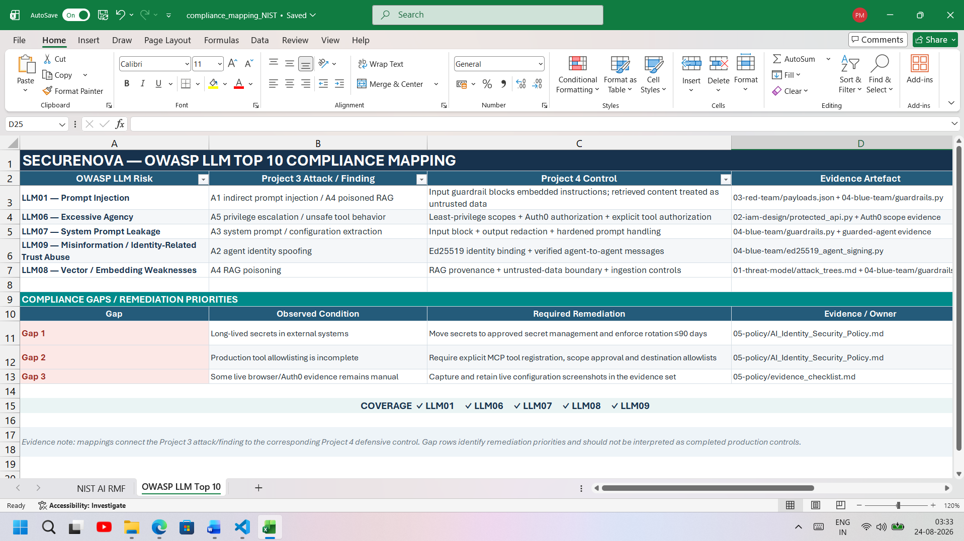
Screenshot 5: GitHub Repository — File Tree
Where from: github.com/YOUR_USERNAME/SecureNova
What must be visible: All five project folders (01-threat-model through 05-policy) visible in the file tree.
[ Paste Screenshot 5 Here ]

Screenshot 6: GitHub Commit History
Where from: github.com/YOUR_USERNAME/SecureNova — Insights → Contributors, or the commit graph
What must be visible: Contributions visible across all 5 project commits.
[ Paste Screenshot 6 Here ]

Screenshot 7: Risk Priority Matrix
Where from: Risk_Priority_Matrix.xlsx
What must be visible: All 5 findings plotted with CVSS scores labelled.
[ Paste Screenshot 7 Here ]

Screenshot 8: Top 5 Recommendations
Where from: Trainer_Presentation_Guide.docx, Section 4
What must be visible: All 5 recommendations with effort estimates and business rationale visible.
[ Paste Screenshot 8 Here ]

