SecureNova Inc.
AI Identity Security Capstone
Project 2 — Auth0 Implementation: Screenshot Evidence
Prepared by: AI Identity Security Analyst
Date: August 20, 2026

Screenshot 1: Auth0 Dashboard — Applications Page
Where from: Applications → Applications
What must be visible: Both the Regular Web Application (SecureNova AI Chat Service) and the Machine to Machine application (SecureNova AI Agent M2M) listed with their types visible.
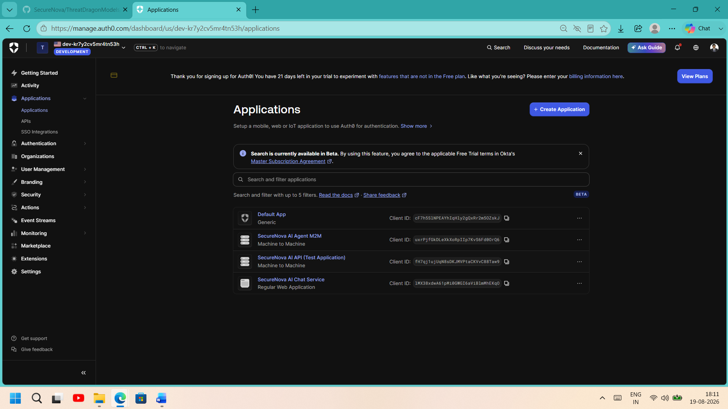
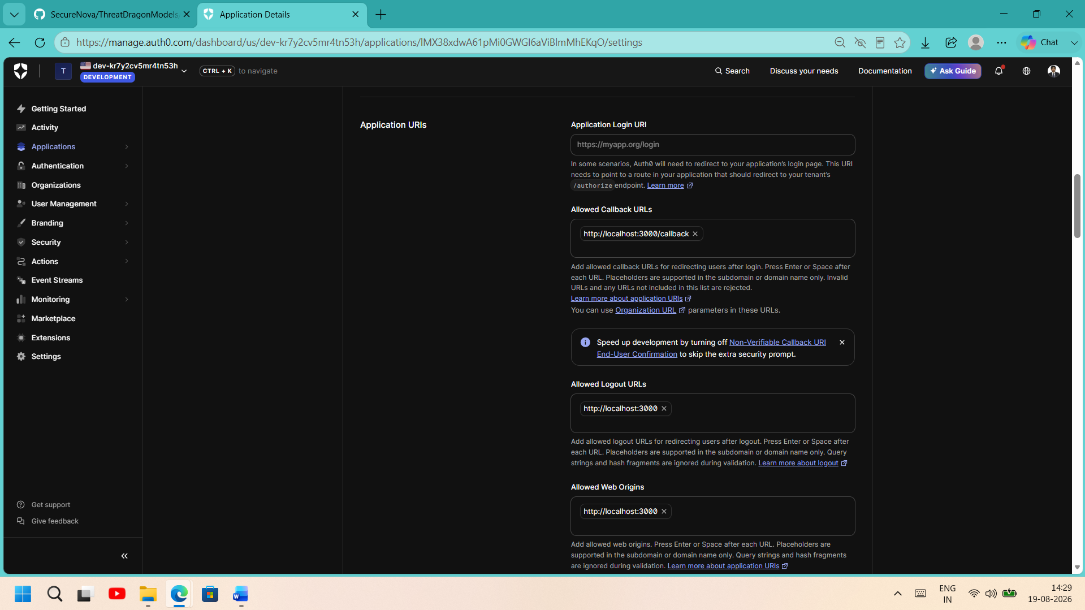

Screenshot 2: Auth0 APIs Page — Custom Scopes
Where from: Applications → APIs → SecureNova AI API → Permissions tab
What must be visible: The API identifier (https://securenova-ai-api) and both custom scopes — read:ai-data and write:admin — with descriptions visible.
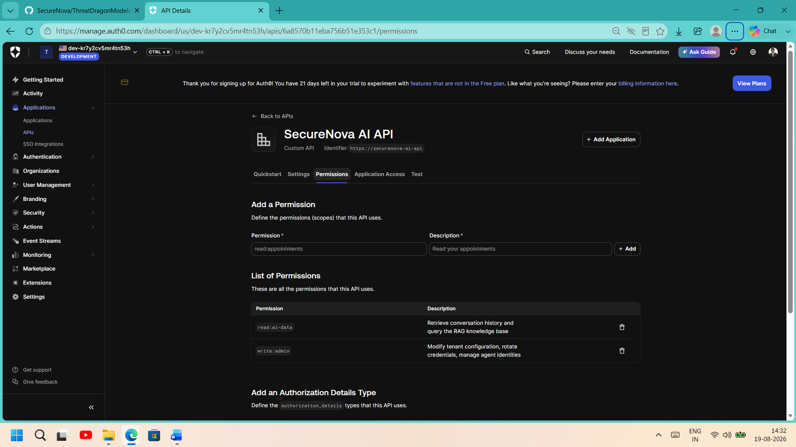
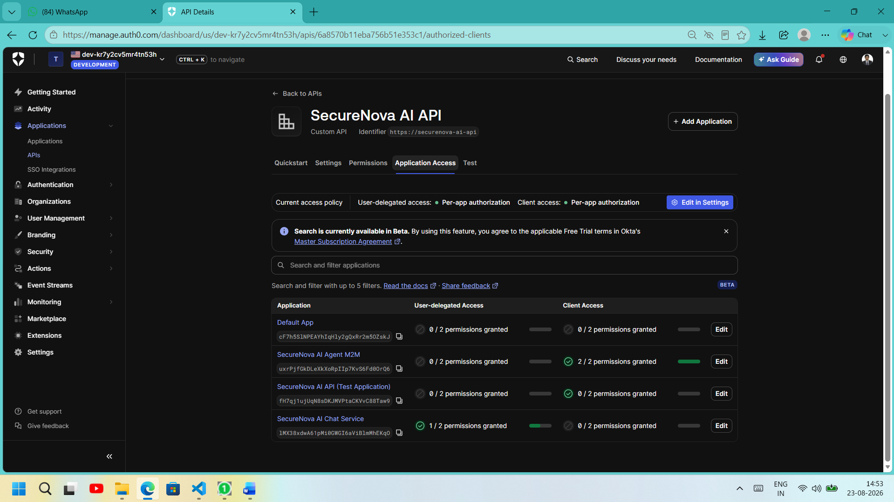
Screenshot 3: jwt.io — Decoded JWT with agent_id Claim
Where from: jwt.io, using the id_token from your PKCE token exchange
What must be visible: Decoded Header (alg: RS256) and Payload showing aud, iss, exp, scope, and the custom claims https://securenova.ai/claims/agent_id and identity_type.
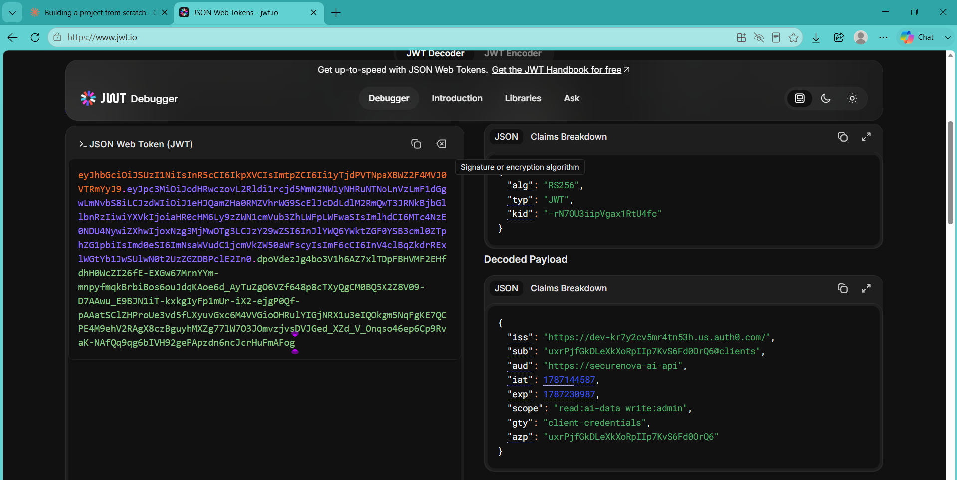
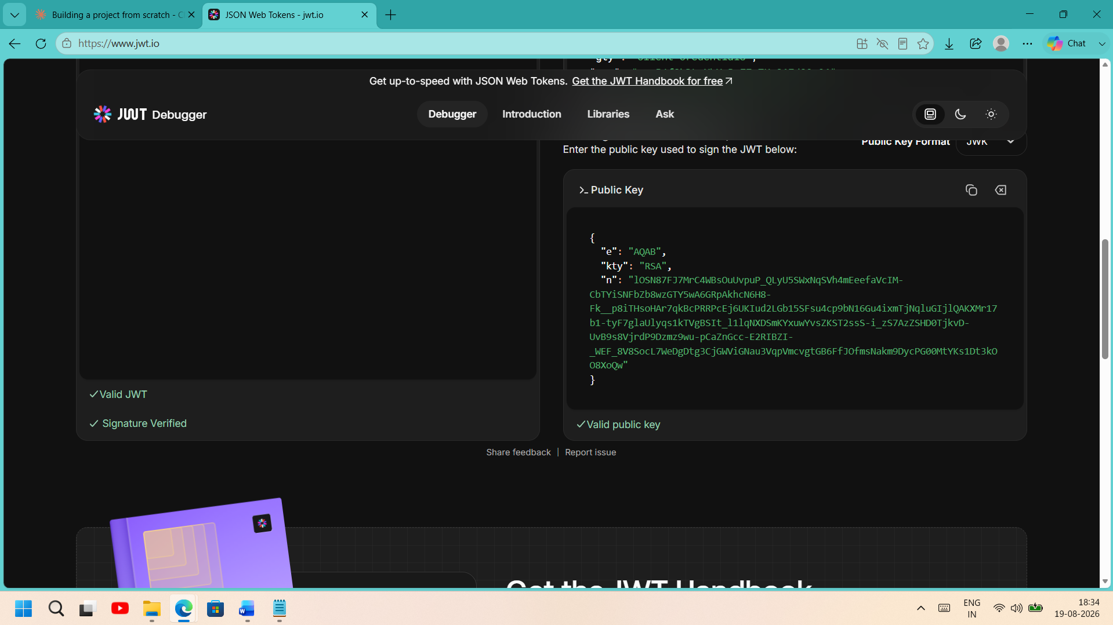

Screenshot 4: Auth0 Universal Login — Custom Branding
Where from: Browser, via the /authorize URL for your Regular Web App
What must be visible: The login page itself showing your applied custom primary color / background, with the browser address bar showing your Auth0 domain.
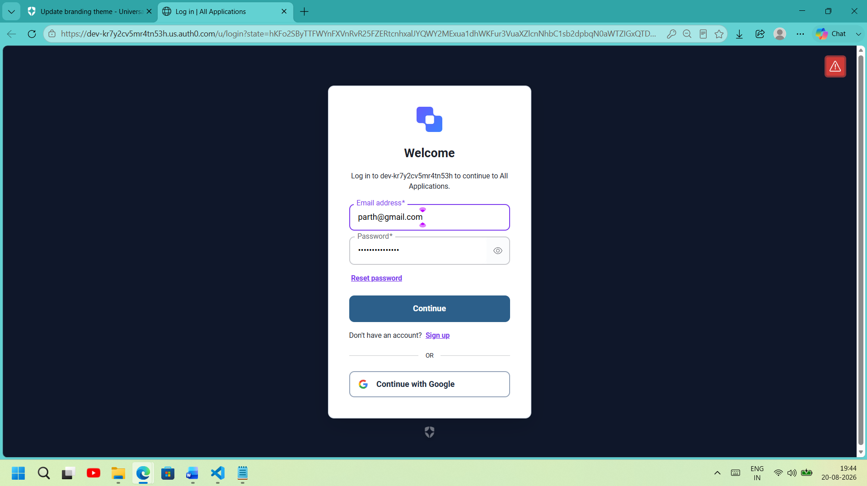

Screenshot 5: Auth0 MFA Enrollment / TOTP Challenge
Where from: Browser, during a real login through the /authorize flow
What must be visible: The QR code enrollment screen or the 6-digit TOTP challenge prompt shown mid-login.
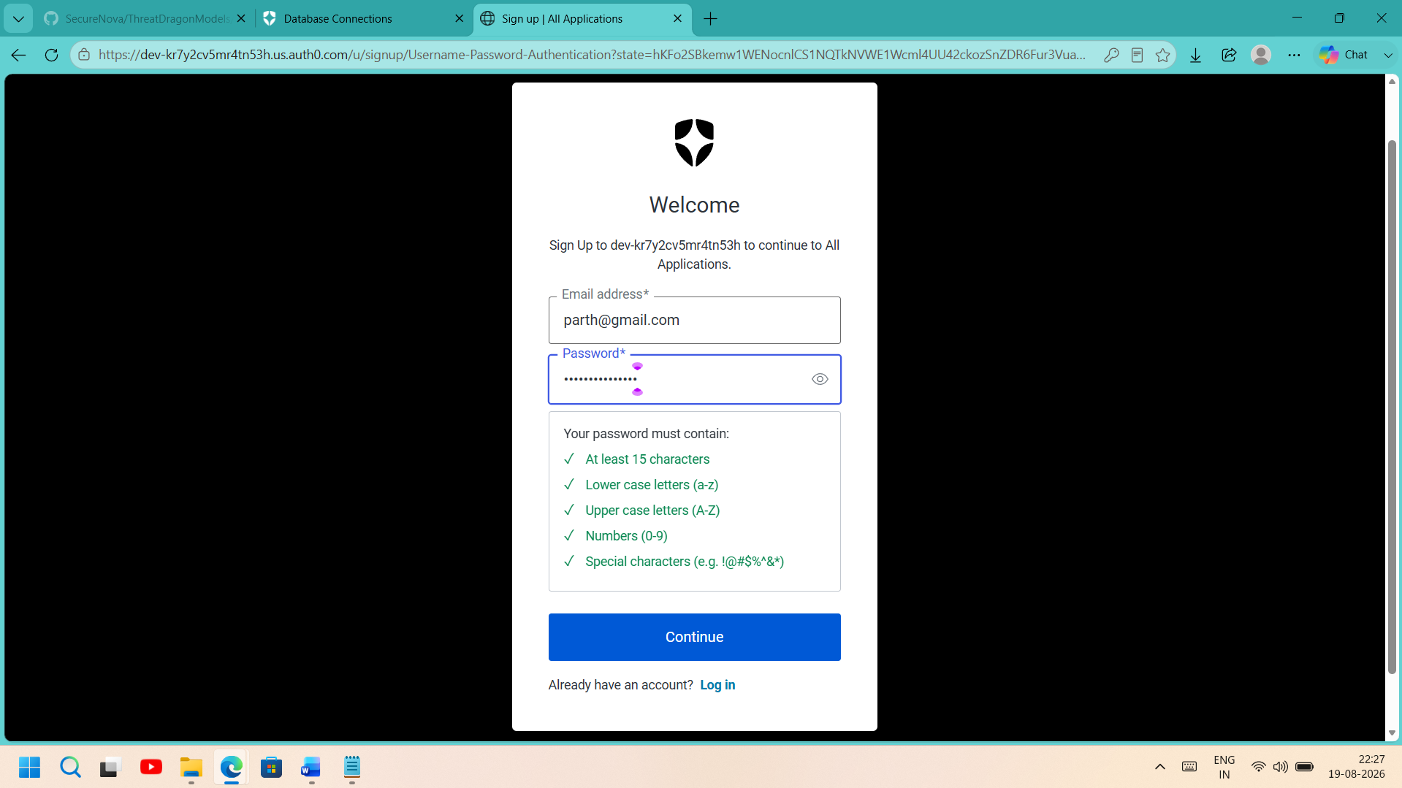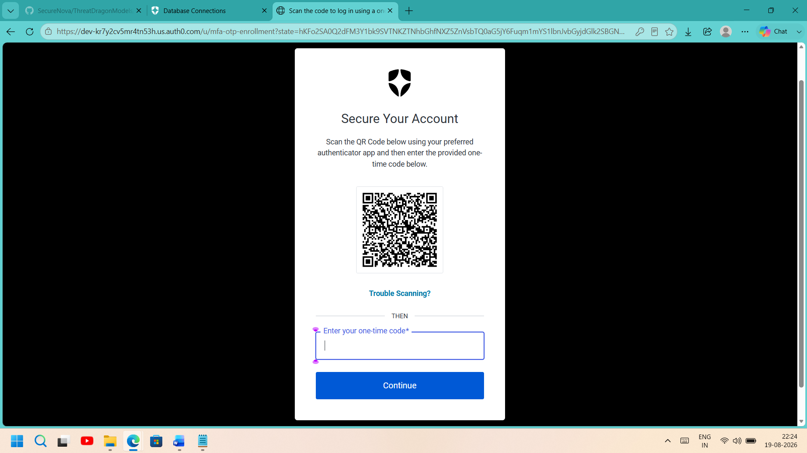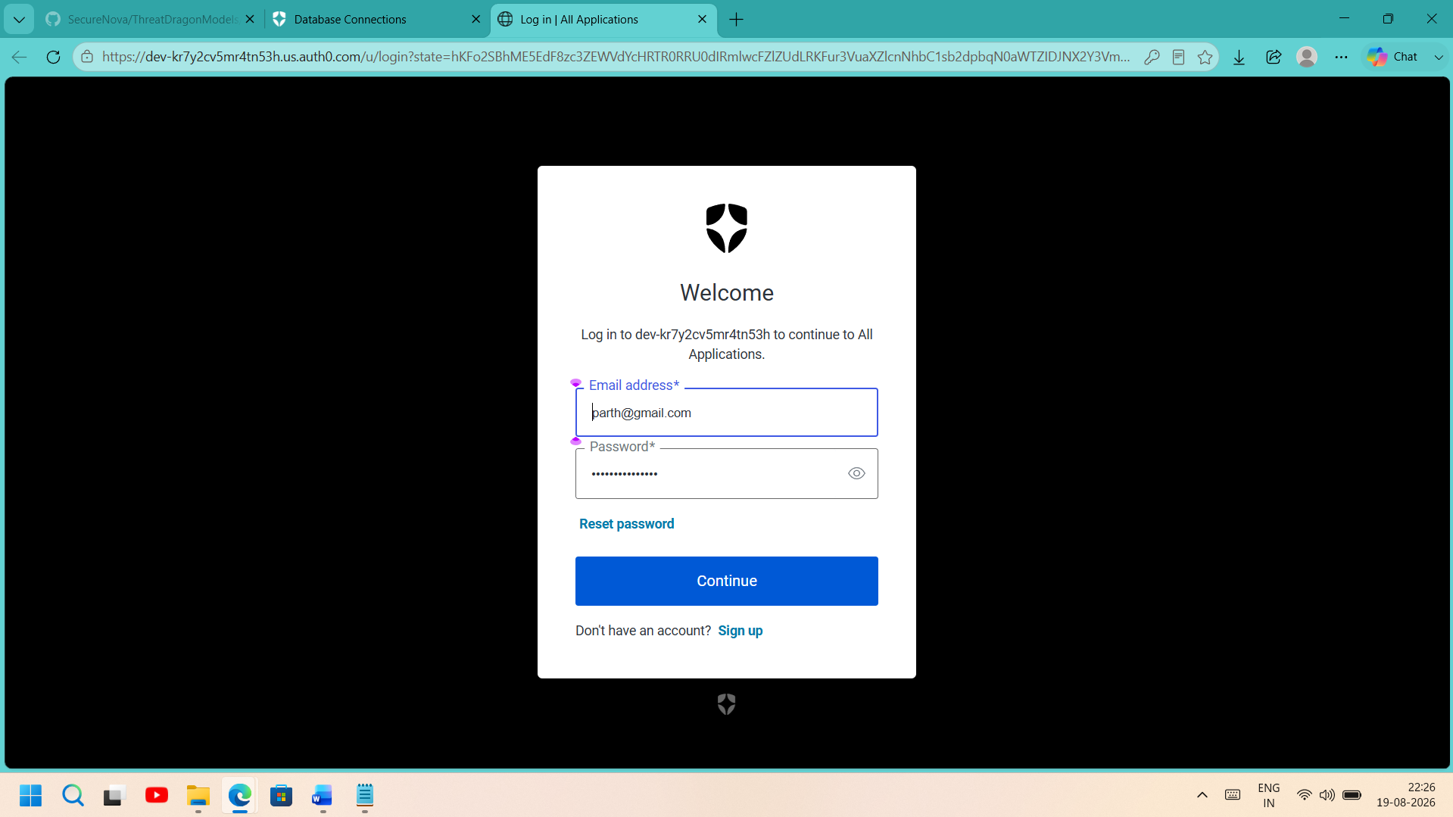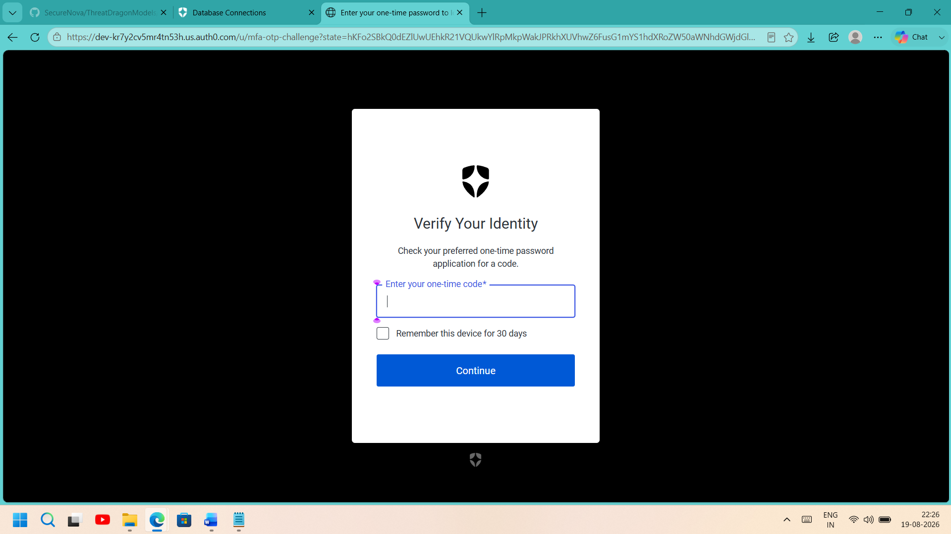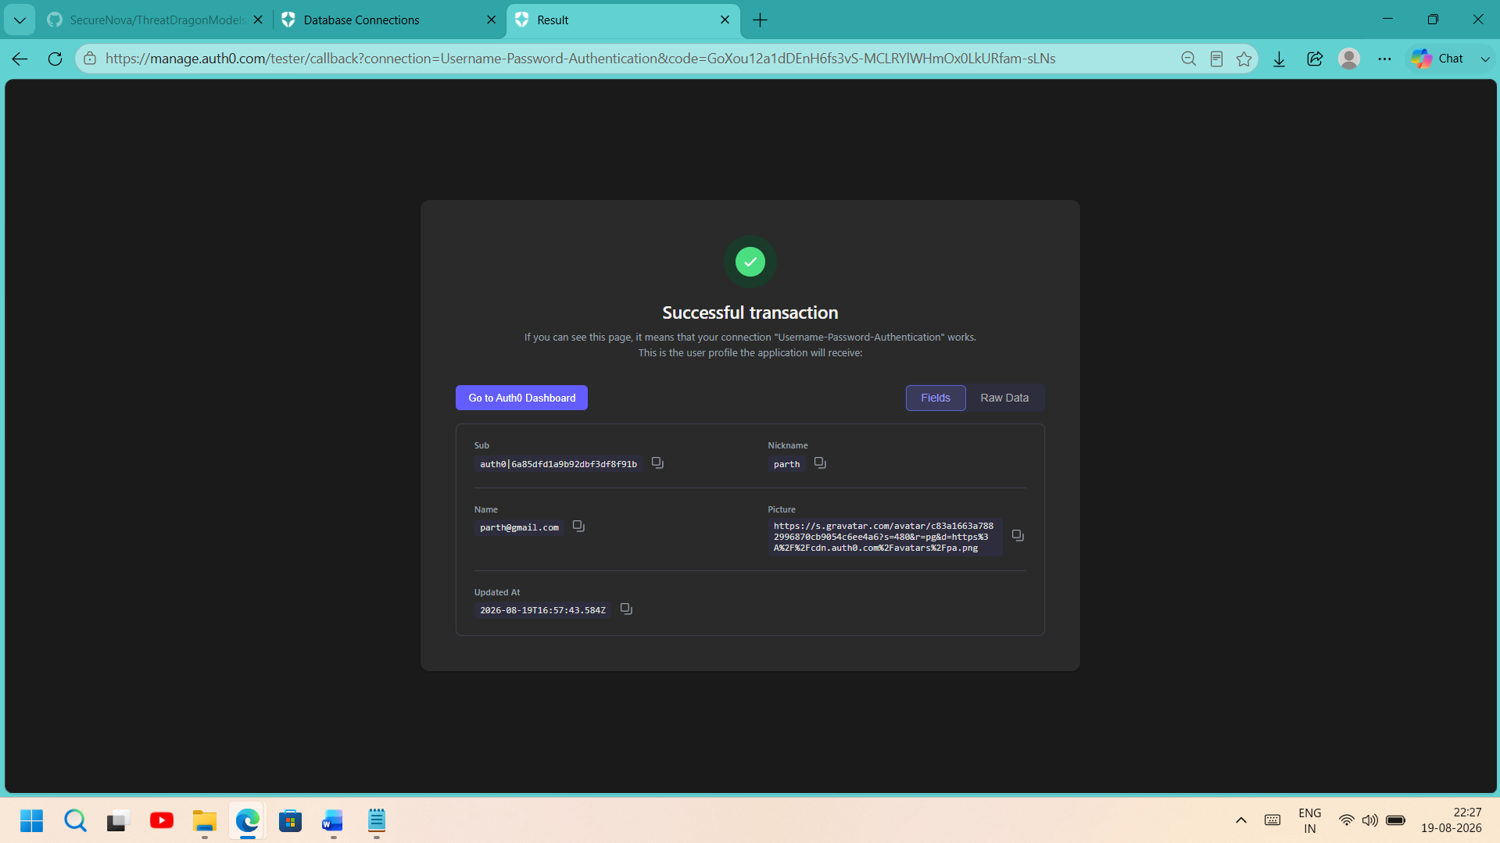

Screenshot 6: Auth0 Actions Editor — Post-Login Action
Where from: Actions → Library → your custom Action ("Add Agent ID Claim")
What must be visible: The deployed code showing the api.idToken.setCustomClaim(...) lines that add the agent_id and identity_type claims.
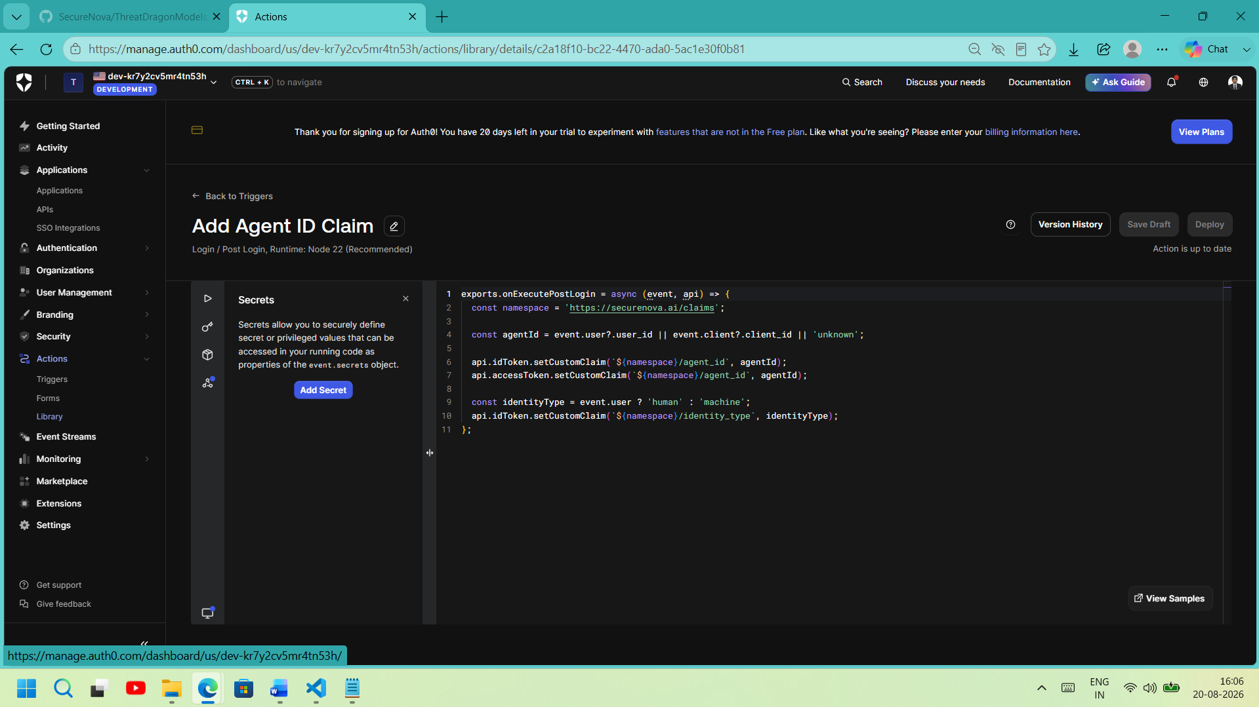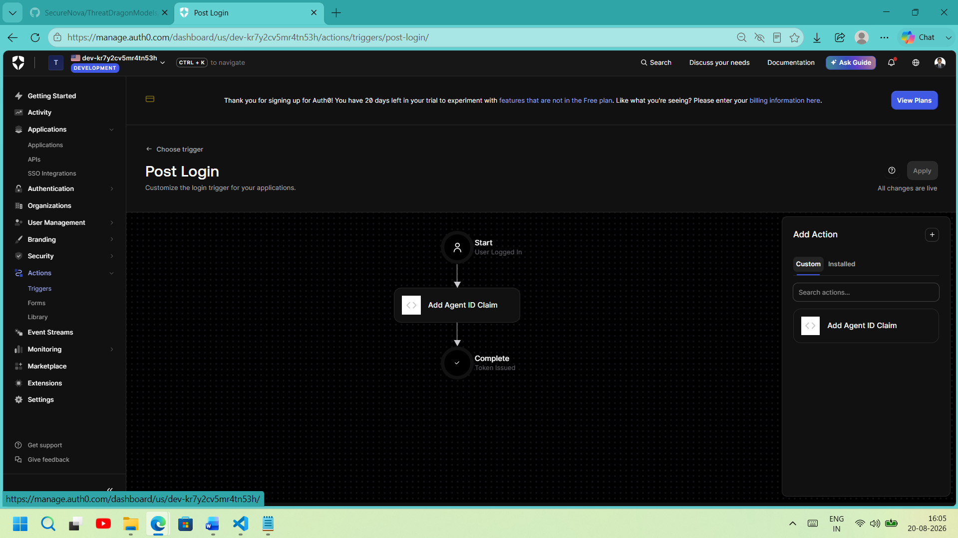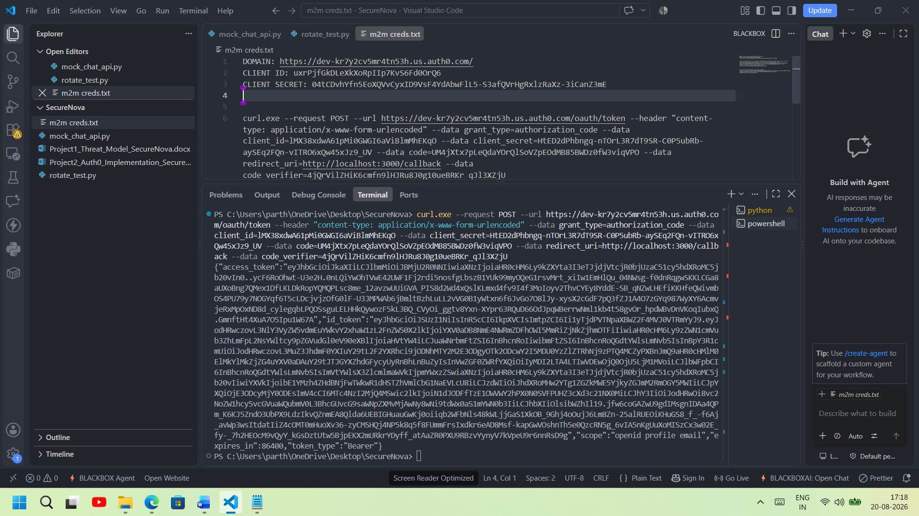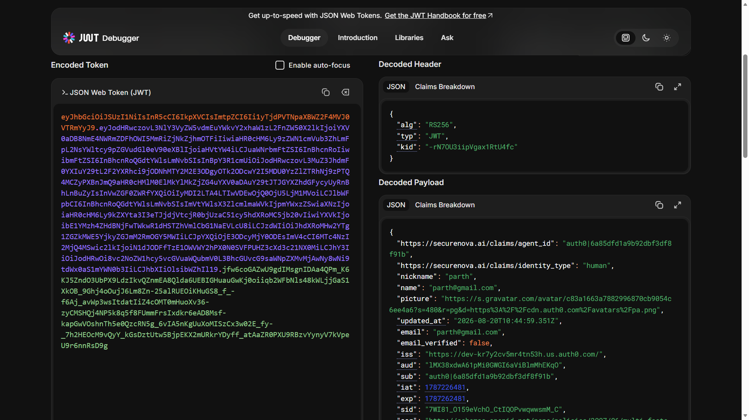

Screenshot 7: Auth0 Attack Protection Panel
Where from: Security → Attack Protection
What must be visible: Both Brute-Force Protection (max 10 attempts / 15-min lockout) and Suspicious IP Throttling shown enabled in the same view.
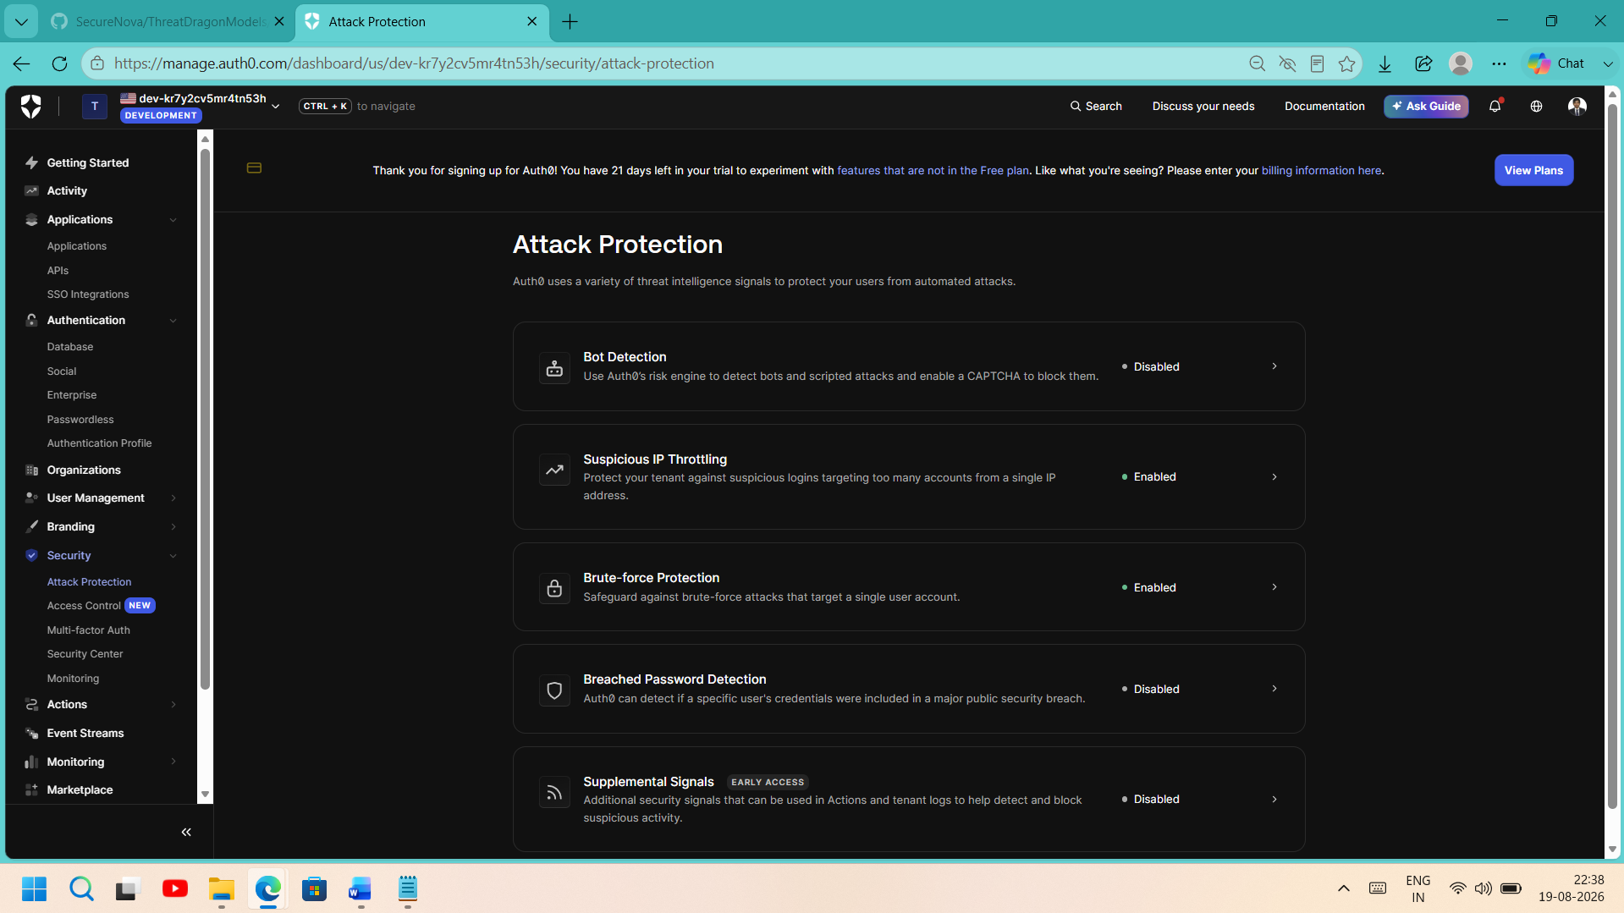

Screenshot 8: Terminal — Credential Rotation Script
Where from: Terminal running rotate_test.py (with mock_chat_api.py running in a second terminal)
What must be visible: Timestamped log lines showing: token obtained (TTL=60s) → first call → status=200 → 65s wait → replay → status=401 → PASS message.
import time
import json
import requests
from datetime import datetime

AUTH0_DOMAIN = "dev-kr7y2cv5mr4tn53h.us.auth0.com"
CLIENT_ID = "uxrPjfGkDLeXkXoRpIIp7KvS6Fd0OrQ6"
CLIENT_SECRET = "04tCDvhYfn5EoXQVvCyxID9VsF4YdAbwFlL5-S3afQVrHgRxlzRaXz-3iCanZ3mE"
AUDIENCE = "https://securenova-ai-api"
CHAT_API_URL = "http://localhost:5000/chat"
TOKEN_TTL_SECONDS = 60

def log(msg):
print(f"[{datetime.now().isoformat(timespec='seconds')}] {msg}")

def get_m2m_token():
resp = requests.post(
f"https://{AUTH0_DOMAIN}/oauth/token",
headers={"content-type": "application/json"},
data=json.dumps({
"client_id": CLIENT_ID,
"client_secret": CLIENT_SECRET,
"audience": AUDIENCE,
"grant_type": "client_credentials",
}),
)
resp.raise_for_status()
body = resp.json()
log(f"Obtained M2M token. expires_in={body.get('expires_in')}s scope={body.get('scope')}")
return body["access_token"]

def call_chat_api(token):
resp = requests.post(
CHAT_API_URL,
headers={"Authorization": f"Bearer {token}"},
json={"message": "ping"},
)
log(f"Called /chat -> status={resp.status_code}")
return resp.status_code

def main():
log("=== Step 1: Request short-lived M2M token ===")
token = get_m2m_token()

log("=== Step 2: Call /chat immediately with fresh token ===")
status1 = call_chat_api(token)
assert status1 == 200, f"Expected 200 on first call, got {status1}"

wait_for = TOKEN_TTL_SECONDS + 5
log(f"=== Step 3: Sleeping {wait_for}s to let token expire (TTL={TOKEN_TTL_SECONDS}s) ===")
time.sleep(wait_for)

log("=== Step 4: Replay the SAME (now-expired) token ===")
status2 = call_chat_api(token)
if status2 == 401:
log("PASS: Expired token correctly rejected with 401 Unauthorised.")
else:
log(f"FAIL: Expected 401 on replay, got {status2}. Check token TTL / rotation config.")

if __name__ == "__main__":
main()

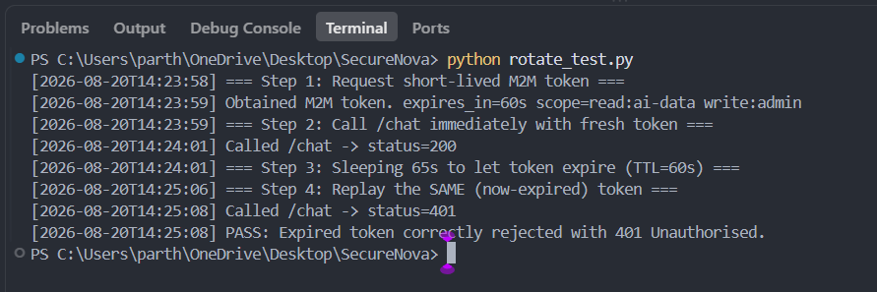
Screenshot 9: Authorization Boundary — User Token Rejected

