Olist Brazil E-Commerce
Order Funnel Analysis
Track the journey. Fix the leaks. Grow revenue.
An end-to-end data analytics project using Python, SQL, and Power BI
Portfolio Project | 2026

Table of Contents
1. Executive Summary
2. Project Objective & Methodology
3. Data Cleaning Summary
4. Dashboard Overview
5. Key Findings
6. Business Recommendations
7. Appendix — Tech Stack & Resources

1. Executive Summary
This project analyzes the end-to-end order funnel of Olist, a Brazilian e-commerce marketplace, covering roughly 99,000 orders placed between 2016 and 2018. The goal was to identify where orders drop off between placement and delivery, quantify the revenue impact of that drop-off, and surface operational and regional patterns that a business team could act on.
The funnel overall converts well: 97.02% of orders that are placed are eventually delivered, and average customer satisfaction sits at 4.09 out of 5. The most significant leak in the funnel is the Approved-to-Shipped stage, where a 1.63% drop-off translates into an estimated $161,560 in revenue at risk. Delivery speed is the clearest lever for improving customer satisfaction — orders taking longer than 7 days show a visibly higher share of low review scores.
Geographically, the business is heavily concentrated: São Paulo (SP) alone accounts for 38.28% of total revenue, with the top 3 states (SP, RJ, MG) contributing over 63% combined — a concentration worth flagging for both risk and growth-opportunity conversations.

Headline Metrics
99K  Total Orders | $13.59M  Total Revenue | $136.68  Avg Order Value | 97.02%  Conversion Rate
4.09 / 5  Avg Review Score | 94.96%  On-Time Delivery | 12.50  Avg Delivery Days | $161.56K  Revenue at Risk

2. Project Objective & Methodology

Objective
Answer one central business question: where in the order lifecycle are we losing orders or time, and what is that costing the business? The funnel is defined across five stages: Order Placed → Payment Approved → Shipped to Carrier → Delivered to Customer → Review Left.

Dataset
Olist Brazilian E-Commerce Public Dataset (Kaggle) — 9 relational CSV files covering ~99K orders, including order status and timestamps, order items, payments, reviews, customers, products, and sellers, spanning September 2016 to October 2018.

Methodology — Three-Phase Pipeline
- Phase 1 — Python (pandas): loaded and cleaned all 9 raw tables individually, resolved one-to-many relationships (items, payments, reviews aggregated to one row per order), validated join keys, and exported 7 clean tables — deliberately kept unmerged so relational joins could be demonstrated in SQL.
- Phase 2 — SQL: loaded the 7 clean tables into a relational database and wrote 40 business-question queries spanning filtering, aggregation, HAVING, multi-table joins, CTEs, subqueries, and window functions — building up to the core funnel and stage-conversion queries.
- Phase 3 — Power BI: modeled the cleaned tables with proper relationships and a dedicated date table, built ~20 DAX measures, and designed a 5-page interactive dashboard (plus a home/navigation page) covering executive KPIs, funnel mechanics, delivery performance, customer/product insights, and geographic analysis.

3. Data Cleaning Summary
Cleaning was performed in a Jupyter notebook, with each of the 9 raw tables inspected and cleaned individually before export. Key steps and issues found:
- Converted all date/timestamp columns from object/string to proper datetime types across the orders table.
- Removed a small number of logically invalid rows where the recorded delivery date preceded the purchase date.
- Aggregated payments (multiple payment methods per order, e.g. voucher + credit card) down to one row per order, summing total value and taking the primary payment type.
- Aggregated order items (multiple line items per order) down to one row per order, computing item count, total item revenue, and total freight.
- Deduplicated reviews to one row per order, keeping the most recent review where duplicates existed.
- Verified uniqueness of every join key (order_id, customer_id, product_id, seller_id) before export, so downstream SQL joins would be reliable 1-to-1 or 1-to-many as intended.
The result was 7 clean, independently-usable tables — orders, items, payments, reviews, customers, products, and sellers — matching the naming convention used consistently through SQL and Power BI.

4. Dashboard Overview
The Power BI dashboard is structured as a home/navigation page plus five analytical pages, each targeting a different business lens on the same underlying funnel.

Home
A landing page with navigation cards into each of the five analytical pages, giving any viewer an immediate map of what the dashboard covers.
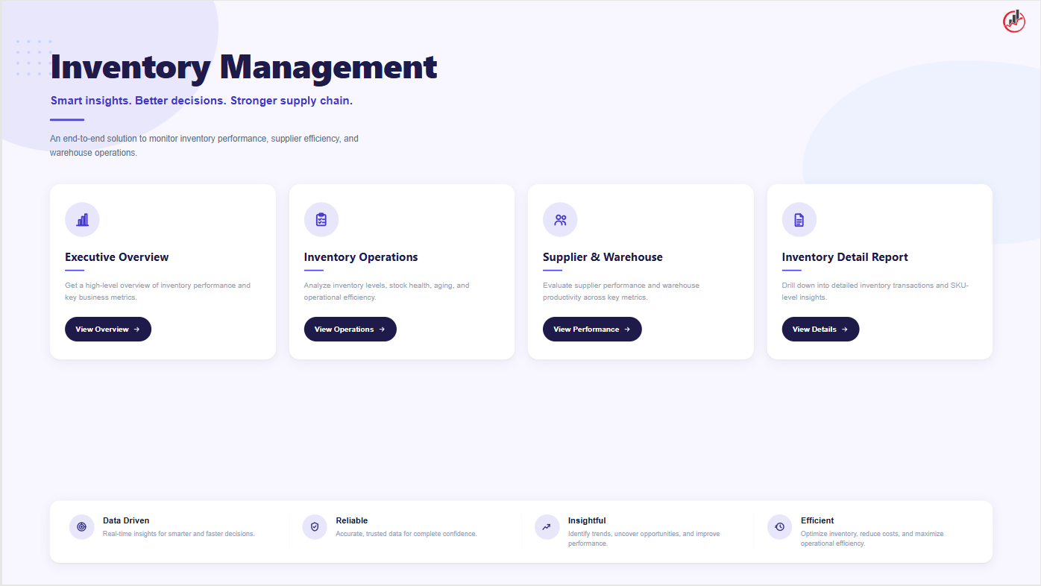
Figure 1 — Dashboard home/navigation page

4.1 Executive Overview
High-level KPIs (orders, revenue, average order value, review score, conversion rate) alongside monthly order trends, revenue by state, and top product categories by revenue contribution.
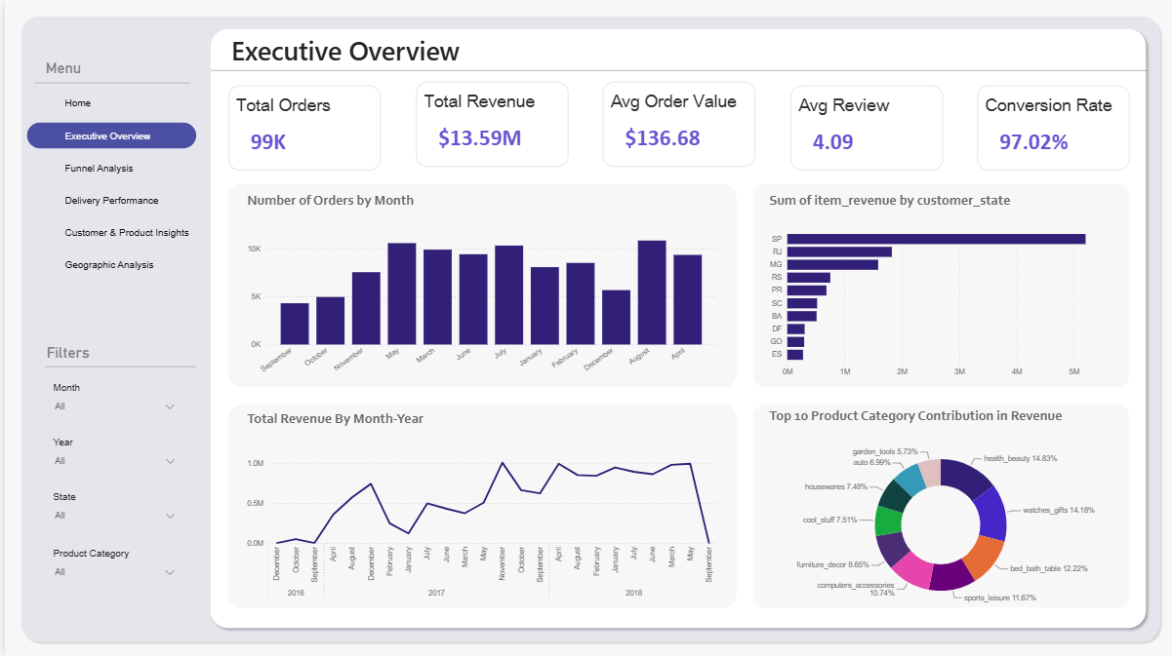
Figure 2 — Executive Overview page

4.2 Funnel Analysis
The core funnel visual — Total Orders through Orders Reviewed — paired with stage-by-stage drop-off percentages, a delivery-rate gauge against a 95% target, and the monthly delivered-rate trend.
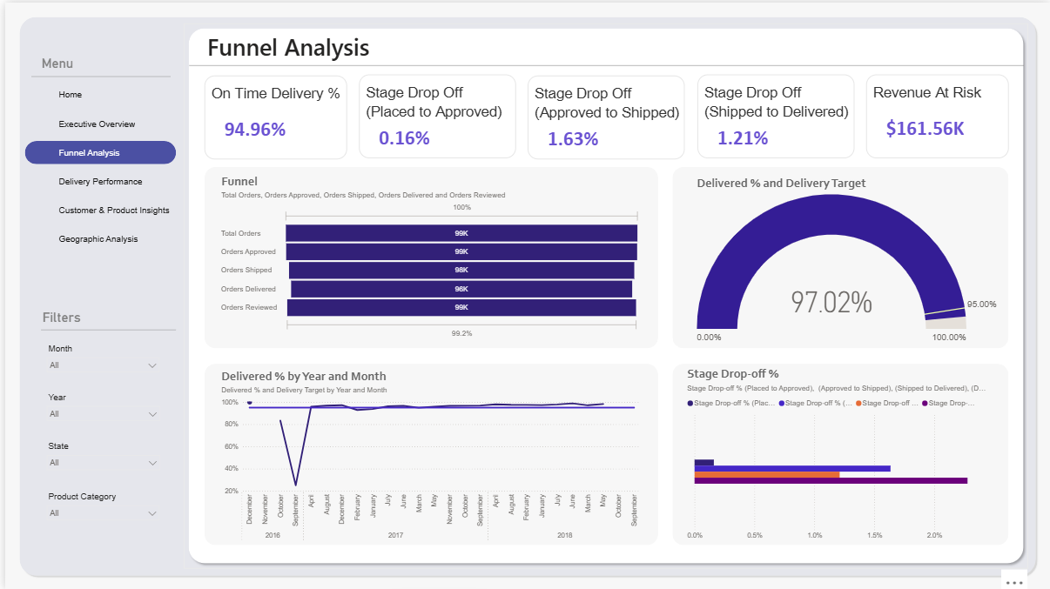
Figure 3 — Funnel Analysis page

4.3 Delivery Performance
Delivery-time distribution, delivery bucket breakdown (same-day through 8+ days), on-time vs. late delivery by state, and the relationship between delivery time and average review score.
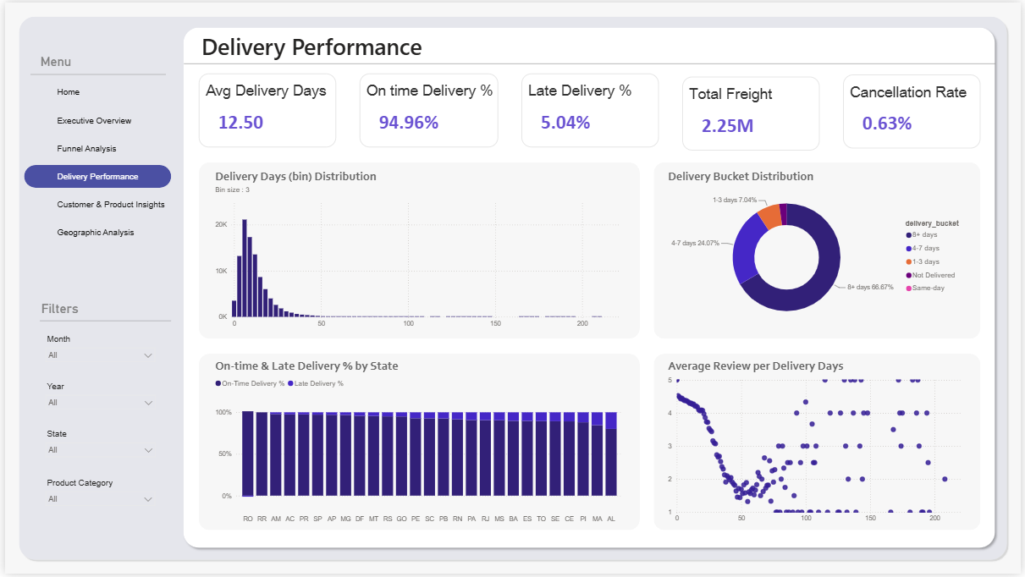
Figure 4 — Delivery Performance page

4.4 Customer & Product Insights
Total customers, products, and categories, alongside top products and sellers by revenue, a treemap of top categories, and the review score distribution.
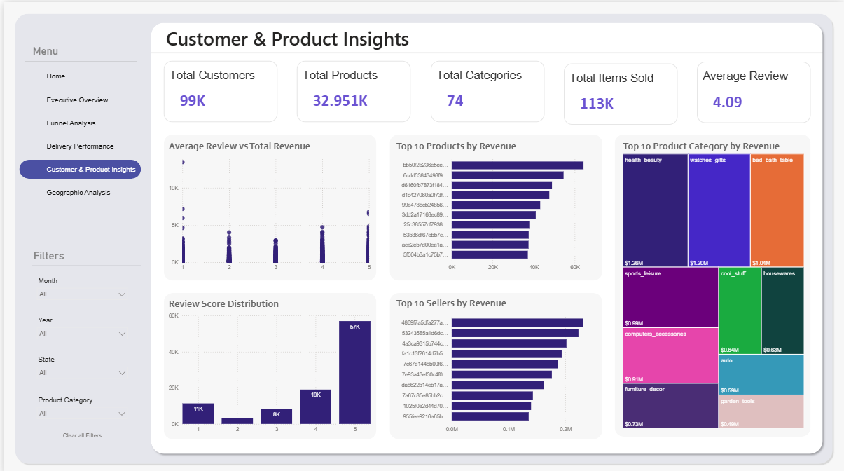
Figure 5 — Customer & Product Insights page

4.5 Geographic Analysis
Revenue and order volume by state and city on filled maps, top revenue-generating cities, and average review score and delivery time by state.
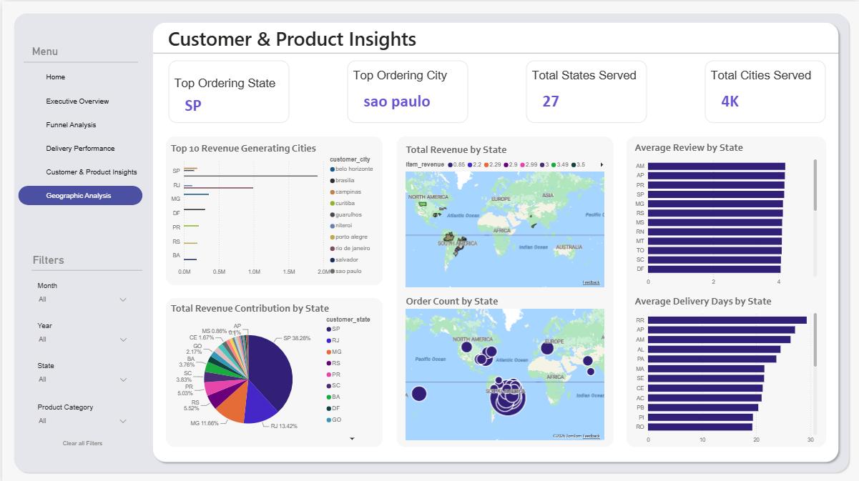
Figure 6 — Geographic Analysis page

5. Key Findings

5.1 The funnel is healthy overall, but one stage stands out
Of the three tracked stage-to-stage transitions, Approved → Shipped shows the largest drop-off at 1.63%, compared to 0.16% (Placed → Approved) and 1.21% (Shipped → Delivered). This single transition accounts for an estimated $161,560 in revenue at risk — the clearest, most fixable leak in the funnel.

5.2 Delivery speed is the strongest visible driver of satisfaction
The relationship between delivery days and review score is not subtle: review scores decline sharply as delivery time increases from same-day into the 50-100 day range, before scattering more widely for outlier deliveries. Meanwhile, a striking 66.67% of delivered orders fall into the 8+ days bucket — the slowest bucket is also the most common, which is a significant opportunity.

5.3 Revenue is heavily concentrated in one region
São Paulo (SP) alone generates 38.28% of total revenue and is both the top ordering state and home to the top ordering city (São Paulo city). Combined with Rio de Janeiro (13.42%) and Minas Gerais (11.66%), the top 3 states account for over 63% of all revenue — despite the business serving 27 states and roughly 4,000 cities.

5.4 Category performance is broad but top-heavy
Health & beauty ($1.26M), watches & gifts ($1.20M), and bed & bath ($1.04M) are the top 3 categories by revenue. The top 10 categories span a fairly wide range ($0.49M–$1.26M), suggesting a diversified catalog rather than dependence on one blockbuster category.

5.5 Customer satisfaction is bimodal, not just average
With an average review score of 4.09, the headline number looks healthy — but the distribution is bimodal: roughly 57K reviews are 5-star, yet 11K are 1-star, more than the 2-, 3-, and 4-star counts combined in some views. This means a meaningful minority of customers are having a distinctly bad experience, which an average score alone would mask.

6. Business Recommendations
- Investigate the Approved → Shipped handoff first. This is the single largest controllable leak ($161.56K at risk) — audit seller-side fulfillment SLAs and warehouse/carrier pickup scheduling to find the root cause of delay at this specific step.
- Treat delivery speed as a satisfaction lever, not just a logistics metric. With 66.67% of orders taking 8+ days, even modest improvements to the slowest bucket could measurably lift average review scores, given the clear negative correlation observed.
- De-risk the geographic concentration. With SP, RJ, and MG contributing over 63% of revenue, evaluate targeted marketing or seller-onboarding incentives in under-represented states to diversify revenue exposure.
- Address the 1-star review segment directly. Rather than optimizing only for the average score, investigate what specifically drives the ~11K 1-star reviews (likely tied to delivery delays or specific categories/sellers) and treat it as a distinct retention risk.
- Monitor top sellers for both revenue and satisfaction together. The dashboard's paired seller revenue/review view makes it possible to flag high-revenue sellers with below-average review scores — a segment worth proactive account management.

7. Appendix — Tech Stack & Resources

Tools Used
Stage | Tool | Output
Data Cleaning | Python (pandas, numpy, Jupyter) | 7 clean, relational CSV tables
EDA & Business Questions | SQL (joins, CTEs, subqueries, window functions) | 40 business-question queries
Visualization | Power BI (Power Query, DAX, relationships) | 6-page interactive dashboard
Reporting | Word / PowerPoint | This report and an executive summary deck

Funnel Stage Definitions
Order Placed → order_purchase_timestamp | Payment Approved → order_approved_at | Shipped to Carrier → order_delivered_carrier_date | Delivered to Customer → order_delivered_customer_date | Review Left → review_creation_date

Data Source
Olist Brazilian E-Commerce Public Dataset, available on Kaggle. Data covers orders placed between September 2016 and October 2018 across the Olist marketplace.

