AI-Driven Antibiotic Discovery for Antimicrobial Resistance
1. Problem Definition
Antimicrobial resistance happens when bacteria change so that the antibiotics meant to kill them stop working. Common infections then become hard, and sometimes impossible, to treat. In 2021, drug-resistant bacteria were directly responsible for about 1.14 million deaths worldwide and played a part in about 4.71 million deaths. The same global study projects that resistance will directly cause more than 39 million deaths between 2025 and 2050, with the yearly toll almost doubling by mid-century (GRAM study, The Lancet, 2024).
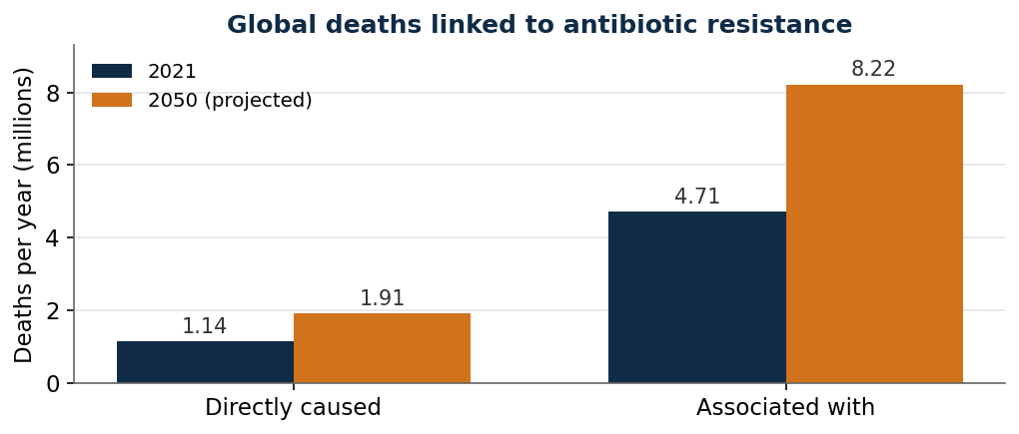
Figure 1. Deaths linked to antibiotic resistance, 2021 and the 2050 projection. Source: GRAM, The Lancet, 2024.
India carries a heavy share of this burden. On current trends, resistance could be associated with about 1.2 million deaths a year in India by 2030 (IHME). The country’s own surveillance shows the direction of travel. Between 2017 and 2023, the share of E. coli infections still treatable with imipenem, a last-resort antibiotic, fell from 81 percent to 63 percent, and for Klebsiella pneumoniae it fell from 59 percent to 36 percent (ICMR, 2023). Typhoid makes the point plainly: of about 730,000 typhoid hospitalisations in India in 2023, roughly 600,000, or 82 percent, involved strains resistant to fluoroquinolones, once the standard cure (Lancet Regional Health, 2025). Those hit hardest are patients with bloodstream, lung, and hospital infections, especially newborns and older adults, along with health systems forced onto costlier, more toxic drugs.
2. Current Landscape
For decades, new antibiotics were found by testing natural substances and chemical libraries one at a time. That method has slowed, and few genuinely new classes have reached patients. The pipeline is thin: the World Health Organization counted about 90 antibacterial medicines in clinical development in 2025, of which only around 15 were genuinely new and only 5 worked against the most dangerous bacteria.
Machine learning has begun to change discovery. In 2020, a model at MIT identified halicin, the first antibiotic found by deep learning. In 2023 the same group found abaucin. In 2024, Google DeepMind released AlphaFold 3, which predicts the shapes of proteins and helps researchers spot new bacterial targets. The clearest breakthrough came in August 2025, when the MIT group published two antibiotics, NG1 and DN1, designed from scratch by generative AI, meaning software that invents new molecules rather than picking from a shelf. NG1 attacks drug-resistant gonorrhoea, and DN1 cleared an MRSA skin infection in mice (Cell, 2025). Almost all of this work, however, uses data and priorities from western\ countries, the molecules still face years of testing, and the money side stays broken.
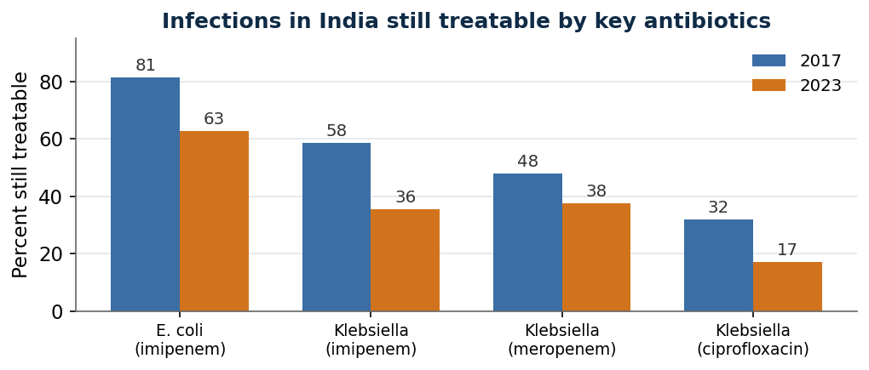
Figure 2. Share of key infections in India still treatable by major antibiotics, 2017 versus 2023. Source: ICMR AMRSN, 2023.
3. The AI/ML Solution and What Makes It Innovative
The proposed approach is a discovery engine built around India’s own bacteria and resistance data. It runs from input, to an AI layer, to an action, to an outcome.
- Input: chemical libraries, bacterial genomes, India’s resistance surveillance records, and laboratory results on how well candidates kill bacteria and how safe they are.
- AI layer: generative models design new molecules and short bacteria-killing proteins aimed at the resistant strains that matter most in India; screening models rank millions of candidates; structure prediction finds new targets.
- Action: the strongest and most makeable candidates are synthesised and tested in an automated laboratory, and each result trains the next round.
- Outcome: a ranked set of tested early-stage candidates produced in months rather than years.
What separates this from the crowded field of AI drug-discovery firms is three deliberate choices. It trains on India-specific resistance data, so it targets local threats such as carbapenem-resistant Klebsiella rather than strains common in the West. It gives equal weight to drug combinations and to repurposing approved drugs, both of which reach patients faster and cheaper because their safety is already known. And it is built around an access funding model from the start, rather than assuming ordinary drug sales will pay for it. The value lies not in using AI, which many already do, but in joining local data, a faster clinical route, and a funding model made for a market that does not reward antibiotics.
4. Surface-Level Implementation
- Data: public chemical databases, genome banks, and India’s ICMR surveillance network, plus laboratory results generated in-house.
- Infrastructure: computing for the models, an automated laboratory or a partner that runs one, and secure data pipelines.
- People: microbiologists, chemists, machine-learning engineers, and clinical and regulatory advisers.
- Workflow: pick a priority bacterium, generate and rank candidates, synthesise and test the best, and repeat.
- Pilot: one campaign against a priority pathogen such as carbapenem-resistant Klebsiella pneumoniae, aiming for a small set of validated hits in 12 to 18 months.
- Partners: Indian research bodies such as ICMR and CSIR, an automated-chemistry partner, and global health funders such as CARB-X, GARDP, and the AMR Action Fund.
5. Feasibility
- Technical: AI has now designed antibiotics from scratch, but turning candidates into approved drugs remains hard.
- Data: Global data is plentiful; curated Indian resistance data is thinner and must be built.
- Economic: The market for antibiotics is broken, so public funding is essential.
- Regulatory: Special approval routes exist, but antibiotic trials struggle to recruit patients.
- Operational: Rare, cross-skilled teams and close laboratory links are needed.
- Scalability: The platform scales across bacteria, but each drug still faces slow clinical testing.
6. Economics and Business Case
The economics are the hardest part. A new antibiotic is held in reserve to slow resistance, so it sells in small volumes and earns little, which is why several large companies left the field. Public payment schemes are now filling the gap. The United Kingdom runs the world’s first subscription model, paying a fixed yearly fee for access rather than per pack, and in 2024 it moved to contracts worth almost 1.9 billion pounds over sixteen years. The United States has proposed a similar law, the PASTEUR Act, offering fixed contracts of up to 3 billion dollars. The AMR Action Fund, backed by more than twenty companies, has raised close to 1 billion dollars to bring new antibiotics to patients by 2030. Revenue for the proposed engine would come from licensing candidates, research grants, and these fixed-payment schemes, not from sales volume. The benefit is measured in lives and costs avoided, a social return that markets underpay for. Useful measures of success are validated candidates per year, hit rate against traditional screening, cost per candidate, and candidates handed to clinical partners.
7. Constraints and Risks
- The path from a computer design to an approved drug is long and costly, and most candidates fail.
- The broken market remains the deepest risk, even for an excellent drug.
- Indian resistance data is limited, which is the very asset the approach relies on.
- Bacteria can evolve against new drugs, and any new antibiotic must be used sparingly, which limits sales further.
- Over-optimism is a risk in itself, because AI claims often outrun clinical proof.
8. Existing Players and Comparable Solutions
- Phare Bio, linked to the MIT team behind halicin and NG1, uses generative AI to design new antibiotics and won up to 27 million dollars from the US agency ARPA-H in 2024. It aims at new molecules for global markets, while the proposed approach centres on Indian strains and on faster combination and repurposing routes.
- Broad AI drug-discovery firms such as Insilico Medicine, Recursion, and Isomorphic Labs mostly target profitable diseases, not antibiotics.
- CARB-X, GARDP, and the AMR Action Fund fund antibiotic work but do not run discovery platforms, so they are natural partners rather than rivals.
Critical Assessment
The strength here is real and now proven: in 2025, AI designed working antibiotics from scratch for the first time. The weakness is that discovery was never the only problem. The pipeline is thin mainly because antibiotics do not sell, not because molecules cannot be found. A plan that simply promised to find more antibiotics with AI would repeat what others already do and would ignore the market failure underneath.
The approach becomes credible when it does three things most players do not. It focuses on India’s own resistant bacteria, using local surveillance data. It leads with combinations and repurposing, which are cheaper and faster to reach patients. And it treats the funding model as part of the design, tying itself to subscription schemes and global health funders. Presented this way, the message is that AI now cuts the cost of discovery sharply, and the plan also confronts the harder economic and clinical barriers. That honesty carries more weight than a promise to solve resistance with software alone.
Sources
- Global AMR deaths and 2050 projection (GRAM, The Lancet, 2024): https://www.thelancet.com/journals/lancet/article/PIIS0140-6736(24)01867-1/fulltext and https://www.eurekalert.org/news-releases/1057804
- India AMR burden, about 1.2 million associated deaths by 2030 (IHME): https://www.healthdata.org/sites/default/files/2023-09/India.pdf
- India typhoid fluoroquinolone resistance, 2023 (Lancet Regional Health SEA): https://www.ncbi.nlm.nih.gov/pmc/articles/PMC12808886/
- ICMR resistance decline 2017 to 2023: https://www.downtoearth.org.in/health/new-icmr-report-highlights-growing-resistance-in-bacteria-to-antibiotics-critical-for-human-health
- Generative AI antibiotics NG1 and DN1 (Cell, 2025), MIT: https://news.mit.edu/2025/using-generative-ai-researchers-design-compounds-kill-drug-resistant-bacteria-0814
- Phare Bio ARPA-H award, 2024: https://www.businesswire.com/news/home/20240926055961/en/
- UK antibiotic subscription model and 1.9 billion pound tender: https://www.pharmaceutical-technology.com/analyst-comment/uk-antibiotic-subscription-funding-model-a-route-to-market-sustainability/

