Innovation Assignment / Agriculture
A Voice-First AI Companion for India's Small Farmers: From Crop Diagnosis to Fair Insurance
Analysis and critical evaluation. Maturity labels: Exists (live today), Demonstrated (shown in research or pilots), Feasible (credible but not widely deployed), Speculative (the ambitious leap).
1. Problem Definition
Farming supports about 46 percent of India’s workforce but produces only about a sixth of the country’s output, a gap that keeps hundreds of millions of families poor and exposed (Ministry of Agriculture, 2024 to 2025). Most of these are small farmers: about 86 percent work less than two hectares, often under one. They make high-stakes decisions almost blind. What is wrong with a sick crop and what to do about it. How much water and fertiliser to use. When to sow and harvest as the weather turns. And, when a crop fails, how to win a fair insurance payment.
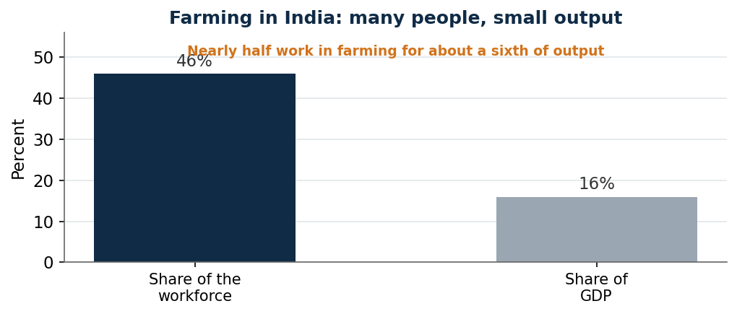
Figure 1. Farming carries nearly half of India’s workers but a small share of output, a sign of low incomes and productivity. Source: Ministry of Agriculture, 2024 to 2025.
The losses are heavy. Pests and diseases alone destroy an estimated 15 to 30 percent of India’s crops each year, and the global figure reaches 40 percent (ICAR and government estimates; FAO). Expert help barely reaches farmers: the national pest system leans on about 10,000 extension officers for tens of millions of farms. And when disaster strikes, insurance is slow and disputed. Under the national crop-insurance scheme, one flooded farmer was paid 2.30 rupees because satellite images judged his loss too small (Down To Earth, 2026). Those who bear all this are the small farmers themselves, who lose yield, waste money on the wrong inputs, and slide into debt.
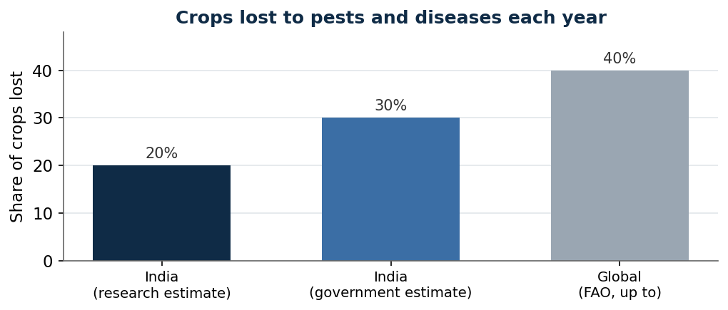
Figure 2. Estimated share of crops lost to pests and diseases each year. Sources: ICAR and government estimates for India; FAO for the global figure.
2. Current Landscape
India has built real digital foundations for farming, but they work as separate tools. The Digital Agriculture Mission, launched in September 2024 with 2,817 crore rupees, is building AgriStack, a digital record of farmers, land, and crops, with more than 84 million farmer IDs created by early 2026. On pests, the National Pest Surveillance System, launched in 2024, lets a farmer photograph a sick crop and receive an AI diagnosis, reaching farmers through about 10,000 extension officers. On advice, the Kisan e-Mitra voice chatbot answers scheme questions in 11 languages and had handled more than 93 lakh queries by December 2025. On insurance, the crop scheme now uses satellite yield estimates (YES-TECH) and automatic weather stations (WINDS) to settle area claims, and since 2024 it charges insurers a 12 percent penalty for late payment.
These are strong pieces, but a farmer meets them one at a time, in different apps and offices, and they do not talk to each other. Advice sits apart from insurance, so the same satellite that estimates a yield does not explain a claim, and disputes follow.
3. The AI/ML Solution and What Makes It Innovative
The proposed approach is a single, voice-first companion that follows a farmer through the whole season on a basic phone, in the local language, joining four tasks handled separately today. It runs from input, to an AI layer, to an action, to an outcome.
- Input: a photo of a sick crop, the field location and crop type, satellite images, weather and rainfall data, and soil information.
- AI layer: vision models name the pest or disease from the photo; satellite and weather models predict drought, the right time to sow and harvest, and the likely yield for that field; and simple models turn soil and crop data into water and fertiliser advice.
- Action: the farmer hears a plain-language answer by voice, what the problem is, what to do, and how much water and fertiliser to use, and when a crop fails, the same field data opens and supports an insurance claim.
- Outcome: fewer losses, less wasted input and water, and faster, better-trusted payouts.
What separates this from the tools already in use is three choices. It joins advice and insurance on the same data, so the satellite and weather signals that guide a farmer through the season also explain and back the claim, instead of arriving as a stranger’s verdict after the loss. It is voice-first and vernacular by default, built for farmers who cannot read forms or use English, rather than an app that assumes literacy. And it follows one field across the season rather than answering a single question and forgetting, learning that field’s soil, crop, and risk. The value is in the join and the voice, not in any single photo diagnosis.
4. Surface-Level Implementation
- Data: farmer photos, the AgriStack farmer and land records, satellite imagery, the weather-station network, and soil-health data.
- Infrastructure: a phone app and a plain phone-call line, cloud models, and links to the pest system, the advisory services, and the insurance portal.
- People: farmers, extension officers, insurers, and a technical team of vision and data engineers.
- Workflow: a farmer sends a photo or a voice question, the models answer by voice, advice follows the field through the season, and at loss time the same data opens a claim.
- Pilot: one district and two or three major crops, measured on losses, input use, and claim speed against nearby areas.
- Partners: the Agriculture Ministry’s digital mission, a pest and advisory body such as ICAR, an insurer, and a language-technology provider such as Bhashini.
5. Feasibility Analysis
- Technical: High. Every part, photo diagnosis, satellite advice, and voice in local languages, already runs in India; the work is joining them.
- Data: Medium to High. AgriStack, satellite, and weather data are growing, though soil and field-level records are patchy.
- Economic: Medium. Government schemes and insurers can fund it, but reaching tiny farms cheaply is hard.
- Regulatory: Medium to High. National missions and the insurance scheme actively invite such tools, within data-protection limits.
- Operational: Medium. It needs several agencies to share data and extension officers to help farmers trust it.
- Scalability: High. A voice service on a phone can reach millions once it works in one region.
6. Economics and Business Case
The value is large and measurable. Cutting even part of the 15 to 30 percent lost to pests and diseases, and the waste of water and fertiliser, puts money straight back in farmers’ hands. The buyers are mainly public: the Agriculture Ministry through its digital mission, state governments, and insurers who gain from faster, less-disputed, and less fraudulent claims. The crop-insurance scheme already moves large sums, about 10,000 crore rupees in claims in 2024 to 2025 across more than 4 crore enrolled farmers, so better data lowers both wrong payouts and angry disputes. Revenue for a provider can come from building and running the service for government and insurers, and from analytics. The returns show up as higher yields, lower input and water use, faster payouts, and greater trust. Useful measures of success are crop losses avoided, fertiliser and water saved, the share of claims settled quickly, and the share of claims disputed.
7. Constraints and Risks
- Photo diagnosis is only as good as the picture and the training data, and it fails on unknown or mixed diseases, so it must guide, not replace, an expert.
- Satellite-based insurance already misjudges real losses; joining advice to it must reduce disputes, not lend them false authority.
- Wrong advice at scale can spread a bad practice quickly, so human checks matter.
- Small farms have patchy soil and yield records, which weakens field-level advice.
- Voice and language models can still misread dialects, and trust must be earned through extension officers.
- Data on farmers’ land and income is sensitive and must be protected and used only with consent.
8. Existing Players and Comparable Solutions
- The National Pest Surveillance System diagnoses pests from photos. The proposed approach folds this into a season-long voice companion rather than a stand-alone tool.
- Kisan e-Mitra answers scheme questions by voice in many languages. The proposed approach extends the same voice-first method from paperwork to farming decisions and claims.
- YES-TECH and WINDS bring satellite and weather data to insurance. The proposed approach uses the same data to advise the farmer first, so a claim is understood, not just imposed.
- Private advisory apps offer crop tips and market prices, but most assume a literate app user, while the proposed approach is built for voice and local language.
Critical Assessment
The strength of this direction is that its parts are already live in India and working: farmers photograph pests for an AI diagnosis, a voice bot answers in eleven languages, and satellites estimate yields for insurance. The weakness is that these sit in separate silos, so a farmer meets them one at a time and advice never meets insurance. The fresh and defensible move is to join them into one voice-first companion that follows a single field through the season, and to use the same data both to advise the farmer and to support the claim, which is where trust is won or lost.
Two cautions keep the claim honest. The technology assists judgement, it does not replace the eye of an experienced farmer or officer, and photo and satellite models will sometimes be wrong. And joining advice to satellite-based insurance cuts both ways: done well it makes claims understandable and fair; done badly it dresses a flawed estimate in extra authority, as the farmer paid 2.30 rupees for a flooded field shows. Built for voice, for one field at a time, and with human checks, the case is strong; sold as an app that ends crop loss, it would be wrong.
Sources
- Agriculture share of workforce and output, 2024 to 2025 (Ministry of Agriculture data): https://agriculture.institute/institutional-support/current-status-agriculture-india-overview/
- Crop losses to pests and diseases, India about 15 to 30 percent and FAO up to 40 percent: https://www.eco-business.com/news/climate-pests-and-pollution-fuel-crop-losses-across-india/
- Digital Agriculture Mission (Sept 2024, 2,817 crore rupees) and AgriStack farmer IDs: https://www.biometricupdate.com/202602/india-advances-digital-agriculture-mission-with-over-84m-farmer-ids-generated
- National Pest Surveillance System and Kisan e-Mitra (11 languages, 93 lakh queries): https://www.pib.gov.in/PressNoteDetails.aspx?ModuleId=3&NoteId=157351&reg=3&lang=2
- Crop insurance scheme, enrolment and claims, YES-TECH and WINDS, 12 percent delay penalty: https://www.pib.gov.in/PressNoteDetails.aspx?NoteId=155010&ModuleId=3&reg=3&lang=1
- Satellite-based crop-insurance disputes and the 2.30 rupee payout: https://www.downtoearth.org.in/agriculture/when-crop-insurance-fails-farmers-pmfby-needs-a-rethink and https://www.downtoearth.org.in/agriculture/beyond-the-lens
- Wadhwani AI pest models in the national system, average pest yield loss about 23 percent: https://www.wadhwaniai.org/impact/agriculture-solutions/

