Innovation Assignment / 3 of 3
AI for Flood and Disaster Risk and General-Insurance Penetration in North and Northeast India
Analysis and critical evaluation. Maturity labels: Exists, Demonstrated, Feasible, Speculative.
1. Problem Definition
North and Northeast India face two problems at once: severe disaster risk and very little insurance. The region floods almost every year, and the mountains add sudden, violent events. In October 2023, a mountain lake in Sikkim burst when about 14.7 million cubic metres of frozen debris slid into it. The wave drained roughly 50 million cubic metres of water, destroyed the 1,200 megawatt Teesta III dam, and affected about 88,400 people (Science, 2025). India already sees more than a fifth of the world’s flood deaths.
Insurance barely reaches these places. India’s non-life insurance covers just 1.0 percent of national income, against a world average of 4.3 percent, and each person spends about 25 dollars a year on it, against 555 dollars worldwide (IRDAI and Swiss Re, 2024 to 2025). For disasters the gap is starker still: reinsurer Swiss Re estimates that about 93 percent of India’s natural-catastrophe losses are uninsured. When a flood hits, households, farmers, and small businesses absorb the loss, and the cost then falls on state relief budgets.
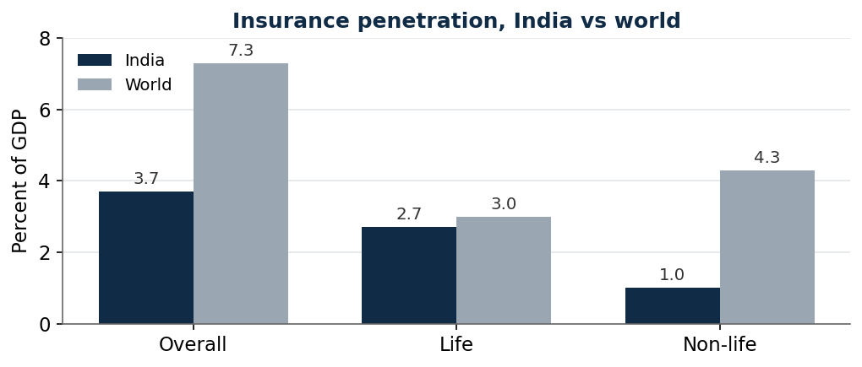
Figure 1. Insurance penetration in India compared with the world. Sources: IRDAI Annual Report 2024-25 and Swiss Re.
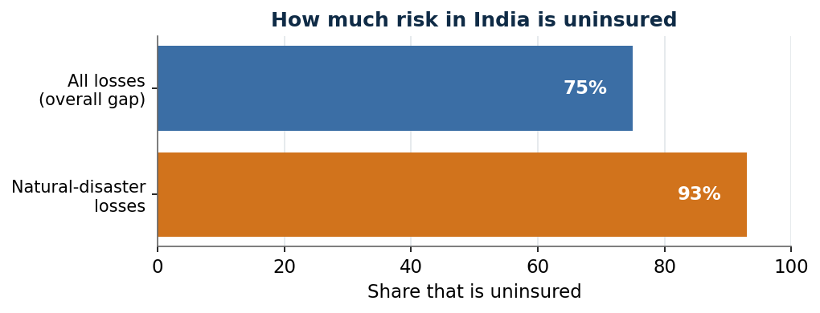
Figure 2. Share of losses in India that carry no insurance. Sources: IRDAI (overall gap) and Swiss Re (disaster losses).
2. Current Landscape
Flood forecasting in India is already strong. Google Flood Hub, working with the Central Water Commission, now covers the whole country, warns up to seven days ahead, reaches more than 200 million people, and has sent more than 30 million alerts; a Google survey found that 65 percent of warned people acted. Satellites can map how far and how deep a flood has spread within a day. So the missing piece is not the forecast.
Insurance has begun to experiment. Nagaland became the first Indian state to insure its whole territory against heavy rain. Its first attempt, from 2021, paid nothing because the trigger was set too high, which damaged trust. A redesigned scheme with SBI General and reinsurer Munich Re paid its first claim, about 1.06 crore rupees, in March 2025, sent digitally with no field visit. In October 2025, the central government began early talks on a national disaster-insurance scheme, although no formal plan yet exists.
3. The AI/ML Solution and What Makes It Innovative
The proposed approach links good risk data to insurance that people will actually trust and use.
- Input: satellite images, rainfall grids and forecasts, river sensors, elevation maps, and records of past floods and losses.
- AI layer: models that score flood risk building by building; models that design payout triggers matching real flooding, so payment tracks actual loss; and satellite checks that confirm an event automatically.
- Action: insurers can price cover in places they once avoided; policies pay out automatically when a trigger is met, sent by phone; and governments can warn earlier.
- Outcome: more cover in high-risk districts, faster and cheaper claims, and less uninsured loss on public budgets.
What is new is not the forecast but three things. Property-level risk scores let insurers underwrite the Northeast for the first time, rather than only warn people. Triggers built from measured flooding, not distant rain gauges, fix the failure that made Nagaland’s first scheme pay nothing. And automatic, phone-based payouts remove the cost and delay that make small policies unworkable. The value is in joining these into one chain, from risk data to product to trigger to payment.
4. Surface-Level Implementation
- Data: Indian satellite and radar imagery, rainfall grids, river sensors, elevation maps, and historical loss records.
- Infrastructure: a mapping platform, a risk-scoring service, a payout engine on the national payments system, and a simple local-language app.
- Stakeholders: insurers and reinsurers, state disaster authorities, banks and local agents, and the insured households and small businesses.
- Workflow: build the risk map, design the trigger, distribute through partners, monitor rainfall and flooding, pay automatically, and feed losses back to improve the models.
- Pilot: one high-risk cluster, such as an Assam river belt or the Teesta valley, with a state government as the main buyer.
5. Feasibility Analysis
- Technical: High. Forecasting, mapping, and risk scoring all exist; the work is joining them.
- Data: Medium to High. Satellite data is rich, but detailed past-loss records for the Northeast are thin.
- Economic: Medium. Small-policy margins are slim, so premiums usually need subsidy.
- Regulatory: Medium to High. The regulator supports parametric and small-ticket cover; rules on government-paid premiums are still a hurdle.
- Operational: Medium. Reaching and building trust in remote, low-connectivity areas is hard.
- Scalability: Medium to High. The template can extend across districts, but each needs local tuning and a willing buyer.
6. Economics and Business Case
Governments are the natural main buyers, as Nagaland shows, paying premiums so that whole districts are covered, while households and small firms add small top-ups. Insurers gain a product that is cheap to run because claims are automatic, and state budgets gain because sudden relief spending falls. Revenue for the platform comes from selling risk analytics to insurers and governments, from underwriting margin, and from distribution fees. Closing even part of a gap where more than 90 percent of disaster loss is uninsured shifts serious risk off families and the state. Useful measures of success are the share of a district covered, the gap between payout and real loss, claim-settlement time, the share of claims paid automatically, and the fall in relief spending.
7. Constraints and Risks
- Better risk data can make the most dangerous places more expensive or uninsurable, unless subsidy or pooling is added.
- If triggers still miss real losses, trust collapses again, as in Nagaland’s first attempt.
- Affordability and trust are not data problems; AI cannot create willingness to pay or the belief that a payout will come.
- Past-loss records for the Northeast are thin, which weakens pricing.
- Reaching remote areas, and funding rules for government premiums, remain real hurdles.
8. Existing Players and Comparable Solutions
- Google Flood Hub and the Central Water Commission forecast floods nationwide; the proposed approach adds the property-level risk layer and the insurance product that turn a warning into cover.
- The Nagaland scheme with SBI General and Munich Re shows state-level parametric cover works; the proposed approach reduces its weak point, basis risk, with measured-flood triggers.
- Satellite flood-mapping firms sell data feeds; the proposed approach builds a full product and distribution chain around them.
Critical Assessment
The strength is the pairing of prediction and insurance in a region that badly needs both. The weakness is that the prediction half is largely solved: Google Flood Hub and the Central Water Commission already forecast floods across India, and most warned people act. A plan built around building a forecast would look like a solved problem. The real openings are property-level risk scores for underwriting and triggers that match measured flooding.
It is also wrong to assume people go uninsured only because they lack information. The true barriers are affordability, trust, distribution, and insurers avoiding dangerous places, and better risk data can even make those places harder to insure. AI can lower basis risk, make underwriting possible, and cut distribution cost, but it cannot create willingness to pay or trust. So the honest design is social as well as technical: parametric cover that is subsidised or bundled, sold through trusted local networks, and paid automatically to rebuild faith. A sharper starting point than general river flooding may be Himalayan glacial-lake floods, where both the warning systems and the insurance are still missing.
Sources
- Sikkim South Lhonak glacial-lake flood, October 2023 (Science, 2025): https://www.science.org/doi/10.1126/science.ads2659
- India insurance penetration and density, FY2024-25 (IRDAI and Swiss Re): https://www.pib.gov.in/PressReleasePage.aspx?PRID=2216048&reg=3&lang=1 and https://www.business-standard.com/economy/analysis/insurance-for-all-2047-india-irda-roadmap-penetration-gap-126042800528_1.html
- Share of natural-catastrophe losses uninsured in India (Swiss Re Institute).
- Google Flood Hub coverage in India: https://indiaai.gov.in/news/google-s-flood-forecasting-initiative-extends-to-the-whole-of-india-and-bangladesh
- Nagaland parametric insurance and first payout, March 2025: https://india.mongabay.com/2025/06/first-payout-under-extreme-weather-insurance-triggers-relief-and-intrigue/
- India early talks on a national parametric scheme, October 2025: https://programbusiness.com/news/india-explores-nationwide-climate-linked-insurance-scheme/

