Innovation Assignment / Cybersecurity
Finding the Leaks Before Attackers Do: AI-Assisted Side-Channel Testing for India's Post-Quantum Shift
Analysis and critical evaluation. Maturity labels: Exists (live today), Demonstrated (shown in research or pilots), Feasible (credible but not widely deployed), Speculative (the ambitious leap).
1. Problem Definition
Modern encryption rests on hard mathematics, and that mathematics is rarely the weak point. The weak point is how the mathematics is built into real chips, cards, and software. A working device leaks small clues while it runs: how long an operation takes, how much power it draws, what electromagnetic signals it gives off, and how it disturbs shared parts of a processor. Attacks that read these clues are called side-channel attacks, and they can recover secret keys without ever breaking the underlying code. In plain terms, the lock is strong, but the way it is fitted to the door leaves gaps.
In 2024, researchers revealed GoFetch, an attack on Apple’s M-series chips that pulls secret keys straight out of software written to be safe, including the widely used OpenSSL library and, importantly, the new post-quantum algorithms Kyber and Dilithium. The flaw sits in the hardware and cannot be fully fixed (USENIX Security, 2024). Earlier, Hertzbleed had turned a chip’s power use into a remote timing attack and extracted a full key over a network (2022). A 2024 academic survey catalogued a long list of power, electromagnetic, and fault attacks against the very post-quantum algorithms now being standardised (ACM, 2024).
India is unusually exposed, because so much of daily life now runs on encryption. The country has roughly 130 crore active SIM cards, close to 100 crore debit cards, and more than 144 crore Aadhaar numbers, and it clears more than 23 billion digital payments a month (TRAI, RBI, UIDAI, and NPCI, 2025 to 2026). Every one of these depends on cryptographic code that will soon have to be rebuilt. Those who carry the risk are chipmakers, banks, payment networks, telecom operators, and governments, and behind them every citizen whose card, SIM, or identity record relies on that code.
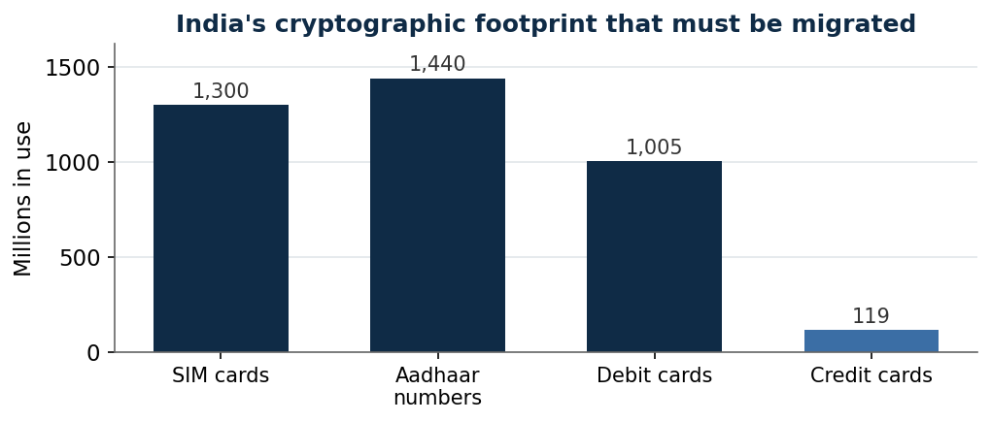
Figure 1. The scale of Indian systems whose cryptography must be re-secured. On top of these, India clears about 23.7 billion UPI payments a month. Sources: TRAI, RBI, UIDAI, NPCI, 2025 to 2026.
2. Current Landscape
Two forces are reshaping this field at once. First, encryption itself is being replaced. In August 2024, the United States standards body NIST published the first post-quantum standards, new algorithms named ML-KEM and ML-DSA, built to resist a future quantum computer, meaning a machine that could break today’s RSA encryption. NIST plans to retire the old algorithms after 2030 and ban them after 2035. India has set an even faster course: its February 2026 roadmap aims to move critical systems to post-quantum encryption by 2029. No quantum computer able to break RSA exists yet, but attackers are already storing encrypted data to unlock later, a tactic called harvest now, decrypt later. The catch is that this switch forces every library and device to be rewritten, and each rewrite can add fresh leaks. GoFetch already found leaks in real post-quantum code.
Second, AI has entered side-channel work, so far mostly on the attacker’s side. Using a public benchmark called ASCAD, deep-learning models can now recover a secret key from a protected chip using very few measurements, in the best recent case only about thirty (2024 to 2025 research). The same power that makes AI a fast attacker can be turned to defence, and that reversal is the opening this work takes.
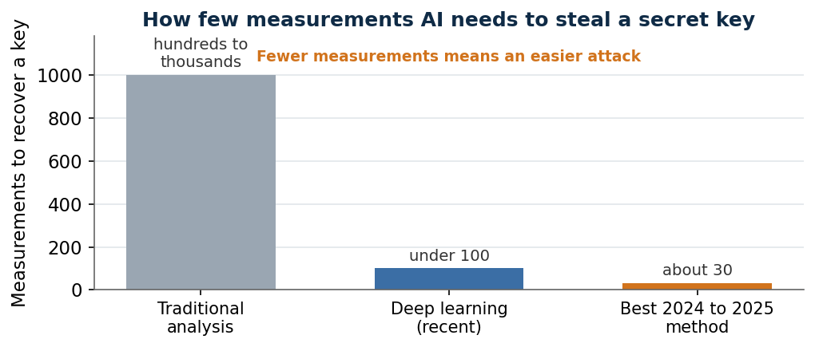
Figure 2. Machine learning has made key theft far more efficient on the ASCAD benchmark. The same techniques can be pointed at finding leaks first. Sources: ASCAD studies, 2024 to 2025.
Defensive tools exist but are earlier in their development. Standard leakage tests, known as TVLA, and code checkers such as ct-verif and Pascal can flag some leaks, and firms like Keysight, which bought the specialist Riscure, and eShard sell side-channel testing, increasingly with AI inside. What is missing is an AI system built to hunt leaks in post-quantum code before attackers do.
3. The AI/ML Solution and What Makes It Innovative
The proposed approach is an AI-assisted checker that finds side-channel leaks in cryptographic implementations, aimed at the new post-quantum algorithms and tuned for Indian certification and banking.
- Input: the source code and compiled program of a cryptographic implementation, plus real power and electromagnetic traces captured from the chip as it runs.
- AI layer: models trained to recognise the signature of a leak, using the same deep-learning methods attackers use, combined with code analysis that flags operations whose timing or memory use depends on secret data.
- Action: the checker ranks the likely leak points, explains each one, and where possible suggests a fix, feeding the results back into the developer’s build pipeline.
- Outcome: leaks caught during design and testing rather than after release, and a clear report a certification laboratory can act on.
What separates this from the current field is three choices. It turns AI from an attacker’s tool into a defender’s tool, closing the gap where offensive methods run years ahead of defensive ones. It targets the post-quantum algorithms in particular, exactly where fresh, untested implementations are being written. And it is built for India’s own certification labs and banks, aligned to the national roadmap, rather than sold only as a Western evaluation service. The value lies not in AI alone, which attackers already use, but in aiming it at prevention, at the new algorithms, and at India’s migration.
4. Surface-Level Implementation
- Data: open trace datasets such as ASCAD, in-house traces captured on real post-quantum implementations, and known-leak code samples for training.
- Infrastructure: a trace-capture bench of probes and an oscilloscope, or an existing academic setup, computing for the models, and a plug-in for common build pipelines.
- People: cryptographers, hardware-security engineers, and machine-learning engineers.
- Workflow: capture code and traces, run the AI and code checks, rank and explain the leaks, suggest fixes, and re-test.
- Pilot: work with one Indian hardware-security laboratory to benchmark the checker on ML-KEM and ML-DSA implementations.
- Partners: SETS Chennai, C-DAC, or an IIT laboratory, and a bank or payment body guided by the Reserve Bank’s quantum-safe committee.
5. Feasibility Analysis
- Technical: Medium to High. The attacking methods are proven; turning them into a reliable defensive tool is achievable but not yet standard.
- Data: Medium. Public datasets exist, but traces for the new post-quantum algorithms must be gathered.
- Economic: Medium to High. Clear buyers exist in certification labs, banks, and chipmakers, driven by the migration deadlines.
- Regulatory: Medium to High. India’s roadmap and the Reserve Bank’s committee create demand, although they are guidance, not yet binding rules.
- Operational: Medium. Rare, cross-skilled teams and access to test benches are needed.
- Scalability: Medium to High. Once trained, the software can check many implementations, though each new chip type needs fresh traces.
6. Economics and Business Case
The cost of getting encryption wrong is large and rising. The average data breach in India reached about 22 crore rupees in 2025 and about 25.5 crore in 2026, the highest on record, with financial services the worst-hit sector (IBM, 2026). The move to post-quantum encryption is a vast, one-time rebuild: the United States government alone budgeted about 7.1 billion dollars to migrate its civilian systems by 2035. Every rebuilt implementation needs testing, and testing is what this tool sells. The buyers are clear. India plans to open certification labs for post-quantum products by the end of 2026, and these labs need exactly this kind of testing. Banks and payment networks, pushed by the Reserve Bank’s quantum-safe committee, must check their new systems. Chipmakers and device makers must prove their products are safe before sale. Revenue can come from licensing the tool to these labs and firms and from testing services. Useful measures of success are leaks found before release, time saved against manual testing, and the number of post-quantum products certified with the tool.
7. Constraints and Risks
- Defensive AI for leak-finding is less mature than the attacking version, so results must be checked by experts, not trusted blindly.
- A tool that finds leaks could also teach attackers where to look, so access and results must be handled with care.
- The new algorithms and chips change fast, so the models need constant retraining on fresh traces.
- India’s roadmap is guidance today, not a binding rule, so demand could arrive slower than the deadlines suggest.
- The work needs rare skills, and India already faces a shortage of more than a million cybersecurity workers.
- A false sense of safety is a risk in itself, because passing the tool does not prove a device is leak-free.
8. Existing Players and Comparable Solutions
- Keysight, which bought the side-channel specialist Riscure, sells leak-testing platforms and has begun adding AI. The proposed approach differs by focusing on prevention inside the build pipeline and on India’s own labs.
- eShard and PQShield test post-quantum hardware for leaks, and PQShield’s design was checked over two million measurements. The proposed approach aims to be the testing engine, tuned for Indian certification, rather than a single hardware product.
- Academic tools such as ct-verif and Pascal find some leaks in code but are not full, AI-driven products. The proposed approach joins code checks with AI trace analysis in one usable tool.
- SETS Chennai already explores AI for side-channel analysis and is a natural partner rather than a rival.
Critical Assessment
The strength here is timing and honesty. The mathematics of encryption is being replaced worldwide, every new implementation can leak, and AI is already a proven attacker on the side-channel front. Turning that same AI toward defence, and aiming it at the new post-quantum code, targets a real and growing gap rather than a crowded market.
The honest weaknesses are two. Defensive leak-finding with AI is less developed than the attacking version, so the tool assists experts rather than replacing them, and it must never be sold as a guarantee. And the demand rests partly on deadlines that are still guidance, not law, so the pace depends on regulators following through. Put plainly, AI cannot make the mathematics stronger, but it can find the weak joints where strong mathematics is fitted into real devices, faster than people can, and just as the country rebuilds all of it. Focused on prevention, on the new algorithms, and on India’s certification labs, the case is strong; sold as AI that makes encryption unbreakable, it would be wrong.
Sources
- GoFetch side-channel attack on Apple M-series chips (USENIX Security, 2024): https://gofetch.fail and https://www.usenix.org/conference/usenixsecurity24/presentation/chen-boru
- Hertzbleed frequency side-channel attack (2022): https://www.hertzbleed.com
- Side-channel and fault attacks on Kyber and Dilithium (ACM TECS, 2024): https://dl.acm.org/doi/10.1145/3603170
- NIST first post-quantum standards, August 2024: https://www.nist.gov/news-events/news/2024/08/nist-releases-first-3-finalized-post-quantum-encryption-standards
- NIST migration timeline, deprecate 2030 and disallow 2035 (NIST IR 8547 draft): https://nvlpubs.nist.gov/nistpubs/ir/2024/NIST.IR.8547.ipd.pdf
- Deep-learning side-channel analysis and the ASCAD benchmark: https://github.com/ANSSI-FR/ASCAD
- Automated detection of leaks in constant-time code (Pascal, Yale, 2023): https://www.cs.yale.edu/homes/piskac/papers/2023ErataETALTowards.pdf
- Keysight and PQShield, post-quantum hardware validated over two million traces (Nov 2025): https://www.keysight.com/us/en/about/newsroom/featured/2025/1117-keysight-enables-pqshields-industry-readiness-for-post-quantum-cryptography.html
- India Quantum-Safe roadmap, targeting critical systems by 2029 (DST, Feb 2026): https://postquantum.com/security-pqc/india-quantum-safe-final-roadmap/
- India cost of a data breach (IBM, 2025): https://in.newsroom.ibm.com/2025-08-07-India-Records-Highest-Average-Cost-of-a-Data-Breach-IBM
- SETS Chennai hardware security and side-channel analysis: https://setsindia.in/hardware/

