AI for Smarter, Safer Traffic in India: Joining Enforcement, Flow, and Safety
1. Problem Definition
India has the deadliest roads in the world. In 2023, the country recorded 480,583 road accidents, which killed 172,890 people and injured 462,825 more, about twenty deaths every hour (MoRTH, 2023). With roughly one percent of the world’s vehicles, India suffers close to ten percent of the world’s road deaths. The cost is not only human. Government studies put the yearly economic loss at about 3 percent of national income (MoRTH and World Bank).
The pattern of these deaths shows clearly where help is needed. Overspeeding was blamed for about 68 percent of deaths, and the most exposed road users are the least protected: two-wheeler riders made up 44.8 percent of those killed and pedestrians another 20.4 percent (MoRTH, 2023). More than 54,000 people died without a helmet in that single year. Those who bear the risk are ordinary road users, especially the young, since people aged 18 to 45 make up two-thirds of the dead.
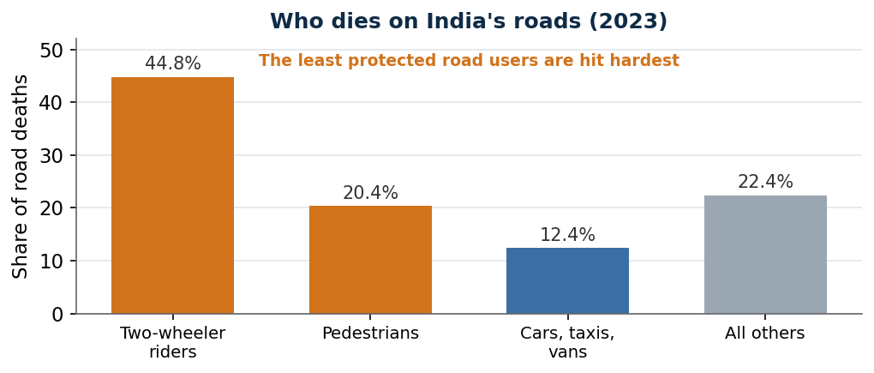
Figure 1. Road deaths in India by type of road user, 2023. Two-wheeler riders and pedestrians account for about two-thirds. Source: MoRTH, Road Accidents in India 2023.
Enforcement, meanwhile, barely bites. Between 2020 and early 2023, traffic fines worth about 3,793 crore rupees were issued, but only about 269 crore, roughly seven percent, was ever collected. Detection without collection changes little.
2. Current Landscape
Indian cities and highways already use pieces of the answer, but rarely joined up. On enforcement, AI cameras now spot violations and issue fines automatically: Kerala runs 726 such cameras, Delhi uses an intelligent traffic system with radar cameras for speeding and red-light jumping, and Bengaluru sends contactless fines by text message. On flow, Bengaluru’s Adaptive Traffic Control System, launched in May 2024 and built on the home-grown CoSiCoSt software from C-DAC, adjusts signal timing in real time using camera sensors. Across its first phase of 169 junctions it cut travel time by 15 to 20 percent, raised throughput by 20 percent, and reached a 33 percent delay reduction at one major junction.
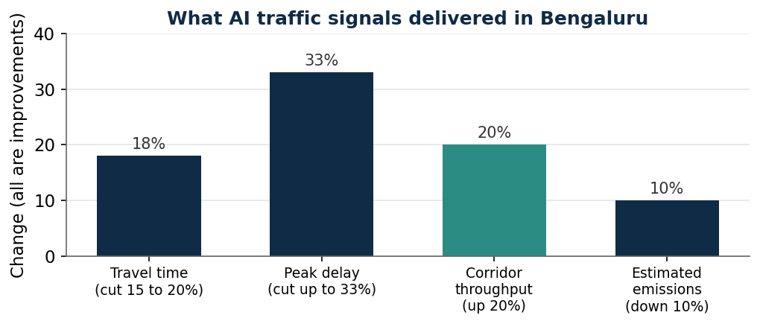
Figure 2. Results from Bengaluru’s AI-based adaptive traffic signals, first phase. Source: Bengaluru Traffic Police and C-DAC, 2024 to 2025.
On safety, the iRASTE project in Nagpur put cameras on 150 public buses to warn drivers seconds before a likely crash and to find grey spots, places that are turning dangerous before they become accident black spots. Crashes fell by about a third during the study. Yet the gaps are wide. Of 13,795 accident black spots identified on national highways, only 5,036 have been permanently fixed, which a parliamentary committee called a serious governance failure in 2025. The tools exist, but they work in isolation, city by city and camera by camera.

3. The AI/ML Solution and What Makes It Innovative
The proposed platform joins the three tasks that are usually handled separately, enforcement, flow, and safety, into one system for a city or a highway corridor. It runs from input, to an AI layer, to an action, to an outcome.
- Input: live camera and sensor feeds at junctions, the national vehicle and licence databases, historical crash records, and signals such as weather and road geometry.
- AI layer: computer vision reads violations and number plates; models predict congestion and the safest signal timing; and a risk model scores each stretch of road for crash danger, learning where a black spot is forming.
- Action: fines are raised automatically and fairly; signals adapt in real time and clear a path for ambulances; and authorities receive a ranked list of dangerous spots to fix, with drivers warned in advance.
- Outcome: fewer violations, smoother and faster traffic, and crashes prevented before they cluster.
What separates this from the scattered tools in use today is three things. It treats enforcement, flow, and safety as one loop rather than three separate products, so the same cameras that catch violations also feed signal control and crash prediction. It shifts the focus from punishing after the event to preventing, by finding black spots while they are still forming, the approach iRASTE proved. And it is built for Indian conditions, using mixed-traffic vision and the home-grown CoSiCoSt signal method, rather than imported systems tuned for orderly lane traffic. The value lies in the join, not in any single camera or signal.
4. Surface-Level Implementation
- Data: junction cameras and sensors, the VAHAN and Sarathi vehicle and licence databases, the national crash database (iRAD and e-DAR), and weather and map layers.
- Infrastructure: edge computing at junctions, a city or corridor command centre, and links to the challan and payment systems.
- People: traffic police, city and highway authorities, and a technical team of vision and data engineers.
- Workflow: capture feeds, detect and predict, act on signals and fines, warn drivers, and feed outcomes back to improve the models.
- Pilot: one corridor or mid-sized city, measured on travel time, violations, and crashes against the year before.
- Partners: C-DAC for signals, a state traffic police force, and a road-safety research group such as those behind iRASTE.
5. Feasibility Analysis
- Technical: High. Every part is already running somewhere in India; the work is joining them.
- Data: Medium to High. Vehicle, licence, and crash databases exist, though quality and sharing between agencies vary.
- Economic: Medium to High. Clear savings in lives, time, and fuel, and fines can help fund it, although collection is weak today.
- Regulatory: Medium to High. The Motor Vehicles Act allows electronic enforcement, but rules on cameras, privacy, and evidence remain uneven.
- Operational: Medium. It needs cooperation across police, city, and highway bodies that rarely share systems.
- Scalability: Medium to High. A proven corridor can be copied, but each city needs local tuning and calibration.
6. Economics and Business Case
The prize is large. Road crashes cost India about 3 percent of national income each year, and congestion drains billions more in lost time and fuel in the big cities. The buyers are governments: city traffic police, state road-safety bodies, and the highways ministry, often funded through the Smart Cities programme and road-safety budgets. Money can also come from fines, though the seven percent collection rate shows that enforcement must be made to work, not merely installed. Revenue for a provider can come from building and running the platform, from analytics services, and from maintenance. The returns show up as lives saved, shorter trips, lower fuel use and emissions, and fairer, better-collected fines. Useful measures of success are deaths and serious injuries per year on the covered roads, average travel time, the share of fines collected, and black spots fixed before they cause harm.
7. Constraints and Risks
- Automated fines can be wrong, and a flood of faulty challans destroys public trust, so human review and easy appeals are essential.
- Cameras that watch every vehicle raise real privacy questions and need clear rules on data use and storage.
- Poorly tuned AI signals can create new dangers; in Bengaluru some skipped the amber light and caused near-misses.
- Indian traffic is mixed and unpredictable, so vision models trained elsewhere often fail and must be retrained locally.
- The system spans police, city, and highway agencies that rarely share data, which is often the hardest barrier.
- Technology cannot fix bad road design or missing footpaths; it must sit alongside engineering, not replace it.
8. Existing Players and Comparable Solutions
- Bengaluru’s Adaptive Traffic Control System and C-DAC’s CoSiCoSt software show flow control works in India. The proposed platform adds enforcement and crash prediction on the same feeds.
- iRASTE in Nagpur and Telangana proved AI can predict accident-prone spots and warn drivers. The proposed platform would run this continuously as part of one system.
- Kerala’s 726 AI cameras and Delhi’s radar-based traffic system show enforcement at scale. The proposed platform links their data to signals and safety rather than issuing fines alone.
- Global traffic-management vendors sell full systems, but they are tuned for orderly lane traffic. The proposed platform is built for Indian mixed traffic and uses home-grown tools.
Critical Assessment
The strength of this direction is that its parts are already proven on Indian roads, not just in theory: adaptive signals cut travel time in Bengaluru, and AI crash prediction saved lives in Nagpur. The weakness of most current efforts is that they stop at an AI camera that issues a fine, which is now common and does little on its own, as the seven percent fine-collection rate shows. The fresh and defensible move is to treat enforcement, flow, and safety as one loop, and to shift the emphasis to prevention, finding and fixing danger before it kills.
Technology is only one of the four pillars of road safety, alongside engineering, education, and emergency care, and it cannot rescue badly designed roads. And automated systems bring their own risks, wrong fines, privacy intrusion, and unsafe signal behaviour, that must be managed openly. Put plainly, AI can make Indian roads move better and kill fewer people, but only as part of a joined-up system with human oversight, not as a box of cameras that issues fines.
Sources
- MoRTH, Road Accidents in India 2023 (172,890 deaths, overspeeding 68 percent, two-wheelers 44.8 percent, pedestrians 20.4 percent): https://www.business-standard.com/india-news/india-road-accidents-deaths-injuries-report-road-highway-ministry-nitin-gadkari-125082801527_1.html
- Challan collection about 7 percent of fines issued, 2020 to 2023: https://www.deccanherald.com/opinion/fast-and-fatalcrisis-on-roads-3800210
- Socio-economic cost of road crashes about 3 percent of GDP (MoRTH and World Bank): https://www.pib.gov.in/PressReleaseIframePage.aspx?PRID=1941052
- Bengaluru Adaptive Traffic Control System results and CoSiCoSt (C-DAC): https://www.deccanherald.com/amp/story/opinion%2Fhow-bengaluru-rewired-its-traffic-signals-to-beat-gridlock-3832080
- Bengaluru AI signals skipping the amber light, a safety caution: https://www.deccanherald.com/amp/story/india%2Fkarnataka%2Fbengaluru%2Fcity-s-ai-traffic-signals-cut-out-amber-push-riders-into-red-alert-3718264
- iRASTE Nagpur, AI crash prediction and driver alerts: https://360info.org/how-ai-can-save-lives-on-indian-roads/
- National highway black spots, 13,795 identified and 5,036 rectified (parliamentary committee, 2025): https://vajiramandravi.com/current-affairs/govt-to-map-highway-black-spots-with-real-time-e-dar-data/
- Kerala AI cameras and Delhi intelligent traffic system: https://indianinfrastructure.com/2025/01/06/safer-roads-technology-solutions-to-reduce-accidents/

