# Home Page

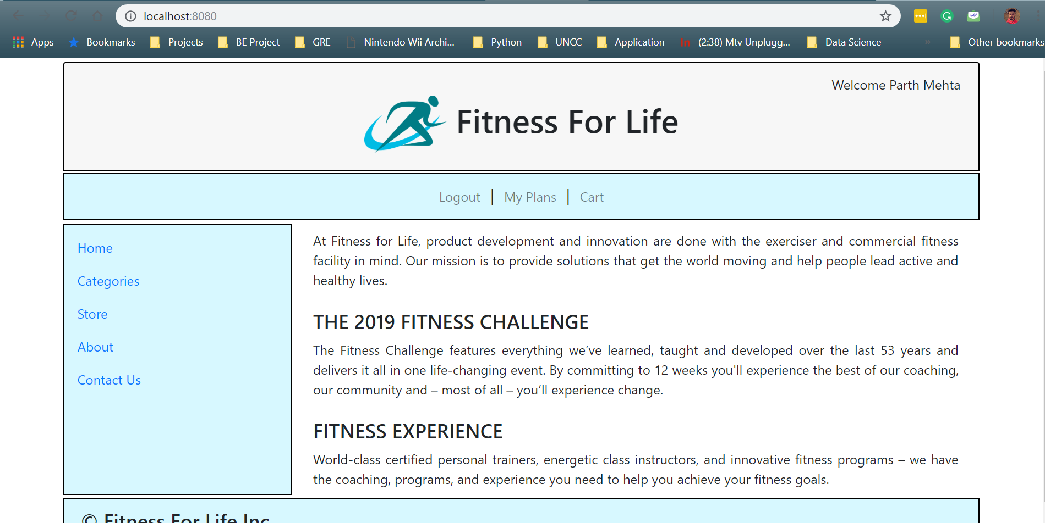

* Instead of storing entire Item in UserItem class I am storing only the itemCode, itemName & catalogCategory since my dummy Items had huge large values and it was difficult to replicate entire Item in UserProfile data.
* Logic of displaying a user's saved items is being written in catalogController file.

Additional Features: None

Application Status: Currently have completed all the features mentioned in the assignment guidelines.

Challenges: -

1. It was challenging assignment to work with sessions. It took a while to understand how exactly it works.
2. I tried to understand the flow by debugging multiple times and understanding the flow of the request.

References:

1. [https://www.bodybuilding.com/](https://www.bodybuilding.com/store/opt/whey.html?searchTerm=on%2Bwhey)
2. <https://www.goldsgym.com/>